Supplementary material
Reproductive females and young mouflon (Ovis gmelini musimon x Ovis sp.) in poor body condition are the main spreaders of gastrointestinal parasites

Gilles Bourgoin^{1,2,*}, Elodie Portanier^{1,2}, Marie-Thérèse Poire^{1,2}, Christian Itty³, Jeanne Duhayer², Slimania Benabed^{1,2}, Anne Cockenpot¹, Marie-Pierre Callait-Cardinal^{1,2}, Mathieu Garel³

¹Université de Lyon, VetAgro Sup - Campus Vétérinaire de Lyon, Laboratoire de parasitologie vétérinaire, 1 avenue Bourgelat, BP 83, F-69280 Marcy l'Etoile, France. ; ²Université de Lyon, Université Lyon 1, CNRS, UMR 5558, Laboratoire de Biométrie et Biologie Evolutive F-69622 Villeurbanne, France. ; ³Office Français de la Biodiversité, Unité Ongulés Sauvages, 5 allée de Bethléem, Z.I. Mayencin, F-38610 Gières France.

* Author for correspondence: G. Bourgoin, E-mail address: gilles.bourgoin@vetagro-sup.fr

Table S1: Model selection of mixed-effects models for individual characteristics based on corrected Akaike’s Information Criterion (AICc) for testing the effects of the scaled delay (scaled number of days) between sampling and coproscopic analyses (delay), and the scaled sampling date (sampling date) on the fecal oocyst/egg count (FOC and FEC for Eimeria spp. and gastro-intestinal strongyles, respectively) in mouflon in the Caroux-Espinouse massif, France. df are the degree of freedom, weight are the Akaike weights. All models included the individual identity and the year of sampling as random effects.
Response variable | Model | df | AICc | ΔAICc | weight
FOC | Sampling date | 5 | 1404.4 | 0.00 | 0.293
 | Sampling date + delay | 6 | 1405.1 | 0.69 | 0.207
 | Sampling date + sampling date² | 6 | 1405.3 | 0.91 | 0.186
 | Sampling date + sampling date² + delay | 7 | 1405.8 | 1.38 | 0.147
 | Sampling date + delay + delay² | 7 | 1406.7 | 2.30 | 0.093
 | Sampling date + sampling date² + delay + delay² | 8 | 1407.2 | 2.80 | 0.072
 | Null | 4 | 1415.3 | 10.90 | 0.001
 | Delay | 5 | 1417.3 | 12.88 | 0.000
 | Delay + delay² | 6 | 1418.3 | 13.95 | 0.000
FEC | Delay | 5 | 1370.7 | 0.00 | 0.460
 | Sampling date + delay | 6 | 1372.6 | 1.83 | 0.184
 | Delay + delay² | 6 | 1372.8 | 2.06 | 0.165
 | Sampling date + sampling date² + delay | 7 | 1374.5 | 3.76 | 0.070
 | Sampling date + delay + delay² | 7 | 1374.6 | 3.90 | 0.065
 | Sampling date + sampling date² + delay + delay² | 8 | 1376.6 | 5.83 | 0.025
 | Null | 4 | 1377.1 | 6.38 | 0.019
 | Sampling date | 5 | 1378.7 | 7.97 | 0.009
 | Sampling date + sampling date² | 6 | 1380.8 | 10.02 | 0.003

Figure S1. Predicted fecal oocyst count (FOC) values for Eimeria spp. as a function of the selected variables related to sampling design (see Table S1) scaled sampling date (a) and scaled delay (scaled number of days) between sampling and coproscopic analyses (b), with null values of delay and sampling date, respectively. Lines represent predicted values and grey bands represent the 95% confidence interval. Points represent average partial residuals of scaled sampling date (a) and scaled delay (b) (values were grouped at 10% quantile intervals), with the size of the dots being proportional to the number of observations (top of the graph).

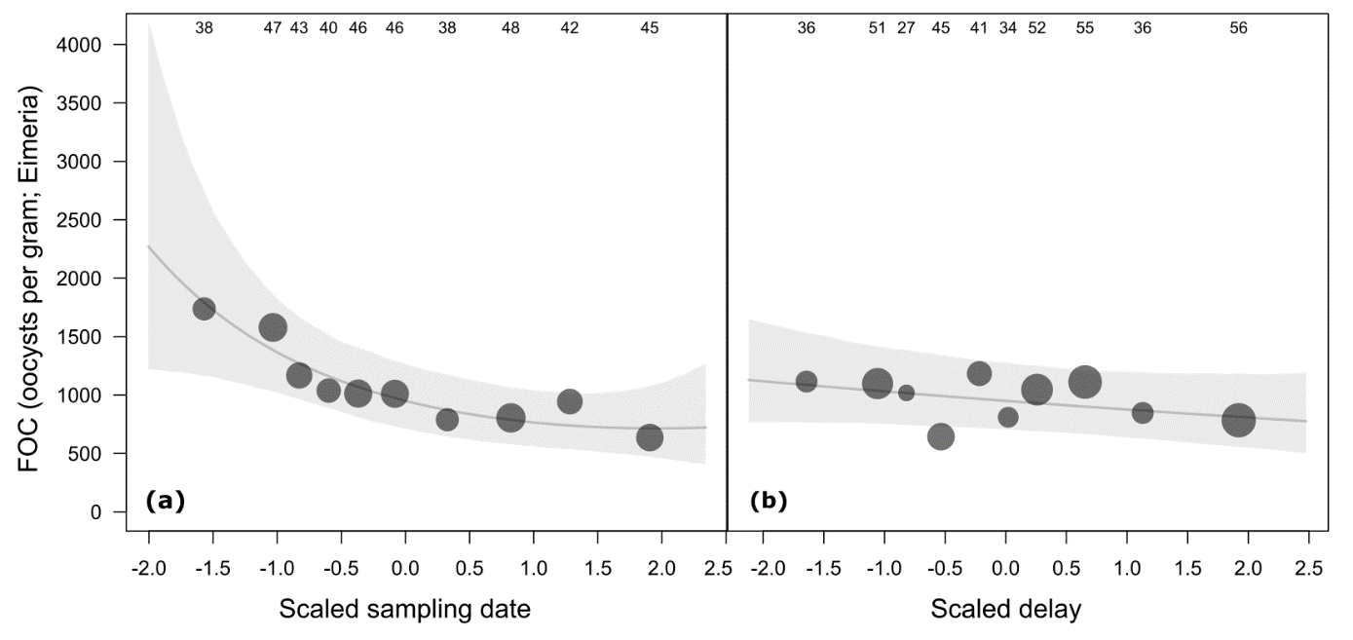

Figure S2. Predicted fecal egg count (FEC) values for gastro-intestinal strongyles as a function of the selected variables factors related to sampling design (see Table S1) scaled sampling date (a) and scaled delay (scaled number of days) between sampling and coproscopic analyses (b), with null values of delay and sampling date, respectively. See Fig. S1 for details.

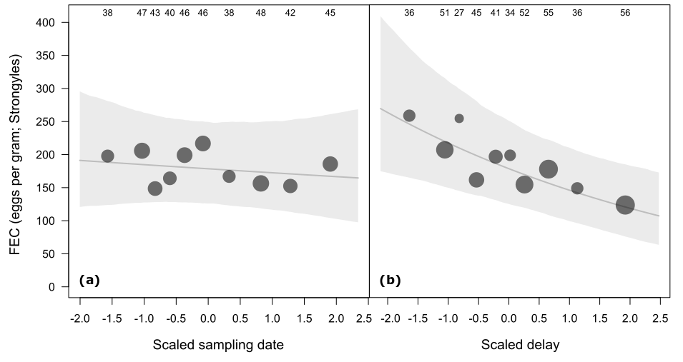

Figure S3. Predicted fecal egg counts (FEC) for gastro-intestinal strongyles as a function of the scaled mass index (SMI) of males and females mouflon based on the second best model (Table 2). Predictions were computed for null values of scaled delay (scaled number of days) between sampling and coproscopic analyses, and scaled sampling date, and for 4 years old mouflon. Numbers on the top of the graph are the total number of females and males used to compute average partial residuals. See Fig. S1 for details.
