Supplementary Material
Appendix 1. Sampling sites, sampling effort and parasite species richness
Fig. S1. Map of sampling sites. See Table S1 for full names of the localities. Colours designate predominant landscape in a locality. Blue- tundra, yellow – grasslands and forest-steppes, purple – mixed forests, green – mountain taiga forests, red –northern taiga forests, black – southern taiga forests.
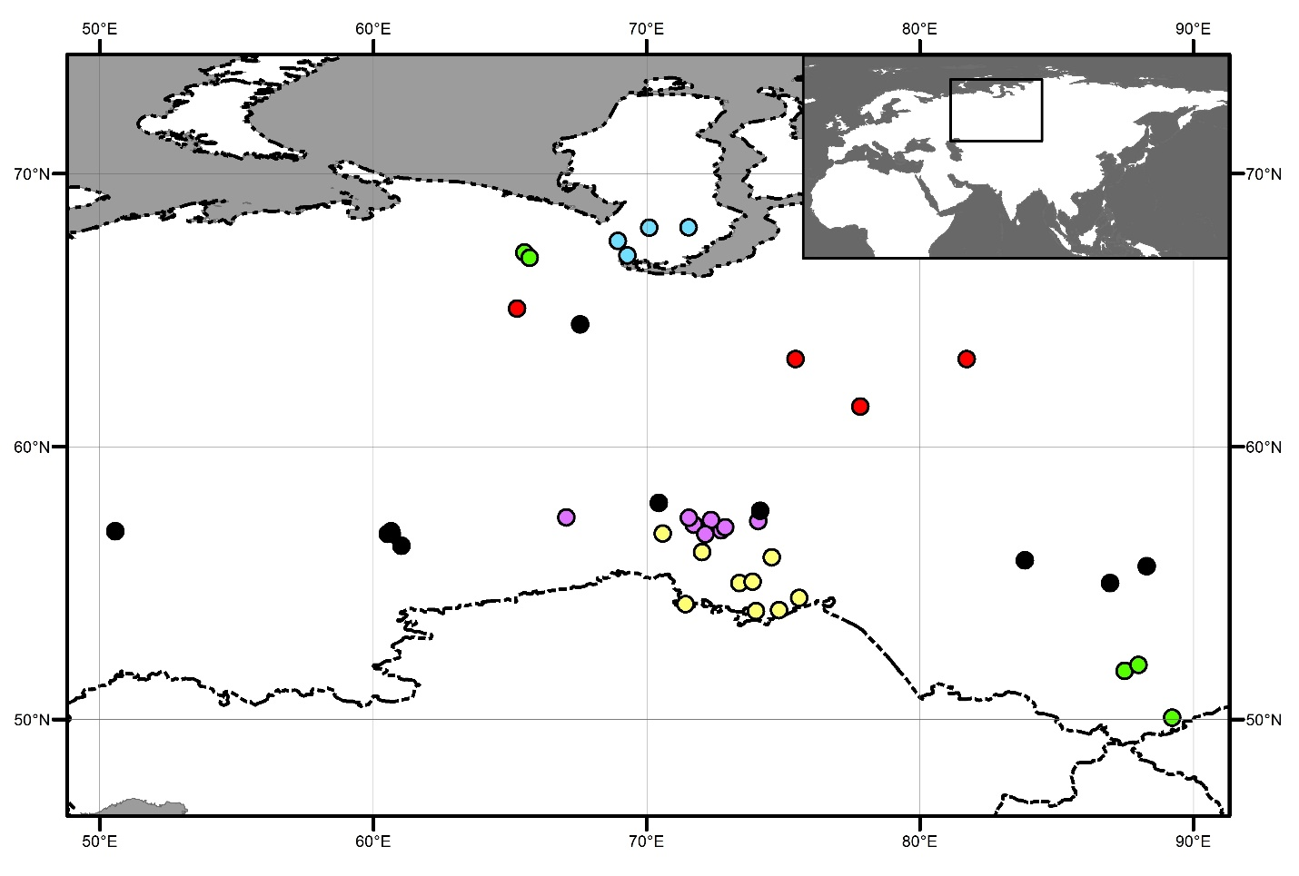

Appendix 2. Brief description of the Double Principal Coordinate Analysis (DPCoA) (Pavoine et al. (2004).
The DPCoA is applied for comparing multiple communities composed of species that differ in phylogeny or functional traits. In a nutshell, the aim of the DPCoA is the analysis of the relationships between two types of data, namely phylogenetic or trait differences among species (presented as a dissimilarity matrix) and differences in species distribution among communities (presented as a species abundance or presence/absence matrix). The main result of the DPCoA is the construction of a multidimensional space common to both species and communities, with the initial application of a principal coordinate analysis (PCoA) to between-species distances. This creates a swarm of species points in a Euclidean space of orthogonal axes and then introduces the communities into this space. An important feature of the DPCoA is that the dissimilarity information is given by the Rao’s index of diversity (quadratic entropy Q; Rao, 1982), which integrates diversity and dissimilarity measures by measuring the diversity of a distribution (e.g., a community) and the dissimilarity between distributions (e.g., communities). It can further be decomposed into within- and between-community diversity values (Pavoine et al., 2004), the sum of which represents the total diversity across all communities. In other words, the space of the DPCoA represents both dissimilarities among species and dissimilarities among communities.
References
Pavoine S, Dufour AB and Chessel D (2004) From dissimilarities among species to dissimilarities among communities: a double principal coordinate analysis. Journal of Theoretical Biology 228, 523-537. Doi:10.1016/j.jtbi.2004.02.014
Rao CR (1982) Diversity and dissimilarity coefficients: a unified approach. Theoretical Population Biology 21, 24-43. Doi:10.1016/0040-5809(82)90004-1

