Appendix, supplementary information

Know your enemy - transcriptome of myxozoan Tetracapsuloides bryosalmonae reveals potential drug targets against proliferative kidney disease in salmonids

Freed Ahmad¹*, Paul V. Debes², Lilian Pukk³, Siim Kahar³, Hanna Hartikainen⁴, Riho Gross³, Anti Vasemägi^{3,5}

¹Department of Biology, University of Turku, FI-20014, Finland;
² Department of Aquaculture and Fish Biology, Hólar University, Saudárkrókur, Iceland;
³Chair of Aquaculture, Institute of Veterinary Medicine and Animal Sciences, Estonian University of Life Sciences, 51014 Tartu, Estonia;
⁴School of Life Sciences, The University of Nottingham, University Park, NG7 5RD, Nottingham, UK; and
⁵Department of Aquatic Resources, Swedish University of Agricultural Sciences, 17893 Drottningholm, Sweden.

Running title: Tetracapsuloides bryosalmonae transcriptome assembly

*Correspondence to:
Anti Vasemägi
⁵Department of Aquatic Resources, Swedish University of Agricultural Sciences, 17893 Drottningholm, Sweden; ³Chair of Aquaculture, Institute of Veterinary Medicine and Animal Sciences, Estonian University of Life Sciences, 51014 Tartu, Estonia

Anti.vasemagi@slu.se

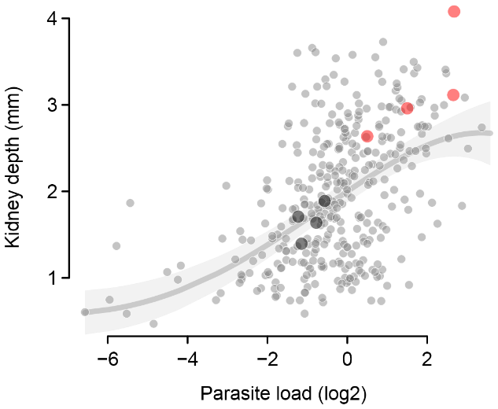
Supplementary figure 1. Relative parasite load vs. length-standardized kidney depth in all infected sampled fish sampled (dots) in the River Mustoja in 2015 and the fitted overall second-order polynomial regression line with 95% confidence bands as in Debes et al. (2017). The enlarged dots highlight the moderately (black; n = 4) and severely infected (red; n = 4) fish as used in transcriptomic analyses.

Supplementary figure 2. Data analysis pipeline.

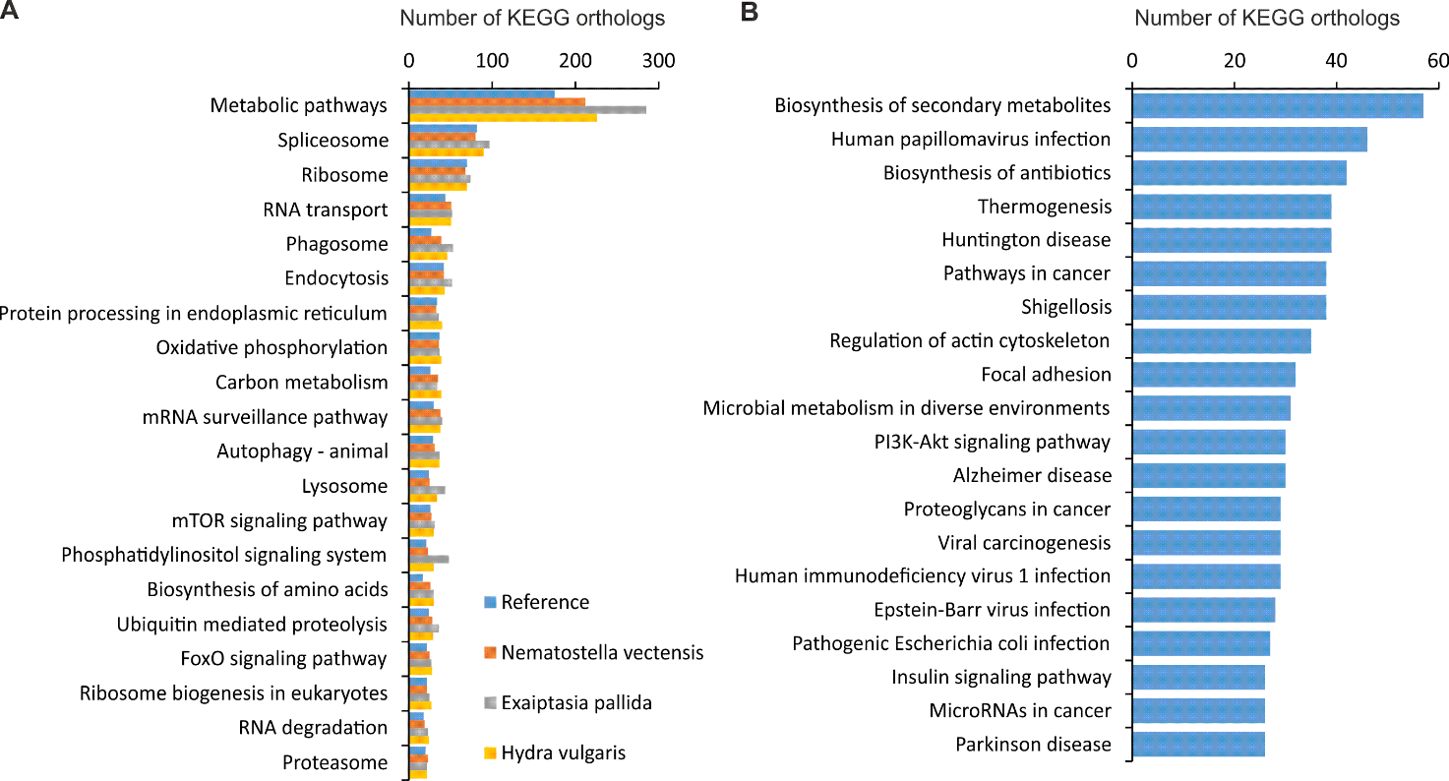
Supplementary figure 34. Top KEGG pathways in the myxozoan parasite transcriptome A) Top 20 pathways found in both reference and cnidarian-specific searches B) Top 20 pathways found only in reference KEGG orthology.

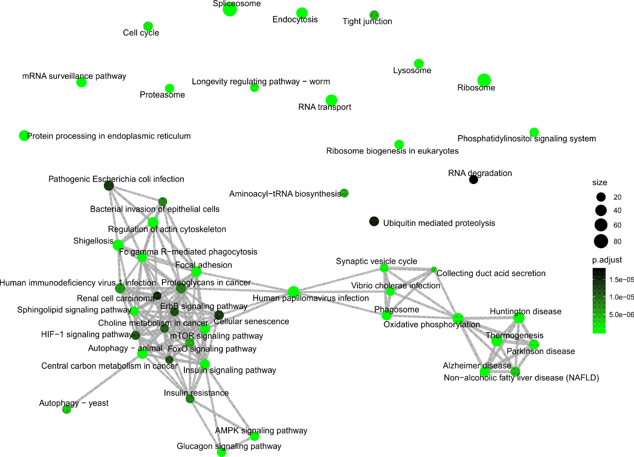
Supplementary figure 45. Top 50 enriched KEGG pathways as enrichment network map. The overlapping genes in the enriched pathways are shown as edges with mutually overlapping gene sets clustering together forming functional module.

Supplementary figure 56. Top 25 most abundant GO terms in A) Cellular component B) Biological process and C) Molecular function.
Supplementary figure 6. Overlap between our T. bryosalmonae assembly and intersect transcriptome of Faber et al. (2020). A) Venn diagram showing overlap between two assemblies using reciprocal BLASTN. Pink circle represents genes present in the intersect transcriptome (Faber et al. 2020) and grey circle corresponds to T. bryosalmonae transcripts identified in current work. The overlap between two circles represents genes found in both assemblies. B) Percentage of genes in different KEGG Brite hierarchies for the genes that were present in both assemblies (red) and the genes present in only current assembly. C) Trinotate assigned GO term differences between the genes that were found in the intersect transcriptome (Faber et al. 2020) and the genes that were unique to our study. Only genes having at least one GO term were used as inputs for both lists. D) Significantly different GO terms are shown in terms of –log (P-value). Both C & D are generated using (WEGO 2.0).

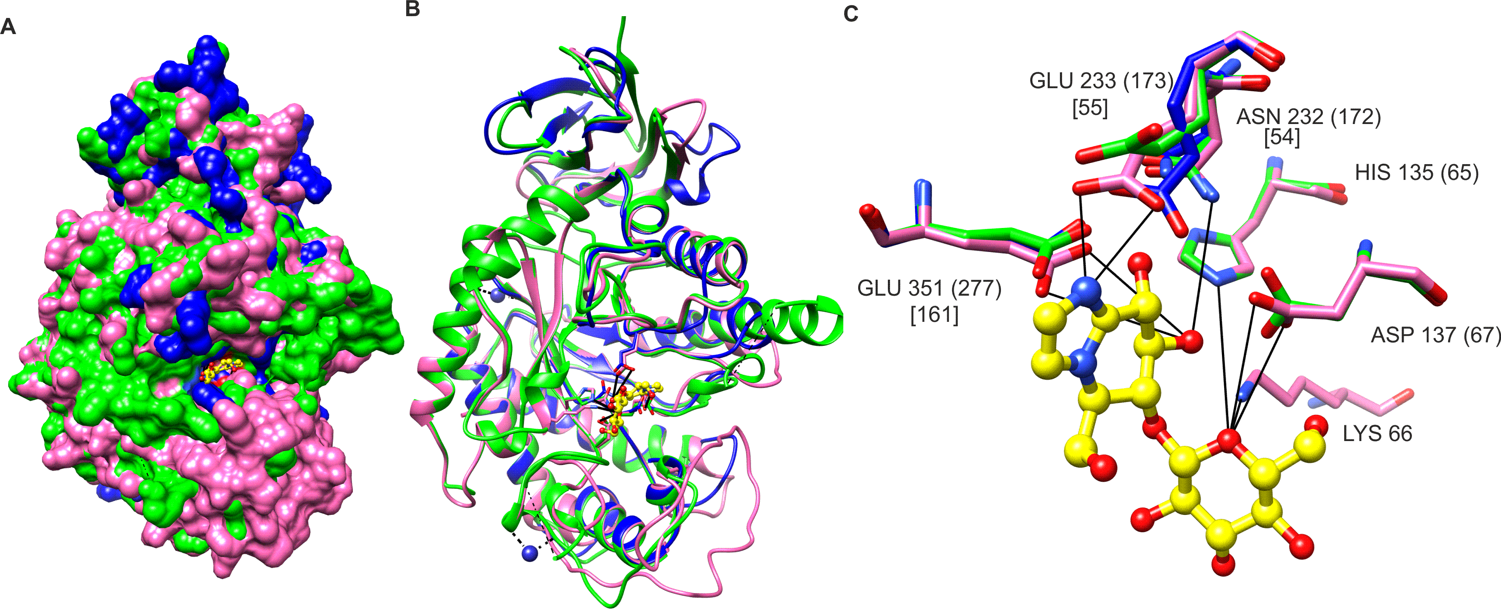 Supplementary figure 7. Prediction of the shorter EGCase1 (DN1345_c0_g1_i1 DN11176_c0_g2_i1) structure and inhibitor binding site in T. bryosalmonae. The inhibitor (yellow) bound to the template is shown in ball and stick representation. The structures of parasite EGCases are superimposed (green and blue) on the chain B of the template endoglycoceramidase ii from rhodococcus sp. (pink). A) Similar binding cavities between template and targets can be seen around the inhibitor molecule. B) The same structure shown in ribbons to illustrate the consistency between template and target structures. C) The interactions between the EGCase II amino acids and inhibitor at the binding site are shown with black lines (Caines et al. 2007). The positions of the conserved amino acids at the binding site are in the template sequence (Caines et al. 2007) (after the amino acid), in the longer T. bryosalmonae EGCase2 (in parenthesis) and the shorter T. bryosalmonae EGCase1 (in square brackets).

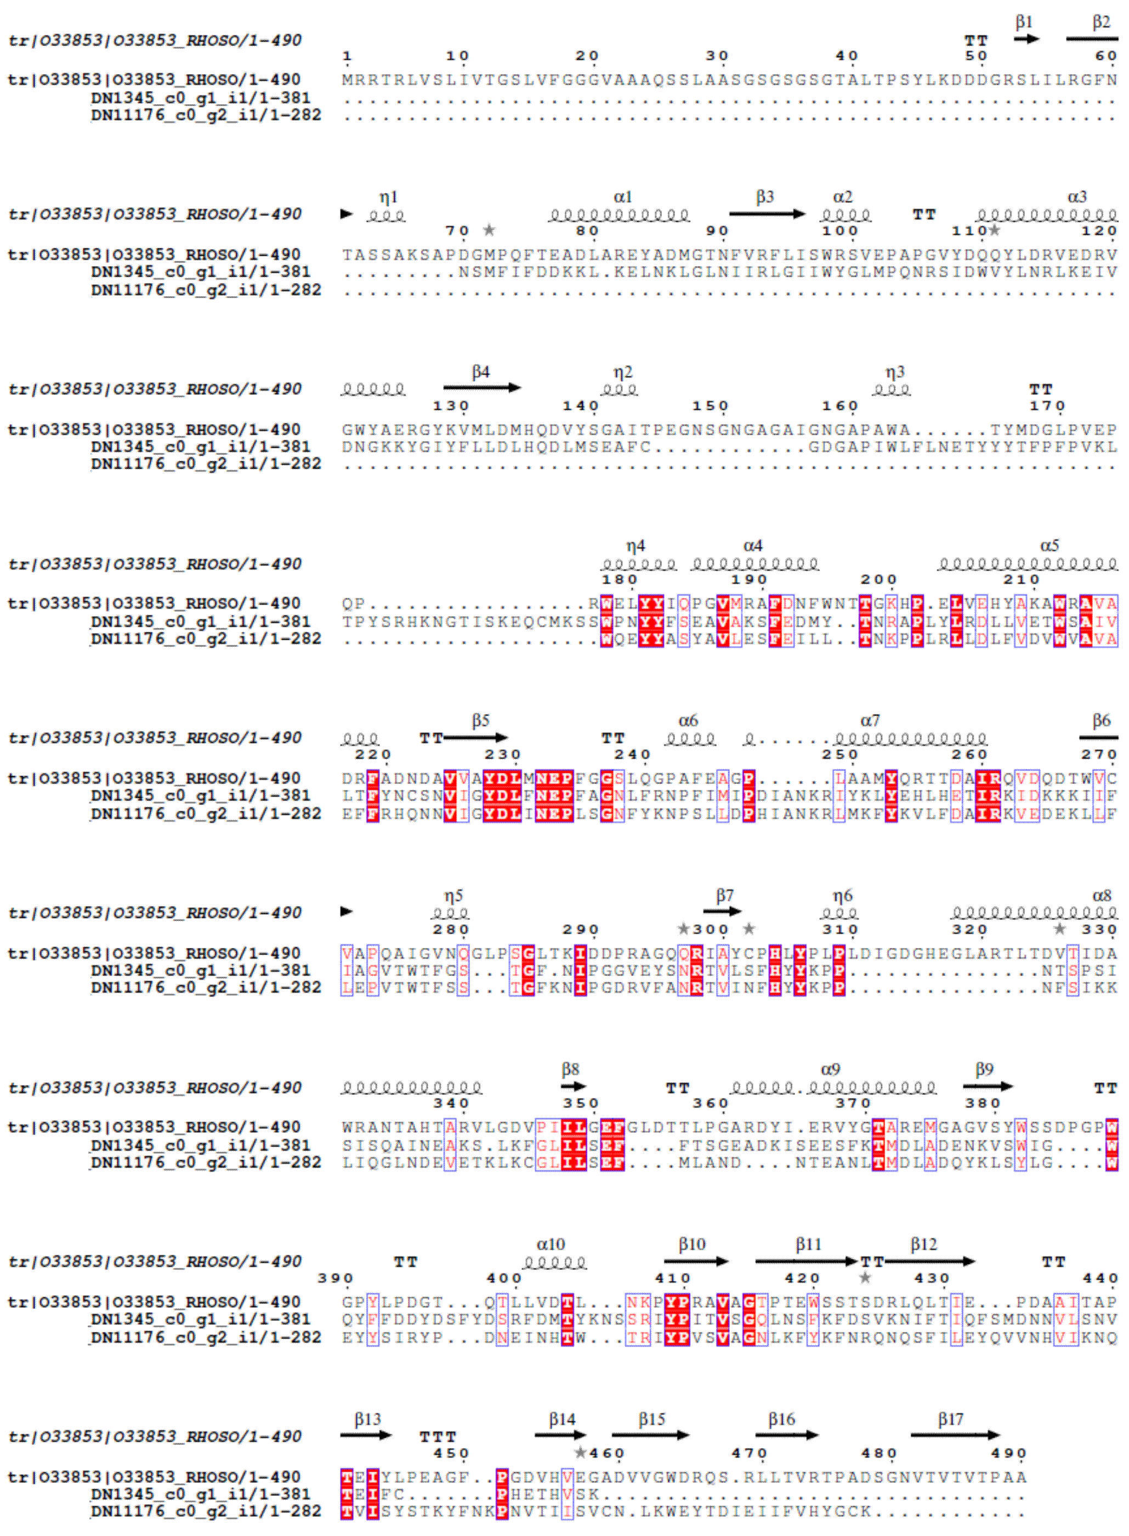

Supplementary figure 8. Multiple sequence alignment of the template (rhodococcus sp. endoglycoceramidase ii) and the two T. bryosalmonae EGCase sequences.

Supplementary figure 9. Sequence alignment of the ChEMBL Legumain-like protease (LGMN; CHEMBL1075261, UniProt ID: Q6PRC7) and the T. bryosalmonae partial legumain (DN3668_c0_g1). Alignment starts from 235th amino acid and does not cover the active site residues His(154) and Cys (195) (marked with red).

Supplementary figure 10. Sequence alignment of the ChEMBL Pancreatic lipase-related protein 2 (PLRP2; CHEMBL2169729, UniProt ID: P81139) and the T. bryosalmonae partial PLRP2s. The active site residues Ser(154) and A (178) and His (247) were not covered by the two T. bryosalmonae sequences.

References:
Caines, MEC, Hancock, SM, Tarling, CA, Wrodnigg, TM, Stick, RV, Stütz, AE, Vasella, A, Withers, SG and Strynadka, NCJ (2007) The Structural Basis of Glycosidase Inhibition by Five-Membered Iminocyclitols: The Clan A Glycoside Hydrolase Endoglycoceramidase as a Model System. Angewandte Chemie International Edition 46, 4474–4476. doi: 10.1002/anie.200700268.
Debes, PV, Gross, R and Vasemägi, A 2017 Quantitative genetic variation in, and environmental effects on, pathogen resistance and temperature-dependent disease severity in a wild trout. American Naturalist 190:244-265.

