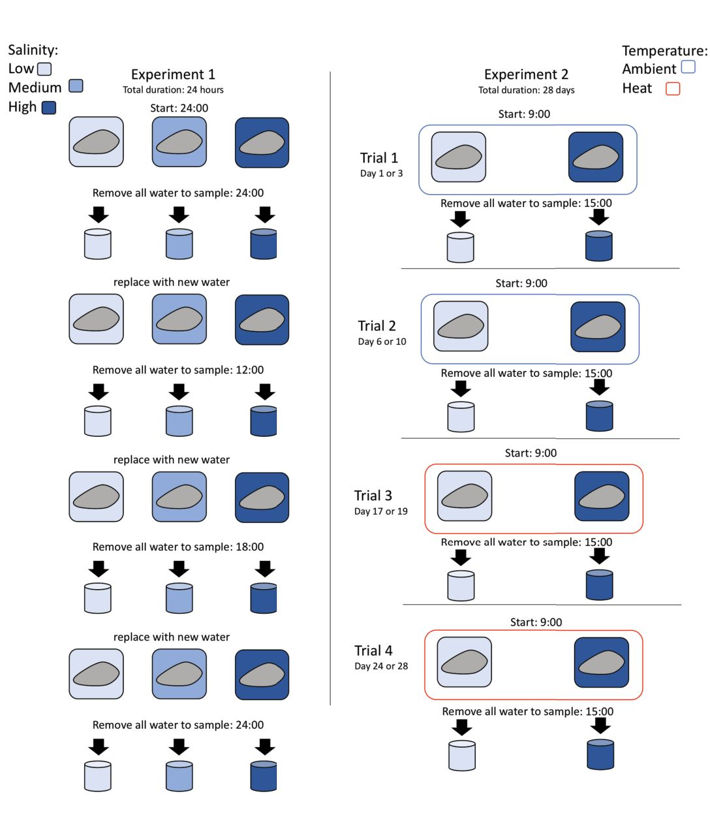
Figure S1. Experimental set up and experiment timeline. A) Experiment #1. Each oyster represents a single replicate inside a single tupperware. The oyster remained inside the tupperware for the duration of the experiment, as water was removed and replaced. B) Experiment #2. Each oyster experienced a total of 4 trials, but only half of the oysters were assayed on a given day due to space restraints. The two days under the trial number indicate when that trial was conducted (half the oysters assayed on the first day and half on the second). Oysters were removed from tupperware and placed in communal holding tanks between trials.

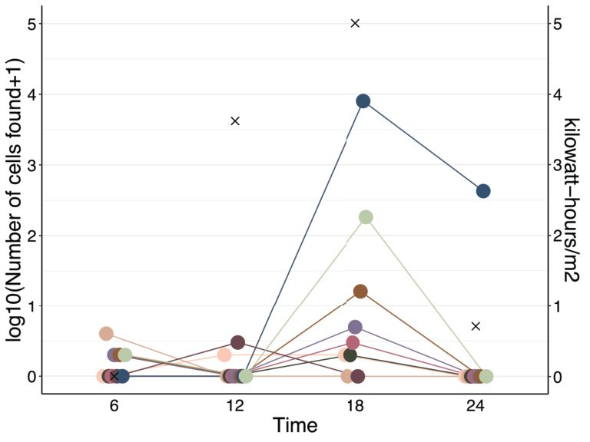
Figure S2 Time of day drove P. marinus release. Nine of the oysters used in Experiment #1 released cells. Number of cells found during a timepoint is colored by oyster replicate and points are connected by lines. The time when the sample was taken is shown, meaning that cells were released in the six hour period beforehand. Sunlight (kilowatt hours/m2) as inferred from the angle of the sun is displayed on the right y axis and denoted by ×

