Supplementary Figure 1: Median-joining networks of represenative Haplogroup A and B constructed with each protein-coding gene of the mitochondrial genome. (a) cox3 (b) cytb (c) nad4L (d) nad4 (e) atp6 (f) nad2 (g) nad1 (h) nad3 (i) cox1 (j) cox2 (k) nad6 (l) nad5
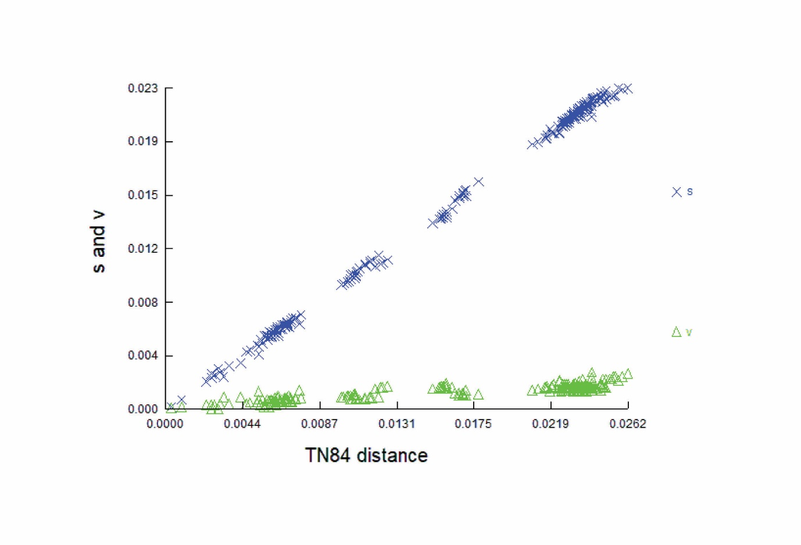
Supplementary Figure 2: A plot showing transition and transversion ratio (Ts/Tv) against genetic distance.

