Supplementary Material
Appendix 1. Sampling sites, sampling effort and parasite species richness
Fig. S1. Map of sites where Miniopterus natalensis were collected. Map was produced using ArcGIS v9.2. Biomes identified following Mucina and Rutherford (2006).
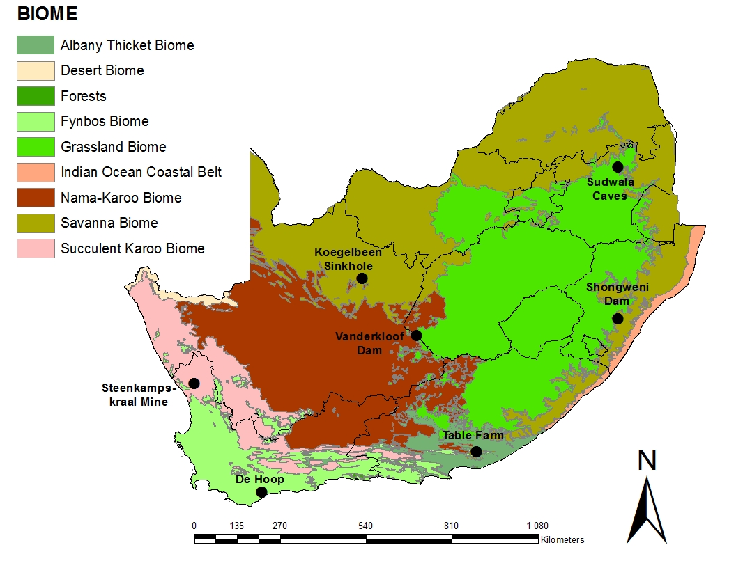
Reference
Mucina L and Rutherford MC (eds) (2006) The Vegetation of South Africa, Lesotho and Swaziland. Strelitzia 19. Pretoria, South Africa: South African National Biodiversity Institute.

Table S1. Characteristics of roosts and mean species richness (± SE) of endo- and ectoparasites at seven sampling sites of Miniopterus natalensis (n = 96) in South Africa.
Sampling site | Roost type | Number of bats captured |  |  | Mean species richness (± SE)
 |  | Males | Females | Total | Endoparasite species (n = 11) | Ectoparasite species (n = 15)
De Hoop Guano Cave | Primarily summer roost, but used year round | 10 | 3 | 13 | 1.62 ± 0.37 | 2.85 ± 0.49
Koegelbeen Sinkhole | Primarily summer roost, but used year round | 10 | 9 | 19 | 2.20 ± 0.19 | 2.68 ± 0.28
Shongweni Dam | Transient pre-maternity roost | 10 | 1 | 11 | 1.64 ± 0.20 | 2.73 ± 0.45
Steenkamps-kraal Mine | Hibernaculum | 2 | 0 | 2 | 1.50 ± 0.50 | 2.00 ± 1.00
Sudwala Caves | Maternity roost | 10 | 10 | 20 | 1.90 ± 0.23 | 2.7 ± 0.27
Table Farm | Primarily summer roost, but used year round | 10 | 10 | 20 | 2.10 ± 0.19 | 3.40 ± 0.34
Vanderkloof Dam | Summer roost | 10 | 1 | 11 | 1.18 ± 0.12 | 3.00 ± 0.47

Table S2. Climate and vegetation characteristics (Mucina and Rutherford, 2006) of sampling sites of Miniopterus natalensis (n = 96) in South Africa.
Sampling sites | Biome characteristics
De Hoop Guano Cave | Situated in a limestone cliff at the northern part of the land-locked De Hoop Vlei (a shallow marshy area that, depending on rain fall, is intermittently covered with water). This roost falls within the Fynbos biome and is surrounded by coastal fynbos, comprising evergreen, sclerophyllous shrubs, and dominated by restios (Odendaal and Jacobs, 2011). The area forms part of the winter rainfall region and rainfall ranges from 250 to 800 mm per year.
Koegelbeen Sinkhole | Situated within a sinkhole near Griekwastad in the Kimberley area. It houses one of two bat colonies in this study located in the Savanna biome (Schoeman and Jacobs, 2008). The Savanna biome is one of the three largest biomes in South Africa, mainly covering the northeastern part of the country, and found mostly below altitudes of 1500 m; it is located in the summer rainfall region with a mean annual rainfall of 500 to 700 mm. Vegetation is characterised by usually open tree and shrub layers combined with a more or less well-developed grass layer.
Shongweni Dam | The second colony in this study situated in the Savanna biome (see Koegelbeen Sinkhole). The colony inhabits the maintenance tunnel of the dam, similar to the bats collected at Vanderkloof Dam.
Steenkampskraal Mine | Located in the Succulent Karoo biome in the western part of South Africa. Rains fall mainly in winter, not exceeding 150 mm per annum, and summers are extremely arid. Vegetation in the Succulent Karoo is dominated by dwarf succulent shrubs and grasses are rare. This roost was a disused monazite mine at the time of sampling but has subsequently been re-opened.
Sudwala Caves | A series of caves situated in the Grassland biome. Although vegetation is strongly dominated by grasses, forbs also form an important component of this biome, whereas the establishment of trees is largely prevented by frosts, fire and grazing. Summer rainfall ranges from 400 to 2500 mm per year.
Table Farm | Situated in an area of environmental transition between the Albany Thicket biome in the east and the Nama-Karoo in the west (Odendaal and Jacobs, 2011). This region receives rain throughout the year, but predominantly from spring to summer. Other than the cave-like maintenance tunnels occupied by the bats at Shongweni Dam and Vanderkloof Dam, the roost at Table Farm consists of a narrow tunnel, excavated for a water pipeline and open at both ends. At the time of sampling, Table Farm was run as an active cattle farm.
Vanderkloof Dam | Located in the Nama-Karoo biome, which covers the central plateau of the western half of South Africa and is dominated by a combination of arid grassland and dwarf scrubland. Annual rainfall in this biome is highly variable, ranging from 70 to 500 mm per year, and most likely to occur in the late summer months. The colony inhabits the Dam’s maintenance tunnel, similar to the bats collected at Shongweni Dam.

Appendix 2. Parasite species
Table S1. Ecto- and endoparasite taxa collected from Miniopterus natalensis at seven sampling sites in South Africa. Taxa designated by a letter could not be identified to species level, but were morphologically distinct from each other and any known congeners.

ECTOPARASITES

Phylum Arthropoda
Class Arachnida
Order Ixodida
Family Ixodidae
Ixodes simplex Neumann, 1906
Order Mesostigmata
Family Laelapidae
Ichoronyssus miniopteri (Zumpt & Patterson, 1952)
Family Macronyssidae
Macronyssus sp. A
Macronyssus sp. B
Macronyssus sp. C
Macronyssus sp. D
Steatonyssus sp. A
Steatonyssus sp. B
Family Spinturnicidae
Spinturnix semilunaris de Meillon & Lavoipierre, 1944
Order Prostigmata
Family Myobiidae
Calcarmyobia rhinolophia (Womersley, 1941)
Class Insecta
Order Diptera
Family Nycteribiidae
Nycteribia schmidlii Schiner, 1853
Penicillidia fulvida Bigot, 1885
Family Streblidae
Ascodipteron sp.
Brachytarsina sp.
Order Siphonaptera
Family Ischnopsyllidae
Oxyparius isomalus (Waterston, 1915)

ENDOPARASITES

Phylum Nematoda
Class Adenophorea
Order Enoplida
Family Capillariidae
Aonchotheca sp.
Class Secernentea
Order Strongylida
Family Molineidae
Molinostrongylus ornatus (Mönnig, 1927)
Molinostrongylus sp. A
Molinostrongylus sp. B
Order Spirurida
Family Onchocercidae
Litomosa chiropterorum Ortlepp, 1932
Family Physalopteridae
Physaloptera sp.
Phylum Platyhelminthes
Class Cestoda
Order Cyclophyllidea
Family Hymenolepididae
Class Trematoda
Order Plagiorchiida
Family Anchitrematidae
Anchitrema sanguineum (Sonsino, 1894)
Family Lecithodendriidae
Paralecithodendrium khalili (Saoud & Ramadan, 1977)
Paralecithodenrium pyramidum (Looss, 1896)

