SUPPLEMENT

Video S1. Egg hatching followed by nauplius and naupliiar molting. https://youtu.be/3h3fHgeuVlo
Note at 7:12 the naupliiar molt becomes visible.

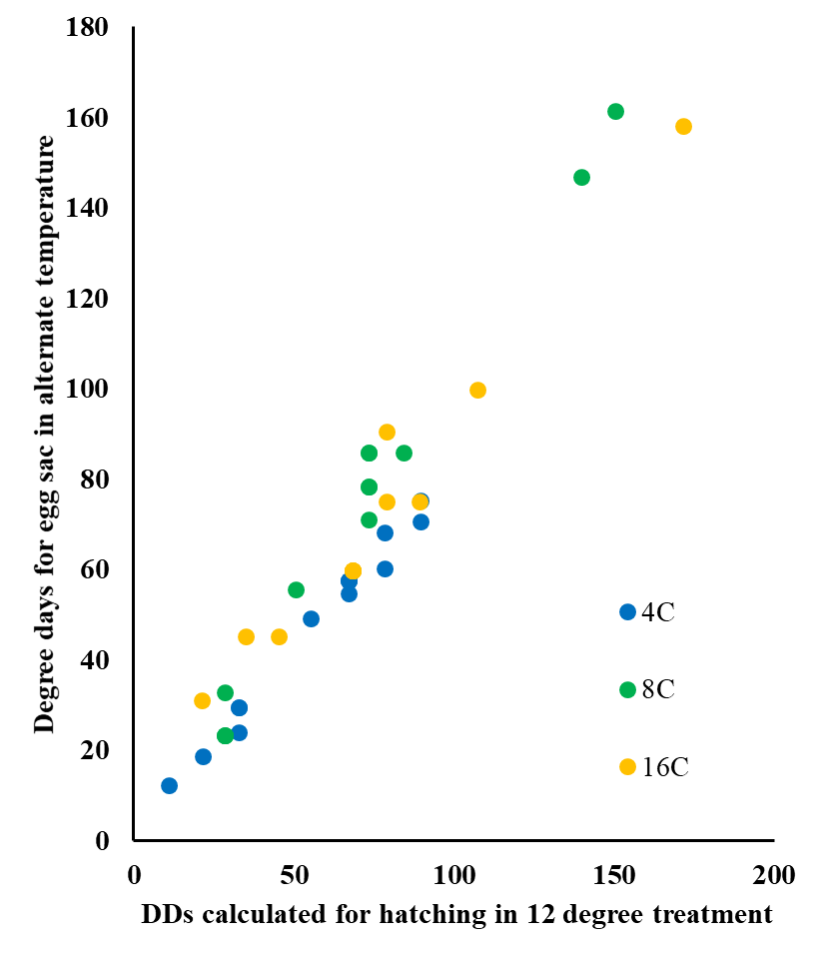
Figure S1. Correspondence of degree days until hatch for paired egg sacs held at different temperatures, highlighting results for each of the alternate treatment temperatures used.

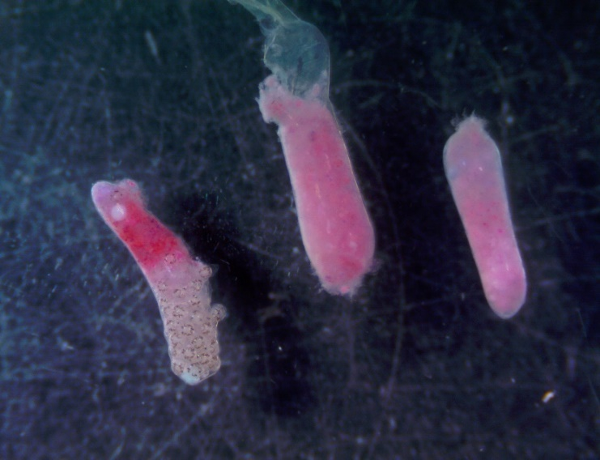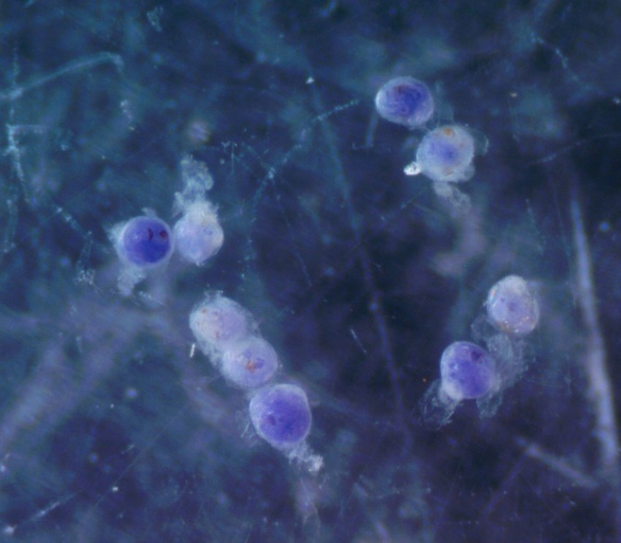
Figure S2. Pink and blue eggs observed in egg sacs that failed to hatch. Photos by W. Gerth.

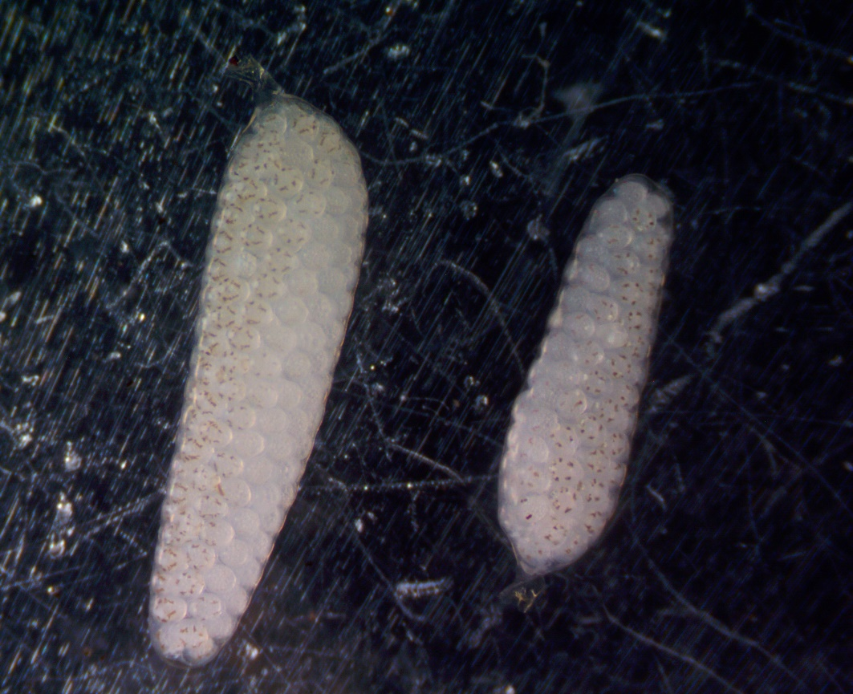
Figure S3. Split development when eggs were placed in a petri dish on ice, resulting in a cool, less-developed side (non-pigmented) and a warm, more-developed side (pigmented). Photo by W. Gerth.

