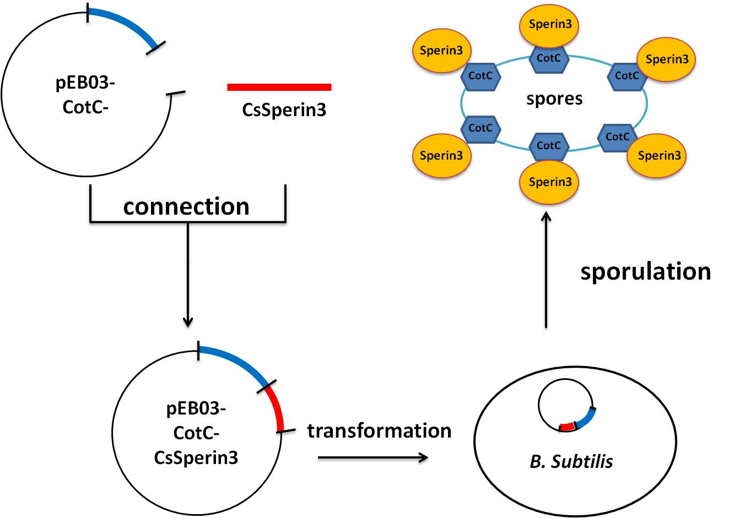

Figure S1 Schematic diagram for the construction of recombinant plasmid and bacillus subtilis spores expressing CsSerpin3. The recombinant plasmid (pEB03-CotC-CsSperin3) were constructed by connecting the Serpin3 gene segment of Clonorchis sinensis (CsSperin3) into pEB03-CotC plasmid. The pEB03-CotC-CsSperin3 plasmid was transfected into Bacillus subtilis WB600 strain and the strain were induced for spore formation.

