Sckrabulis et al. - Direct onshore wind predicts daily swimmer’s itch (avian schistosome) incidence at a Michigan beach

Supplemental Material:
For the present study, swimmers during the summers of 2013 to 2016 were asked to report any cases of swimmer’s itch (SI) to lifeguards at CSA beach during swimming hours. To maximize the accuracy of self-reporting data, an informational brochure (Fig. S1) was publicly distributed at no cost throughout Benzie County, Michigan including at pharmacies, libraries, hospitals, resorts, government buildings, and grocery stores. An estimated 4,000 brochures were distributed throughout our study period (2013-2016). Brochures were also provided to lifeguards at CSA beach and made publicly available in the CSA community building nearby.
Additional efforts to inform swimmers of SI risk included posting large informational signs concerning SI symptoms (Fig. S2), inviting experts to give presentations about SI at annual CLWA meetings, and publishing recent SI information in the CLWA newsletter “Crystal Whitecaps” (available online at http://crystallakewatershed.org/education/newsletter).
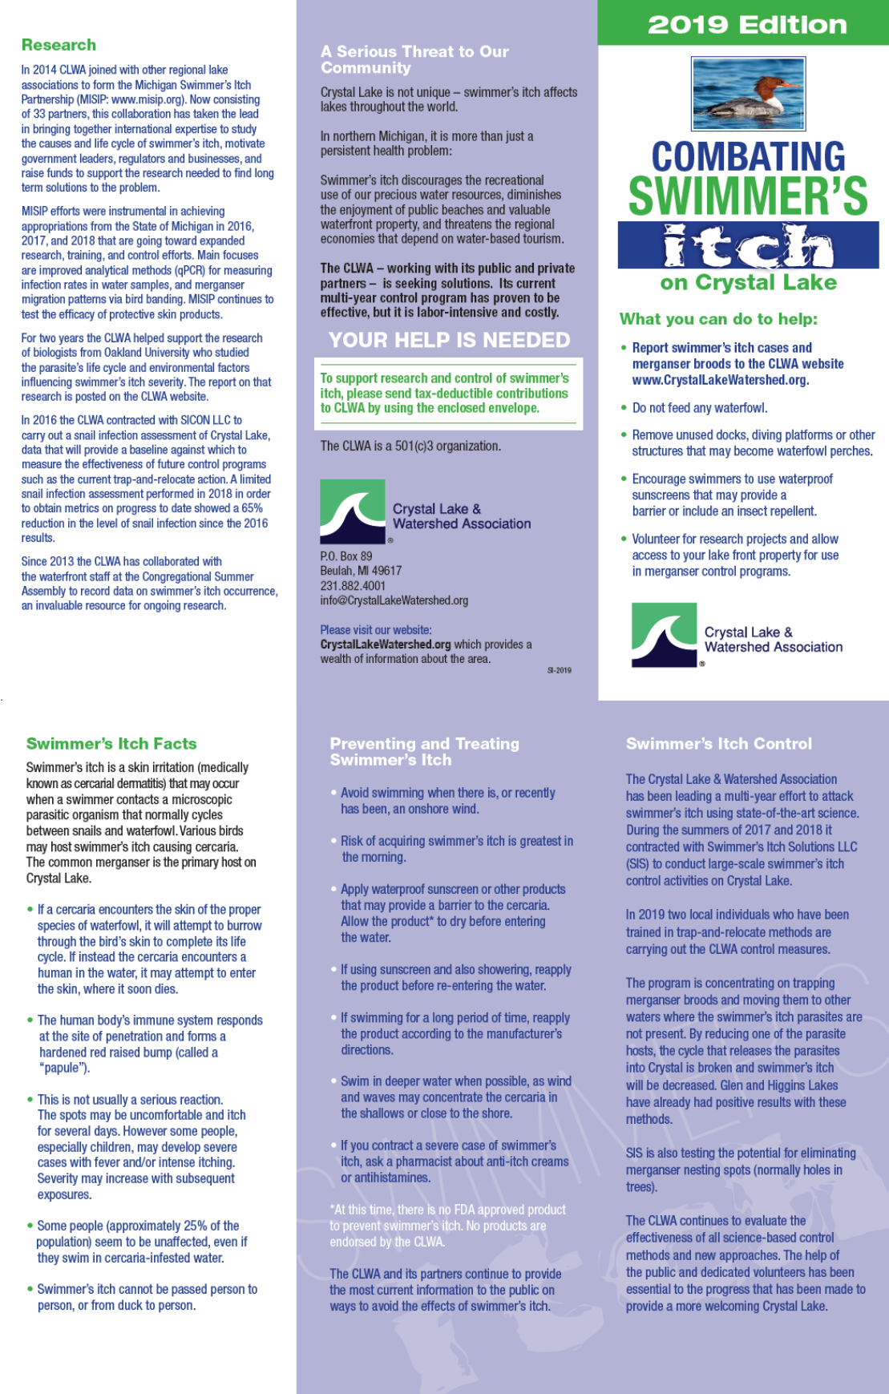
Figure S1: The front and back of the 2019 version of the SI informational brochure distributed throughout Benzie County, Michigan. © Crystal Lake Watershed Association, reproduced with permission.
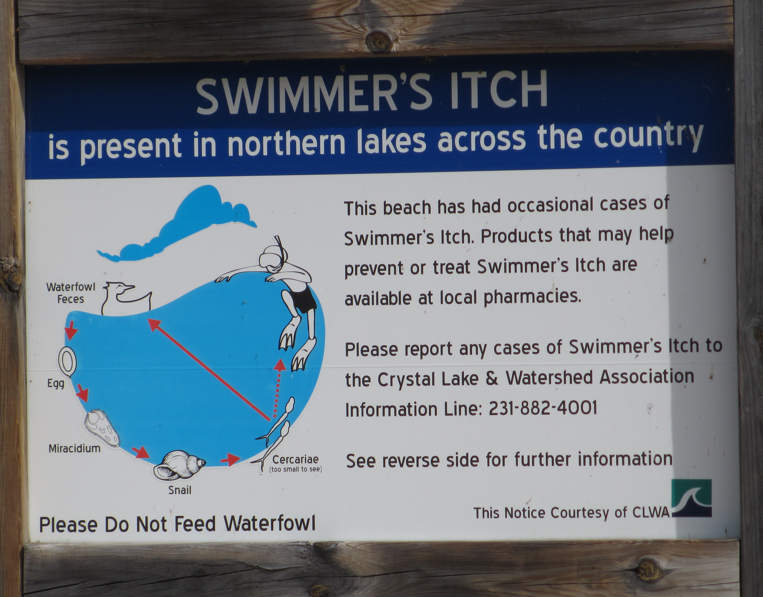
Figure S2: Photograph of the 2019 version of SI informational signs posted at beaches and community buildings around Crystal Lake. Photo courtesy of Ellen Herscher.

Figure S3: The correlation between the proportion of swimmers in the morning session and total number of swimmers per day at CSA beach. There was a significant negative correlation between the two variables (r = -4.47; P < 0.001).

