Longevity and lifetime fecundity methods
After 15 (A1) and 17 generations (A2) of selection, 50 adult female mites were extracted from the selected and control cultures and allowed 72 hours to lay eggs in five, 90 mL ventilated, plastic containers filled with 50 mL of organic medium containing nematodes (10 females per container). The adult females were then discarded and their offspring were allowed 96 hours to mature and mate. Hence, we performed the fitness assays on the F1 generation (without selection). For each replicate line (A1 and A2) mites from selected and control lines were further split into two groups: with and without access to a host (see supplementary Fig. S.1 for dichotomy). Sixty newly matured adult female mites from each replicate line’s selected and control groups were each placed into a separate infection chamber and subsequently exposed to a single female D. hydei host for 60 minutes (i.e., 1 mite per fly). The flies were, on average, 14.63 ± 0.37 SE days post-eclosion in age and were first anesthetized with CO₂ for placement in experimental infection chambers. Mites were never anesthetized and instead transferred from the media to an infection chamber using a small paintbrush.
After 60 minutes, each mite was scored as ‘attached’ or ‘unattached’ to its fly host (see Supplementary Table S.1 for attachment prevalence of the exposed mites). Mites that did not attach to their fly were discarded. Mites that attached were left in their infection chambers with their host for an additional 20 hours to feed. During this time, infection chambers were housed in an incubator (25 °C, 70% RH and a 12D:12L photoperiod). Of the mites that remained attached to the fly, ten (per replicate line per selection treatment) were randomly assigned to the ‘with host access’ group. These mites were then transferred individually to fresh mite media. The fly’s thorax was crushed with forceps, and the carcass along with the attached mite was then placed into a new 90 mL ventilated plastic container filled with 50 mL of organic medium. At the same time, the ‘without host access’ mites were prepared by individually transferring ten (per replicate line per selection treatment) newly matured adult female mites into a 90 mL ventilated plastic container filled with 50 mL of organic medium. Containers were sealed with Parafilm® (Neenah, WI) to prevent contamination by other mites. All containers were kept at 25 °C, 70% relative humidity and a 12D:12L photoperiod.
Each container was inspected under a dissecting scope every 48 hours, and once located, the female was transferred to a new 90 mL ventilated container with fresh organic media. The media that each female was recovered from was transferred to a plastic container and preserved in 95% ethanol for fecundity counts later. Eggs hatch roughly seven hours after they are laid; thus, most of the offspring in the preserved media samples were in a nymphal stage of development (Wade and Rodriguez, 1961). Female recovery ceased when the female was found dead or was assumed dead when the female could not be located after two complete rounds of inspection. Any dead females recovered were preserved in 95% ethanol, and the number of days alive since adult emergence was recorded (i.e., longevity).
Taking advantage of the mite’s hydrophobic exoskeleton, preserved media samples were transferred to 150 mL plastic containers and filled with 75 mL of tap water. The containers were covered with parafilm® and homogenized by inversion. The supernatant was poured off into a 14 mm diameter petri dish and examined under a dissecting microscope. All recovered nymphs were counted and recorded (eggs were not included in the counts). A single media sample was washed and examined for nymphs three times to ensure full recovery.

Morphological measurement methods
Fifty adult female mites were collected from each of the replicate lines per selected and control treatment and stored in 70% ethanol. To prepare mites for slide mounting, each specimen was placed in distilled water for 48 hours to soften the cuticle. Mites were then individually slide-mounted in 90% polyvinyl alcohol (PVA). Care was taken to separate the chelicerae from the mite during the mounting process.
To estimate body size we measured the dorsal and ventrianal shields of the preserved specimens (Newton and Proctor, 2013). All images were captured using a Leica MC 120 HD camera on a compound microscope. Shield measurements were made using the Leica Application Suite (v4.6). Dorsal shield length was measured from the anterior edge of the shield between the j1 setae, to the dorsal edge of the shield midway through the J5 setae (see Supplemental Fig. S.2a for our measurements; see Özbek et al., 2015 for M. muscaedomesticace setae identification). Ventrianal shield length was measured from the anterior edge of the shield midway between the anterior-most pair of setae to the beginning of the cribiform plate, midway through the most-posterior pair of setae (Supplemental Fig. S.2b). Dorsal and ventri-anal shields were measured only if they were not damaged during the mounting process. We measured the length of the chelicera’s moveable digit if the entire chelicera could be brought into focus in a single viewing plane (Supplemental Fig. S.2c). We measured the length of the first and second cheliceral digit, from the apodeme of moveable digit to the end of the sclerotization of the first digit as a proxy for cheliceral strength (Supplemental Fig. S.2d). We used this measurement for strength because there is a tendon attached to the apodeme that runs the entire length of the chelicera to which muscles attach to close the chelicera (Alberti and Coons, 1999; Krantz and Walter, 2009). The dorsal shields, ventrianal shields and moveable cheliceral digits were measured by a single researcher that was blind to the identity of the mites. A different researcher that was blind to mite identity made all of the cheliceral segment measurements.

Supplementary Table S.1 Prevalences of Macrocheles muscaedomesticae mite attachment to Drosophila hydei hosts after 15 (replicate line 1) and 17 (replicate line 2) generations of artificial selection. Ten ‘Attached’ mites were randomly selected from each replicate line’s selected and control groups for the ‘with host access’ treatment in our fecundity and longevity measurements.
Selection Treatment | Replication Line | Exposed Mites (n) | Attached Mites | Attachment Prevalence
Selected | 1 | 60 | 15 | 0.25
Control | 1 | 60 | 20 | 0.33
Selected | 2 | 60 | 44 | 0.73
Control | 2 | 60 | 35 | 0.58

Replicate Line
1
2
Selection Treatment
Control
Control
Selected
Selected
No Fly
No Fly
Fly
Fly
No Fly
No Fly
Fly
Fly
Host Availability
n=10
n=10
n=10
n=10
n=10
n=10
n=10
n=10
Supplementary Figure S.1 Experimental set-up for comparing the fecundity and longevity of Macrocheles muscaedomesticae mites selected for increased propensity for host-attachment and unselected control mites with and without access to a host. The mites used in this experiment came from selection experiment A which continued for 15 and 17 generations in replicate lines 1 and 2 respectively (Durkin and Luong 2018). Selected and control mites were further divided into two groups based on whether they had access to a fly host (Drosophila hydei).

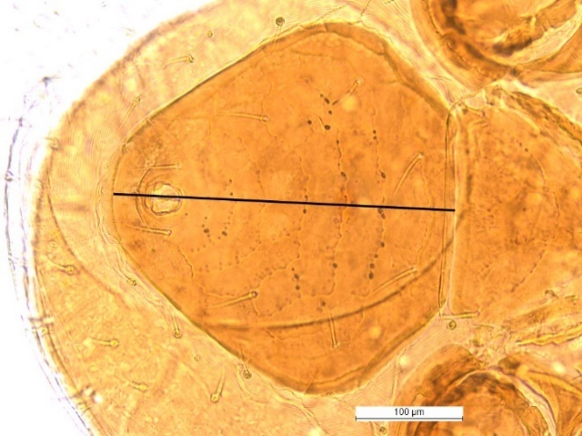
Figure S.2a Figure S.2b
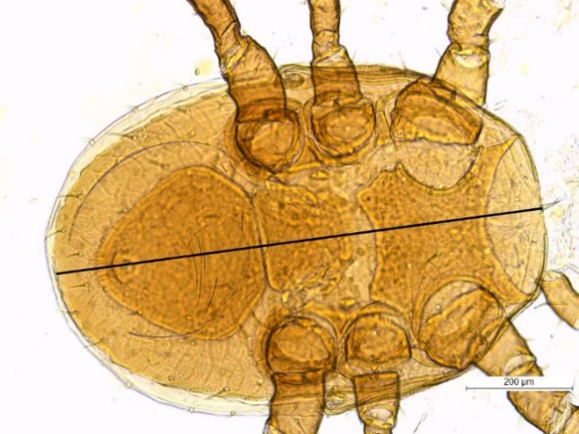
Figure S.2c Figure S.2d
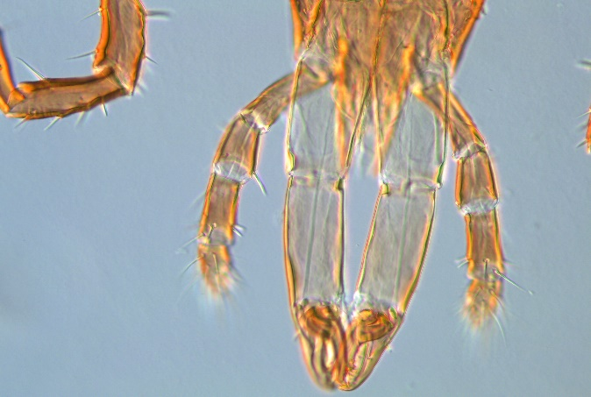
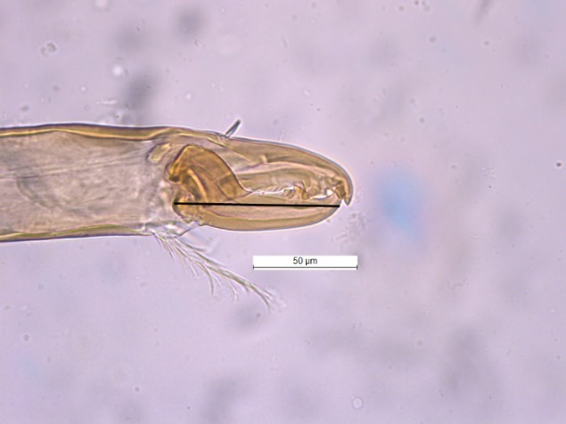
100 µm
Supplementary Figure S.2 The mites used in these comparisons came from selection experiment B (Durkin and Luong 2018). The dorsal shield was measured from the j1 setae on the anterior end to the posterior end through the J5 setae (a). The ventrianal shield was measured from the anterior end the anterior-most pair of setae through to the posterior end (between the posterior-most pair of setae) (b). This measurement ended at the beginning of the cribiform plate (circled). The moveable digit of the chelicerae was measured from its proximal attachment to the distal tip (c). Lastly, the length of the first and second digits of the chelicerae were measured (d).

References
Alberti, G and Coons, LB (1999) Acari-Mites. In Harrison, F W (ed). Microscopic Anatomy of Invertebrates. New York, NY: John Wiley and Sons, pp. 515–1256.
Krantz, GW and Walter, DE (2009) A Manual of Acarology. Lubbock, TX: Texas Tech University Press.
Özbek, HH, Bal, DA and Doğan, S (2015) The genus Macrocheles Latreille (Acari: Mesostigmata: Macrochelidae) from Kelkit Valley (Turkey), with three newly recorded mite species. Turkish Journal of Zoology 39, 768–780. doi:10.3906/zoo-1409-14
Wade, CF and Rodriguez, JG (1961) Life history of Macrocheles muscaedomesticae (Acarina: Macrochelidae), a predator of the house fly. Annals of the Entomological Society of America 54,776–781.

