SUPPLEMENTARY DATA 3

ARTICLE TITLE: Morphological characterisation and molecular phylogeny of zoonotic trematodes in the freshwater snail Asolene platae

JOURNAL NAME: Parasitology
AUTHORS: Federico A. Dellagnola^{a,b,c}, Martín M. Montes^{d}, Sergio R. Martorelli^{d}, and Israel A. Vega^{a,b,c*}
AFFILIATIONS
ª Universidad Nacional de Cuyo, Facultad de Ciencias Médicas, Instituto de Fisiología, 5500 Mendoza, Argentina.
^{b} IHEM, CONICET, Universidad Nacional de Cuyo, 5500 Mendoza, Argentina
^{c} Universidad Nacional de Cuyo, Facultad de Ciencias Exactas y Naturales, Departamento de Biología, 5500 Mendoza, Argentina.
^{d} CEPAVE, CONICET, Universidad Nacional de La Plata, 1900 La Plata, Argentina.

Federico A. Dellagnola – dellagnolaf@gmail.com
Martín M. Montes – martinmiguelmontes@gmail.com
Sergio R. Martorelli – sergio.martorelli@gmail.com
Israel A. Vega – israel.vega7@gmail.com

CORRESPONDING AUTHOR
Israel A. Vega
Laboratorio de Fisiología (IHEM–CONICET). Casilla de Correo 33. 5500 Mendoza, Argentina.
Email: israel.vega7@gmail.com. Phone/fax: +54 261 413 5000- 2715

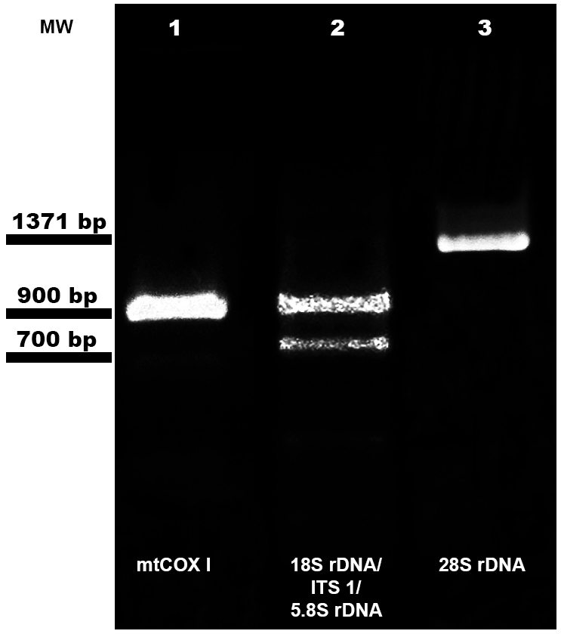
Supplementary Figure 1. Representative Agarose gel (1.2 %) containing the PCR amplification products using total DNA from cercariae isolated from two digestive glands of A. platae. Three genic regions were amplified for phylogenetic studies. Lane 1: amplicon that corresponds to the gene that encodes for the 28S rRNA. Lane 2: amplicon that corresponds to the non-coding region of the Internal Transcribed Spacer (ITS1), located between the 18S rRNA and 5.8S rRNA genes. Lane 3: amplicon that corresponds to the gene that encodes for the mitochondrial Cytochrome c Oxidase subunit I (mtCOXI). MW: molecular weight markers. Bp: base pairs.

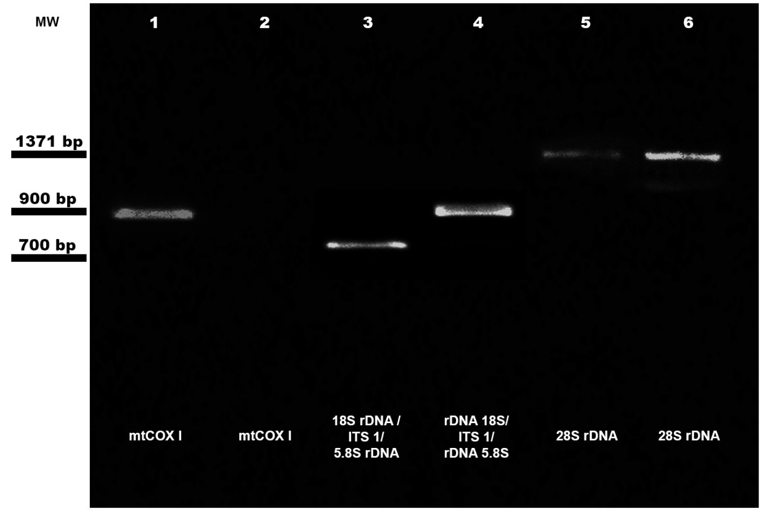
Supplementary Figure 2. Representative Agarose gel (1.2 %) containing the PCR amplification products using total DNA isolated from cercarial shedding. Template DNA from echinocercariae released by a single specimen of Asolene platae (lanes, 1, 3 and, 5). Template DNA from xiphidiocercariae released by a single specimen of Asolene platae (lanes, 2, 4 and, 6). MW: molecular weight markers. Bp, base pairs. 28S rRNA: 28S ribosomal subunit. 18S rDNA /ITS1/ 5.8S rDNA: 18S ribosomal subunit / Internal Transcribed Spacer 1/ 5.8S ribosomal subunit gene region. MtCOXI: mitochondrial Cytochrome c Oxidase subunit I.

