Suppl. figure1. Distribution of the Alouatta palliata subspecies. Produced using data from Rylands et al. 2006.
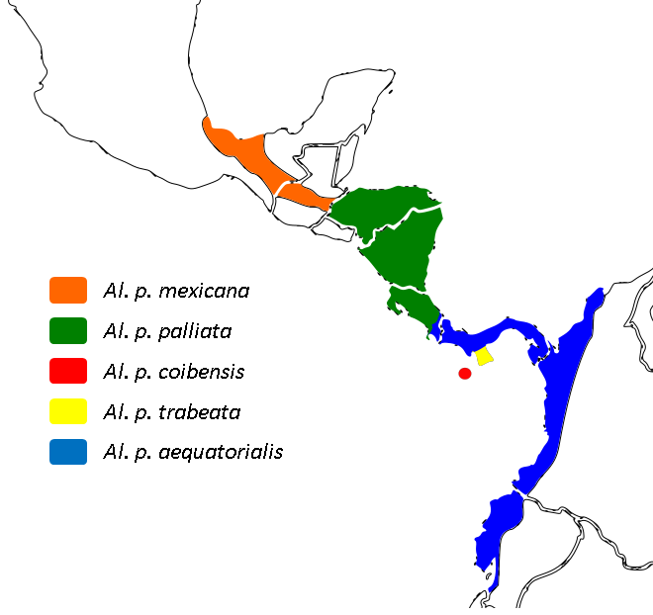

Rylands AB, Groves CP, Mittermeier RA, Cortes-Ortiz L and Hines J (2006). Taxonomy and Distributions of Mesoamerican Primates. In New perspectives in the study of Mesoamerican primates: Distribution, ecology, behavior and conservation (ed. Estrada A, Garber PA, Pavelka M and Luecke L), pp. 29–79. Springer, New York.

Suppl. figure 2. Distribution of the Ateles geoffroyi subspecies. Produced using data from Rylands et al. 2006.
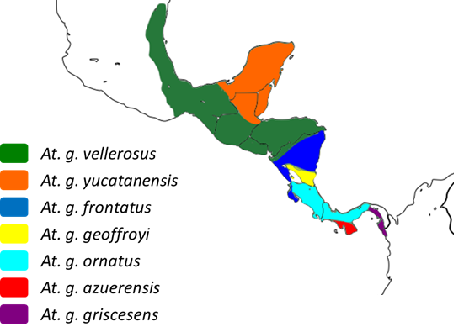

Rylands AB, Groves CP, Mittermeier RA, Cortes-Ortiz L and Hines J (2006). Taxonomy and Distributions of Mesoamerican Primates. In New perspectives in the study of Mesoamerican primates: Distribution, ecology, behavior and conservation (ed. Estrada A, Garber PA, Pavelka M and Luecke L), pp. 29–79. Springer, New York.

