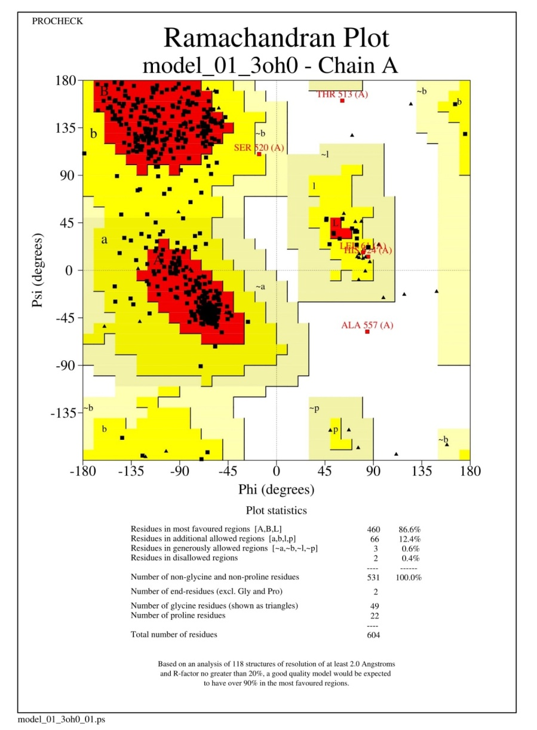

Supplementary Fig.1. Ramachandran plot for the cgd7_1830 protein structure predicted by SWISS-MODEL

