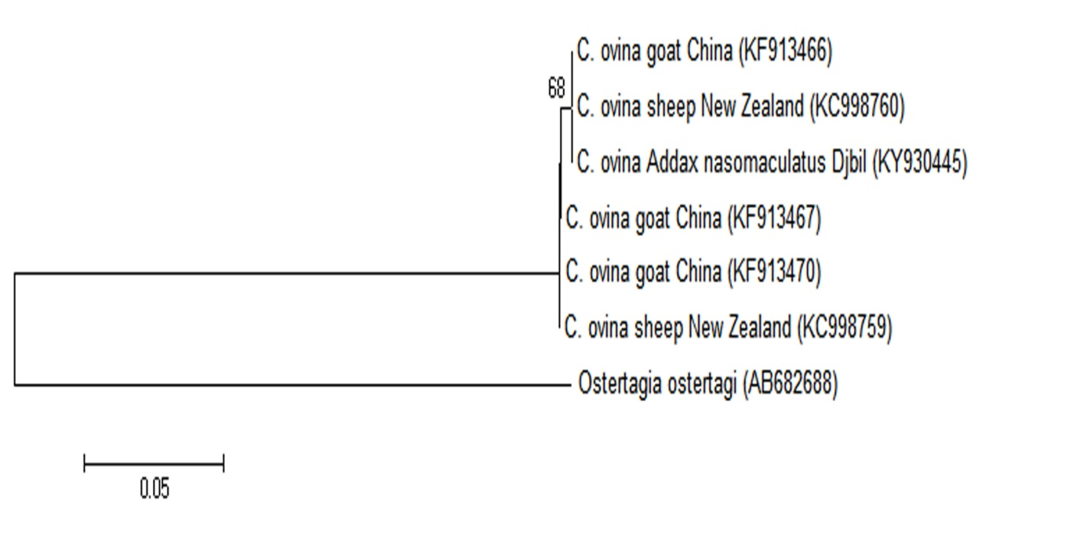

Supplementary Figure: Phylogenetic tree of Chabertia ovina based on ITS2 sequences of rDNA. The ITS2 sequences were aligned with Mega 6. Neighbor-joining (NJ) tree represents phylogenetic relationships for one sequence isolated in Addax nasomaculatus faecal sample from Djbil national park in Tunisia and 6 sequences from Genbank data base. The scale bar represents 0.05 substitution per site. Numbers associated with nodes represent the percentage of 1000 bootstrap supporting the nodes (only percentages higher than 65% were represented).

