**Electronic appendix**

**Table S1:** Model results for cercarial removal rates (searching rates) of barnacles per experimental runs of 3 hours and % survival of cercariae for each treatment combination (cercarial density and presence/absence of alternative prey) and the block effect which were all included in the best fitting model (model 1; see Table 1).

|  |  |  |  |  |
| --- | --- | --- | --- | --- |
| **Cercarial density** | **Alternative prey** | **Block** | **Cercarial removal rate** | **Cercarial survival** |
| 20 | Present | 1 | 1.04 | 35.2% |
| 20 | Present | 2 | 1.78 | 16.9% |
| 20 | Absent | 1 | 1.12 | 32.7% |
| 20 | Absent | 2 | 1.85 | 15.7% |
| 60 | Present | 1 | 2.04 | 13.0% |
| 60 | Present | 2 | 2.77 | 6.2% |
| 60 | Absent | 1 | 1.14 | 32.0% |
| 60 | Absent | 2 | 1.87 | 15.3% |
| 100 | Present | 1 | 1.58 | 20.6% |
| 100 | Present | 2 | 2.31 | 9.9% |
| 100 | Absent | 1 | 1.08 | 33.9% |
| 100 | Absent | 2 | 1.81 | 16.3% |
| 300 | Present | 1 | 1.36 | 25.7% |
| 300 | Present | 2 | 2.09 | 12.3% |
| 300 | Absent | 1 | 2.24 | 10.6% |
| 300 | Absent | 2 | 2.98 | 5.1% |

**Table S2:** Model results for cercarial removal rates (searching rates) of shrimps per experimental runs of 3 hours and % survival of cercariae for each treatment combination (cercarial density and presence/absence of alternative prey) which was included in the best fitting model (model 3; see Table 1).

|  |  |  |  |
| --- | --- | --- | --- |
| **Cercarial density** | **Alternative prey** | **Cercarial**  **removal rate** | **Cercarial survival** |
| 20 | Present | 0.16 | 85.6% |
| 20 | Absent | 0.09 | 91.3% |
| 60 | Present | 0.16 | 84.8% |
| 60 | Absent | 0.26 | 77.1% |
| 100 | Present | 0.17 | 84.1% |
| 100 | Absent | 0.10 | 90.9% |
| 300 | Present | 0.17 | 84.4% |
| 300 | Absent | 0.76 | 46.9% |



**Figure S1:**A) Schematic representation of the model selection procedure based on the best fitting model. Numbers in red circles represent model number from the most complex (1) to the least complex (5) model. X indicates explanatory variables with X1 representing cercarial density and X2 representing presence/absence of alternative prey. Blue arrows indicate which model was tested with which. The testing procedure started with testing the most complex model to the next, less complex model, and so on (i.e., model 1 was tested against model 2, model 2 against model 3 and 4, model 3 against model 5 and model 4 against model 5). When a significant difference between two models occurred it was not necessary to continue (as indicated by the red arrows in Figures S2-S5) with a reversed direction).



**Figure S2:** Actual model selection procedure for the effect of cercarial density and presence/absence of alternative prey on cercarial removal by barnacles. Significant differences between models are indicated by red arrows (* denoting a significance level of 0.05).

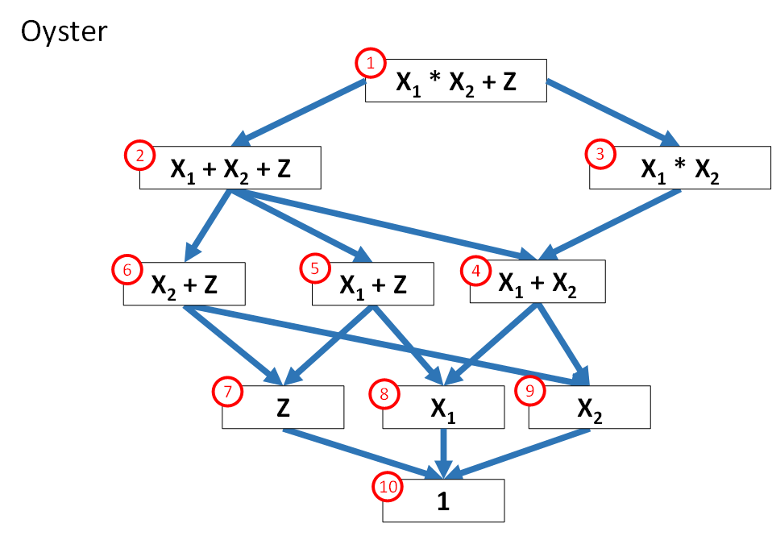

**Figure S3:** Actual model selection procedure for the effect of cercarial density and presence/absence of alternative prey on cercarial removal by oysters. Significant differences between models are indicated by red arrows (* denoting a significance level of 0.05).



**Figure S4:** Actual model selection procedure for the effect of cercarial density and presence/absence of alternative prey on cercarial removal by crabs. Significant differences between models are indicated by red arrows (* denoting a significance level of 0.05).



**Figure S5:** Actual model selection procedure for the effect of cercarial density and presence/absence of alternative prey on cercarial removal by shrimps. Significant differences between models are indicated by red arrows (* denoting a significance level of 0.05).