Supplementary Material.

Figure S1. Phylogenetic relationship (neighbour-joining consensus tree) of 18S rDNA sequences of haemogregarines used in the phylogenetic analyses of this study. The tree was rooted with Cryptosporidium serpentis. Numbers at the branches show consensus support (%). GenBank Accession numbers and associated host are shown.

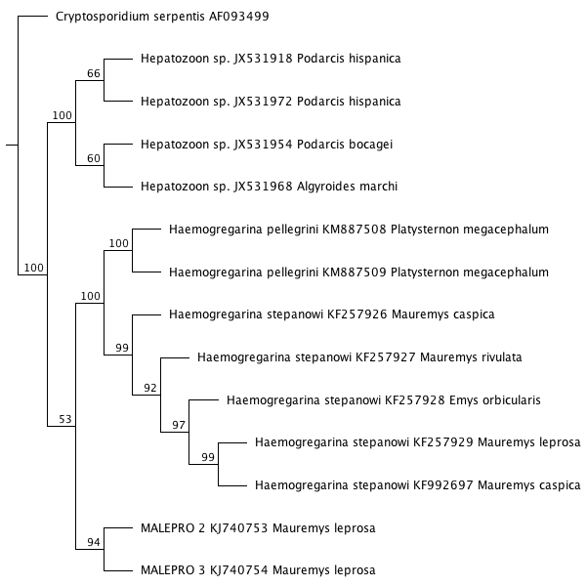
Table S1. Estimates of Evolutionary Divergence among sequences of different organisms used in the phylogenetic analyses of this study. The number of base pair differences per sequence are shown.

 | (1) | (2) | (3) | (4) | (5) | (6) | (7) | (8) | (9) | (10) | (11) | (12) | (13) | (14)
(1) Cryptosporidium serpentis AF093499 | *
(2) Haemogregarina pellegrini KM887508 | 70 | *
(3) Haemogregarina pellegrini KM887509 | 70 | 0 | *
(4) Haemogregarina stepanowi KF257926 | 70 | 2 | 2 | *
(5) Haemogregarina stepanowi KF257927 | 70 | 2 | 2 | 0 | *
(6) Haemogregarina stepanowi KF257928 | 70 | 2 | 2 | 0 | 0 | *
(7) Haemogregarina stepanowi KF257929 | 70 | 2 | 2 | 0 | 0 | 0 | *
(8) Haemogregarina stepanowi KF992697 | 70 | 2 | 2 | 0 | 0 | 0 | 0 | *
(9) Hepatozoon sp. JX531918 | 72 | 17 | 17 | 16 | 16 | 16 | 16 | 16 | *
(10) Hepatozoon sp. JX531954 | 72 | 17 | 17 | 16 | 16 | 16 | 16 | 16 | 0 | *
(11) Hepatozoon sp. JX531968 | 72 | 17 | 17 | 16 | 16 | 16 | 16 | 16 | 0 | 0 | *
(12) Hepatozoon sp. JX531972 | 72 | 17 | 17 | 16 | 16 | 16 | 16 | 16 | 0 | 0 | 0 | *
(13) MALEPRO 2 KJ740753 | 66 | 11 | 11 | 10 | 10 | 10 | 10 | 10 | 12 | 12 | 12 | 12 | *
(14) MALEPRO 3 KJ740754 | 66 | 14 | 14 | 13 | 13 | 13 | 13 | 13 | 13 | 13 | 13 | 13 | 3 | *

