Table S1. Excretion of Neospora caninum oocysts by the dog
bioassayed during the experimental period.
Days post inoculation | Amount of faeces/day (g) | N. of oocysts/g | Total of oocysts/ day
1 | 110 | 11 | 1210
2 | 102 | 15 | 1530
3 | 107 | 151 | 16157
4 | 122 | 34 | 4148
5 | 95 | 946 | 89870
6 | 99 | 25 | 2475
7 | 110 | 27 | 2970
8 | 156 | 53 | 8268
9 | 140 | 23 | 3220
10 | 100 | 122 | 12200
11 | 139 | 11 | 1529
12 | 90 | 2 | 180
13 | 139 | 5 | 695
14 | 138 | 2 | 276

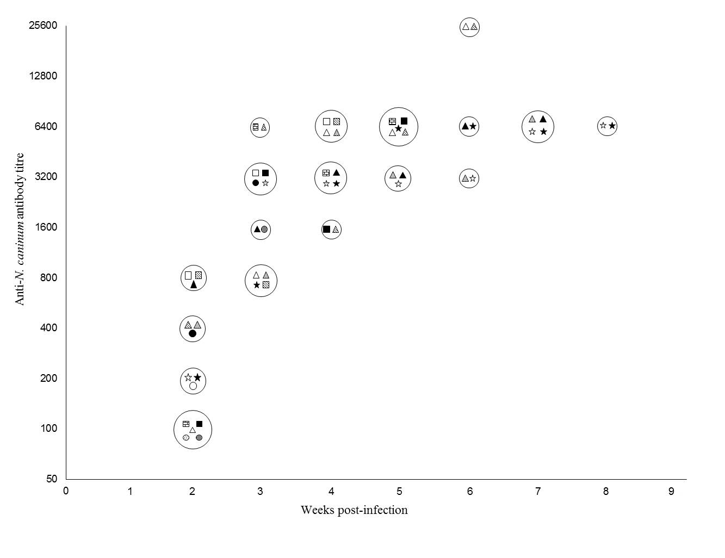Fig. S1. Titres of anti-N. caninum IgG antibodies in fourteen gerbils that were orally challenged with 200 oocysts of the isolate NC-SP1. Two gerbils were euthanised seven days PI (IFAT < 50). Each gerbil is represented by a symbol inside the circles.

Table S2. Neospora caninum tissue distribution in gerbils that were orally challenged with 200 oocysts of the isolate NC-SP1, based on DNA detection*.
 | Weeks post-inoculation
Tissues collected | 1st | 2nd | 3rd | 4th | 5th | 6th | 7th | 8th
Blood
Skeletal muscle
Tongue
Liver
Spleen
Diaphragm muscle | •
Reproductive system | •
Lung | • | •
Intestine |  | •
Heart |  | •
Kidney |  |  | •
Mesenteric lymph node | • | • | • | •
Eye |  | • |  |  |  | •
Spinal cord |  | • | • | • |  | • | • | •
Brain | • | • | • | • | • | • | • | •
* PCR assays using the primers Np6 plus and Np21 plus.

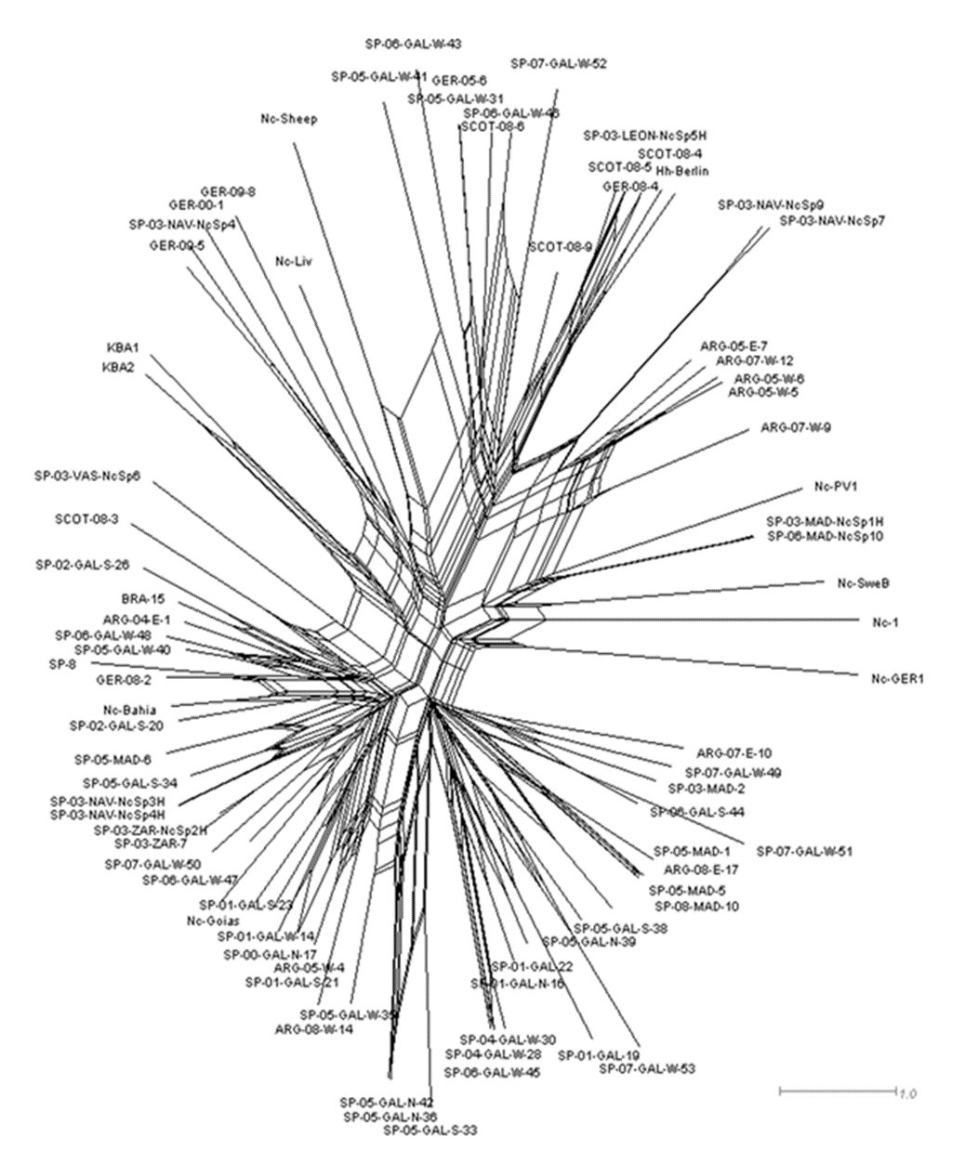
Fig. S2. Phylogenetic analysis showing genetic relationships of the Neospora caninum isolates and NC-SP1 isolate (BRA-15).

Table S3. Principal Coordinates Analysis (PCoA)
PCoA via Covariance matrix with data standardization |  |  |  |  | No. of samples by population
Data Sheet | GD (2) |  |  |  | INT | SPA | ARG | SCOT | GER | BRA
Data Title | ALLELE FREQ
No. Samples | 82 |  | No. Pops. | 6 | 10 | 49 | 10 | 5 | 6 | 2
Percentage of variation explained by the first 3 axes
Axis |  | 1 | 2 | 3
% |  | 15,28 | 8,38 | 7,01
Cum % |  | 15,28 | 23,66 | 30,68

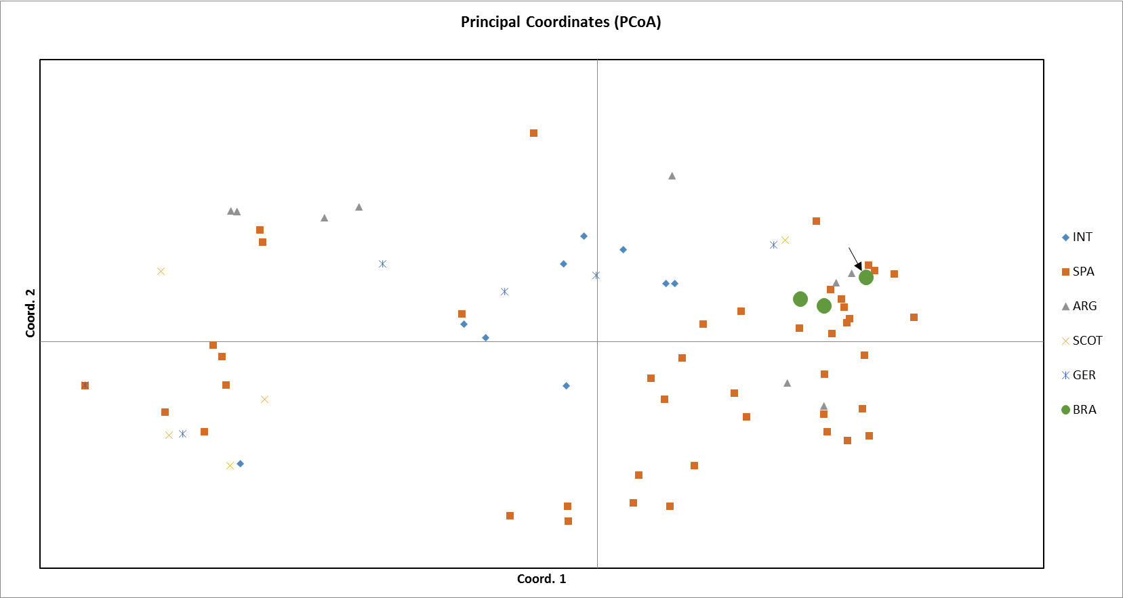
INT: Reference strains; SPA: Spain; ARG: Argentina; SCOT: Scotland; GER: Germany; BRA: Brazil.
Fig. S3. Population structure based on principal coordinate analysis (PCA).

