Figure S1. The abundance, intensity, and prevalence of co-introduced *Camallanus cotti* infecting native *Awaous stamineus* from all watersheds in 2009 and 2011.

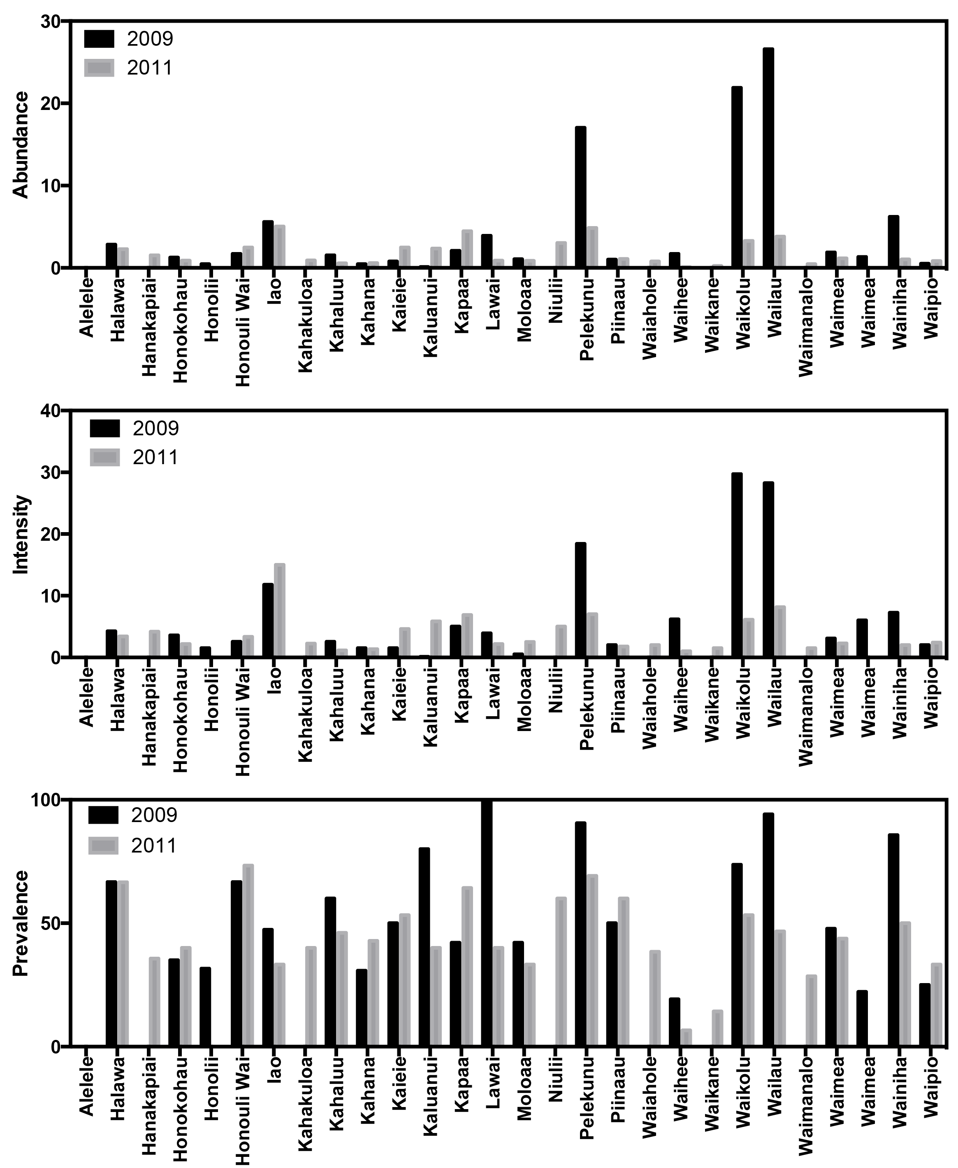

Figure S2. The abundance, intensity, and prevalence of co-introduced *Camallanus cotti* infecting introduced poeciliid fishesfrom all watersheds in 2009 and 2011.

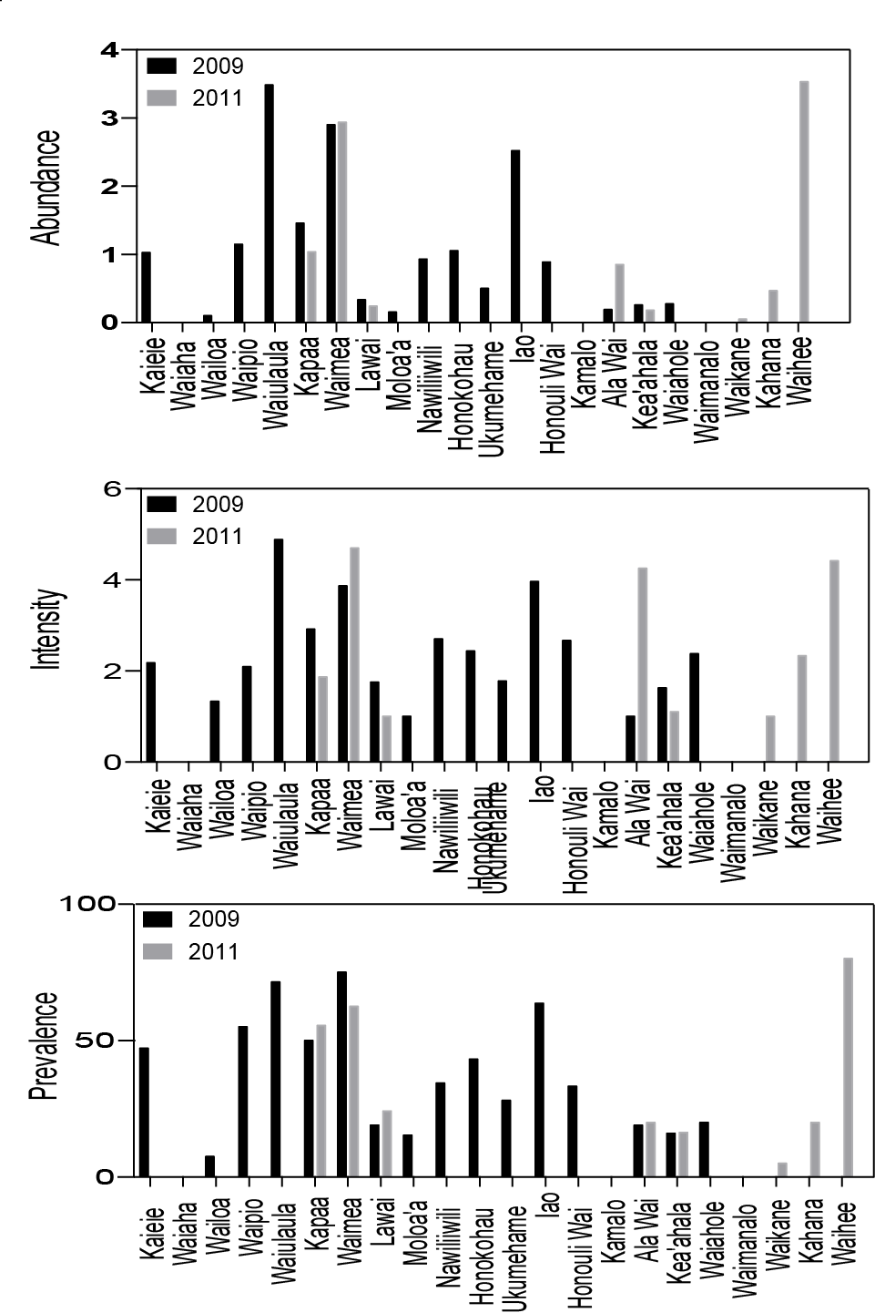

Figure S3. Intensity of *Camallanus cotti* infecting native *Awaous stamineus* relative to the density of introduced poeciliids.

