Supplementary Figure 1: Phylogeny estimated by Bayesian inference from the combined digenean mitochondrial 16S and COI sequences. Nodes receiving less than 0.50 posterior probabilities were not labelled. Bar: 10% sequence divergence. Host organisms, sampling area and digenean family are depicted for each clade. Curtuteria sequences are taken from Leung et al. 2009a.

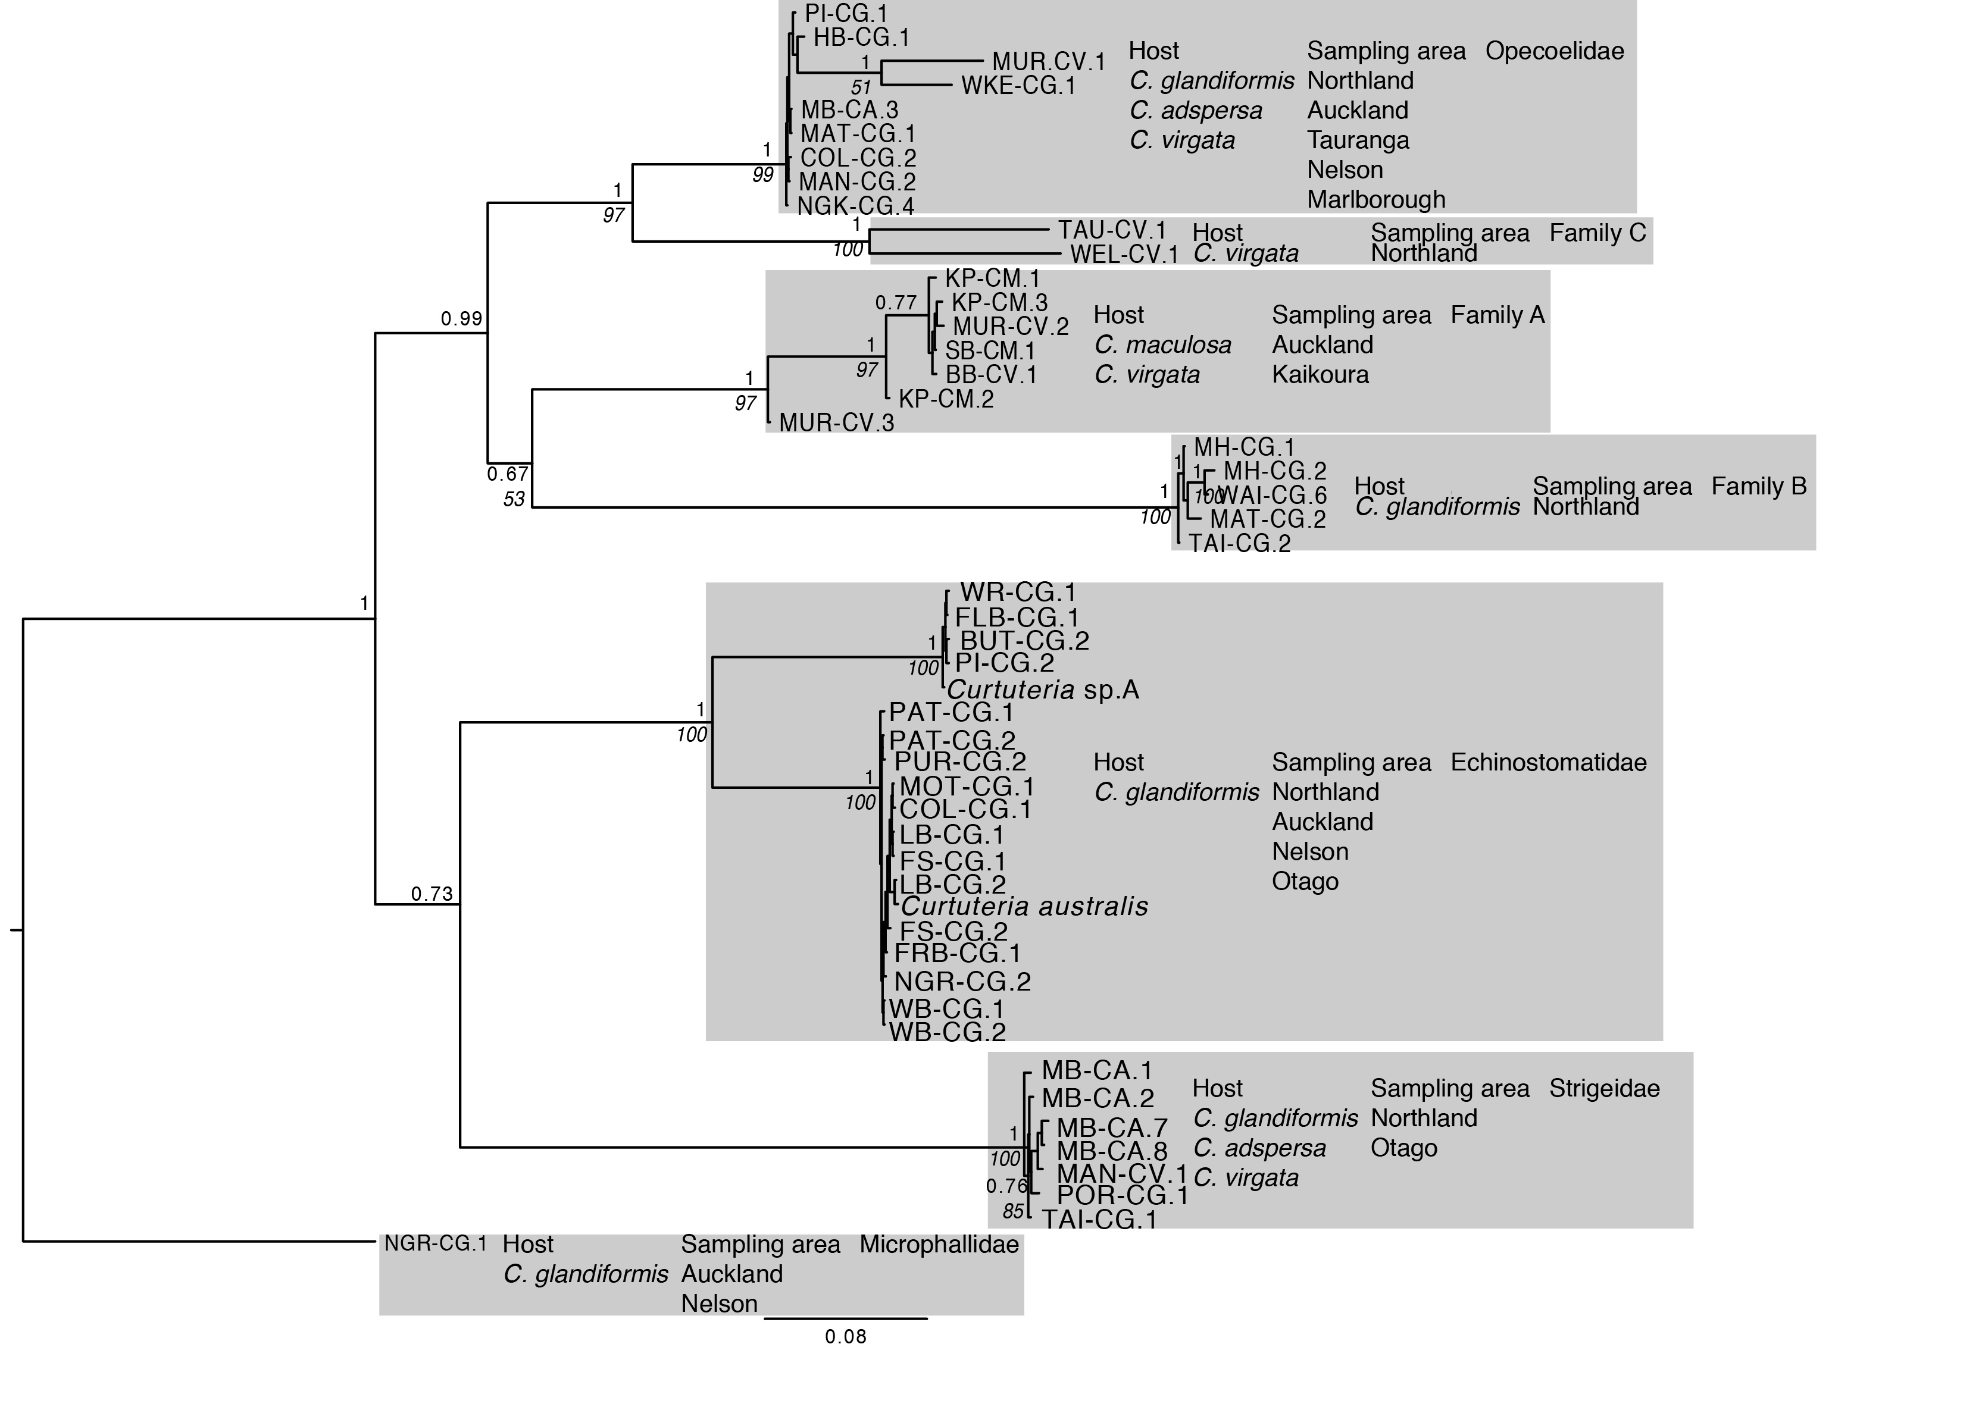

Supplementary Figure 2: Phylogeny estimated by Bayesian inference from digenean ITS1 sequences. The topologies recovered by Bayesian. Nodes receiving less than 0.50 posterior probabilities were not labelled. Bar: 10% sequence divergence. Host organisms, sampling area and digenean family are depicted for each clade. Curtuteria sequences are taken from Leung et al. 2009a.

