Supplementary material

The ups and downs of life: population expansion and bottlenecks of helminth parasites through their complex life cycle

Robert Poulin and Clément Lagrue

DETAILED METHODS

Study Lakes and sampling sites
Based on existing knowledge and accessibility, Lake Hayes, Lake Tuakitoto, Lake Waihola and Tomahawk Lagoon (South Island, New Zealand) were selected to provide a variety of lake types (size, depth, altitude; Table S1) and freshwater communities (coastal versus alpine, oligotrophic versus eutrophic, tidal or not, etc.). Within each lake, 4 sampling sites were selected along the littoral zone. Site selection was partly restricted by accessibility and sampling permit specification (New Zealand Department of Conservation permit N° OT-34204-RES and Fish and Game New Zealand permit to capture fish for research purposes), but was ultimately made to represent all habitat types (substrate, macrophytes, riparian vegetation, etc.) present within each lake. Sampling sites consisted of 225m² square areas (15m × 15m) with one side of the square following the shore (Figure S1). Distances between sampling sites varied within and among lakes according to lake size and shape as well as sampling site distribution (Table S1; Figure S1). The four lakes were sampled in early spring, summer and late autumn (austral seasons: September 2012, January and May 2013). In each lake and in each season (4 lakes × 4 sites per lake × 3 seasons = 48 full sets of samples), fish, benthic and demersal invertebrates were sampled in each sampling site to determine their local species composition and density as well as that of their parasites.

Field sampling
Fish
Fish were sampled once per season and at each sampling site and in each lake (1 sample × 4 sites × 3 seasons = 12 replicates per lake). We used a combination of fish catching gear types following a standardized protocol so that samples represented accurately fish diversity and density. First, two fyke nets and ten minnow traps were set in the evening. Fyke nets were positioned perpendicularly to the shore at either edge of the sampling site (i.e. 15m apart) to stop and capture fish swimming in and out of the focal 225m² area. Fyke nets consist of a cylinder of netting (2m length, 15mm mesh size) wrapped around a series of hoops to create a trap. Fish enter through the mouth of the trap and are retained by a series of funnel-shaped constrictions. One leader (or wing) is attached to the mouth and used to direct fish into the fyke net. The leader (3m length, 50cm height, 15mm mesh size) has a float-line at the top and lead-line at the bottom to keep it upright in the water and in close contact with the substrate. To prevent fish from swimming around, the end of the leader was securely anchored to the lake shore. Along with the two fyke nets, 10 minnow traps were set overnight in each sampling site. Traps were set diagonally across the sampling area at regular intervals (i.e. ~1.7m apart). Minnow traps are small fish traps that typically consist of two funnel-shaped entrances (25mm entrance diameter) at either end of a mesh box (40 × 25 × 25cm, 2mm mesh size). Fyke nets and minnow traps were set during the night, when fish are more active, as they are passive sampling methods relying on fish to willingly encounter and enter traps. The next day, all trapped fish were recovered from the nets and a subsample of fish from each species was set aside for later dissection. Remaining individuals were identified to species, counted and measured to the nearest mm (fork length). These fish were then released at least a hundred meters away from the sampling site.
Fish sampling was then complemented using two 15m long multi-mesh gillnets. Gillnets were benthic weighted sets with top floats, 1.5m high and comprised 3 panels of 25, 38 and 56mm meshes, each 5m long. Nets were set 15m apart similarly to fyke nets, perpendicularly to the shore line and anchored to the lake shore on the edge of the 225m² sampled area with the finer mesh panel closer to shore on one side and further from shore on the other. Gillnets covered the whole water column in all cases, and were checked every 15 min for an hour. Fish caught in the nets were removed immediately to avoid excessive accumulation and the potential visual deterrence to incoming fish. Fish caught in fyke nets and gillnets were either entering or exiting the sampling site and thus considered as site “users/occupants”. All fish were identified, counted and measured. Again, a subsample was kept for later dissection and the remaining fish released away from the sampling site.
Finally, fish sampling was completed using a standard, fine-mesh purse seine net. As an active sampling method, seine netting captures small and/or sedentary (i.e. resident) fish that are not captured by passive gear like fyke nets or gillnets. The seine net was 20m long and 1.5m high (5mm mesh size), thus covering the whole water column, and dragged by two people across the whole sampling area, catching virtually all small, sedentary fish remaining in the 225m² area. A final subsample of fish was kept for dissections and all other fish captured in the seine net were identified, counted, measured and immediately released. All fish set aside for later dissection were killed immediately following University of Otago Animal Ethics Committee guidelines (permit N° ET 10/12), to inhibit the digestion process and stored on ice to preserve internal tissues, stomach contents and parasites for future identification and count.

Demersal and benthic invertebrates
Six demersal and six benthic invertebrate samples were taken per site and per season in each lake (6 samples × 4 sites × 3 seasons = 72 replicates per lake for each sample type). Benthic sampling was done using a standard Surber sampler net with a 0.1m² horizontal metal frame (0.33 × 0.3m) fitted with a 250µm mesh collecting net. Samples were taken by embedding the Surber’s metal frame into the lake bottom. Substrate and macrophytes enclosed within the frame were manually scooped up into the net to a depth of 5cm so that animals living on or within (hyporheic habitat) the substrate were captured into the net. Demersal invertebrates living on or near the substrate but either too fast or too rare to be captured in Surber nets were sampled using a rectangular dip net, i.e. a 30cm wide and 22cm high frame fitted with a 250µm mesh net and attached to a long pole. Each demersal sample consisted of a fast, two meter long sweep of the net along the lake bottom without dredging the substrate. Again, the 12 samples (6 benthic and 6 demersal) were distributed haphazardly across the 225m² sampling area so that none overlapped. Substrate, wood debris and macrophytes contained in the net (Surber or dip net) were placed into a bucket of water and stirred, shaken and/or scrubbed to dislodge attached invertebrates, and then transferred into another bucket. Animals and substrate remaining in the first bucket were transferred onto a sieve (250µm mesh size) so fine sediment could be rinsed off. Samples were then stored individually in jars filled with 70% ethanol for later sorting, identification, count and measurement of invertebrates. Benthic and demersal invertebrate density was then determined using sample counts and sampling surface area.

Laboratory analyses
Fish
In the laboratory, fish were identified to species, measured to the nearest mm (fork length) and then dissected. Their gastrointestinal tract, from oesophagus to anus, and all internal organs (heart, liver, gall bladder, gonads, swim bladder, etc.) were removed and preserved in 70% ethanol for later parasite analyses. Fish bodies were frozen individually.
All fish bodies were later examined for parasites. The head, gills, eyes, brain and spine of each fish were examined under a dissecting microscope using fine forceps to pull apart fish tissues to obtain an accurate overall parasite count for each fish. Soft tissues (muscle and skin) were removed from the spine, crushed between two glass plates and examined by transparency under a dissecting microscope to identify and count parasites. Internal organs and gastrointestinal tract were first rinsed in water to wash off the ethanol. The digestive tract was then separated from other organs. Liver, swim bladder, gall bladder, gonads and other organs and tissues from the body cavity (fat, mesentery, kidneys, heart, etc.) were all screened for parasites. Finally, the digestive tract was dissected and stomach contents were removed and examined. Oesophagus, stomach, pyloric caeca (when present), intestine and rectum were examined for gastrointestinal parasites. All parasites were identified and counted.

Demersal and benthic invertebrates
Demersal and benthic samples were sorted under a dissecting microscope. All invertebrates were separated from debris and sediment, identified to genus or species when possible and counted. Invertebrates were then dissected under a dissecting microscope using fine forceps and examined for parasites. For abundant invertebrate taxa (chironomid larvae, gastropods, amphipods, etc.), subsamples of 20 to 80 individuals per sample were dissected. All parasites were identified and counted.

Density
Density of organisms (number of individuals per m²) (and its variance) was calculated for all taxa. For fish, we obtained a single estimate of abundance (number of fish per species) per sampling site per season. Since we used a combination of passive and active gear types and virtually captured all fish individuals present in (sedentary individuals) or passing through (user/occupant) each sampling area, we considered the number of fish captured as representative of the fish community present at and/or using the site. Fish density was thus calculated as the total number of fish captured divided by the surface of the entire sampling area (225m²). One value of fish density was thus obtained per sampling site per season per lake and for each species present.
Densities of benthic and demersal invertebrates were simply calculated as the number of individuals of each taxa captured in a sample divided by the surface of the lake bottom sampled, regardless of water depth since these organisms live in, on and/or close to the substrate. Sample surface was 0.1m² for benthic and 0.6m² (0.3m net width × 2m sweep of the net) for demersal invertebrates. Invertebrate densities were calculated for all samples and could then be used to estimate mean densities per site, season and/or lakes.
Parasite populations were quantified as parasite densities (individuals per m²) to provide a suitable metric of population size. Because distinct life stages of parasites with complex life cycles (trematodes, nematodes, acanthocephalans) exploit completely different host species, we estimated parasite densities separately for each life stage. Parasite abundance (mean number of parasites per individual host, including uninfected ones) was first calculated for each parasite taxon in each host species from dissection data. Parasite abundance was then multiplied by host density (number of hosts per m²) to obtain parasite density. Parasite densities were also estimated in all individual samples. In the case of trematode parasites in their snail host, we did not count each individual redia or sporocyst as separate individual parasites, since these are the product of clonal multiplication. All rediae or sporocysts are issued from the same larva hatched from a single egg and were considered as a single individual. Density of these life stages was thus estimated as the number of infected snail hosts per m².

Figure S1. Location, size (see scale bars) and shape of the four study lakes on the South Island of New Zealand. The position of the 4 sampling sites per lake is indicated by shaded squares (not drawn to scale).

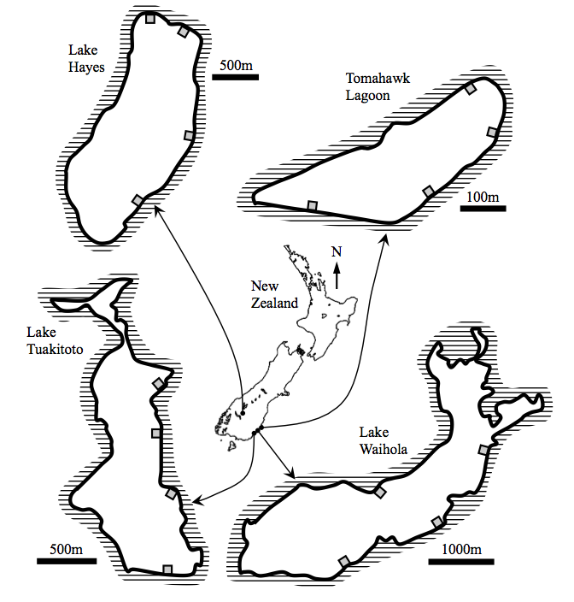

Table S1. Geographical locations and characteristics of the four study lakes (South Island of New Zealand), and distance between sampling sites (straight lines).

Lake | GPS coordinates | Surface area (km²) | Depth (m)  Mean – Max | Altitude (m) | Distance between sites (m)  Min – Mean – Max
Hayes | 44°58'59.4"S  168°48'19.8"E | 2.76 | 3.1 – 33 | 329 | 313.9 – 1190 – 2250
Tuakitoto | 46°13'42.5"S  169°49'29.2"E | 1.32 | 0.95 – 3 | 15 | 416.8 – 794.2 – 1590
Waihola | 46°01'14.1"S  170°05'05.8"E | 6.35 | 1.3 – 2.2 | 4 | 1330 – 1620 – 2020
Tomahawk Lagoon | 45°54'06.0"S  170°33'02.2"E | 0.096 | 1.0 – 1.2 | 15 | 123.6 – 253.0 – 437.9

