Supplementary Information - Smith et al.
(A). Hematodinium infection scale based on the relative abundance of parasites in the hepatopancreas
Ht
T
Ha
Level 1 infection in hepatopancreas characterised by fewer Hematodinium (Ht) than free haemocytes (Ha) in the intertubular space. Tubule (T).
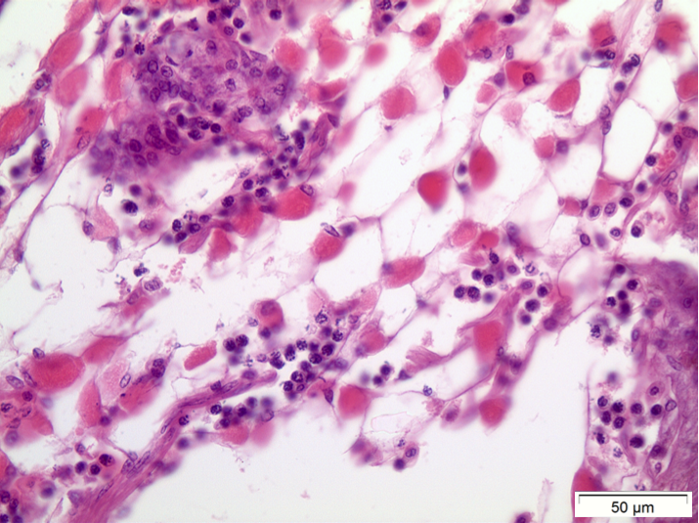
Ht
Ha
Level 2 infection in hepatopancreas with approximately equal numbers of Hematodinium (Ht) and haemocytes (Ha) in the interstitial tissue.
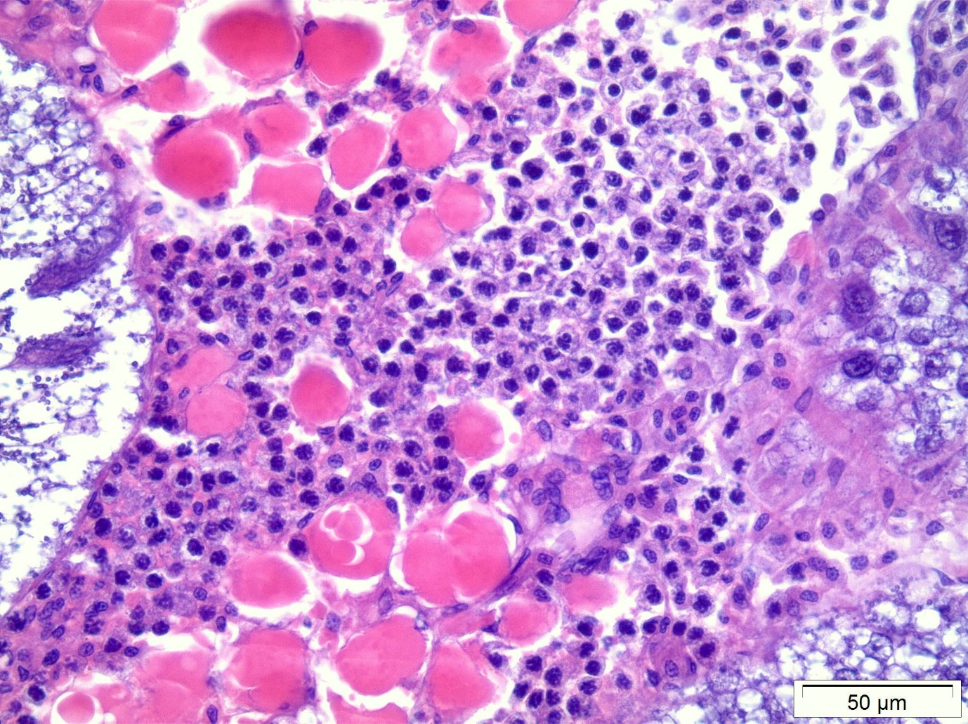
Ht
Ha
T
Level 3 infection – more Hematodinium (Ht) than haemocytes (Ha). Intertubular spaces are slightly distended as a result of parasitisation. Tubule (T).

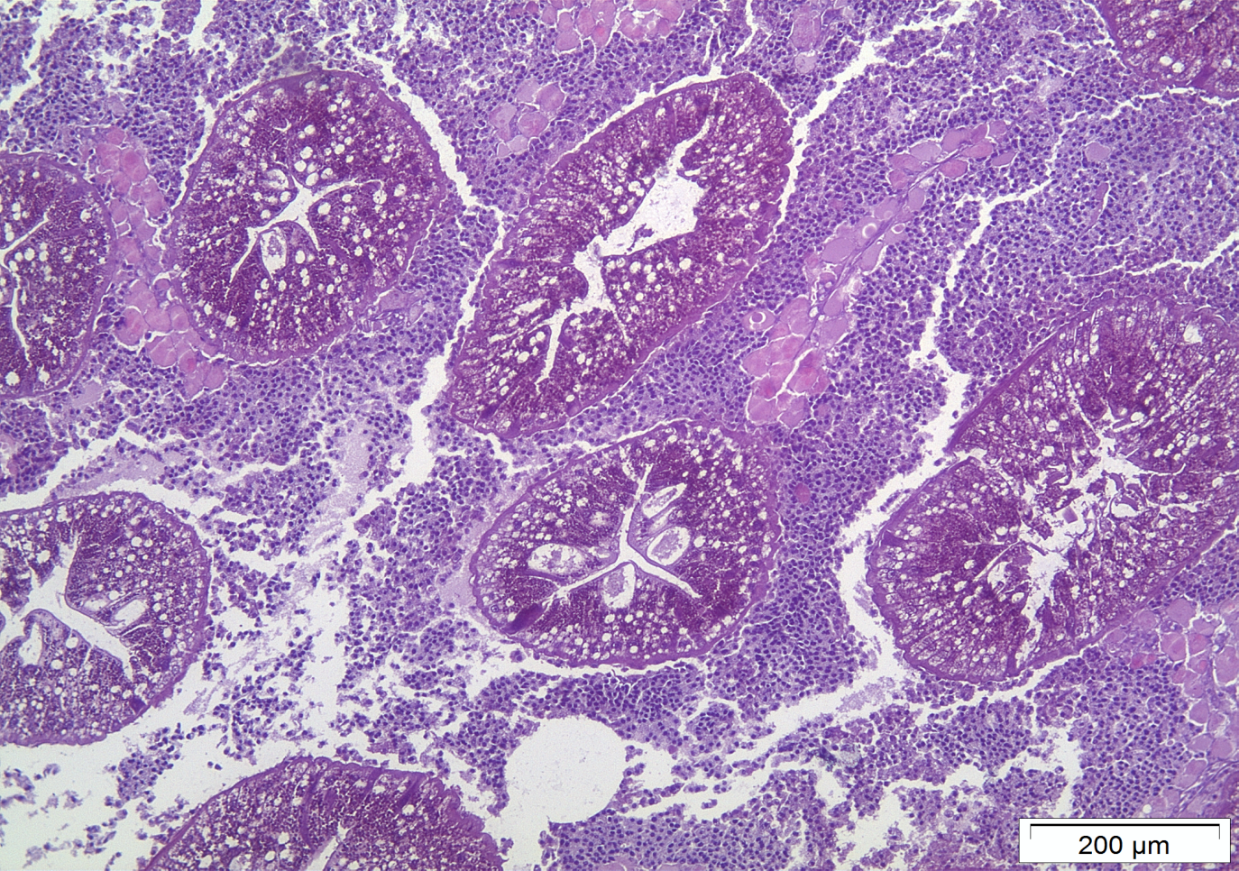
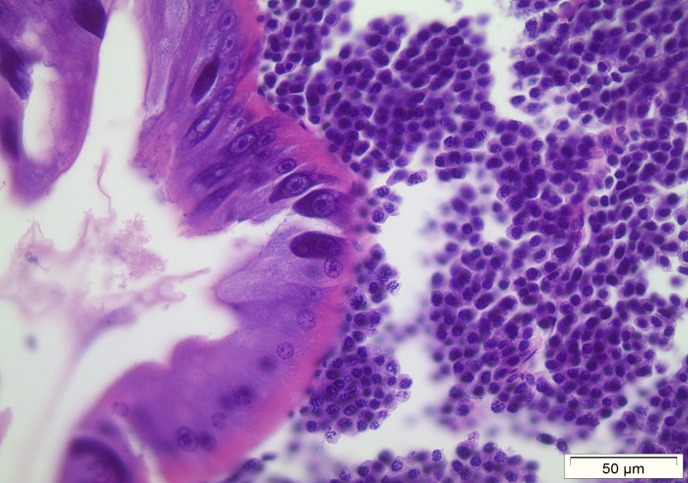
A
Level 4 – all intertubule spaces filled with Hematodinium cells
T
T
Ht

B
T

T
Ht

Level 4 infection – all of intertubular area replete with Hematodinium (Ht), very few to no haemocytes apparent. Tubules (T).

(B). EXAMPLE OF COLOUR CHANGE IN CRABS INFECTED WITH HEMATODINIUM
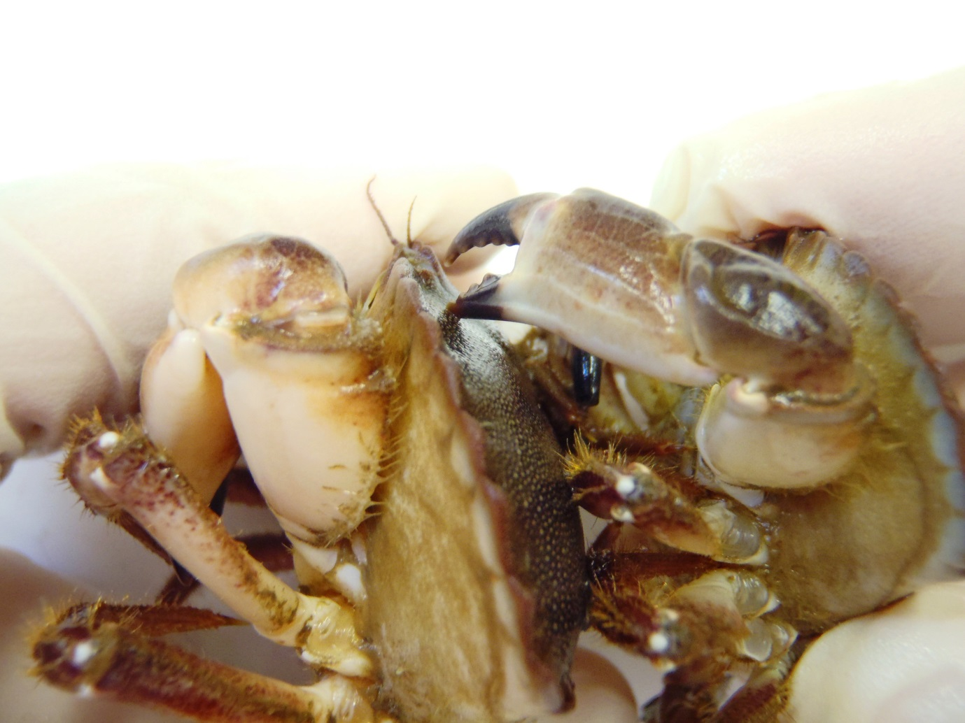
Example of colour change in edible crabs infected with Hematodinium. Note the pinkish-orange tinge to the claw in the infected animal on the left. The crab on the right is uninfected.

