Supporting Information

Table S1: Summary of results in the TUNEL and PI-staining assays.
 |  |  | Results
compoundª | dose (μM)^{b} | time of exposition (h)^{b} | TUNEL^{c} | PI-staining (%)^{d}
Fx1 | 150 | 9, 24, and 48 | (-) | 25-50
 | 75 |  | (-) | 0-25
 | 45 |  | (-) | 0-25
Fx2 | 80 | 24 and 48 | (-) | 50-75
 | 40 |  | n.s.^{e} | 0-25
 | 24 |  | n.s. | 0-25
Bfx1 | 72 | 24 and 48 | (-) | 25-50
 | 48 |  | n.s. | 0-25
 | 24 |  | n.s. | 0-25
Bfx2 | 200 | 48 and 72 | (-) | 25-50
 | 130 |  | (-) | 0-25
 | 65 |  | n.s. | 0-25
Qx1 | 16 | 6 and 24 | n.s. | 75-100
 | 8 |  | (-) | 0-25 at 6 h / 75-100 at 24 h
 | 4.8 |  | n.s. | 0-25
Qx2 | 18 | 3 and 6 | (-) | 75-100
 | 9 |  | (-) | 0-25 at 3 h / 25-50 at 6 h
Nfx | 100 | 24 and 48 | (-) | 50-75
 | 50 |  | (-) | 0-25
Nf1 | 19.5 | 6, 24 and 48 | (-) | 0-25
 | 13 |  | (-) | 0-25
ª Incubated with T. cruzi Y strain, except for compound Fx1; in this experiment the CL Brener clone was used. ^{b} One of the assayed dose and time of exposition was similar as those in Table 2, additionally extra doses and times were studied. ^{c} “(-)”: represents a negative TUNEL result, that is, an apoptotic index equal or lower than the negative control. ^{d} Percentage of cells stained with PI. ^{e} “n.s.”: not studied.

a)
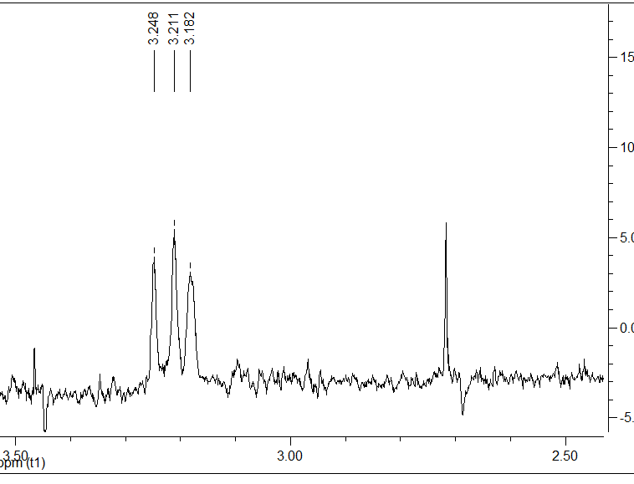
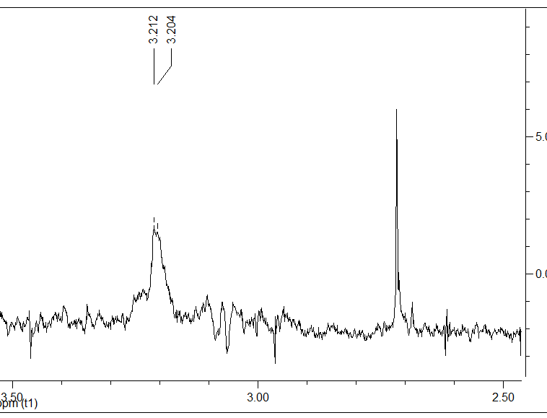
b)
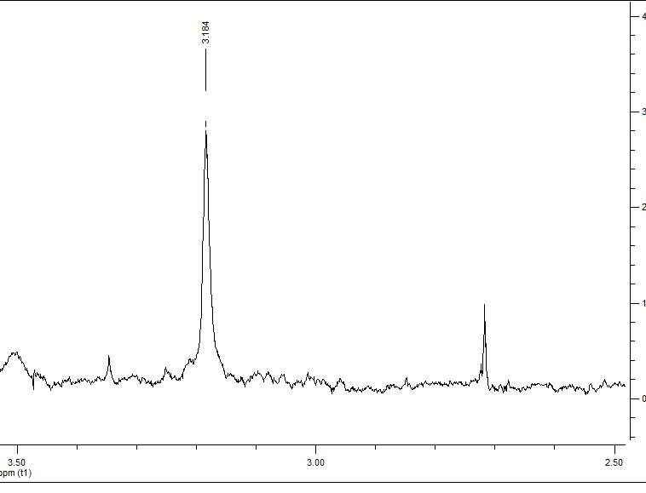
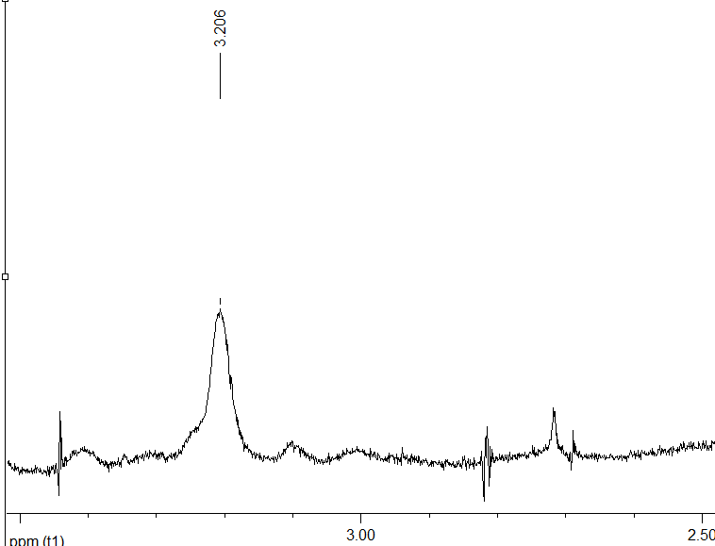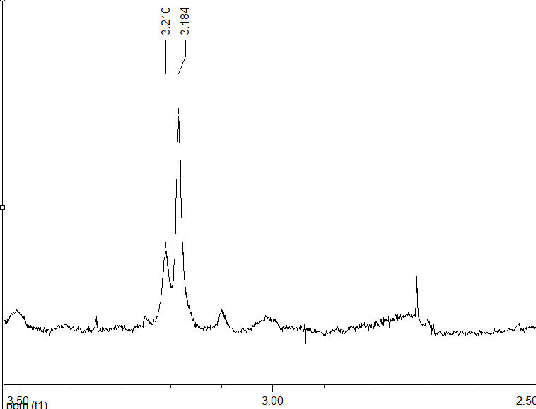
Figure S1: “Choline” and “PUFAs” regions. a) Control PBS-untreated parasites (left) and Fx2-treated parasites (right). b) Control PBS-untreated parasites (left), Bfx1-treated parasites (center), and Bfx2-treated parasites (right).

