**Supplementary file 2**

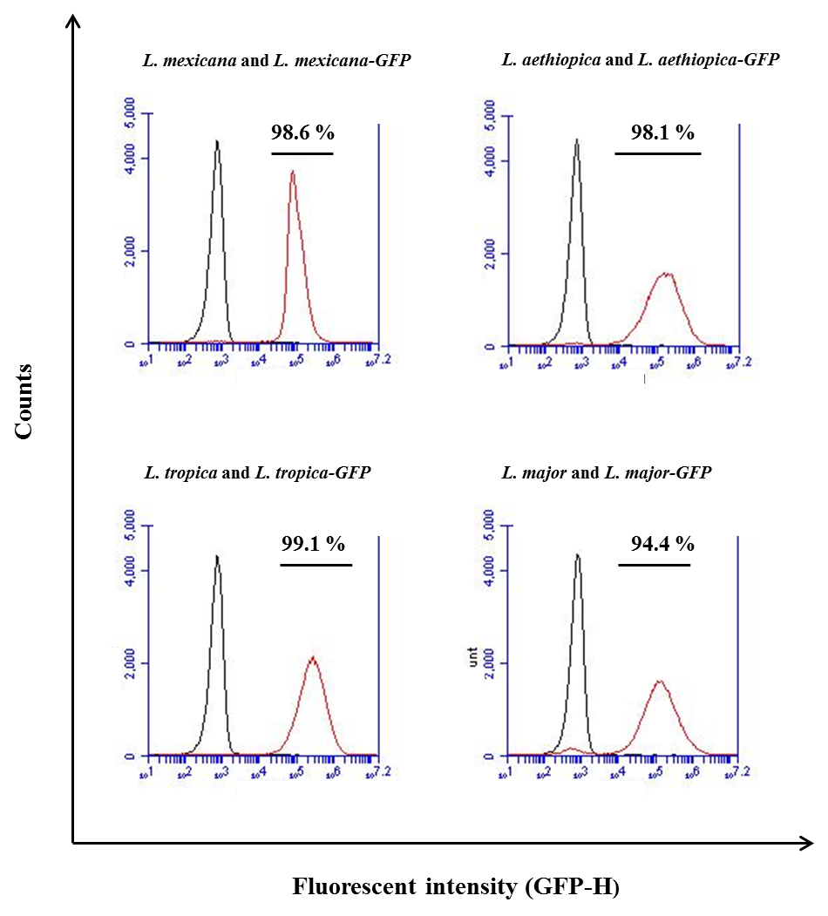

**A**

**Count (GFP expressing parasites)**

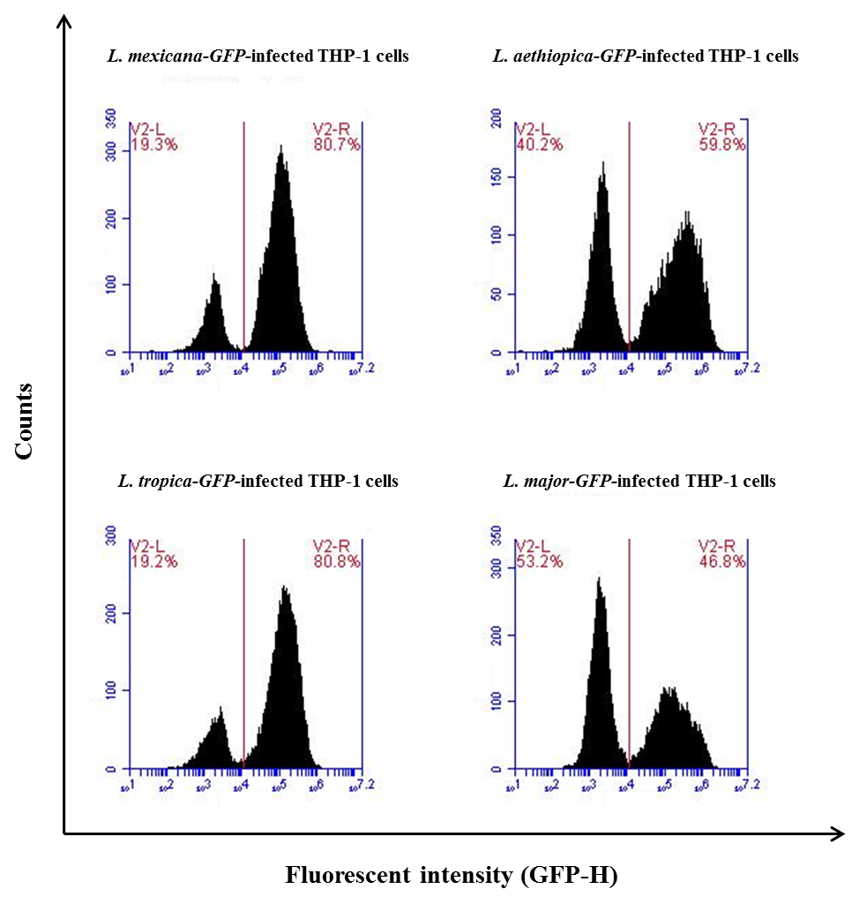

**Fluorescence GFP-H**

**B**

**Count (THP cells infected with GFP expressing parasites)**