Bird diversity in forest and coconut farms of Sulawesi, Indonesia
Nurul L. Winarni, Simon L. Mitchell, Bhisma G. Anugra, Nicolas J. Deere,
Khaleb Yordan, Boas Immanuel, Zuliyanto Zakaria, Muhajir A. W. Gaib,
Jatna Supriatna and Matthew J. Struebig

Supplementary material is published as supplied by the authors. It is not checked for accuracy, copyedited, typeset or proofread. The responsibility for scientific accuracy and file functionality remains with the authors.

Supplementary Table 1 Locations of 54 bird point counts across three landscapes in Gorontalo province, Sulawesi in 2021.
Landscape/point count |  | Village/District (kecamatan) | Latitude | Longitude | Habitat
Nantu-Tamilo
Nantu_PC01 |  | Wonosari | 0.7775 | 122.3039 | Coconut
Nantu_PC02 |  | Wonosari | 0.7785 | 122.3025 | Corn
Nantu_PC03 |  | Wonosari | 0.7777 | 122.3009 | Coconut
Nantu_PC04 |  | Wonosari | 0.7820 | 122.2930 | Coconut
Nantu_PC05 |  | Wonosari | 0.7820 | 122.2910 | Coconut
Nantu_PC06 |  | Wonosari | 0.7812 | 122.2893 | Coconut
Nantu_PC07 |  | Asparaga | 0.7870 | 122.2824 | Forest
Nantu_PC08 |  | Asparaga | 0.7877 | 122.2807 | Forest
Nantu_PC09 |  | Asparaga | 0.7881 | 122.2790 | Forest
Tamilo_PC01 |  | Wonosari | 0.7762 | 122.2792 | Open farmland
Tamilo_PC02 |  | Wonosari | 0.7749 | 122.2779 | Open farmland
Tamilo_PC03 |  | Wonosari | 0.7736 | 122.2791 | Corn
Tamilo_PC04 |  | Wonosari | 0.7721 | 122.2695 | Corn
Tamilo_PC05 |  | Wonosari | 0.7704 | 122.2690 | Open farmland
Tamilo_PC06 |  | Wonosari | 0.7693 | 122.2675 | Corn
Tamilo_PC07 |  | Wonosari | 0.7736 | 122.2606 | Open farmland
Tamilo_PC08 |  | Wonosari | 0.7752 | 122.2611 | Open farmland
Tamilo_PC09 |  | Wonosari | 0.7764 | 122.2598 | Forest edge
Hutamono-Tapaada
Hutamonu_PC01 | Botumoito |  | 0.4942 | 122.2189 | Coconut
Hutamonu_PC02 | Botumoito |  | 0.4961 | 122.2191 | Open farmland
Hutamonu_PC03 | Botumoito |  | 0.4961 | 122.2210 | Open farmland
Hutamonu_PC04 | Botumoito |  | 0.5042 | 122.2251 | Coconut
Hutamonu_PC05 | Botumoito |  | 0.5060 | 122.2253 | Farmland
Hutamonu_PC06 | Botumoito |  | 0.5076 | 122.2245 | Coconut
Hutamonu_PC07 | Botumoito |  | 0.5105 | 122.2317 | Coconut
Hutamonu_PC08 | Botumoito |  | 0.5098 | 122.2333 | Coconut
Hutamonu_PC09 | Botumoito |  | 0.5112 | 122.2343 | Forest edge
Tapadaa_PC01 | Botumoito |  | 0.5299 | 122.2105 | Coconut
Tapadaa_PC02 | Botumoito |  | 0.5307 | 122.2090 | Bushes and bamboo
Tapadaa_PC03 | Botumoito |  | 0.5322 | 122.2097 | Coconut
Tapadaa_PC04 | Botumoito |  | 0.5410 | 122.2071 | Coconut
Tapadaa_PC05 |  | Botumoito | 0.5427 | 122.2066 | Open farmland
Tapadaa_PC06 |  | Botumoito | 0.5445 | 122.2065 | Aren plantation
Tapadaa_PC07 |  | Botumoito | 0.5535 | 122.2072 | Coconut
Tapadaa_PC08 |  | Botumoito | 0.5548 | 122.2083 | Forest edge
Tapadaa_PC09 |  | Botumoito | 0.5565 | 122.2090 | Forest edge
Bogani-Tinemba
Bogani_PC01 |  | Suwawa Tengah | 0.5387 | 123.1755 | Forest edge
Bogani_PC02 |  | Suwawa Tengah | 0.5394 | 123.1771 | Open habitat
Bogani_PC03 |  | Suwawa Tengah | 0.5398 | 123.1789 | Open habitat
Bogani_PC04 |  | Suwawa Tengah | 0.5488 | 123.1799 | Forest
Bogani_PC05 |  | Suwawa Tengah | 0.5492 | 123.1816 | Forest
Bogani_PC06 |  | Suwawa Tengah | 0.5502 | 123.1831 | Forest
Bogani_PC07 |  | Suwawa Tengah | 0.5575 | 123.1883 | Forest
Bogani_PC08 |  | Suwawa Tengah | 0.5574 | 123.1901 | Forest
Bogani_PC09 |  | Suwawa Tengah | 0.5579 | 123.1918 | Forest
Tinemba_PC01 |  | Suwawa Tengah | 0.5176 | 123.2028 | Forest edge
Tinemba_PC02 |  | Suwawa Tengah | 0.5168 | 123.2046 | Farmland
Tinemba_PC03 |  | Suwawa Tengah | 0.5168 | 123.2067 | Coconut
Tinemba_PC04 |  | Suwawa Tengah | 0.5207 | 123.2146 | Farmland
Tinemba_PC05 |  | Suwawa Tengah | 0.5226 | 123.2145 | Farmland
Tinemba_PC06 |  | Suwawa Tengah | 0.5244 | 123.2147 | Coconut
Tinemba_PC07 |  | Suwawa Timur | 0.5327 | 123.2179 | Coconut
Tinemba_PC08 |  | Suwawa Timur | 0.5343 | 123.2184 | Farmland
Tinemba_PC09 |  | Suwawa Timur | 0.5357 | 123.2195 | Forest edge

[‘Corn field’ and ‘Coconut farm’ would be better than ‘Corn’ and ‘Coconut’, as the latter are crops, not habitats.]
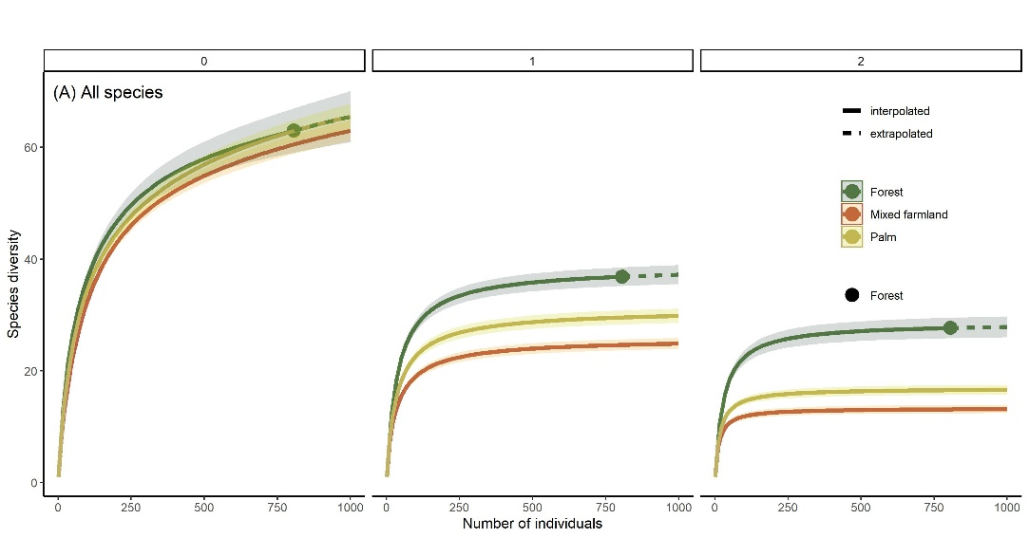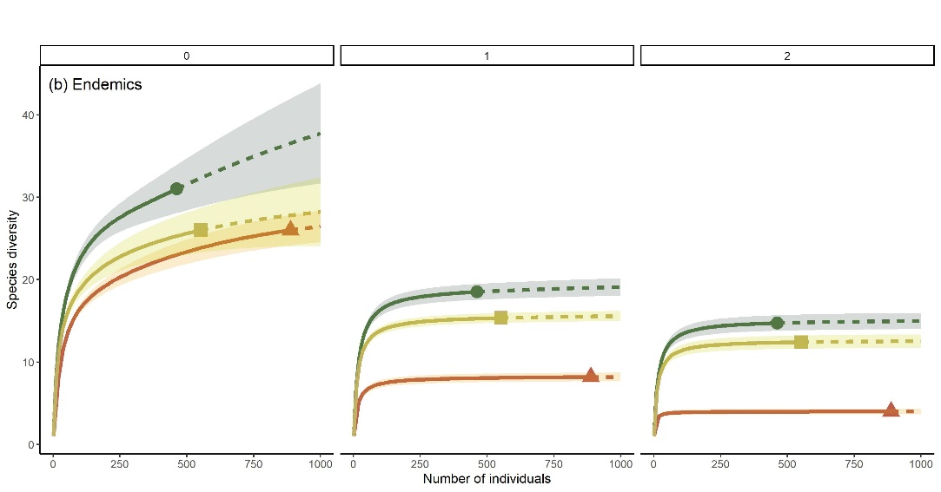
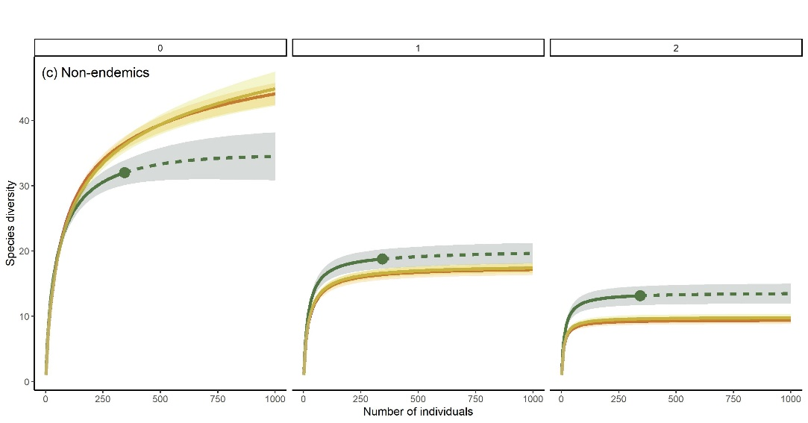
Supplementary Fig. 1 Rarefied accumulation curves for bird communities in forest (dark green) coconut (yellow) and mixed farmland (orange) of Gorontalo, Sulawesi. Curves are presented for richness (q = 0), Shannon diversity (q = 1) and Simpson diversity (q = 2). Analyses were undertaken separately for (a) all species, (b) taxa endemic to Sulawesi and surrounding islands, and (c) non-endemic species. Curves were extrapolated (dashed line) to 1000 individuals to ensure a consistent sample size for each comparison. Confidence intervals (CIs) were set at 84%, which has been demonstrated equivalent to a P-value of 0.05 significant differences (MacGregor-Fors & Payton, 2013). CIs are represented by shaded areas around the curves.
[Some of the labels in this figure are very small and the images are of low resolution. We recommend increasing the font size so that all labels are clearly legible, and using higher-resolution images.
The label ‘(A)’ should be ‘(a)’.

