Population parameters, performance and insights into factors influencing reproduction of the black rhinoceros Diceros bicornis in Namibia

Jeff R. Muntifering, Abigail Guerier, Piet Beytell and Ken Stratford

Supplementary Material 1
Rhinoceros Monitoring Data
For the Far and Mid West subpopulations, individual-based black rhinoceros Diceros bicornis monitoring has been operating since the mid 1980s (Britz & Loutit, 1989), carried out primarily by the local, field-based NGO Save the Rhino Trust (SRT). The first well-documented surveys on the region’s black rhinoceros population were conducted in 1983 and again in 1986 (G. Owen-Smith, unpubl. data, 1986). A standardized database and data collection system were developed in 1997 (Brett, 1997) containing individual rhinoceros profiles and sighting information in 1997. This database remains in use and is managed by the Ministry of Environment, Forestry and Tourism (MEFT), once sighting records are received from SRT.

Typically, the rhinoceros tracking operations use teams of three to four trackers that are either vehicle- or foot-based to cover the 27,000 km² range. Tracking occurs throughout the year, and surveys are rotated across a number of defined eco-zones within the range (Hearn, 2000). When fresh tracks are observed either crossing the road or at freshwater springs along survey routes, trackers continue their search by foot. When a rhinoceros is spotted, standardized information such as individual identification, body condition, location and reproductive condition are recorded on a data form and, more recently, via a smart phone with a custom application installed (SMART). A photograph is taken of each rhinoceros sighted, with a date and time stamp. Information collected during each sighting is entered into the Kunene black rhinoceros database (Brett, 1997) and, more recently, also recorded into SRT’s SMART database. Sighting frequencies of individuals vary considerably across these subpopulations, but roughly half of the known rhinoceroses are observed each month and the majority is located each year. For the Far West and Mid West subpopulations, both of which fall within the West Kunene rhinoceros range, we used all confirmed individual-based sighting data collected during 2000–2019. We omitted data collected prior to 2000 because monitoring effort was much lower at that time and thus there was a higher degree of uncertainty in the aging estimates of calves (the critical baseline data for most demographic data).

For the Central subpopulation, individual-based rhinoceros monitoring is conducted through the use of tracking teams both on foot and in vehicles, aided also by the use of aerial surveys and camera traps. Tracking occurs on a daily basis across the site throughout the year. For each sighting (observer or camera trap), standard information (animal ID, geographical location, body condition, photographs, etc.) is collected for each rhinoceros, collated into individual animal profiles and stored in a central database. Up to now this process has been paper-based, but it is currently being transitioned to a digital method (SMART) for the tracking teams by reserve staff. All summary data is provided to the MEFT Rhino Custodianship Coordinator.
Monitoring in the Far East is conducted by the local Conservancy Game Guards and MEFT staff who conduct monthly vehicle-based patrols in the 10 × 10 km fenced area where the rhinoceroses reside. Patrol teams also check and download images from the remote cameras placed at water points. The data is passed along to the MEFT Rhino Custodianship Coordinator. Aerial surveys are also conducted annually by the MEFT to check on missing individuals and confirm presence and any new births and/or deaths. For the Far East subpopulation, we used individual-based data collected since the rhinoceros were reintroduced there in 2008, provided by MEFT.

Stage-specific survivorship
Because the rhinoceroses in the studied subpopulations are individually identifiable and have nearly 100% chance of obtaining a known fate during a full year of regular monitoring, we employed the Kaplan–Meier or Known Fates method to estimate annual and average stage-based survival rates (Kaplan & Meier, 1958). For each life stage of each known individual, we collapsed all sighting records into 1-year time steps, starting from the entry into each life stage when a known fate (individual confirmed alive, confirmed dead or censored, i.e. missing or emigrated, during the life stage-specific time step) was attributed given the annual sighting histories, until it transitioned into the next life stage. The linking of known fate to life stage was dependent on the proportion of time during that specific time step that the individual spent in that life stage. For example, if a rhinoceros calf dispersed at 3.7 years, its fate of being confirmed alive would be scored as ‘calf’ for four time steps. If a rhinoceros calf dispersed at 3.4 years, its fate of being confirmed alive would be scored as ‘calf’ for three time steps. Thus, for each time step for each life stage, we can estimate the conditional survival probabilities (P_{c}) by:
P_{c} = 1 – (d_{i} / n_{i})
where d_{i} denotes the number of known deaths that occurred during the time step and n_{i} equals the number still alive and still in the population (the number at risk) at the end of the time. Annual survival estimates for each life stage (i.e. year 1 of calf stage, year 2 of calf stage, etc.) was then averaged to obtain a single survival estimate for each life stage. For the Central subpopulation, only time steps for which n ≥ 10 were considered and analysed.

Uncertainty in monitoring data
Following our conservative rule for removing females with birth dates with > 1 month uncertainty, the range of removals varied from removing 32% from the Central subpopulation (females that were introduced), 27% of breeding females in the Far West (where sighting intervals were the largest and birth dates thus had the largest uncertainty), 20% in the Mid West (long sighting intervals) and 0% in the Far East.

Reproductive Performance Covariate Analysis and Model Selection
We examined a set of biologically plausible factors that may influence age at first reproduction and inter-birth interval as the two main measures of fecundity, to better understand which environmental variables influence the population’s reproductive performance. Prior to model selection and evaluation, we selected relevant variables that we believed, based on our knowledge of black rhinoceros biology and ecology, to best explain black rhinoceros fecundity.
The number of variables included in each modelling procedure was aligned with the respective sample size for each response variable (Gelman & Hill, 2007). As individual animals, populations and even small groups may respond differently to the factors that influence fecundity (Nakagawa & Schielzeth, 2010), we also included the identity of both the subpopulation and individual rhinoceros as random effects in mixed-effects models, if sample size permitted (for similar analysis design see Law et al., 2013 and Hrabar & du Toit, 2005).
The models for age at first reproduction were limited by our small sample size (n = 32 independent first reproduction events for individual females across the subpopulations: 9 Far West, 7 Mid West, 15 Central and 2 Far East) and thus we restricted our final candidate model set to include only two explanatory variables: a single measure for browse quality and population density at the time of first reproduction for each sample point. To identify the best measure for browse, we tested a series of measures for the influence of rainfall or NDVI on age at first reproduction by comparing a number of plausible singular model hypotheses including both the cumulative and mean rainfall as well as mean NDVI values over a 6-month, 15-month and 24-month period prior to conception of the first calf. The top performing model (variable) was retained in the final candidate model set. Our inclusion and evaluation of NDVI as a more direct measure of browse complements previous analyses of covariates affecting black rhinoceros age at first reproduction, which only included a measure of rainfall (Hrabar & Toit, 2005; Law et al., 2013). Similar analyses on other browsing megaherbivores in Africa demonstrate that NDVI may provide greater explanatory power than rainfall towards driving demographic processes (Rasmussen et al., 2006; Trimble et al., 2009). However, we recognize that because black rhinoceroses have limited capability to browse at heights above 2 m (Adcock, 2006), utilizing NDVI as a surrogate for browse may over-estimate actual available browse, especially in areas of higher canopy. We also tested for any effects of soil, which may be expected to have more biological impact over a longer rather than shorter time frame, but did not detect any noticeable effect. We therefore omitted the soil variable from the final model set.
The larger sample size available for the inter-birth interval analysis (n = 116 single inter-birth intervals between successive calving events for 35 individual breeding females: 7 in Far West, 8 in Mid West, 16 in Central, and 4 in Far East) enabled us to include additional plausible explanatory variables such as maternal age (estimated at the midpoint of the inter-birth interval) and experience (the number of previously successfully weaned calves that reached the subadult stage), as well as the sex of the calf that initiated the inter-birth interval. In the same way as for age at first reproduction, we also included a measure of browse by evaluating the mean rainfall and NDVI during the 6-month period prior to inter-birth interval initiation (including birth month) as well as the inter-birth interval period itself (including birth month). Lastly, we included a measure of population density estimated at the midpoint of the inter-birth interval. We tested for any effects of clustering in our inter-birth interval analysis by including and testing for an effect of subpopulation (4 classes) and maternal identity (35 females) as random effects fitted by a general linear mixed model. This also accounted for any potential independence bias in the dataset. Given that we were including a categorical binary predictor (calf sex) we mean-centered (and divided by 2 SD) all predictors prior to modelling (Gelman & Hill, 2007; Gelman, 2007).

We extracted rainfall data from the Climate Hazards Group InfraRed Precipitation with Station (CHIRPS) dataset (freely available online; USGS, 2021) at a 5 × 5 km spatial resolution. We obtained the NDVI time-series data from the Collection 6 Moderate Resolution Imaging Spectroradiometer (MODIS), through an eMODIS product (also freely available; USGS, 2021), which is a 10-day maximum-value composite NDVI at 250-m spatial resolution. We obtained data on soil nitrogen and carbon from the SoilGrids database with aggregated values for three depths (0, 15, 30 cm) at a spatial resolution of 250 meters (freely available online; ISRIC, 2021). For these spatial variables, once the raw data was extracted, we calculated the zonal mean for each subpopulation for the data stacks and extracted the time-series values in ArcGIS 10.3 (Esri, Redlands, USA) on a monthly basis during 2000–2019.

Exploring Random Effects in Inter-birth Interval modelling
Because our inter-birth interval dataset included reasonable-sized clusters of data (hierarchal) by site (n=4) and by maternal ID (n=35), we explored whether including random effect(s) in the models would be appropriate. Diagnostically, a simple histogram showing the data distribution of this variable illustrates the small within-group sample size (i.e. > 70% of the grouping levels have less than three samples). With samples of such a small size and skewed distribution, previous studies have recommended to not use random effects in the modelling (Harrison et al., 2018).
However, we further examined the effects of including random effects into the model by fitting mixed effects models for inter-birth interval. We tested the improvements on model performance by (1) comparing the marginal (fixed effects only) and conditional (including the random effect(s)) R²_{GLMM} as well as (2) a likelihood ratio test to examine the significance of the random effect in the model. Very little evidence suggested that including either or both of the random effects improved model performance relative to the global fixed effects only model. While the best candidate was the Maternal Identity mixed effects model (with a much greater amount of variance explained than the fixed effects only) the difference was not statistically significant (p = 0.2361). Therefore, combined with the concerns regarding low and unequally within class sample size, we excluded the random effects from our subsequent modelling of inter-birth interval.

Results
The main findings in terms of the parameter estimates relative to global standards for each subpopulation (including confidence intervals) are summarized in Supplementary Table 1.

Supplementary Table 1 Summary of the mean parameter estimates for different subpopulations of the black rhinoceros Diceros bicornis in Namibia. Numbers in parentheses are 95% confidence intervals for the above mean value.
Key population performance parameter | IUCN Benchmark | Subpopulations  Mean (± 95% CI)
 |  | Far West | Mid West | Central | Far East | Overall
Calf sex ratio (male:female) |  | 0.56 | 0.51 | 0.44 | 0.81 | 0.52  (± 0.16)
% of the population < 1 year old | 0.08 | 0.06  (± 0.21) | 0.09  (± 0.04) | 0.10  (± 0.06) | 0.10  (± 0.02) | 0.09  (± 0.02)
% of the population < 3.5 years old | 0.28 | 0.17  (± 0.04) | 0.33  (± 0.05) | 0.30  (± 0.09) | 0.25  (± 0.05) | 0.27  (± 0.07)
Stage-based survivorship
Adult male |  | 0.85  (± 0.21) | 0.98  (± 0.04) | 0.97  (± 0.03) | 1 | 0.95  (± 0.07)
Adult female |  | 0.95  (± 0.06) | 0.98  (± 0.062) | 0.99 (± 0.02) | 1 | 0.98  (± 0.02)
Subadult |  | 0.99  (± 0.02) | 0.95  (± 0.02) | 0.99 (± 0.01) | 1 | 0.98  (± 0.02)
Calf |  | 0.95  (± 0.09) | 0.97  (± 0.02) | 0.95 (± 0.05) | 1 | 0.97  (± 0.02)

Age at first reproduction summary by subpopulations
A total of eight breeding females in the Far West subpopulation had a mean age at first reproduction of 9.1 years (± 1.24 95% CI; median 9.6 years; range 81–189 months (6.75–15.75 years)). A total of seven breeding females in the Mid West subpopulation had a mean age at first reproduction of 7.6 years (± 1.29 95% CI; median 7.5 years; range 69–124 months (5.75–10.3 years)). A total of fifteen breeding females in the Central subpopulation had a mean age at first reproduction of 7.1 years (± 0.28, 95% CI; median 6.9 years; range 65–116 months (5.4–9.7 years)). Only 2 breeding females were available for analysis in the Far East subpopulation, with a mean age at first reproduction of 5.8 years (± 1.14 95% CI; Supplementary Fig. 1).

Inter-birth interval summary by subpopulations
Eight breeding females in the Far West subpopulations produced a total of 21 calves during the study period, with a mean inter-birth interval of 44.6 months (± 17.04 95% CI; median 37 months; range 27–71 months). Eight breeding females in the Mid West subpopulations produced a total of 34 calves during the study period, with a mean inter-birth interval of 39.1 months (± 5.36 95% CI; a median inter-birth interval of 34.8; range 30–55 months). Twenty-six breeding females in the Central subpopulation produced a total of 57 calves during the study period, with a mean inter-birth interval of 33.1 months (± 1.55, 95% CI; median 31 months; range 25–49 months). Four breeding females in the Far East subpopulation produced a total of 12 calves during the shorter study period, with a mean inter-birth interval of 36.4 months (± 5.07 95% CI; median 36.7 months; range 18–50 months; Supplementary Fig. 2b).

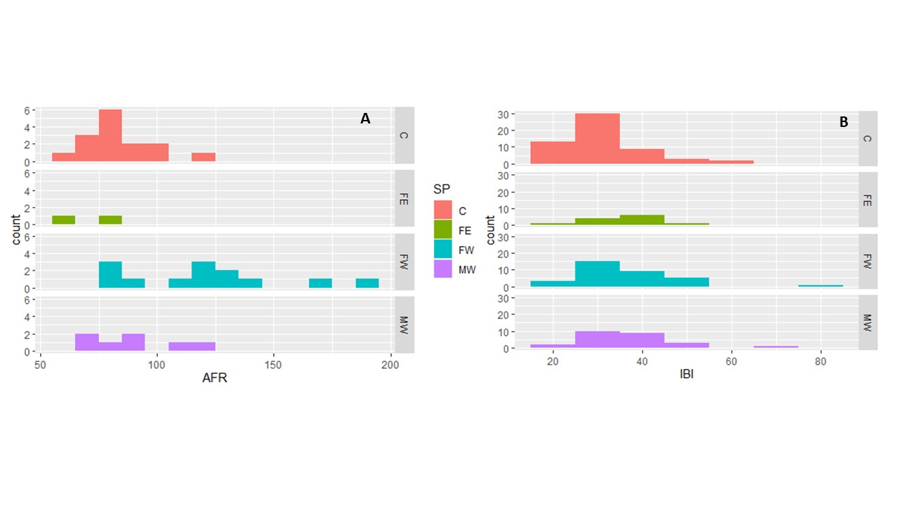
Supplementary Fig. 1 Histograms summarizing frequency of (A) age at first reproduction in months and (B) inter-birth interval in months across the black rhinoceros subpopulations in Namibia: C = Central, FE = Far East, FW = Far West, MW = Mid West.

Relationships between parameters
These reproductive parameters of individuals may in turn affect population structure and growth. Firstly, the positive (although not significant) relationship between age at first reproduction and inter-birth interval suggests that females that give birth later in life may be less productive overall (i.e. exhibit longer inter-birth intervals and produce fewer calves). This could potentially be driven by habitat quality or by density-dependence effects, with areas of poorer habitat quality or higher rhinoceros density possibly increasing both age at first reproduction and inter-birth interval, to the detriment of the population performance. Secondly, and expectedly, a slightly negative but not statistically significant relationship was found between inter-birth interval and number of calves produced per female. This suggests that females with shorter inter-birth intervals may maintain this characteristic over time, leading to greater overall number of births. Both of these correlations warrant further studies regarding the influence of various covariates (i.e. habitat quality and/or population density) on reproductive parameters (Hrabar & Toit, 2005; Law et al., 2013).
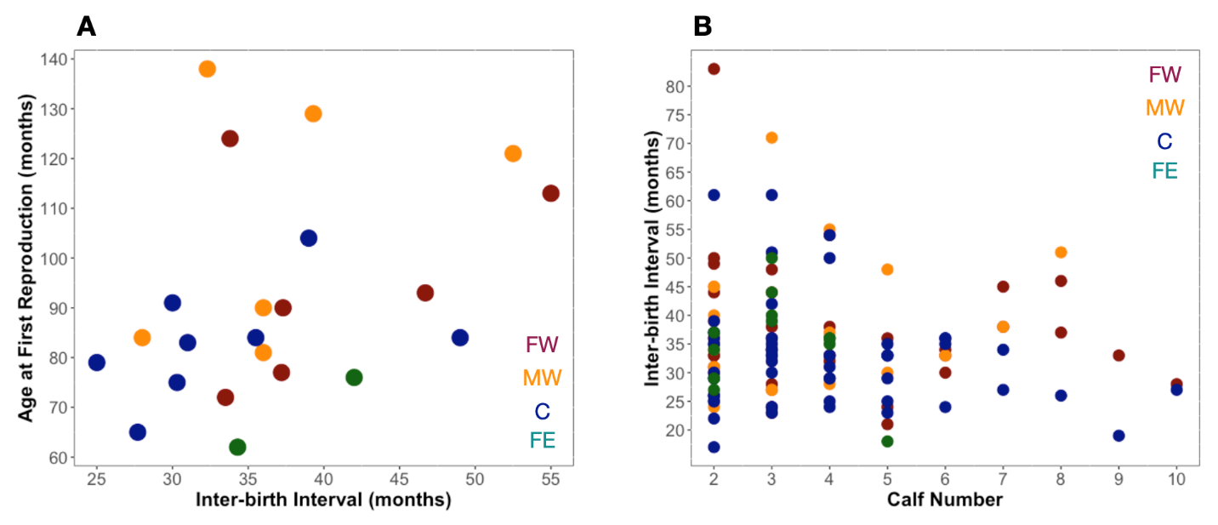
Supplementary Fig. 2 Relationships between (A) age at first reproduction and inter-birth interval, and (b) inter-birth interval and total number of calves weaned.

Additional Population Performance Metrics
Overall, the average annual per cent of the population aged < 1 year old was 9% (95% CI = 7–11%), which is slightly higher than the IUCN benchmark of 8%. The lowest score of 6% was recorded in the Far West subpopulation, whereas both the Central and Far East subpopulation averaged 10% for this metric. The average annual per cent of the population aged < 3.5 years was 27% (95% CI = 20 – 34%), which is slightly lower than the IUCN Benchmark of 28%. Again, the lowest score was the Far West subpopulations, with 17%, whereas the Mid West subpopulation had the highest mean value of 33%.

Covariate analysis of key reproductive performance parameters
Age at First reproduction
We identified and examined the effects of 10 plausible explanatory variables on age at first reproduction (Supplementary Table 2, Supplementary Fig. 3). Many of the 10 predictor variables were highly correlated and emphasized the need to restrict the final model variable set. Comparatively, our model ranking of the candidate models identified a clear top model, with the mean NDVI 15 months prior to the inter-birth interval representing 58.2% of the Akaike weight. The model also performed well with an adjusted R² of 0.282 and was statistically significant (p < 0.001).
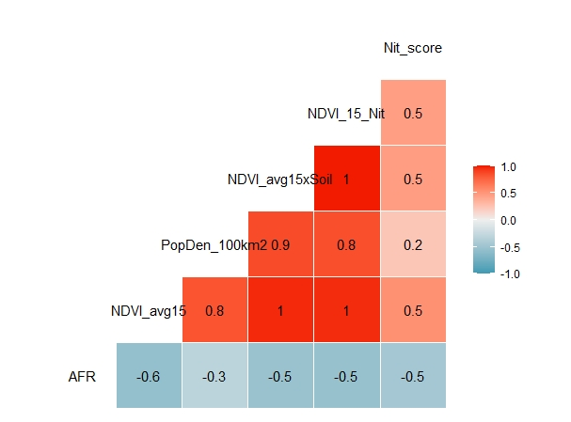
Supplementary Fig. 3 Correlation matrix for age at first reproduction and covariates.

Supplementary Table 2 Linear model results for age at first reproduction combined with each individual candidate predictor illustrating the top variables for consideration in candidate model set.
Model¹ | df | logLik | AICc | ΔAICc | Weight ωi | R² | P-value
NDVI_avg15 | 3 | -121.048 | 249.055 | 0 | 0.582 | 0.282 | 0.001
NDVI_avg24 | 3 | -121.442 | 249.843 | 0.788 | 0.393 | 0.262 | 0.003
NDVI_avg6 | 3 | -124.206 | 255.336 | 6.281 | 0.025 | 0.394 | 0.0001
Rain_avg15 | 3 | -135.059 | 276.976 | 27.921 | 0 | 0.283 | 0.001
Rain_cum15 | 3 | -135.061 | 276.979 | 27.924 | 0 | 0.283 | 0.001
Rain_avg24 | 3 | -135.359 | 277.574 | 28.519 | 0 | 0.269 | 0.001
Rain_cum24 | 3 | -135.363 | 277.583 | 28.528 | 0 | 0.269 | 0.001
Rain_cum6 | 3 | -135.993 | 278.842 | 29.787 | 0 | 0.24 | 0.003
Rain_avg6 | 3 | -136.005 | 278.867 | 29.812 | 0 | 0.239 | 0.003
Null | 2 | -140.913 | 286.239 | 37.184 | 0 | 0 | n/a²
¹The labelling of variables in the model set follows a pattern describing the variable that first lists the measure (NDVI or rainfall), followed by whether the values were averaged (avg) or cumulative (cum), and finally with a time period from when the values were incorporated: 6, 15 or 24 months prior to first calving event.
²Not applicable.

On a univariate level, the two explanatory variables demonstrated some degree of linearity (negative as expected), and efforts to transform the data did not improve model performance. Diagnostic plots for the predictors did not illustrate any substantial non-linearities or departures from normality to preclude a linear modelling approach, nor were outliers detected (Supplementary Fig. 4).
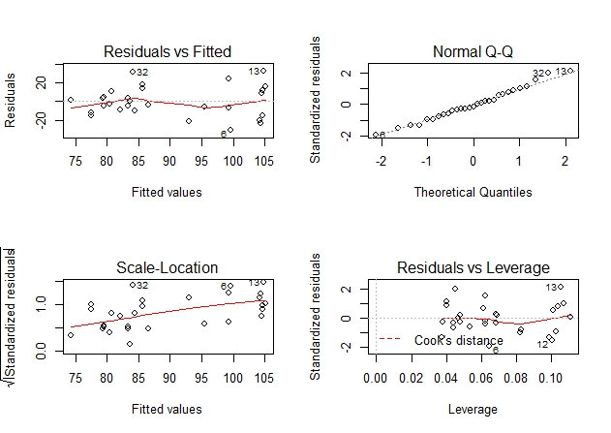
Supplementary Figure 4 Example Diagnostics for age at first reproduction vs NDVI 15 (monthly NDVI values averaged over a 15-month period prior to first calving event).

Inter-birth interval
There were fewer correlations between explanatory variables in the inter-birth interval dataset. Highly correlated variables included both pairs of prior and mean rainfall and NDVI as well as maternal age and maternal experience (Supplementary Fig. 5).
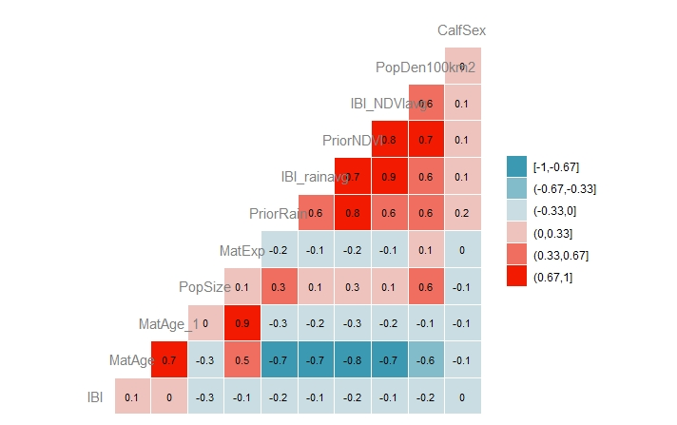
Supplementary Fig. 5 Correlation matrix (including Pearson’s values) for response and predictor variables in the model.

We tested two groups of variables for correlation, to identify which variables to remove. Firstly, maternal experience was selected over maternal age as the better model (Akaike weight = 54.4%) and thus a better proxy for maternal characteristics that may influence inter-birth interval (Supplementary Table 3).

Supplementary Table 3 Summary of model selection statistics for maternal predictors showing maternal experience is a better predictor of inter-birthing interval than maternal age.
Model | df | logLik | AICc | ∆AICc | Weight ꭃi
Maternal experience | 3 | -363.506 | 733.2618 | 0 | 0.5443
Maternal age | 3 | -363.684 | 733.6174 | 0.3556 | 0.4557

For the prior rainfall versus NDVI explanatory variables, prior rain was the better model, whereas for the mean rain or NDVI during the inter-birth interval, mean NDVI was the better model. As the two predictors measure different effects (before and during the inter-birth interval) and were not correlated (< 0.7), both were retained in the final model (Supplementary Table 4).

Supplementary Table 4 Summary of model selection statistics for prior and mean rain vs NDVI predictors demonstrating that prior rain is the best predictor of inter-birthing interval.
Model¹ | df | logLik | AICc | ∆AICc | Weight ꭃi
Prior rain | 3 | -361.551 | 729.3521 | 0 | 0.3307
Prior NDVI | 3 | -361.638 | 729.5266 | 0.1745 | 0.3031
IBI_NDVIavg | 3 | -361.765 | 729.78 | 0.4279 | 0.267
IBI_Rainavg | 3 | -362.755 | 731.7605 | 2.4083 | 0.0992
¹Prior rain is cumulative rainfall from 6 months prior to each inter-birth interval event, prior NDVI refers to averaged monthly NDVI values from 6 months prior to each calving event, IBI_NDVIavg is averaged monthly NDVI values during the inter-birth interval, and IBI_Rainavg refers to averaged monthly rainfall values during the inter-birth interval.

We thus selected five fixed effects explanatory variables in the final model candidate set including (1) maternal experience, (2) prior rain, (3) mean NDVI during the inter-birth interval, (4) population density and (5) calf sex. Diagnostic plots for the predictors did not illustrate any substantial non-linearities or departures from normality to preclude a linear modelling approach, nor were outliers detected (Supplementary Fig. 6). 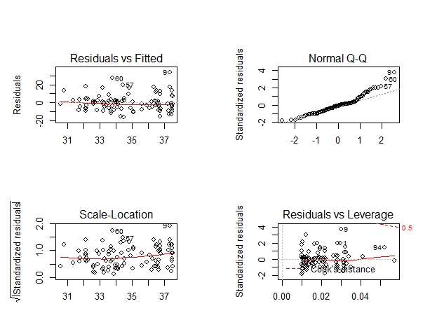
Supplementary Fig. 6 Example diagnostics for inter-birth interval vs prior rain.

Our full dataset included clusters of data (hierarchical) by site (n=4) and by maternal ID (n=35), with 35 females contributing at least one inter-birthing interval to the dataset. Thus, we explored whether including random effect(s) in the models would be appropriate. Diagnostically, a simple histogram (Supplementary Fig. 7) of illustrates the low level of within-group sample size (i.e. > 70% of the grouping levels have less than three samples). With samples of such a small size and skewed distribution, previous studies have recommended to not use random effects in the modelling (Harrison et al., 2018).

Supplementary Fig. 7 Histogram of maternal ID (frequency of samples per grouping level).

However, we further examined the contributions of random effects to the model by fitting mixed effects models for inter-birth interval. We tested the improvements on model performance by (1) comparing the marginal (fixed effects only) and conditional (including the random effect(s)) R² general linear mixed models (GLMM), and (2) a likelihood ratio test to examine the significance of the random effect in the model (Supplementary Table 5). There was little evidence to suggest that including either or both of the random effects improved model performance relative to the global fixed effects only model. Although the best candidate was the maternal ID mixed effects model (with a greater amount of variance explained than the fixed effects only), the difference was not statistically significant (p = 0.2361). Therefore, combined with the concerns regarding small within-class sample size and highly skewed distribution, we excluded the random effects from our subsequent modelling of inter-birth interval.

Supplementary Table 5 Summary statistics of fixed only and mixed effects models illustrating that the additional random effects do not improve the model.
Model | K | logLik | AICc | Deviance | R² _{a} | p
Only fixed effects (global) | 7 | -360.2 | 736.4 | 720.4 | 0.061
Mixed effects (site) | 8 | -360.2 | 736.4 | 720.4 | 0.078 | 1
Mixed effects (maternal ID) | 8 | -359.5 | 734.99 | 718.99 | 0.204 | 0.2361
Mixed effects (site/maternal ID) | 9 | -359.5 | 736.99 | 718.99 | 0.204 | 0.4956

The global linear model produced no evidence that any of our selected explanatory variables was contributing to the inter-birth interval response. The model fit was very poor (adj. R² = 0.021) and no single variables were significant (Table S6).

Supplementary Table 6 Global model summary statistics illustrating our predictor variables do not appear to influence inter-birth interval.
Model¹ | R² _{a} | F | df | p
Global (IBI ~ Pr + NDVIa + ME + PD + CS) | 0.021 | 1.409 | 5,94 | 0.228
Variable | β | SE | t | p
(Intercept) | 34.682 | 0.9152 | 37.895 | < 2e-16
Pr | -1.5278 | 1.2326 | -1.239 | 0.218
NDVIa | -1.1373 | 3.1816 | -0.357 | 0.722
ME | -2.255 | 1.9164 | -1.177 | 0.242
PD | -1.2097 | 2.7701 | -0.437 | 0.663
CS | -0.2351 | 1.8646 | -0.126 | 0.9
¹Pr = Prior rain, NDVIa = mean monthly NDVI 6 months prior to inter-birth interval, ME = maternal experience, PD = population density, CS = sex of previous calf.

The best model (Supplementary Table 7), which only included the prior rain predictor, was significant (p = 0.036) but still only explained 3.5 % of the variance in the data (adjusted R² = 0.035).

Supplementary Table 7 Summary statistics of the top model with prior rainfall identified as the best model for the inter-birth interval.
Model | R² _{a} | F | df | p
Best Model (IBI ~ PR) | 0.035 | 4.538 | 1,98 | 0.036
Variable | β | SE | t | p
(Intercept) | 34.6788 | 0.9085 | 38.17 | < 2e-16
Pr | -1.9463 | 0.9137 | -2.13 | 0.0357

Prior rain contributed the greatest relative importance (0.56), with NDVI avg 15 next (0.412) and calf sex contributing the least (0.187; Supplementary Fig. 8).

Supplementary Fig. 8 Comparison of relative importance of predictor variables. Pr = Prior rain, NDVIa = mean monthly NDVI 6 months prior to inter-birth interval, ME = maternal experience, PD = population density, CS = sex of previous calf.

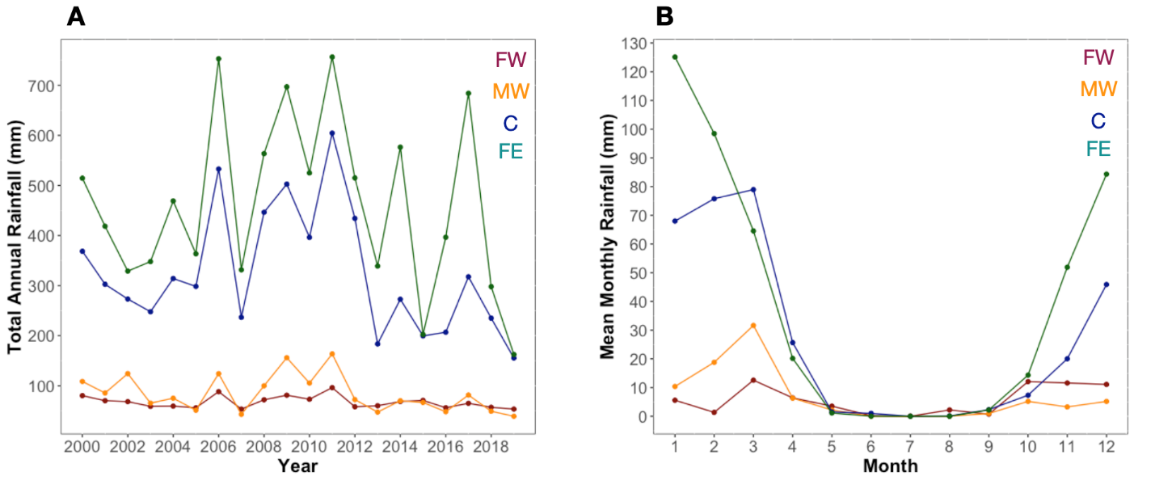
Supplementary Fig. 9 Comparison of (A) relative rainfall patterns by year and (B) mean monthly rainfall across the black rhinoceros subpopulations in Namibia.
Supplementary Table 8 Summary of estimated key demographic parameters of black rhinoceros subpopulations in Namibia and South Africa.
Protected area/ subpopulation | Country | Age at first reproduction ± 95% CI (months) | Inter-birthing interval ± 95% CI (months) | Data period | Reference
Great Fish River Reserve | South Africa | 80 ± 14 | 29 ± 8 | 1986–1997 | Law, Fike & Lent, 2013
Pilansberg | South Africa | 87 ± 15 | 34 ± 3 | 1985–2001 | Hrabar & du Toit, 2005
Hluhluwe-iMfolozi | South Africa | 144 ± 11 | 45 ± 6 | 1998–2013 | Nhleko et al., 2017
Far West | Namibia | 109 ± 15 | 45 ± 17 | 2000–2019 | This Study
Mid West | Namibia | 91 ± 15 | 39 ± 5 | 2000–2019 | This Study
Central | Namibia | 85 ± 3 | 33 ± 2 | 2000–2019 | This Study
Far East | Namibia | 70 ± 14 | 36 ± 5 | 2008–2019 | This Study

References
Brett, R. (1997) Save the Rhino Trust, Namibia: Upgrading of monitoring system, data analysis and equipment, assessment of the black rhino surveillance in west Kunene, Namibia. Report for Save the Rhino Trust.
Britz, M. & Loutit, B. (1989) Monitoring and identification of black rhinocros Diceros bicornis in Damaraland. Koedoe, 32, 61–63.
Gelman, A. (2007) Scaling regression inputs by dividing by two standard deviations. Statistics in Medicine, 27, 2865–2873.
Gelman, A. & Hill, J. (2007) Data Analysis using Regression and Hierarchial/Multilevel Models. Cambridge University Press, New York, USA.
Harrison, X.A., Donaldson, L., Correa-Cano, M.E., Evans, J., Fisher, D.N., Goodwin, C.E.D. et al. (2018) A brief introduction to mixed effects modelling and multi-model inference in ecology. PeerJ, 6, e4794.
Hrabar, H. & Toit, J.T. (2005) Dynamics of a protected black rhino (Diceros bicornis) population: Pilanesberg National Park, South Africa. Animal Conservation, 8, 259–267.
ISRIC (International Soil Reference and Information Centre) (2021) SoilGrids — Global Gridded Soil Information. isric.org/explore/soilgrids [accessed 28 May 2021].
Kaplan, E.L. & Meier, P. (1958) Nonparametric estimation from incomplete observations. Journal of the American Statistical Association, 53, 457–481.
Law, P.R., Fike, B. & Lent, P.C. (2013) Mortality and female fecundity in an expanding black rhinoceros (Diceros bicornis minor) population. European Journal of Wildlife Research, 59, 477–485.
Nakagawa, S. & Schielzeth, H. (2010) Repeatability for Gaussian and non-Gaussian data: a practical guide for biologists. Biological Reviews, 935–956.
Rasmussen, H.B., Wittemyer, G. & Douglas-Hamilton, I. (2006) Predicting time-specific changes in demographic processes using remote-sensing data. Journal of Applied Ecology, 43, 366–376.
Swets, D.L., Reed, B.C., Rowland, J.D., & Marko, S.E. (1999). A weighted least-squares approach to temporal NDVI smoothing. In: 1999 ASPRS Annual Conference: From Image to Information. Proceedings. Portland, Oregon, May 17–21, 1999. American Society for Photogrammetry and Remote Sensing, Bethesda, USA.
Trimble, M.J., Ferreira, S.M. & van Aarde, R.J. (2009) Drivers of megaherbivore demographic fluctuations: inference from elephants. Journal of Zoology, 279, 18–26.
USGS (U.S. Geological Survey) (2022) USGS FEWS NET Data Portal. earlywarning.usgs.gov/fews [accessed March 2021].

