Exploring the demography and conservation needs of hawksbill sea turtles Eretmochelys imbricata in north-west Mexico

Lourdes Martínez-Estévez, Abelino Angulo Angulo, Mayra Estrella Astorga, Cosme Damián Becerra, Nazario Campaña Leyva, Felipe Cuevas Amador, Juan Pablo Cuevas Amador, Tania de la Vega Carvajal, Anely Fernández Robledo, Alexander R. Gaos,
Catherine E. Hart, Amy Hudson Weaver, José Luis López, Jesus Lucero, Israel Llamas, Agnese Mancini, Karen Oceguera, Jeffrey A. Seminoff, Bernie R. Tershy,
Ingrid L. Yañez, Alan Zavala-Norzagaray and Donald A. Croll

Supplementary Table 1 Records of hawksbill sea turtles Eretmochelys imbricata (captures and recaptures), by providing organization.
Organization | Records
Angostura Vive Verde A.C. | 4
Amigos para la Conservación de Cabo Pulmo A.C. | 77
Conservation Action Laboratory, University of California Santa Cruz | 147
Eco Mayto A.C. | 101
Grupo Tortuguero de Bahía Kino | 6
Grupo Tortuguero de las Californias A.C. / ICAPO | 245
Iniciativa Carey del Pacífico Oriental (ICAPO) | 18
IPN-CIIDIR Unidad Sinaloa | 31
ICSAS A.C. / Red Tortuguera A.C. | 23
Sociedad de Historia Natural Niparajá A.C. | 54
Sociedad de Pescadores El Brinco S.C. | 1
Southwest Fisheries Science Center, NOAA | 6
Tortugueros Comcáac Desemboque | 1
Tortugueros Comcáac Punta Chueca | 4

Supplementary Table 2 Marine habitats of the Gulf of California including information sources.
Habitat | Sources
Mangrove estuaries | CONABIO. (2016) Distribución de los manglares de México en 2015, escala: 1:50000. 1ª. Edición. Comisión Nacional para el Conocimiento y Uso de la Biodiversidad. Sistema de Monitoreo de los Manglares de México (SMMM). Ciudad de México, México.
 | http://www.biodiversidad.gob.mx/ecosistemas/manglares2013/manglares.html
 | http://www.biodiversidad.gob.mx/ecosistemas/manglares2013/pdf/InfGQ004.pdf
Coral reefs | Bezaury-Creel, J.E. & Castro Campos, M. (2010) Base de Datos Geográfica de los Rasgos Costeros, Islas y Arrecifes Mexicanos de INEGI, Versión 1.0. En: Conjunto de Bases de Datos Geográficas sobre la Zonificación Marina Mexicana. Versión 1.0. (eds J.E. Bezaury-Creel & J.F. Torres). The Nature Conservancy, Arlington, USA.
 | ReefBase: A Global Information System for Coral Reefs. December 2016. http://www.reefbase.org
 | Burke, L., Reytar, K., Spalding, M. & Perry, A. (2016) Reefs at Risk Revisited. World Resources Institute. https://www.wri.org/research/reefs-risk-revisited
 | Reyes-Bonilla, H. (2003) Coral reefs of the pacific coast of Mexico. In: Latin American Coral Reefs (ed. J. Cortes), pp. 331–349. Elsevier, Amsterdam, The Netherlands.
 | Reyes-Bonilla, H. & Lopez-Perez A. (2009) Corals and coral-reef communities in the Gulf of California. In: Atlas of Coastal Ecosystems in the Western Gulf of California (eds M.E. Johnson & J. Ledesma-Vazquez), pp. 45–57 pp. The University of Arizona Press, Tucson, USA.
Rocky reefs | Spalding, M.D., Brumbaugh, R.D. & Landis, E. (2016) Atlas of Ocean Wealth. The Nature Conservancy, Arlington, USA.
 | Munguia-Vega, A., Torre, J., Turk-Boyer, P., Marinone, G., Lavin, M., Pfister, T. et al. (2015) PANGAS: an interdisciplinary ecosystem-based research framework for small-scale fisheries in the Northern Gulf of California. Journal of the Southwest, 57, 337–390.
Sargassum beds | Spalding, M.D., Brumbaugh, R.D. & Landis, E. (2016) Atlas of Ocean Wealth. The Nature Conservancy. Arlington, VA.
Seagrass beds | Lopez-Calderon, J. M., Riosmena-Rodríguez, R., Torre, J., Meling, A. & Basurto, X. (2016) Zostera marina meadows from the Gulf of California: conservation status. Biodiversity and Conservation, 25, 261–273

Supplementary Table 3 Summary of the factors and the scores used to develop the conservation index for hawksbill sea turtle sites in the north-west Pacific of Mexico.

Factor | Parameters | Score
Isolation | Mainland coast  Peninsula coast  Island | 1  2  3
Protection status | No protection  Federal marine protected area  No-take marine protected area | 0  1  1
Local engagement | No  Yes | 0  1
Fishing pressure | 5–10 boats/500 km²  11–20 boats/500 km²  21–40 boats/500 km²  41–60 boats/500 km² | -1  -2  -3  -4

Supplementary Table 4 Summary of hawksbill sea turtle captures and recaptures, including curved carapace length range and mean, in the north-west Pacific of Mexico.
State |  | Locality | Captured/recaptured individuals | Curved carapace length range (cm) | Mean curved carapace length (cm)
Baja California Sur | 1 | Laguna de San Ignacio | 2/0 | 40.0−62.4 | 51.2
 | 2 | López Mateos | 4/0 | 36.8−43.3 | 40.2
 | 3 | Bahía Magdalena | 11/3 | 42.5−77.6 | 51.8
 | 4 | Cabo Pulmo | 20/13 | 35.5−59.2 | 44.4
 | 5 | Isla Cerralvo | 1/0 | 34.5 | 34.5
 | 6 | El Saltito | 1/0 | 59.0 | 59.0
 | 7 | Archipiélago de Espíritu Santo | 92/38 | 37.5−86.8 | 57.6
 | 8 | Isla San José - Isla El Pardito | 120/30 | 35.0−90.3 | 52.6
 | 9 | Isla San Marcial | 2/0 | 55.5–75.0 | 65.2
 | 10 | Agua Verde | 7/0 | 31.5–63.0 | 49.0
 | 11 | Isla Montserrat | 6/0 | 40.9−65.4 | 51.2
 | 12 | Quemado | 3/1 | 48.0−73.5 | 63.0
 | 13 | La Pila | 1/0 | 52.0 | 52.0
 | 14 | Puerto Escondido | 2/0 | 61.9–68.0 | 64.9
 | 15 | Isla Carmen | 5/0 | 45.6−61.3 | 53.0
 | 16 | Isla Coronados | 4/0 | 45.7–57.0 | 52.3
 | 17 | Mulegé | 3/0 | 34.0–49.0 | 43.1
Baja California | 18 | Bahía de los Ángeles | 6/0 | 37.2−54.5 | 41.9
Sonora | 19 | Estero El Sargento | 2/0 | 44.5–69.0 | 56.7
 | 20 | Canal de Infiernillo | 3/0 | 32.0–96.0 | 62.0
 | 21 | Isla Choyudo | 1/0 | 39.0 | 39.0
 | 22 | Estero Santa Cruz | 2/0 | 42.0−44.5 | 43.2
 | 23 | Isla San Pedro Mártir | 3/0 | 37.5–46.0 | 42.3

Sinaloa | 24 | Sistema Lagunar Santa María-Topolobampo-Ohuira | 1/0 | 41.0 | 41.0
 | 25 | Sistema Lagunar San Ignacio-Navachiste-Macapule | 14/0 | 34.1–78.0 | 41.9
 | 26 | Sistema Lagunar Playa Colorada-Santa Maria-La Reforma | 8/0 | 35.8–47.0 | 42.1
 | 27 | El Elefante | 1/0 | 66.5 | 66.5
 | 28 | Sistema Lagunar Altata-Ensenada El Pabellón | 2/0 | 38.1 | 38.1
 | 29 | Sistema Lagunar Céuta | 2/0 | 38.9−49.9 | 44.4
Nayarit | 30 | Isla Isabel | 1/0 | 45.2 | 45.2
 | 31 | Isla Cleofas | 7/0 | 38.7−63.2 | 48.1
 | 32 | Chacala | 2/0 | 41.5–42.0 | 41.7
 | 33 | Bahía de Jaltemba | 10/1 | 37.6−63.2 | 46.6
 | 34 | Punta Mita | 5/0 | 53.5−80.3 | 72.2
Jalisco | 35 | Boca de Tomatlán | 1/0 | 44.0 | 44.0
 | 36 | Piedra Percebe | 1/0 | 37.0 | 37.0
 | 37 | Campamento Mayto | 2/1 | 37.0–40.0 | 38.5
 | 38 | Bajo de los muchachos | 4/0 | 39.0–49.0 | 43.0
 | 39 | Playa Corrales | 1/0 | 38.0 | 38.0
 | 40 | Bahía de Tlalpichichi | 16/2 | 35.0–47.0 | 40.9
 | 41 | Rocas hotel Mayto | 5/0 | 38.0−59.5 | 48.7
 | 42 | Playa del amor | 4/0 | 39.0−45.5 | 43.1
 | 43 | Barco hundido | 4/1 | 37.0–43.0 | 39.5
 | 44 | Bodega Tehua | 1/0 | 38.0 | 38.0
 | 45 | Piedra Partida | 14/0 | 33.0–53.0 | 39.6
 | 46 | Torrecillas | 19/1 | 33.0–72.0 | 43.8
 | 47 | Faro de Tehuamixtle | 3/0 | 37.0–45.0 | 40.3
 | 48 | Hakuna Matata | 1/1 | 43.0 | 43.0
 | 49 | Peñitas | 9/0 | 33.5–75.0 | 50.4
 | 50 | Isla Cocinas | 1/0 | 36.5 | 36.5
 | 51 | Costa Careyes | 7/0 | 41.0−84.4 | 64.8
 | 52 | Manzanilla | 1/0 | 42.2 | 42.2

Supplementary Table 5 Summary of recaptured hawksbill sea turtle individuals by location, including mean residency and growth rate.

State | Location | Recaptured individuals | Mean residency (years) | Mean growth rate (cm/year)
Baja California Sur | Bahia Magdalena | 3 | 1.4 | 3.2
 | Cabo Pulmo | 13 | 2.2 | 1.0
 | Archipiélago de Espíritu Santo | 38 | 2.1 | 3.7
 | Isla San José - Isla El Pardito | 30 | 2.2 | 2.8
 | Quemado | 1 | 1.3 | 7.9
Nayarit | Bahía de Jaltemba | 1 | 1.7 | 9.9
Jalisco | Bahía de Tlalpichichi | 2 | 2.6 | 0.9
 | Barco Hundido | 1 | 1.9 | 8.8
 | Campamento Mayto | 1 | 1.0 | 5.9
 | Torrecillas | 1 | 3.0 | 1.2
 | Hakuna Matata | 1 | 1.3 | 0.8

Supplementary Table 6 Hawksbill sea turtle capture sites in the north-west Pacific of Mexico organized by main habitat type. Numbers correspond to the assigned scores for each of the influencing factors: isolation, protection status, local engagement, and fishing pressure. Colour ranges from red (low scores) to green (high scores). The final score and scaled score columns have different colour scales because of the values considered (−2 to 4; 0.14 to 1.00). Detailed information on the assigned scores is available on the methods section and in Supplementary Table 3.

Locality (by habitat type) | Hawksbill captures | Isolation | Protection status | Local engagement | Fishing pressure | Final score | Scaled score
MANGROVE ESTUARY
Isla San José - Isla El Pardito, Baja California Sur | 120 | 3 | 1 | 1 | -1 | 4 | 1.00
Puerto Escondido, Baja California Sur | 2 | 2 | 1 | 0 | -1 | 2 | 0.71
Estero El Sargento, Sonora | 2 | 1 | 0 | 1 | -1 | 1 | 0.57
Bahía Magdalena, Baja California Sur | 11 | 2 | 0 | 0 | -3 | -1 | 0.29
Mulegé, Baja California Sur | 3 | 2 | 0 | 0 | -3 | -1 | 0.29
Estero Santa Cruz, Sonora | 2 | 1 | 0 | 1 | -3 | -1 | 0.29
Sistema Lagunar Céuta, Sinaloa | 2 | 1 | 0 | 1 | -3 | -1 | 0.29
Sistema Lagunar San Ignacio-Navachiste-Macapule | 14 | 1 | 0 | 1 | -4 | -2 | 0.14
Sistema Lagunar Playa Colorada -Santa Maria-La Reforma | 8 | 1 | 0 | 1 | -4 | -2 | 0.14
Sistema Lagunar Altata-Ensenada El Pabellón, Sinaloa | 2 | 1 | 0 | 1 | -4 | -2 | 0.14
Sistema Lagunar Santa María-Topolobampo-Ohuira, Sinaloa | 1 | 1 | 0 | 1 | -4 | -2 | 0.14
ROCKY/CORAL REEF
Isla San Pedro Mártir, Sonora | 3 | 3 | 1 | 1 | -1 | 4 | 1.00
Isla San Marcial, Baja California Sur | 2 | 3 | 1 | 0 | -1 | 3 | 0.86
Isla Cleofas, Nayarit | 7 | 3 | 1 | 0 | -1 | 3 | 0.86
Bahía de los Ángeles, Baja California | 6 | 2 | 1 | 1 | -1 | 3 | 0.86
Archipiélago de Espíritu Santo, Baja California Sur | 92 | 3 | 1 | 1 | -3 | 2 | 0.71
Cabo Pulmo, Baja California Sur | 20 | 2 | 1 | 1 | -2 | 2 | 0.71
Agua Verde, Baja California Sur | 7 | 2 | 1 | 0 | -1 | 2 | 0.71
Isla Montserrat, Baja California Sur | 6 | 3 | 1 | 0 | -2 | 2 | 0.71
Isla Coronados , Baja California Sur | 4 | 3 | 1 | 0 | -2 | 2 | 0.71
Laguna de San Ignacio, Baja California Sur | 2 | 2 | 1 | 1 | -2 | 2 | 0.71
La Pila, Baja California Sur | 1 | 2 | 1 | 0 | -1 | 2 | 0.71
Isla Choyudo, Sonora | 1 | 3 | 0 | 1 | -2 | 2 | 0.71
Isla Isabel, Nayarit | 1 | 3 | 1 | 1 | -3 | 2 | 0.71
Isla Carmen, Baja California Sur | 5 | 3 | 1 | 0 | -3 | 1 | 0.57
Isla Cerralvo, Baja California Sur | 1 | 3 | 0 | 1 | -3 | 1 | 0.57
López Mateos, Baja California Sur | 4 | 2 | 0 | 1 | -2 | 1 | 0.57
Isla Cocinas, Jalisco | 1 | 3 | 0 | 0 | -2 | 1 | 0.57
El Quemado, Baja California Sur | 3 | 2 | 0 | 1 | -2 | 1 | 0.57
Canal del Infiernillo, Sonora | 3 | 1 | 0 | 1 | -2 | 0 | 0.43
Torrecillas, Jalisco | 19 | 1 | 0 | 1 | -2 | 0 | 0.43
Bahía de Tlalpichichi, Jalisco | 16 | 1 | 0 | 1 | -2 | 0 | 0.43
Piedra Partida, Jalisco | 14 | 1 | 0 | 1 | -2 | 0 | 0.43
Rocas Hotel Mayto, Jalisco | 5 | 1 | 0 | 1 | -2 | 0 | 0.43
Playa del Amor, Jalisco | 4 | 1 | 0 | 1 | -2 | 0 | 0.43
Barco hundido, Jalisco | 4 | 1 | 0 | 1 | -2 | 0 | 0.43
Bajo de los muchachos, Jalisco | 4 | 1 | 0 | 1 | -2 | 0 | 0.43
Faro de Tehuamixtle, Jalisco | 3 | 1 | 0 | 1 | -2 | 0 | 0.43
Campamento Mayto, Jalisco | 2 | 1 | 0 | 1 | -2 | 0 | 0.43
Bodega Tehua, Jalisco | 1 | 1 | 0 | 1 | -2 | 0 | 0.43
Hakuna Matata, Jalisco | 1 | 1 | 0 | 1 | -2 | 0 | 0.43
Piedra Percebe, Jalisco | 1 | 1 | 0 | 1 | -2 | 0 | 0.43
El Saltito, Baja California Sur | 1 | 2 | 0 | 0 | -3 | -1 | 0.29
Bahía de Jaltemba, Nayarit | 9 | 1 | 0 | 1 | -3 | -1 | 0.29
Chacala, Nayarit | 3 | 1 | 0 | 1 | -3 | -1 | 0.29
Peñitas, Jalisco | 9 | 1 | 0 | 0 | -2 | -1 | 0.29
Costa Careyes, Jalisco | 7 | 1 | 0 | 0 | -2 | -1 | 0.29
Boca de Tomatlán, Jalisco | 1 | 1 | 0 | 0 | -2 | -1 | 0.29
Manzanilla, Jalisco | 1 | 1 | 0 | 0 | -2 | -1 | 0.29
Playa Corrales, Jalisco | 1 | 1 | 0 | 0 | -2 | -1 | 0.29
Punta Mita, Nayarit | 5 | 1 | 0 | 1 | -4 | -2 | 0.14
El Elefante, Sinaloa | 1 | 1 | 0 | 0 | -3 | -2 | 0.14

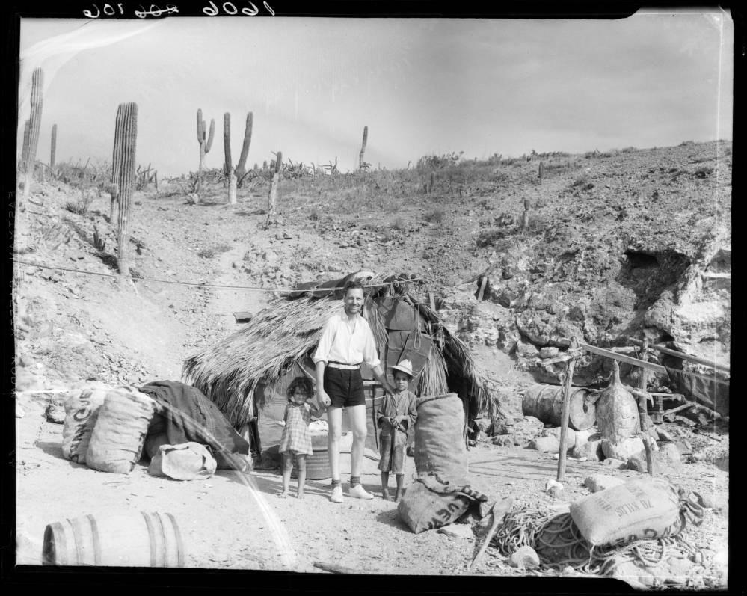
Supplementary Plate 1 Photograph of filmmaker Emory Johnson, from Velero III Expedition, at Isla El Pardito, Mexico, 1936. To the right there is a hanging, dried hawksbill sea turtle Eretmochelys imbricata. Photo credit: Allan Hancock Foundation Collection, University of Southern California (CC BY 4.0).

Supplementary Fig. 1 Estimated growth rate of hawksbill sea turtles Eretmochelys imbricata in the three locations of the Gulf of California, Mexico, with the largest sample sizes: Cabo Pulmo (green diamonds), Isla San José–Isla El Pardito (yellow triangles) and Archipiélago de Espíritu Santo (blue squares).

