Amidst nets and typhoons: conservation implications of bat–farmer conflicts on Okinawa Island

Weerach Charerntantanakul, Shozo Shibata and Christian Ernest Vincenot*
*Corresponding author: christian@vincenot.biz

Supplementary Fig. 1 Number of tankan farmers, cultivation area (ha), and produce sold (t) in the study area from 2012 to 2017.

Supplementary Table 1 Number of visits detected by camera-trap photographs taken at 15-second intervals and detectability rate of different animals with photographs taken at 5-minute intervals. Only C. macrorhynchos and P. dasymallus (highlighted in bold) were seen causing new damages to intact tankan fruits in the photographs.
Animal species | 15-sec (visit) | Average duration per visit (min) | 5-min (visit) | 5-min detectability (%)
Corvus macrorhynchos | 62 | 3.21 | 25 | 40.3
Zosterops japonicus | 166 | 1.49 | 42 | 25.3
Pycnonotus sinensis | 11 | 1.88 | 3 | 27.3
Hypsipetes amaurotis | 4 | 1.82 | 1 | 25.0
Pteropus dasymallus | 1 | 10.00 | 1 | 100.0
Herpestes sp. | 0 |  | 0
Turdus pallidus | 28 | 2.92 | 9 | 32.1
Human | 39 | 2.09 | 9 | 23.1

Supplementary Table 2 Number of tankan farmers, cultivation area (ha), and produce sold (t) of each municipality in 2018 (production year 2017).
Municipality | Number of tankan farmers | Cultivation area (ha) | Produce sold (t)
Nago | 135 | 27 | 206
Motobu | 87 | 22 | 452
Nakijin¹ | 26 | 17 | nd²
Higashi | 5 | 2.94 | 11.8
Ogimi | nd² (10–20)³ | 4.45 | 22.5
Kunigami | 121 | 25.7 | 114
Total | 384–394 | 82 | 806
¹Data of 2017.
²nd = no data.
³According to Northern Okinawa Island Government data on citrus growers in the ‘non-shikwasa (flat lemon)’ category.

Supplementary Table 3 Species-specific damage amount to tankan oranges reported by each administration office (t).
City/  town/  village | Year | Large-billed crow  C. macro-  rynchos | Brown-eared bulbul  H. amaurotis | Light-vented bulbul  P. sinensis | Boar  S. scrofa | Ryukyu flying fox  P. dasymallus | Rat Rattus sp. / mongoose Herpestes sp. | Okinawa woodpecker D. noguchii | Total
Nago | 2013  2014  2015  2016  2017  2018  2019  2020 | 27.3  10.0  15.2  11.0  11.6  8.0  6.0  1.1 | 1.0  1.0  1.5  3.0  2.0  1.5  0.5 | 1.0 | 4.0  1.0  1.5  1.0  1.0  0.8  1.0  0.4 | 18.7  3.0  4.5  2.0  2.0  3.0  2.0  0.7 |  |  | 52.0  15.0  22.7  17.0  16.6  13.3  8.0  1.6
Motobu | 2013  2014  2015  2016  2017  2018  2019  2020 | 8.1  8.0  11.8  12.7  4.5  3.9  2.8 |  |  |  |  | 0.2  0.8 |  | 8.1  8.0  11.8  12.7  4.7  4.7  2.8
Kunigami | 2013  2014  2015  2016  2017  2018  2019  2020 | 5.0  4.0  3.0  2.0  2.0  2.0  5.1  4.6 | 6.7  2.1 |  | 6.7  1.0  1.0  1.0  4.0  3.0  1.0  1.0 | 13.3  4.0  2.0  1.0  1.0  0.5  2.6 |  | 1.7  0.5  1.0  1.0  1.0  0.5  0.5  0.5 | 33.3  9.5  7.0  5.0  8.0  6.0  9.3  8.2
Ogimi | 2013  2014  2015  2016  2017  2018  2019  2020 | 6.0  1.3  2.0  3.0  4.0  2.5  3.0  1.0 | 2.0 | 1.5 | 2.5  1.0  2.3  2.1  2.0  1.5  1.0  0.5 | 3.0  1.0  2.0  3.0  2.0  2.0  2.0  1.0 |  |  | 15.0  3.3  6.3  8.1  8.0  6.0  6.0  2.5
Higashi | 2013  2014  2015  2016  2017  2018  2019  2020 | 2.0  0.3  0.3 | 2.0  0.2  0.3 |  |  | 4.0  0.2  0.2 |  |  | 8.0  0.7  0.8  0.0  0.0  0.0  0.0  0.0
Nakijin | 2013  2014  2015  2016  2017  2018  2019  2020 | 5.0  3.0  2.0  2.0  1.3  8.7  0.3  0.3 |  | 1.0  2.0  1.3  1.0  0.5  0.3 |  | 15.0  0.0  2.0  2.0  1.3 |  |  | 20.0  3.0  5.0  6.0  3.9  9.7  0.8  0.6
Total | 2013  2014  2015  2016  2017  2018  2019  2020 | 53.4  26.6  34.3  30.7  23.4  25.1  17.2  0.7 | 11.7  1.2  1.8  3.0  2.0  1.5  0  2.5 | 2.5  0.0  1.0  2.0  1.3  1.0  0.5  0.3 | 13.2  3.0  4.8  4.1  7.0  5.3  3.0  1.9 | 54.0  8.2  10.7  8.0  6.3  5.5  6.6  1.7 | 0.0  0.0  0.0  0.0  0.2  0.8  0.0  0.0 | 1.7  0.5  1.0  1.0  1.0  0.5  0.5  0.5 | 136.4  39.5  53.6  48.8  41.2  39.7  26.8  12.9

Supplementary Table 4 Crop-damaging species mentioned by respondents (n = 43).

Common name | Scientific name | Number of participants mentioning | Percentage (%)
Crow | Corvus sp. | 39 | 90.7
Flying fox | Pteropus dasymallus | 25 | 58.1
Brown-eared bulbul | Hypsipetes amaurotis | 15 | 34.9
Light-vented bulbul | Pycnonotus sinensis | 12 | 27.9
White-eye | Zosterops japonicus | 10 | 23.3
Okinawa woodpecker | Dendrocopos noguchii | 5 | 11.6
Boar | Sus scrofa | 12 | 27.9
Mongoose | Herpestes sp. | 2 | 4.7

Supplementary Table 5 Number of responses about crop protection measures used by the interviewed farmers and measures provided by the local governments.

Crop protection measure | Used by farmers | Provided by local governments
Net (against birds and flying foxes) | 36 (83.7%) | 27 (62.8%)
Fence (against S. scrofa) | 3 (7.0%) | 6 (14.0%)
Noise deterrent (explosion, fireworks, etc.) | 3 (7.0%)
C. macrorhynchos culling | 4 (9.3%) | 14 (32.6%)
S. scrofa culling |  | 2 (4.7%)
Others | 1 (2.3%) | 2 (4.7%)
Nothing | 5 (11.6%) | 7 (16.3%)

Supplementary Table 6 Number of visits by each animal species. Only C. macrorhynchos and P. dasymallus (highlighted in bold) were seen causing new damages to intact tankan fruits in the photographs.

Animal species | On or under the target tree (within a 5-m radius) | Eating fruits¹ | Causing damage²
Corvus macrorhynchos | 286 | 113 | 38
Zosterops japonicus | 281 | 61 | 0
Pycnonotus sinensis | 120 | 20 | 0
Hypsipetes amaurotis | 18 | 3 | 0
Turdus pallidus | 73 | 0 | 0
Pterpus dasymallus | 5 | 3 | 2
Herpestes sp. | 9 | 0 | 0
Human | 175 | 0 | 0
¹When animals were seen eating fruits, including damaged fruits and fallen fruits.
²When animals were seen causing new damages to intact fruits.

Supplementary Table 7 Data extracted from the records of Nago weather station; maximum wind speed and number of typhoons with a maximum wind speed that exceeded 20 m/s.
Year | Maximum wind speed (m/s) | Number of typhoons with maximum wind speed ≥ 20 m/s
2012 | 29.4 | 3
2013 | 17.9 | 0
2014 | 24.3 | 2
2015 | 22.9 | 1
2016 | 17.0 | 0
2017 | 9.3 | 0
2018 | 22.3 | 1
2019 | 20.3 | 1

Supplementary Table 8 Regression results of scaled damage amount caused by P. dasymallus, C. macrorhynchos, and total damage caused by all species. The damage amount was scaled by extreme values observed for each species and at each location, respectively.

maxwindN*ntyphN + location |  |  | None | 0.82 | 0.74 | 0.998 | 33.87 |  |  |  | None | 0.3 | 0.43 | 0.97 | 64.07 |  |  |  | maxwindN*ntyphN. | 0.62 | 0.67 | 0.999 | 44.85 | . = p < 0.1, * = p < 0.05, ** = p < 0.01
maxwindN*ntyphN |  |  | None | 0.61 | 0.7 | 0.972 | 23.65 |  |  |  | None | 0.24 | 0.34 | 0.998 | 53.88 |  |  |  | maxwindN*ntyphN. | 0.5 | 0.58 | 0.913 | 35.41
ntyphN |  | 0.67 (**) | ** (p=0.004) | 0.41 | 0.55 | 0.699 | 24.3 |  |  | 0.46 (**) | * (p=0.03) | 0.17 | 0.24 | 0.95 | 53.29 |  |  | 0.61 (**)  (4.9e-06) | ** | 0.32 | 0.43 | 0.877 | 37.48
maxwindN |  | 0.56 (**) (2.3e-04) | ** (0.006) | 0.36 | 0.55 | 0.343 | 24.27 |  |  | 0.38 (**) | . (p=0.07) | 0.12 | 0.19 | 0.777 | 55.29 |  |  | 0.50 (**) | * | 0.25 | 0.39 | 0.262 | 39.11
location |  |  | None | 0.11 | -0.01 | NaN | 47.54 |  |  |  |  | 0.05 | 0.08 | 1 | 69.02 |  |  |  | None | 0.09 | 0.1 | NaN | 59.54
 |  | ρ (p-value) | Sign. | R² (McFadden) | R² (Nagelkerke) | Hoslem Test | AICc |  |  | ρ (p-value) | Sign. | R² (McFadden) | R² (Nagelkerke) | Hoslem Test | AICc |  |  | ρ (p-value) | Sign. | R² (McFadden) | R² (Nagelkerke) | Hoslem Test | AICc
 | P. dasymallus | Corr. | GLM |  |  |  |  |  | C. macrorhynchos | Corr. | GLM |  |  |  |  |  | Total Damage | Corr. | GLM

Supplementary Equation 1
${x'}_{abc}=\frac{x_{abc} - min⁡(x_{ab})}{\max\left(x_{ab}\right) - min⁡(x_{ab})}$

where:
${x'}_{abc}$ = scaled damage of species a at location b in year c
$x_{abc}$ = damage amount caused by species a at location b in year c
$min⁡(x_{ab})$ = minimum damage amount caused by species a at location b within our observation
$max⁡(x_{ab})$ = maximum damage amount caused by species a at location b within our observation

Supplementary Equation 2
$$extrapolated mortality=m × \frac{total tankan orchard area (ha)}{surveyed orchard area (ha)}$$
where:
m = total flying fox mortality reported by respondents

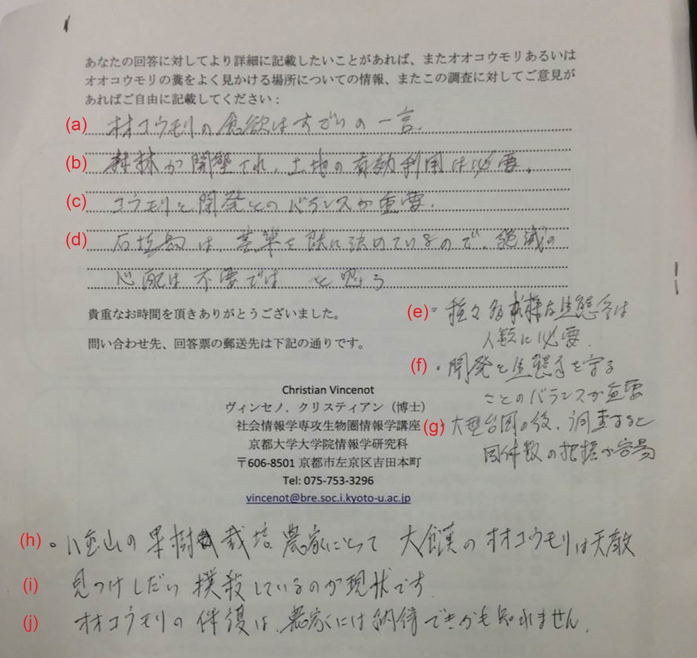
Supplementary Plate 1 An example of questionnaire response collected from farmers on Ishigaki Island by Vincenot et al. (2015).
Translation:
(a) The appetite of flying foxes is in one word incredible.
(b) Clearing forests for effective utilization of land is necessary.
(c) Balance between bat (conservation) and development is important.
(d) Ishigaki Island has already set a standard, so there is no need to worry about extinction...I think.
(e) Species-rich ecosystem is necessary for humanity.
(f) Balance between development and ecosystem protection is important.
(g) If you survey after a large typhoon, it is easy to grasp the population size.
(h) For fruit farmers in Yaeyama, gluttonous flying foxes are natural enemies.
(i) (Farmers) beating them to death whenever they find them is the current situation.
(j) Farmers may not agree with flying fox conservation.

