Validating trends in olive ridley sea turtle nesting track counts in Guatemala in light of a national hatchery protection strategy
B. Alejandra Morales-Mérida, Colum Muccio and Marc Girondot

Supplementary Table 1 Number of monitored nights for olive ridley sea turtles Lepidochelys olivacea on the Pacific coast of Guatemala. A nesting season is defined as the period from 1 June to 31 May in the following year. Non-available data are shown as blank cells and horizontal lines indicate missing data for the complete nesting season.

 | Candelaria | Churirin | Conacaste | El Chico | El Gariton | El Paredon | El Rosario | El Triunfo | El Hawaii | La Barrona | Monterrico
1997–1998 |  |  |  |  |  |  |  |  | 65
1999–2000 |  |  |  |  |  |  |  |  | 34
2000–2001 |  |  |  |  |  |  |  |  | 86
2001–2002 |  |  |  |  |  |  |  |  | 71
2003–2004 |  |  |  |  |  |  |  |  | 138
2004–2005 |  |  |  |  |  |  |  |  | 166
2005–2006 |  |  |  |  | 107 |  | 70 |  | 21 | 114
2006–2007 |  |  |  |  | 120 |  | 127 |  | 170
2007–2008 |  |  |  |  |  |  |  |  | 176
2008–2009 |  |  |  |  |  |  |  |  | 163
2009–2010 |  |  |  |  |  |  |  |  | 141
2010–2011 |  |  |  |  |  |  | 80 |  | 173
2011–2012 |  |  |  |  |  |  | 78 |  | 153
2012–2013 |  |  |  |  |  |  |  |  | 150
2013–2014 | 112 | 12 | 140 | 22 |  | 50 |  | 40 | 115 | 161 | 55
2014–2015 | 105 | 16 | 180 | 40 |  | 111 | 182 |  | 184 | 160 | 173
2015–2016 | 133 | 31 | 159 | 25 |  | 69 |  |  | 181 | 178 | 153
2016–2017 |  | 25 | 150 | 17 |  |  |  |  | 166 | 168 | 119
2017–2018 |  |  | 153 | 17 |  | 126 |  |  | 154 | 122 | 130
2018–2019 |  | 43 | 118 |  |  | 97 |  |  | 108 | 116 | 95

Supplementary Table 2 Number of olive ridley sea turtle eggs incubated in each hatchery located on the Pacific coast of Guatemala during 2001–2018. Non-available data are shown as blank cells. Source: National council of Protected Areas of Guatemala official database.

Hatchery | 2001 | 2002 | 2003 | 2004 | 2005 | 2006 | 2012 | 2013 | 2014 | 2015 | 2016 | 2017 | 2018
La Barrona | 3,100 | 3,700 |  | 1,609 | 7,016 | 11,027 | 13,247 | 12,342 | 16,956 | 15,171 | 8,455 | 15,387 | 15,434
El Hawaii | 12,578 | 13,385 | 13,385 | 22,693 | 22,969 | 28,220 | 30,603 | 48,406 | 51,897 | 41,194 | 37,166 | 50,186 | 34,077
El Rosario | 1,651 | 3,909 | 3,933 | 3,900 | 5,370 | 10,411 | 3,969 | 6,463 | 13,618 | 14,175 | 10,998 | 8,803 | 2,442
El Conacaste | 954 | 2,983 | 1,332 | 994 |  | 768 |  | 2,515 | 2,560 | 3,996 |  | 5,762 | 1,698
Monterrico | 3,538 | 4,260 | 3,682 | 3,798 | 4,262 | 13,917 | 42,471 | 41,031 | 47,181 | 61,965 | 45,462 | 72,259 | 73,552
Barra del Jiote | 4,840 | 1,638 | 1,452 |  |  |  | 3,500 | 1,830 | 12,201 | 3,189 | 4,619 | 6,984 | 18,133
El Garitón | 3,136 | 5,000 | 2,189 | 2,865 | 5,079 | 6,195 | 3,225 | 9,079 | 10,184 | 11,402 | 5,549 | 18,832 | 3,784
El Banco | 658 |  | 840 | 935 | 13,382 | 9,041 | 41,233 | 42,097 | 52,359 | 79,165 | 128,820 | 197,093 | 220,990
Candelaria | 512 | 1,360 | 860 | 800 | 1,454 | 1,940 |  | 1,739 |  |  |  |  | 3,880
Las Lisas | 9,357 | 9,033 | 8,106 | 8,472 | 9,914 | 8,835 | 10,435 | 10,418 | 16,039 | 17,000 | 21,251 | 31,567 | 27,281
El Chapetón | 5,352 | 4,219 | 4,224 | 5,617 | 6,298 | 7,086 | 14,104 | 14,364 | 20,213 | 14,994 | 12,154 | 30,086 | 16,639
La Mañanitas |  |  |  |  |  |  |  | 4,289 | 7,970 | 8,729 | 336 | 1,798 | 1,572
Tilapa |  |  |  |  |  |  |  | 938 | 1,563 | 1,981 |  | 1,948 | 3,154
El Chico |  |  |  |  |  |  |  | 198 | 880 | 1,171 |  | 300 | 380
Sipacate |  |  |  |  |  |  |  | 10,111 | 7,654 | 13,284 |  | 15,650 | 10,308
El Naranjo |  |  |  |  |  |  |  | 21,209 | 38,720 | 1,049 |  | 6,848 | 10,644
El Paredon |  |  |  |  |  |  |  | 12,058 | 10,088 |  |  | 10,293 | 19,382
Tres Cruces |  |  |  |  |  |  |  |  |  | 1,712 |  | 527 | 378
Madre Vieja |  |  |  |  |  |  |  |  |  |  |  | 10,510 | 12,467
Ocos |  |  |  |  |  |  |  | 742 |  | 696 |  |  | 771
AAK |  |  |  |  |  |  |  |  |  |  |  |  | 2,449
La Barona |  |  |  |  |  |  |  | 3,065 | 352 | 829 |  |  | 1,672
Tulate |  |  |  |  |  |  |  | 2,998 | 3,136 | 1,280 |  |  | 1,032
Churirin |  |  |  |  |  |  |  |  |  |  |  |  | 1,032
El Parlamar |  |  |  |  |  |  |  | 4,328
Tahuexco |  |  |  |  |  |  |  |  |  |  |  |  | 584
Bahía Tortuga |  |  |  |  |  |  |  | 16,444
El Manchon |  |  |  |  |  |  |  |  |  | 820
La Barrona |  |  |  |  |  |  |  | 12,342 | 20,249 | 15,351
Champerico |  |  |  |  |  |  |  |  |  | 1,944

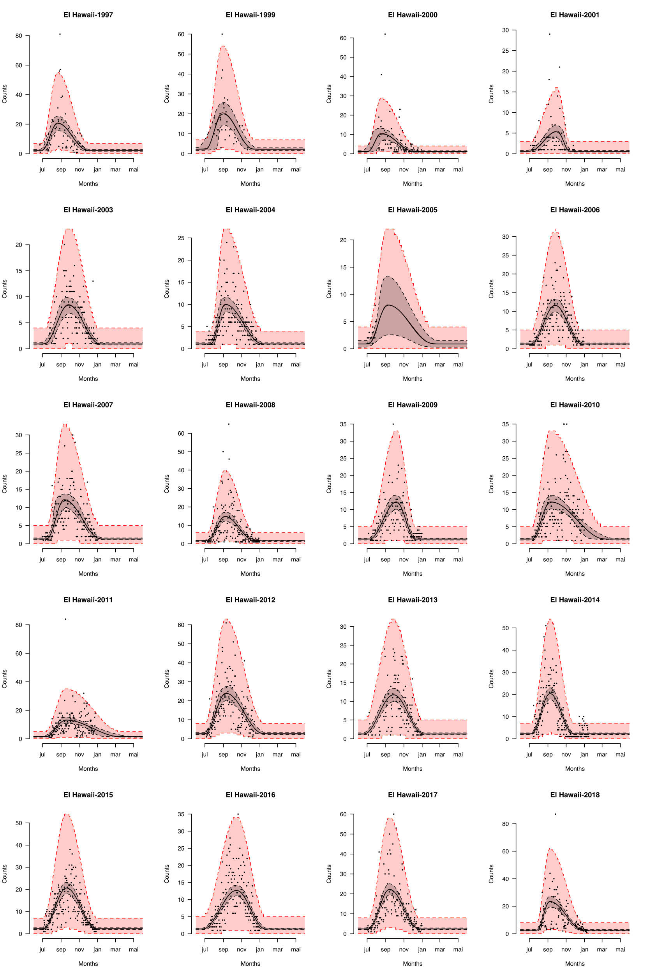Supplementary Fig. 1 Seasonality of olive ridley sea turtle Lepidochelys olivacea nesting activity measured on El Hawaii beach in Guatemala in during 1997-2018. The selected model for assessing the seasonality of nesting activity is that of the year effect on the P, LengthB and LengthE parameters (Table 1). Dots are the nightly counted nests, central plain line is the fitted Bayesian model and central dashed lines represent the 95% credible interval of the seasonality of nesting. Exterior dashed lines represent the 95% credible interval of the nightly nest counts based on negative binomial distribution.

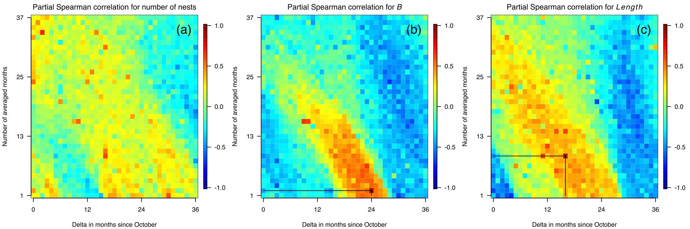 Supplementary Fig. 2 Relationships between cumulative El Niño–Southern Oscillation event effects and (a) number of olive ridley sea turtle nests, (b) beginning of the olive ridley sea turtle nesting season and (c) length of the olive ridley sea turtle nesting season on Hawaii beach in Guatemala. The x- and y-axes represent the lag in months and the number of months of the El Niño–Southern Oscillation event effect, respectively.

