Supplementary materials
Supplementary Fig. 1 Sample image of the Kenyan top bar hive on a stand.

Supplementary Fig. 2 Variation of the air humidity, external and inner temperature of the hives per periods. There were 5 periods: morning (5h-12h); noon (12h-14h); afternoon (14h-18h), evening (18h-21h) and night (21h-24h).

b
a
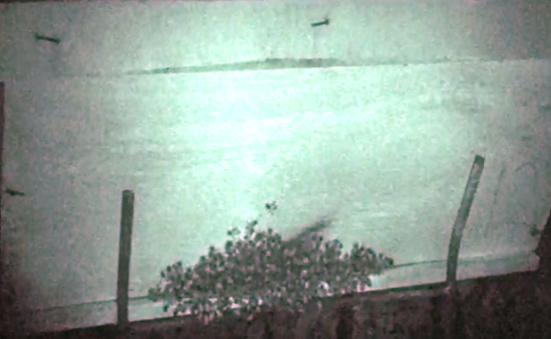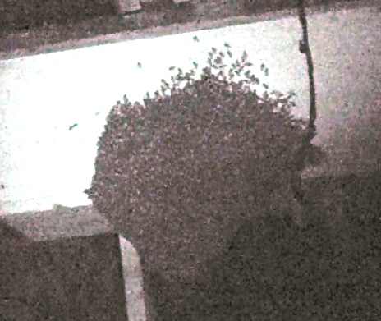
Supplementary Fig. 3 Illustration of the difference in colony size between hive H₁₂ (a) and hive H₁₄ (b) at night.

