SUPPLEMENTAL FILE

Range eclipse leads to tenuous survival of a rare lizard species on a barrier atoll

Jonathan Q. Richmond ¹ (ORCID 0001-9398-4894), Elijah Wostl (ORCID 0003-0746-007X), Robert N. Reed, and Robert N. Fisher (ORCID 0002-2956-3240)

¹Correspondng author: Email, jrichmond@usgs.gov: Phone, +1 (619)225-6434

DNA amplification

Polymerase chain reaction (PCR) primers used in this study are listed below. PCR thermocycling conditions adhered to the following steps: 94°C denaturation - 2 min; 94°C – 30 sec, 58-62°C – 30 sec, 72°C – 45 sec (30 cycles); 72°C extension – 8 min. We used ExoSAP-IT™ PCR Product Cleanup Reagent for enzymatic cleanup of amplified PCR product prior to sequencing.

ND2
L4437b 5'- AAG CAG TTG GGC CCA TRC C-3' (Macey et al., 1997)
ND2r102 5'- CAG CCT AGG TGG GCG ATT G-3' (Sadlier et al., 2004)
tRNA-Met 5'- AAG CTY TYG GGC CCA TAC CCC GA-3' (Richmond et al. 2020)
tRNA-Ala 5'- CVT TAA TKA AAG TGT KTG AGT TGC ATT CAG-3' (Richmond et al. 2020)

RAG-1
G425 5'-AAA GCA AGG ATA GCG ACA AGA G-3') (Sadlier et al., 2004)
G396 (R13) 5'-TCT GAA TGG AAA TTC AAG CTG TT-3') (Groth and Barrowclough, 1999)
G397 (R18) 5’-GAT GCT GCC TCG GTC GGC CAC CTT T-3’ (Groth and Barrowclough, 1999)

Cmos
G303 5'- ATT ATG CCA TCM CCT MTT CC-3') (Smith et al., 2007)
G74 5'- TGA GCA TCC AAA GTC TCC AAT C-3') (Saint et al., 1998)
G708 5’- GCT ACA TCA GCT CTC CAR CA-3’ (Hugall et al., 2008)

REFERENCES
- Groth, J.G., & Barrowclough, G.F. (1999) Basal Divergences in Birds and the Phylogenetic Utility of the Nuclear RAG-1 Gene. Molecular Phylogenetics and Evolution, 12, 115–123.
- Hugall, A.F., Foster, R., Hutchinson, M., & Lee, M.S.Y. (2008) Phylogeny of Australasian agamid lizards based on nuclear and mitochondrial genes: implications for morphological evolution and biogeography. Biological Journal of the Linnean Society, 93, 343–358.
- Macey, J.R., Larson, A., Ananjeva, N.B., & Papenfuss, T.J. (1997) Evolutionary Shifts in Three Major Structural Features of the Mitochondrial Genome Among Iguanian Lizards. Journal of Molecular Evolution, 44, 660–674.
- Richmond, J.Q., Ota, H., Grismer, L.L, & Fisher, R.N. (2020) Influence of niche breadth and position on the historical biogeography of seafaring scincid lizards. In press, Biological Journal of the Linnean Society.
- Sadlier, R.A., Smith, S.A., Aaron, M.B., & Whitaker, A.H. (2004) A New Genus and Species of Live-Bearing Scincid Lizard (Reptilia: Scincidae) from New Caledonia. Journal of Herpetology, 38, 320–330.
- Saint, K.M., Austin, C.C., Donnellan, S.C., & Hutchinson, M.N. (1998) C-mos, a nuclear marker useful for squamate phylogenetic analysis. Molecular Phylogenetics and Evolution, 10, 259–263.
- Smith, S.A., Sadlier, R.A., Bauer, A.M., Austin, C.C., & Jackman, T. (2007) Molecular phylogeny of the scincid lizards of New Caledonia and adjacent areas: evidence for a single origin of the endemic skinks of Tasmantis. Molecular Biology and Evolution, 43, 1151–66.

Table S1. Substitution model selection based on AICc scores calculated in PartitionFinder. The same models were selected for non-phased nuclear gene datasets.
Subset | Best Model | #sites | Partition
1 | HKY+Г+X | 102 | tRNA
3 | GTR+I+Г+X | 347 | ND2 pos_1
4 | TRN+I+Г+X | 347 | ND2 pos_2
5 | GTR+I+Г+X | 347 | ND2 pos_3
2 | GTR+X | 642 | C-mos
6 | TRN+I+X | 675 | R35
7 | HKY+Г+X | 102 | RAG1

Table S2. Haplotype identities and by name and island location (N = no. individuals).

Name | Species | N | Island(s)
Hap_01 | E. atrocostata_13, 17–18 | 3 | Dåno′ & Inarajan, Guam
Hap_02 | E. atrocostata_66–67 | 2 | Agrigan, Guam
Hap_03 | E. atrocostata_68–70 | 3 | Saipan
Hap_04 | E. slevini_01 | 1 | Sarigan
Hap_05 | E. slevini_02, 07–08 | 3 | Sarigan & Alamagan
Hap_06 | E. slevini_03–06 | 4 | Dåno′
Hap_07 | E. cyanura_05 | 1 | Dåno′
Hap_08 | E. caeruleocauda_09 | 1 | Guam
Hap_09 | E. caeruleocauda_19 | 1 | Dåno′

Fig. S1 Time-calibrated maximum clade credibility tree. Bulleted nodes indicate posterior branch support of ≥0.90; numbers on the branches are the median age estimates and blue bars indicate the 95%HPD.
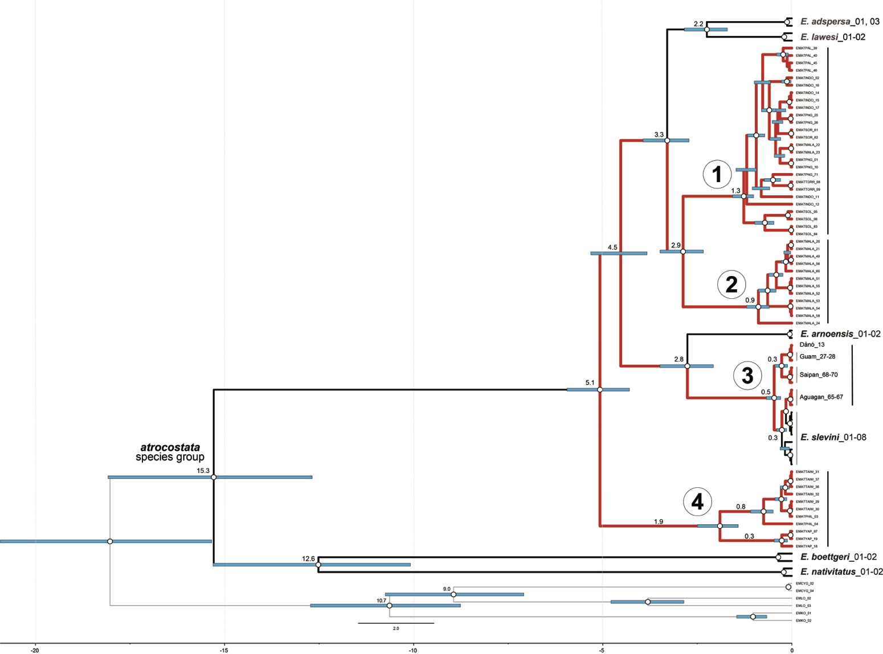

Appendix I. Specimen locality data. Institutions are as follows: USNM (United States National Museum, now National Museum of Natural History, Smithsonian Institution), USGS (U.S. Geological Survey, San Diego Field Station), TNHC (Texas Natural History Collections), KUBI (University of Kansas Biodiversity Institute), QM (Queensland Museum), MVZ (Museum of Vertebrate Zoology), WAM (Western Australia Museum), CAS (California Academy of Sciences), LSU (La Sierra University). Field tag identifiers: JQR (Jonathan Richmond); RNR (Robert Reed); RNF (Robert Fisher); JAM (Jimmy McGuire); DB (Don Buden); LLG (L. Lee Grismer).

Institution | Specimen ID | Species | Species labels | Country | Locality | Lat | Long
USNM | 322723 | E. adspersa | EMAD_01 | Samoa | Upolu Island, Apia, Vaiala Beach | -13.829097 | -171.750434
USGS | RNF7700 | E. adspersa | EMAD_03 | Samoa | Upolu Island, Apia | -13.835528 | -171.744961
USGS | JQR1073 | E. lawesi | EMLAW_01 | United States (territory) | American Samoa, Aunu'u, Pala Lake | -14.283313 | -170.550895
USGS | JQR1074 | E. lawesi | EMLAW_02 | United States (territory) | American Samoa, Aunu'u, Pala Lake | -14.282819 | -170.550594
USGS | F20 | E. arnoensis | EMAR_01 | Micronesia, Federated States of | Marshall Islands, Arno Atoll | 7.047261 | 171.643376
USGS | F21 | E. arnoensis | EMAR_02 | Micronesia, Federated States of | Marshall Islands, Arno Atoll | 7.047261 | 171.643376
USGS | RNF246 | E. atrocostata | EMAT_01 | Papua New Guinea | Madang, Pig Island | -5.169923 | 145.841338
TNHC | 59695 | E. atrocostata | EMAT_02 | Indonesia | Maluku Province, Kai Ketjil Island, Kepalauan Kai | -5.754255 | 132.728414
KUBI | 304896 | E. atrocostata | EMAT_03 | Philippines | Cagayan Province, Municipality of Calayan, Barangay Magsidel | 19.287211 | 121.409173
KUBI | 323195 | E. atrocostata | EMAT_04 | Philippines | Cagayan Province, Municipality of Casiguran | 16.286666 | 122.185830
USNM | 533307 | E. atrocostata | EMAT_05 | Solomon Islands | Temotu Province, Reef Islands, Fenualoa Island | -10.28828 | 166.320492
USNM | 533311 | E. atrocostata | EMAT_06 | Solomon Islands | Temotu Province, Santa Cruz Island, Lata | -10.75904 | 165.764424
USNM | 576201 | E. atrocostata | EMAT_07 | Micronesia, Federated States of | Caroline Islands, Yap Island Group, Yap Island, Colonia | 9.511621 | 138.121546
QM | A005425 | E. atrocostata | EMAT_08 | Australia | Queensland, Torres Strait Islands, Ugar | -9.507608 | 143.545173
QM | A005426 | E. atrocostata | EMAT_09 | Australia | Queensland, Torres Strait Islands, Ugar | -9.509090 | 143.544050
TNHC | CCA612 | E. atrocostata | EMAT_10 | Papua New Guinea | Madang | -5.155689 | 145.800167
MVZ | JAM7673 | E. atrocostata | EMAT_11 | Indonesia | Sulawesi, Central Sulawesi Prov., Kecamatan Bungku Selatan | -2.987930 | 122.277890
MVZ | JAM8597 | E. atrocostata | EMAT_12 | Indonesia | Sulawesi, Central Sulawesi Prov., Uekuli River | -1.366800 | 121.163680
USGS | JQR737 | E. atrocostata | EMAT_13 | United States (territory) | Mariana Islands, Guam, Dånó | 13.234776 | 144.647179
WAM | WAM109565 | E. atrocostata | EMAT_14 | Indonesia | Maluku Province, Aru Islands, Tanahbesar, Pulau Meirang | -5.844542 | 134.310321
WAM | WAM109566 | E. atrocostata | EMAT_15 | Indonesia | Maluku Province, Aru Islands, Tanahbesar, Pulau Meirang | -5.843868 | 134.302824
WAM | WAM109779 | E. atrocostata | EMAT_16 | Indonesia | Maluku Province, Pulau Kai Besar | -5.681604 | 133.006555
WAM | WAM109780 | E. atrocostata | EMAT_17 | Indonesia | Maluku Province, Pulau Kai Besar, Elat | -5.715631 | 132.962484
USGS | DB_3763 | E. atrocostata | EMAT_18 | Micronesia, Federated States of | Carloline Islands, Yap Island Group, Yap Island, Colonia | 9.516301 | 138.121335
USGS | DB_3765 | E. atrocostata | EMAT_19 | Micronesia, Federated States of | Carloline Islands, Yap Island Group, Yap Island, Colonia | 9.516308 | 138.121339
USGS | RNF9012 | E. atrocostata | EMAT_25 | Papua New Guinea | Manus Province, Admiralty Islands, Manus Island | -2.022466 | 147.270424
USGS | RNF9013 | E. atrocostata | EMAT_26 | Papua New Guinea | Manus Province, Admiralty Islands, Manus Island | -2.022466 | 147.270424
USGS | JQR1064 | E. atrocostata | EMAT_27 | United States (territory) | Mariana Islands, Guam, Inarajan | 13.271287 | 144.747553
USGS | JQR1065 | E. atrocostata | EMAT_28 | United States (territory) | Mariana Islands, Guam, Inarajan | 13.271337 | 144.747509
USGS | JQR1208 | E. atrocostata | EMAT_29 | Japan | Ryukyu Islands, Miyako Islands, Miyakojima Island-1 | 24.800482 | 125.321917
USGS | JQR1209 | E. atrocostata | EMAT_30 | Japan | Ryukyu Islands, Miyako Islands, Miyakojima Island-2 | 24.804118 | 125.326215
USGS | JQR1210 | E. atrocostata | EMAT_31 | Taiwan | Lutao Island | 22.663484 | 121.472519
USGS | JQR1211 | E. atrocostata | EMAT_32 | Taiwan | Lutao Island | 22.672974 | 121.498186
USGS | JQR1212 | E. atrocostata | EMAT_33 | Taiwan | Lanyu Island | 22.060727 | 121.569377
USGS | JQR1213 | E. atrocostata | EMAT_34 | Taiwan | Lanyu Island | 22.038389 | 121.568462
USGS | JQR1214 | E. atrocostata | EMAT_35 | Taiwan | Lanyu Island | 22.028224 | 121.583449
USGS | JQR1215 | E. atrocostata | EMAT_36 | Taiwan | Lanyu Island | 22.018333 | 121.596994
USGS | JQR1216 | E. atrocostata | EMAT_37 | Taiwan | Lanyu Island | 22.004809 | 121.578357
CAS | CAS236321 | E. atrocostata | EMAT_38 | Republic of Palau | Ngeruchubtang Island | 7.085315 | 134.332608
CAS | CAS236437 | E. atrocostata | EMAT_39 | Republic of Palau | Ngermalk Island | 7.336717 | 134.464900
CAS | CAS236444 | E. atrocostata | EMAT_40 | Republic of Palau | Ngeaur Island | 6.899211 | 134.127263
CAS | CAS238136 | E. atrocostata | EMAT_41 | Republic of Palau | Ngedbus Island | 7.054000 | 134.263900
CAS | CAS248693 | E. atrocostata | EMAT_42 | Republic of Palau | Ngercheu Island Group; Turtle Cove Island | 7.090933 | 134.265433
CAS | CAS248833 | E. atrocostata | EMAT_43 | Republic of Palau | Southwest Islands, Sonsorol Island | 5.332066 | 132.219550
CAS | CAS248939 | E. atrocostata | EMAT_44 | Republic of Palau | Malakal | 7.327202 | 134.452056
CAS | CAS248957 | E. atrocostata | EMAT_45 | Republic of Palau | Babeldaob, Airai State, Airai Village, | 7.349376 | 134.536870
CAS | CAS249310 | E. atrocostata | EMAT_46 | Republic of Palau | Koror: Koror town, Ngesaol Hamlet | 7.349516 | 134.506850
LSU | LLG4793 | E. atrocostata | EMAT_49 | West Malaysia | Pahang, Pulau Tulai | 2.913569 | 104.107166
LSU | LLG4794 | E. atrocostata | EMAT_50 | West Malaysia | Pahang, Pulau Tulai | 2.914501 | 104.105573
LSU | LLG5183 | E. atrocostata | EMAT_20 | West Malaysia | Johor, Pulau Seri Buat | 2.683770 | 103.912267
LSU | LLG5194 | E. atrocostata | EMAT_21 | West Malaysia | Johor, Pulau Seri Buat | 2.690312 | 103.916476
LSU | LLG5770 | E. atrocostata | EMAT_22 | West Malaysia | Johor, Pulau Sibu | 2.226346 | 104.062379
LSU | LLG5771 | E. atrocostata | EMAT_23 | West Malaysia | Johor, Pulau Sibu | 2.226346 | 104.062379
LSU | LLG5772 | E. atrocostata | EMAT_47 | West Malaysia | Johor, Pulau Sibu | 2.200975 | 104.085620
LSU | LLG5773 | E. atrocostata | EMAT_48 | West Malaysia | Johor, Pulau Sibu | 2.200360 | 104.085945
LSU | LLG5801 | E. atrocostata | EMAT_58 | West Malaysia | Johor, Pulau Sibu Kukus | 2.179838 | 104.110778
LSU | LLG5806 | E. atrocostata | EMAT_59 | West Malaysia | Johor, Pulau Sibu Tengah | 2.186566 | 104.102942
LSU | LLG5815 | E. atrocostata | EMAT_60 | West Malaysia | Johor, Pulau Sibu Papan | 2.196118 | 104.071284
LSU | LLG6179 | E. atrocostata | EMAT_24 | East Malaysia | Sabah (Borneo), Turtle Island | 6.185105 | 118.118535
LSU | LLG6271 | E. atrocostata | EMAT_57 | West Malaysia | Pahang, Pulau Tulai | 2.910718 | 104.100446
LSU | LLG6275 | E. atrocostata | EMAT_56 | West Malaysia | Pahang, Pulau Tulai | 2.910886 | 104.098254
LSU | LLG6333 | E. atrocostata | EMAT_55 | West Malaysia | Johor, Pulau Nangka Besar | -2.406597 | 105.795551
LSU | LLG6362 | E. atrocostata | EMAT_51 | West Malaysia | Johor, Pulau Simbang | 2.265431 | 104.150750
LSU | LLG6363 | E. atrocostata | EMAT_52 | West Malaysia | Johor, Pulau Simbang | 2.265054 | 104.151217
LSU | LLG6406 | E. atrocostata | EMAT_53 | West Malaysia | Johor, Pulau Sibu Tengah | 2.187238 | 104.101422
LSU | LLG6407 | E. atrocostata | EMAT_54 | West Malaysia | Johor, Pulau Sibu Tengah | 2.186944 | 104.102278
USGS | DB_4015 | E. atrocostata | EMAT_61 | Micronesia, Federated States of | Sorol Atoll | 8.134948 | 140.380779
USGS | DB_4016 | E. atrocostata | EMAT_62 | Micronesia, Federated States of | Sorol Atoll | 8.134948 | 140.380779
USGS | JQR1889 | E. atrocostata | EMAT_63 | Solomon Islands | Choiseul Province, Taro Island | -6.711430 | 156.39920
USGS | JQR1890 | E. atrocostata | EMAT_64 | Solomon Islands | Choiseul Province, Taro Island | -6.711430 | 156.39920
USGS | JQR2528 | E. atrocostata | EMAT_65 | United States (territory) | Mariana Islands, Agrigan (Guam) | 13.243350 | 144.708784
USGS | JQR2529 | E. atrocostata | EMAT_66 | United States (territory) | Mariana Islands, Agrigan (Guam) | 13.243557 | 144.708751
USGS | JQR2533 | E. atrocostata | EMAT_67 | United States (territory) | Mariana Islands, Agrigan (Guam) | 13.243282 | 144.708728
USGS | RNR295 | E. atrocostata | EMAT_68 | United States (Commonwealth) | Northern Mariana Islands, Saipan, Isleta Maigo Luao | 15.150791 | 145.790101
USGS | RNR296 | E. atrocostata | EMAT_69 | United States (Commonwealth) | Northern Mariana Islands, Saipan, Isleta Maigo Luao | 15.150791 | 145.790101
USGS | RNR297 | E. atrocostata | EMAT_70 | United States (Commonwealth) | Northern Mariana Islands, Saipan, Unai Laggua | 15.273712 | 145.828388
USNM | 576213 | E. boettgeri | EMBO_01 | Micronesia, Federated States of | Caroline Islands, Pohnpei | 6.957597 | 158.210438
USGS | F28 | E. boettgeri | EMBO_02 | Micronesia, Federated States of | Marshall Islands, Arno Atoll: Jabonwod Dist. | 7.062704 | 171.551110
USGS | FS01 | E. nativitatus | EMNA_01 | Australia | Christmas Island, Egeria Point | -10.508695 | 105.541263
USGS | FS03 | E. nativitatus | EMNA_02 | Australia | Christmas Island, Egeria Point | -10.511907 | 105.543765
USNM | 536082 | E. slevini | EMSL_01 | United States (Commonwealth) | Northern Mariana Islands, Sarigan Island | 16.711148 | 145.770796
USNM | 536083 | E. slevini | EMSL_02 | United States (Commonwealth) | Northern Mariana Islands, Sarigan Island | 16.713744 | 145.776885
USGS | Es_02 | E. slevini | EMSL_03 | United States (territory) | Mariana Islands, Dånó | 16.713744 | 145.776885
USGS | Es_03 | E. slevini | EMSL_04 | United States (territory) | Mariana Islands, Dånó | 16.713744 | 145.776885
USGS | Es_04 | E. slevini | EMSL_05 | United States (territory) | Mariana Islands, Dånó | 16.713744 | 145.776885
USGS | Es_05 | E. slevini | EMSL_06 | United States (territory) | Mariana Islands, Dånó | 16.713744 | 145.776885
USGS | JQR2538 | E. slevini | EMSL_07 | United States (Commonwealth) | Northern Mariana Islands, Alamagan | 16.713744 | 145.776885
USGS | JQR2551 | E. slevini | EMSL_08 | United States (Commonwealth) | Northern Mariana Islands, Alamagan | 16.713744 | 145.776885
CAS | CAS184020 | E. cyanura | EMCY_05 | United States (territory) | Mariana Islands, Dånó | 13.240163 | 144.657306
USGS | JQR736 | E. caeruleocauda | EMCA_09 | United States (territory) | Mariana Islands, Guam | 13.650323 | 144.856280
USGS | Ec_02 | E. caeruleocauda | EMCA_09 | United States (territory) | Mariana Islands, Dånó | 13.237310 | 144.650720

