Female wanted for the world’s rarest turtle: prioritizing areas where Rafetus swinhoei may persist in the wild

Thong Van Pham, Olivier Le Duc, Cédric Bordes, Benjamin Leprince, Charlotte Ducotterd, Tomas Zuklin, Vinh Luu Quang, Duc Ha Dinh and Luca Luiselli

Supplementary Material 1 Synthesis of the interview survey conducted in Son La and Lai Chau provinces, along the Da River (northern Viet Nam).

Number of persons independently interviewed: 80
Duration of interview survey: 12 days (13– 24 November 2019)
Distance travelled: c. 1,600 km
The interviews were conducted by Olivier Le Duc and Thong Pham Van.

Demographic characteristics of the respondents

Sex Age

Marital status Educational level

Socio-economic data

How long have you been fishing in your life?

Did you start your fishing in this area?

How did you become a fisherman?

What is the nature of your employment?

Will your children become fishers in this area as well?

How would you describe the condition of fishery stock in this area?

Has fishing depleted stocks of any exploited species?

If any stocks have been affected by fishing, name at least 3 important species you consider to be depleted.
Fish | Shrimp | Turtle
Mugil ssp. | Macrobrachium nipponensis | Pelodiscus sinensis
Cranoglanis sinensis | Caridina flavilineata
Cyprinus carpio
Hemiculter leucisculus
Squaliobarbus curriculus
Pleuronectiformes
Hemibagrus spp.
Wallago attu
Bagarius rutilus
Spinibarbus maensis
Cirrhinus spp.
Lateolabrax spp.
Bangana lemassoni
Macrognathus spp.

Fishing has depleted some stocks through which means?

Other answers given: electro-fishing; water not moving; modern fishing equipment; habitat loss;
pesticides; big boats catch too much; hydro dams; not depleted; unknown.

Are your fishing grounds in a good state?

How would you describe the fishing grounds in this area (compared to 10 years ago)?

Are there any places in this area that were once productive fishing grounds but are now depleted?

How many days in a week do you go for fishing/hunting turtles?

What types of fishing gear are used for targeting freshwater turtles in this area?

Other answers given: maze funnel trap (10); catch by hand (7); use head tortch at night (9); electro fishing (1); on sand bank (1); unknown (6); do not catch turtles (3).

How many individual turtles do you catch every month?

How would you describe the conditions of turtle stock in this area?

Other answers given: no more because there is no sand bank; not seen; unknown.

To whom do you sell the turtles?

Other answers given: eat (3%); keep as a pet (2%); sell to the market (1%); do not catch (5%); unknown (18%).

Habitat protection and conservation

Are you aware that the freshwater turtles are threatened with extinction, and have been categorized as such on the IUCN Red List?

Do you want to be involved in turtle’s protection in this area or community?

If yes, how do you think that it would be possible to protect/conserve the turtles?

Stop hunting; Stop electro-fishing; manage the catch; do not destroy the forest; no poison fishing; reguluation of diving to catch fish

What is your view in regards to creation of community protected/gazetted area in this location?
(1) Strongly disagree: 38.8%; (2) Disagree: 2.5%; (3) Neutral: 40%; (4) Agree: 7.5%;
(5) Strongly agree: 11.3%
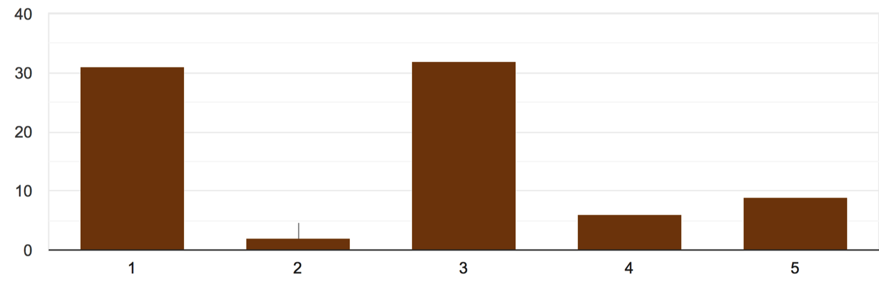

Name the main turtle breeding grounds/zones in this area.
On sand bank along the river, Mu stream, Nam Nhat stream, along the Da River.

Do you have turtles with big red spots on the head in this area?

Where did you last see them?

(2 comments): On land; in the forest.

Do you have very big turtles in this area?

Species | Name of the species in local language |  |  |  |  | Habitat types
 | Kinh ethnic group | Mường ethnic group | Thanh Hoa Province | La Hu ethnic group | Thai ethnic group
Rafetus swinhoei | Con Giải | Con Tốp / Con Tái | Con Chạnh | Pùi Pía | Tồ Tốp | Small rivers, not too deep and swamps
Palea steindachneri | Ba Ba Gai | Con Tốp / Con Tải | Ba Ba Gai | - | Pà Pha Nám | Streams from forests, rarely enter river
Pelodiscus sinensis | Ba Ba Trơn | Ba Ba Trơn | Ba Ba Trơn | Pùi Pía | Tồ Pha | Rivers
Pelochelys cantorii | Đấm Đấm / Rành Rạnh | Đấm Đấm / Rành Rạnh | - | - | Tồ Tốp | Deep river sections of large rivers or large stream
Local language names of the species of large turtles in the area?

If there are very big turtles in this area, when did you last see them?

Interviewee no. 3: There are two kinds of turtle here: Tồ Pha and Tồ Tốp. Tồ Pha is small (< 5 kg) while Tồ Tốp can reach over 100 kg (average is 30–50 kg). People used to hunt them with long fish hook lines put across Mu stream to trap the Tồ Tốp (without bait). The Tồ Tốp was mostly hunted in 1950s–1960s for food, with caught individuals usually weighing 50–60 kg. The interviewee heard that people still caught a large softshell turtle c. 15 years ago. Since 2007, after a hydro dam was built, the stream increased to the size of a river. The interviewee saw at least two big turtles in the river section in front of his house. A big one with the head of c. 10 cm in diameter was observed in July–August 2019, and in 2020 at least another 2–3 times. The interviewee estimated the weight of this turtle to be c. 50 kg. Tồ Tốp (Rafetus swinhoei) do not punch the head to defend themselves from people like Pelochelys does. The interviewee claimed that, when he was child, he saw a Rafetus swinhoei female coming to laying eggs on the sand bank along Mu stream. To Tốp lays several clutches, each with 80–90 eggs. He collected the eggs to eat.
Interviewee no. 4: The interviewee’s daughter said her father sometime saw the big head of a huge turtle emerging from the water. However, other people at the same place (6–7 people who work for him) did not believe him as nobody else had seen the turtle. They claimed that the water level had risen since 2009 when the hydro dam started working, which led to the Mu stream getting bigger. Before 2009, the Mu stream was much smaller than now.
Interviewee no. 5: The interviewee reported that older people (who were not alive anymore) caught a R. swinhoei (Tồ Tốp) weighing c. 30 kg in the 1970s–1980s. He also personally saw a turtle head c. 5 cm in diameter on the Mu stream in front of his house, in 2012. The area is also inhabited by a small softshell species, locally called Tồ Pha (P. sinensis), which weighs 1–2 kg.

Interviewee no. 6: This interviewee apparently knew R. swinhoei well, and described it as a species weighing > 30 kg. During 1962–1966 local people used long fish hook lines positioned across the Mu stream to catch this large turtle. Occasionally, hunters caught R. swinhoei individuals by searching for turtle tracks on sand at night, thus finding the turtle while sleeping and easily catching it. According to the interviewee, the Tồ Tốp is morphologically similar to P. sinensis (Tồ Pha) but a lot bigger in size and with no thorn on the carapace. R. swinhoei was the target of hunting for subsistence in the past. It used to live in the deeper sections of Mu stream, but no one caught or even saw it since the 1970s.
Interviewee no. 7: According to the interviewee, Tồ Pha (P. sinensis) weighs < 5kg. Tồ Tốp (R. swinhoei) is similar to Tồ Pha but much bigger (c. 30–40kg and with a carapace as big as > 1 m in diameter). Tồ Tồp has yellow spots on head, the plastron is yellow and the carapace is black. The interviewee was able to precisely describe the animal because he had seen it multiple times in the past. He reported the species was caught by local people in 1975–1976. One of the hunters is still alive whereas the others have died several years ago. They caught R. swinhoei by long hook lines. The interviewee claimed that there is still at least one Tố Tốp in the surroundings of his house. This turtle sometimes appears on Bó Cùng Cave. It weighs c. 50–60 kg, and because the interviewee had clearly seen its head and the carapace on multiple occasions, was sure about species identification. He saw it for the last time in September–October 2018, but he usually encountered this animal at least 4–5 times per year. The carapace is black and is c. 1 m in diameter. On some occasions, this individual remained visible for > 30 minutes, facilitating its identification. We also interviewed a former R. swinhoei hunter, 87 years old. He confirmed that he had caught three R. swinhoei individuals, two weighing c. 50 kg and one 60 kg. All turtles had been killed for consumption in the village, and none of them had eggs inside them. He did not remember in which exact years he caught these turtles, and he had not kept any remains of these huge turtles (such as skulls or shells).
Interviewee no. 8: An active fisher who has been working along the river reported that c. 40–50 years ago, he saw local people who had just caught a Tồ Tốp (R. swinhoei) weighing c. 80 kg. He reported the identity of the hunter, who apparently caught the Tố Tốp by chance when he saw it in a shallow area of Mu stream. After this event, the interviewee did not see any other Tồ Tốp individuals caught by local people, and he never encountered any live individuals in the Mu stream, although he goes fishing on the river daily.
Interviewee no. 9: The interviewee answered that he had heard about the Tồ Tồp from other fishermen, but had never seen any in his life.
Interviewee no. 10: The interviewee accurately described the Tồ Tốp as weighing 30–40 kg, but occasionally up to 100 kg. The interviewee had heard from the elders that there were Tồ Tồp turtles in the Da River until a few decades ago. The interviewee reported to once, c. 30 years agao, have eaten the meat of a Tồ Tốp individual (c. 40 kg) that had been killed by a soldier. The interviewee described it as very similar to the Tồ Pha (P. sinensis) but much bigger (Tồ Pha always weighs < 5 kg). The Tồ Tốp was killed in Pắc Ma commune, Quỳnh Nhai district, Sơn La province. The interviewee reported that it was the only R. swinhoei she had seen in her life.
Interviewee no. 11: The interviewee accurately described the Tồ Tốp, stating it weighs > 100 kg. Approximately 30–40 years ago, he saw people in Nậm Hân commune, Sìn Hồ district, Lai Chau province, trying to carry a dead Tồ Tốp from the river to the village, with the intention to eat it. The Tồ Tốp looks like P. sinensis but bigger (P. sinensis weighs < 5 kg). On another occasion c. 30 years ago, he saw a large turtle climbing up a sandy bank to bask. He claimed that he had observed this turtle species only in a small area in Thẩm Hể (near the boat park of Nậm Hân commune, Sìn Hồ district).

Interviewee no. 13: The interviewee accurately described the Tồ Tốp and was sure that this species lives in the Da river. According to him, Tồ Tốp can weigh up to 30 kg, whereas Tồ Pha (P. sinensis) always weighs < 5kg. Before the dam was built, people used to hunt the giant turtle with long hook lines (with hundreds of hooks on a line). The river was small and it was possible to put the fish hook line all across the river bed. He also accurately distinguished Palea steindachneri (locally called Ba ba gai or Tồ Pha Nám, meaning thorny softshell turtle), which he considered locally rarer than Tồ Tốp (R. swinhoei), whereas Tồ Pha (P. sinensis) was much more abundant. He normally caught Tồ Tốp individuals weighing 5–10 kg as his fish hook line was only able to capture that size of turtle. According to him, P. steindachneri individuals normally live in rocky streams. Now that the water level has risen because of the hydro dam, he thinks that the turtles have gone somewhere else. He also remembered well a R. swinhoei individual caught by his father and his grandfather. This turtle was c. 1 m in diameter and weighed c. 20–30kg. The interviewee’s father had also caught other large individuals weighing > 30 kg. Some hunters found eggs of these large turtles in his area by following the tracks left by the mother.
Interviewee no. 14: The interviewee had heard from his elders that the Tồ Táu, Tồ Tốp is a large turtle weighing 70–120 kg. The elders used to catch it by fish hook lines. His father caught and ate one big R. swinhoei in 1945–1950. It looked like P. sinensis, but was much bigger.

Do all turtles try to bite you?

What are the types of habitats that turtles need for breeding in the area?

What is the main breeding season of turtles in this area?

How long does it take for the turtles eggs to hatch?

To what extend do you agree or disagree with the statement that the local communities prefer to eat the turtle eggs once they have been found?

(1) Strongly disagree: 66.3%; (2) Disagree: 0%; (3) Neutral: 0%; (4) Agree: 0%;
(5) Strongly agree: 33.7%

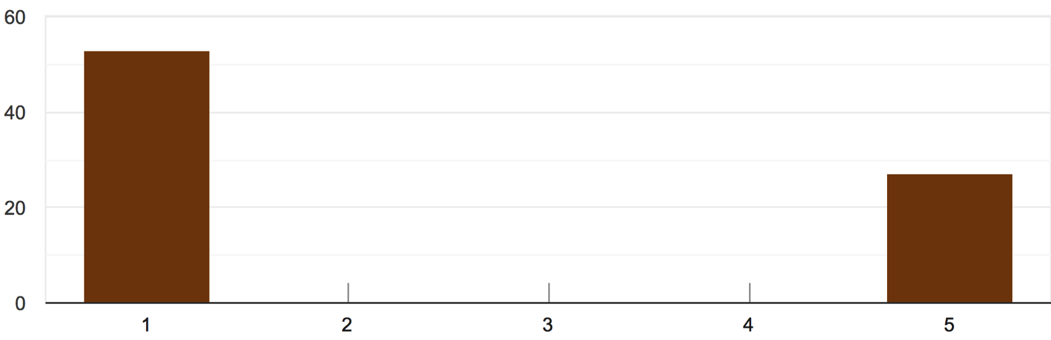

To what extend do you agree or disagree with the statement that the local communities prefer to protect/conserve the turtle eggs once they have been found?

(1) Strongly disagree: 100%; (2) Disagree: 0%; (3) Neutral: 0%; (4) Agree: 0%;
(5) Strongly agree: 0%

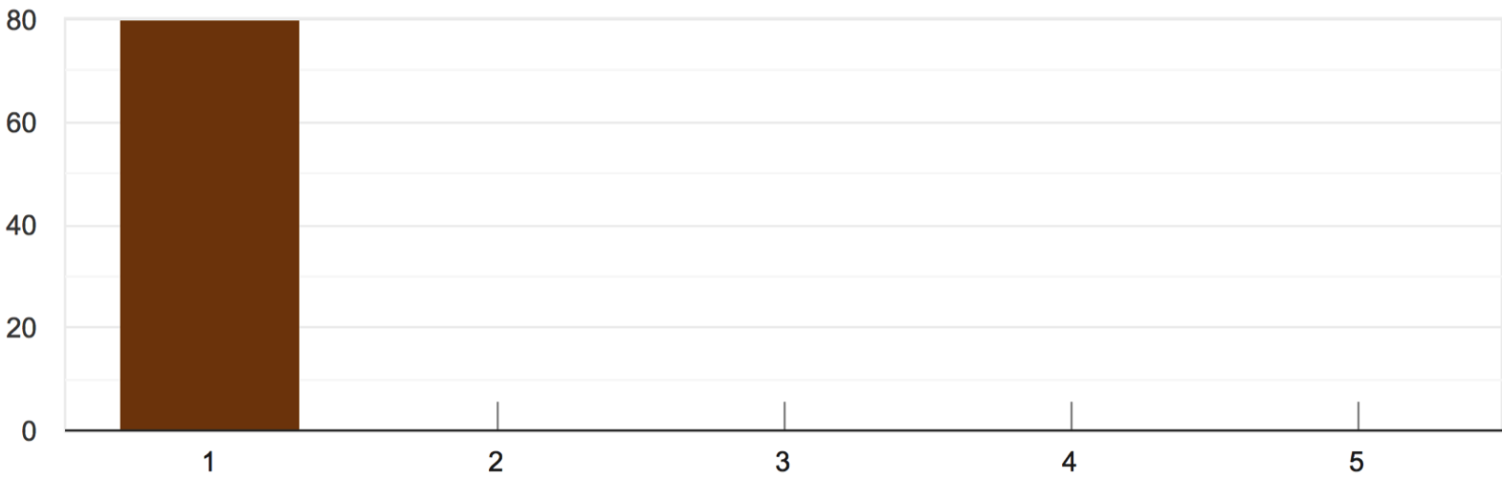

To what extend do you agree or disagree with the statement that the local communities prefer to sell the turtles eggs once they have been found?

(1) Strongly disagree: 100%; (2) Disagree: 0%; (3) Neutral: 0%; (4) Agree: 0%;
(5) Strongly agree: 0%

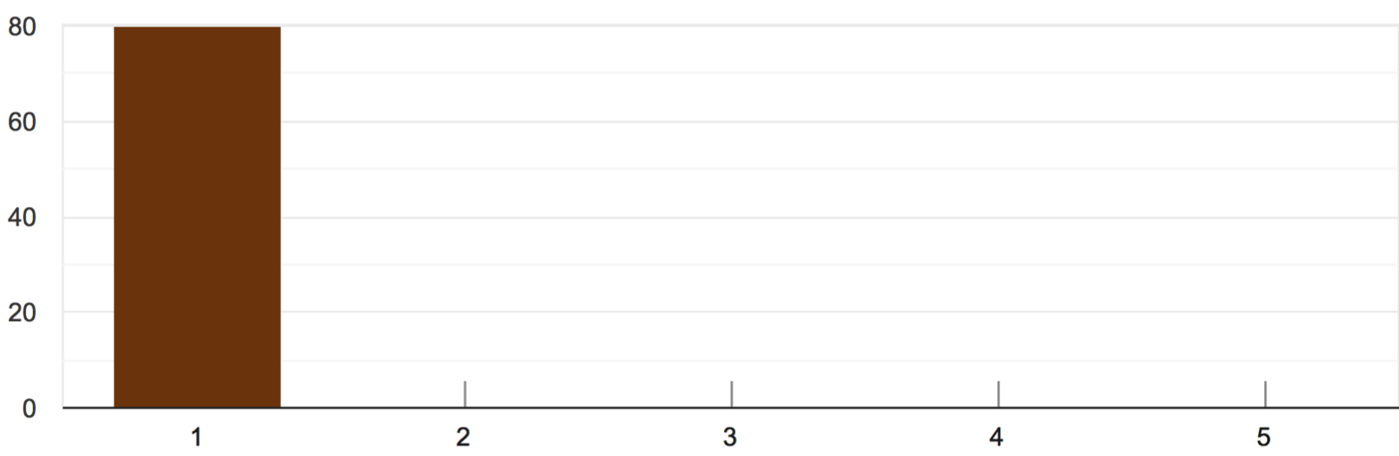

To what extend do you agree and disagree with the statement that the local communities believe that eating turtle’s meat will allow them to live longer?

(1) Strongly disagree: 100%; (2) Disagree: 0%; (3) Neutral: 0%; (4) Agree: 0%;
(5) Strongly agree: 0%

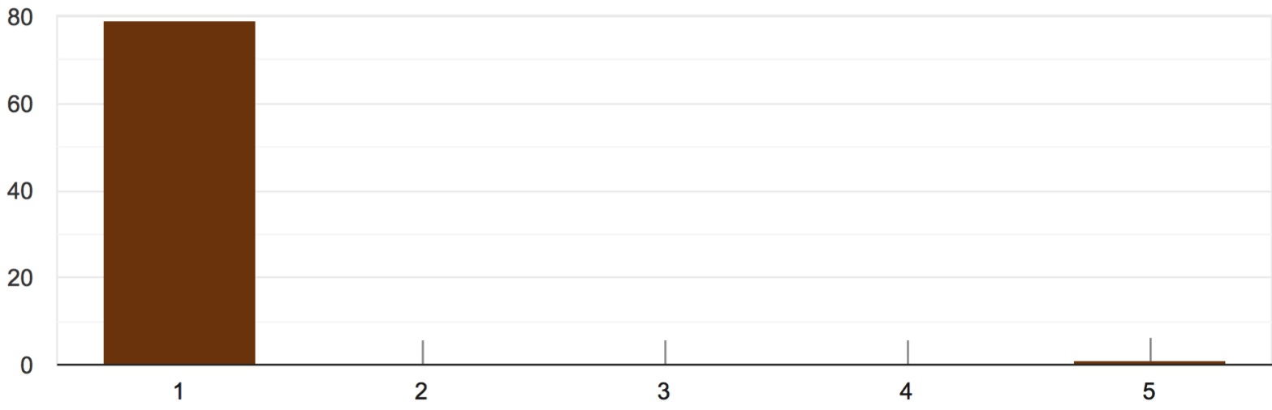

To what extend do you agree and disagree with the statement that the local communities are using the shell of turtles for tradition and culture values?

(1) Strongly disagree: 75.9%; (2) Disagree: 0%; (3) Neutral: 0%; (4) Agree: 0%;
(5) Strongly agree: 24.1%

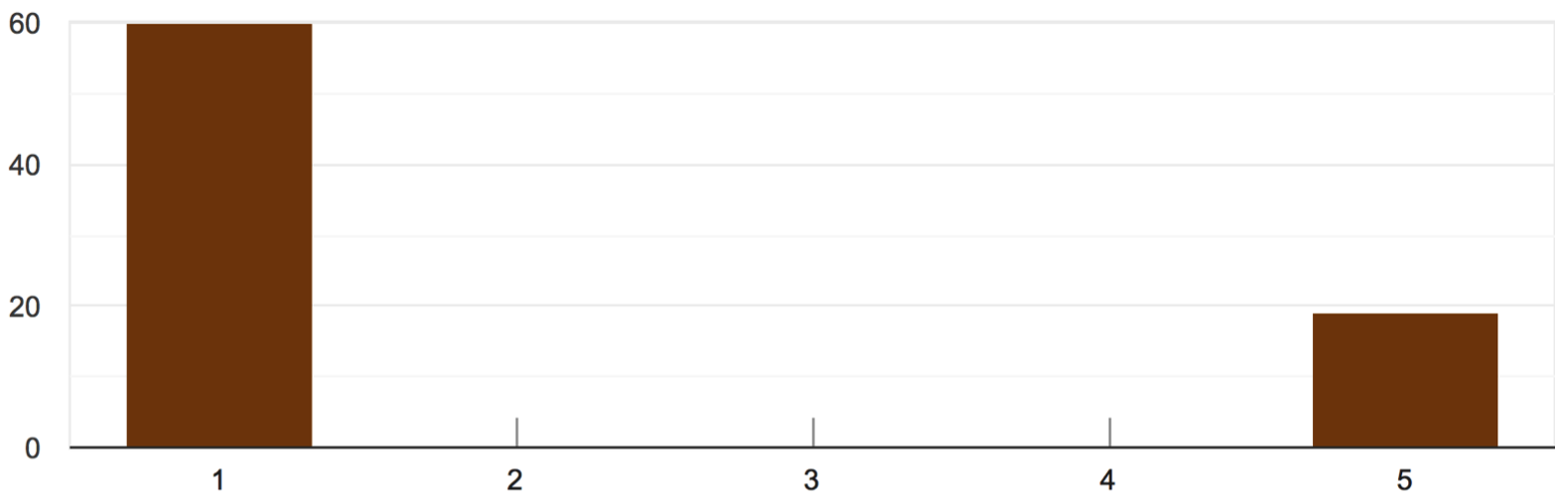

To what extend do you agree or disagree with the statement that the local communities believe that eating turtle’s meat can heal some diseases?

(1) Strongly disagree: 83.8%; (2) Disagree: 0%; (3) Neutral: 0%; (4) Agree: 0%;
(5) Strongly agree: 16.3%

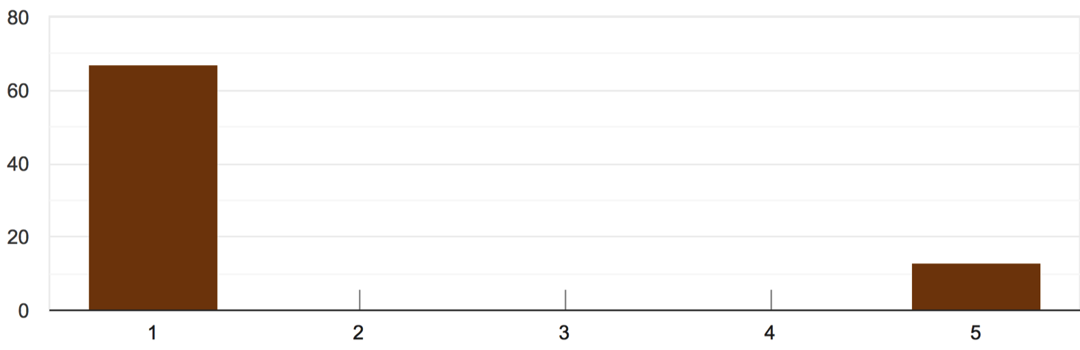

To what extend do you agree or disagree with the statement that the local communities hunt turtles because there is demand in the market?

(1) Strongly disagree: 13.8%; (2) Disagree: 0%; (3) Neutral: 1.3%; (4) Agree: 0%;
(5) Strongly agree: 85%

