Marginal farmers carry the burden of damage caused by Asian elephants Elephas maximus in Bardiya National Park, Nepal

Herbert H.T. Prins, Yorick Liefting and Joost F. De Jong

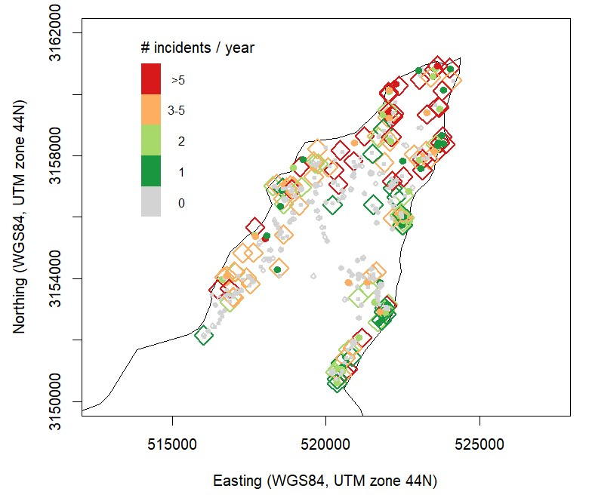
Supplementary Fig. 1 Spatial overview of the occurrence and frequency of elephant damage reported by farmers. The black line represents the edge of the anthropogenic matrix (see Methods). The colourization shows the number of incidences that the farmer estimated to have experienced in the last year, split for fields (diamonds) and houses (circles). Grey diamonds and circles are fields and houses that belong to farmers who indicated that no elephant damage had occurred in the previous 12 months. The raw data visualized in this graph underlies the analyses shown by Figs 3 & 4.

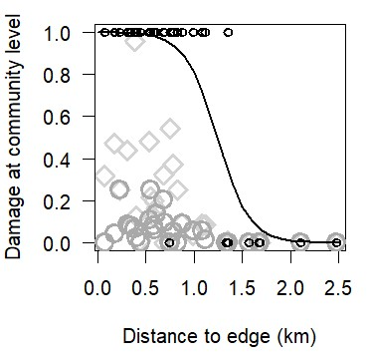
Supplementary Fig. 2 The relationship between elephant-caused damage and distance from the edge (in meters) of the cultivated lands and the wilderness at the cluster (‘settlement’) level. Black circles show whether damage did or did not occur within the community (Boolean values: 1 = damage; 0 = no damage). Light grey diamonds and dark grey circles are the estimate fractions of households that experienced damage on the field and to houses, respectively, in the last 12 months. The black line is the logistic model prediction of Boolean values and represents the predicted chance of occurrence of elephant damage in a settlement. At distances > 1.5 km from the anthropogenic matrix edge, there is little risk of damage to the standing crop on the fields or to houses.

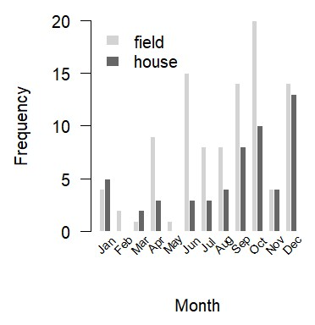
Supplementary Fig. 3 Temporal distribution of elephant-caused damage. This bar chart portrays the answer to the interview question: ‘When does damage occur most frequently?’ Only farmers who indicated that they had experienced damage in recent years were asked this question. Sometimes farmers mentioned 2 consecutive months in their response; in these cases we included only the first month in the bar chart. Farmers frequently indicated October and November as the months with most frequent damage, which explains the high value for October and the low value for November. Overall, damage is particularly high in late autumn.

Supplementary Table 1 Estimation of overall annual damage caused by elephants at household level in the Village Development Committees Patabhar and Gola, in the buffer zone west of Bardiya National Park, Nepal. In addition to financial cost in EUR, equivalents are given in NPR, corresponding weight of rice, and size of landholding in katha (1 katha = 380m²). To aid interpretation, values are coloured according to their value (green = low, orange = moderate, red = high). The median size of landholding per farmer is 15 katha. An average traditional house is estimated to cost EUR 261 (NPR 30,000); if it has a tiled roof it may cost EUR 435 (NPR 50,000).

Type of damage | Distance to matrix edge (m) | No. sampled households |  | Fraction of sampled households with damage |  |  | Damage cost (median) |  | Shared cost per household
 |  |  |  | Typical | Severe |  | Typical | Severe | Typical | Severe | Sum
Field | < 500 | 107 |  | 0.64 | 0.07 |  | 22 | 130 | 6.4 | 3.8
 | 500–1,000 | 79 |  | 0.39 | 0.05 |  | 2,530 NPR | 14,950 NPR | 2.9 | 2.2
 | 1,000–1,500 | 35 |  | 0.17 | 0.03 |  | 101 kg | 598 kg | 0.6 | 0.5
 | > 1,500 | 18 |  | 0.11 | 0.00 |  | 0.8 katha | 4.5 katha | 0.2 | 0.0
 | whole area | 239
House | < 500 | 102 |  | 0.31 | 0.04 |  | 43 | 196 | 5.7 | 3.3
 | 500–1,000 | 85 |  | 0.06 | 0.01 |  | 4,945 NPR | 22,540 NPR | 0.9 | 0.8
 | 1,000–1,500 | 35 |  | 0.11 | 0.00 |  |  |  | 0.7 | 0.0
 | > 1,500 | 18 |  | 0.00 | 0.06 |  |  |  | 0.0 | 0.8
 | whole area | 240
Storage container | < 500 | 102 |  | 0.19 | 0.04 |  | 22 | 126 | 1.8 | 2.1
 | 500–1,000 | 84 |  | 0.05 | 0.00 |  | 2,530 NPR | 14,490 NPR | 0.4 | 0.0
 | 1,000–1,500 | 34 |  | 0.06 | 0.00 |  | 101 kg | 580 kg | 0.2 | 0.0
 | > 1,500 | 18 |  | 0.00 | 0.00 |  |  |  | 0.0 | 0.0
 | whole area | 238
Total | < 500 | 104 |  |  |  |  |  |  | 13.8 | 9.2 | 23.0 | 2,515 NPR
 | 500–1,000 | 83 |  |  |  |  |  |  | 4.1 | 3.0 | 7.1 | 784 NPR
 | 1,000–1,500 | 35 |  |  |  |  |  |  | 1.5 | 0.5 | 2.0 | 230 NPR
 | >1,500 | 18 |  |  |  |  |  |  | 0.2 | 0.8 | 1.0 | 82 NPR

Supplementary Table 2 Estimate of the total damage caused by elephants in the study area. The estimation is based on multiplying the costs per farmer (Supplementary Table 1) by the number of houses. Information on the number of houses was provided by the local administration offices. The damage costs are accounted for distance to the edge of the anthropogenic matrix.

Distance from edge | Shared cost per farmer |  |  | Area (km²) |  |  | Estimated no. of houses | Total damage
 | Typical | Severe | Sum | Within this distance class |  | Cumulative |  | EUR | NPR
< 500m | 13.8 | 9.2 | 23.0 | 12 | 12 |  | 1,350 | 31,000 | 3,565,000
500–1,000m | 4.1 | 3.0 | 7.1 | 9.5 | 21.5 |  | 1,069 | 8,000 | 920,000
1,000–1,500m | 1.5 | 0.5 | 2.0 | 6.5 | 28 |  | 731 | 1,000 | 115,000
> 1,500m | 0.2 | 0.8 | 1.0 | 12 | 40 |  | 1,350 | 1,000 | 115,000
Whole area |  |  |  |  |  |  | 4,500 | 41,000 | 4,715,000

