SUPPLEMENTARY INFORMATION

SI1. Table SI1 Parameter estimates in models predicting attitude to lions, demography model (a), and full model (b). [was table 2]
SI2. Figure SI2. Effect size plots for ordinal response models predicting attitudes to lions. generated using R ‘effects’ package (Fox, 2009). [was figure S1].
SI3. Table SI3. Parameter estimates in models predicting attitude to leopards [was SI1].
SI4. Figure SI4. Effect sizes in ordinal models predicting attitudes to leopards [was SI3].
SI5. Figure SI5. Logistic model predicting probability of a respondent opting for the ‘allow to move unrestrained’ in response to the question about desired management of lions (a) and leopards outside protected areas and near human habitation. Raw data shown ‘jittered’ at 0 and 1. (x axis: Attitude with values 1 = ‘dislike’, 2= ‘indifferent’, 3 = ‘like’). [was figure 3]
SI6. Interview questionnaire [was SI4]
Table SI1. Parameter estimates in mixed ordinal models predicting respondent attitude to lions (1=’dislike’, 2=’indifferent, 3 = ‘like’, hence positive Parameter Estimates (PE) indicate more positive attitude). Model SI2a included demographic variables alone. Full model (SI2b) included socio-demographic factors, conflict experience, GFD management, social awareness, knowledge, and religion with self-reported attitude towards lions based on questionnaire survey of 990 people in Dhari Taluka, India between July 2016 and January 2017. Significant relationships are indicated in bold

Variables | Predictor levels | PE | SE | z value | P
SI1a. Only socio-graphic factors
Socio-Demographic parameters
Age (years) | Ordinal, 3 age classes  1 : <30; 2 : 31-50; 3: >50 | -0.47 | 0.13 | -3.51 | 0.000
Gender (ref =female) | Categoric,  Levels Male, Female | 0.82 | 0.43 | 1.92 | 0.055
Land-holding (bigha) | Ordinal,  0: no land  1: 0.4 - 4.4  2:4.5 - 8.4  3: 8.5 -16.4  4: >16.4 | -0.04 | 0.11 | -0.35 | 0.730
Livestock-holding (numbers) | Ordinal  0: No livestock  1: 1-9  2:10-30  3: 31-100  4:>100 | -0.26 | 0.15 | -1.78 | 0.075
Community
 | 1: Maldhari-Ahir,Bharwad (ref level)
 | 4: Brahmin | 1.50 | 0.72 | 2.08 | 0.038
 | 5: Dalit | 0.33 | 0.48 | 0.70 | 0.486
 | 6: Darbar | 1.46 | 0.43 | 3.37 | 0.001
 | 7 Kadhia, Kumbhar | 0.27 | 0.49 | 0.55 | 0.580
 | 8: Koli | 0.84 | 0.53 | 1.56 | 0.118
 | 10: Patel | 0.55 | 0.34 | 1.62 | 0.106
 | 12: Muslim | 1.00 | 0.51 | 1.97 | 0.049
 | 13: Devipujar | -0.82 | 0.63 | -1.30 | 0.193
 | 14: Others | 1.67 | 0.59 | 2.85 | 0.004
SI1b. All factors
Socio-Demographic parameters
Gender Male |  | 0.20 | 0.53 | 0.37 | 0.71
Age |  | -0.41 | 0.21 | -1.96 | 0.05
Land-holding |  | -0.09 | 0.14 | -0.67 | 0.50
Livestock-holding |  | -0.36 | 0.17 | -2.13 | 0.03
Conflict Experience
Livestock depredation | Categoric  0:N; 1:Y | -1.52 | 0.74 | -2.05 | 0.04
Direct human-lion encounter | Categoric  0:N, 1:Y | -0.20 | 0.25 | -0.78 | 0.43
GFD Management
Agreement on people’s participation in GFD’s conservation goals | Ordinal  1:SA; 2: A; 3: N; 4:D; 5: SD | -0.72 | 0.12 | -5.78 | 0.00
Social Awareness
Awareness about wild animal rescue and relocation by GFD | Categoric  Witnessed (ref level)
 | heard about it | -0.27 | 0.32 | -0.86 | 0.38
 | not aware | -0.61 | 0.53 | -1.15 | 0.25
Perception of community discussion re lions | Ordinal,  0: Never; 1: Rarely; 2: Sometimes; 3: Often | 0.27 | 0.11 | 2.43 | 0.01
Knowledge
Knowledge of lion Census estimate 2015 | Categoric  (0 : N, 1 : Y) | 8.39 | 3.20 | 2.62 | 0.00
Global status of Asiatic lion | Categoric  (0 : N, 1 : Y) | -0.32 | 0.22 | -1.40 | 0.16
Perception of lion population trends | Ordinal  1:increased, 2:same, 3:increased | -0.38 | 0.37 | 2.43 | 0.32
Agreement concerning human-carnivore conflict increase in previous 10 years | Ordinal  SA:1; A:2; NO:3; D:4; SD:5 | 0.28 | 0.15 | -1.01 | 0.00
Religion
Religious association related to lions | (ref= negative)
Positive association related to religion |  | -0.95 | 0.53 | -1.80 | 0.07
None |  | -0.79 | 0.53 | -1.50 | 0.13
‘Other’ Associations |  | -2.14 | 0.93 | -2.29 | 0.02
Commonly believed but respondent does not subscribe |  | -0.85 | 0.67 | -1.27 | 0.20
Age* experience of stock loss | Interaction effect | 0.43 | 0.30 | 1.42 | 0.16
Age*knowledge of lion population | Interaction effect (Fig. SI2f) | -2.67 | 1.14 | -2.36 | 0.02

Figure SI2. Effect sizes in ordinal response models predicting attitudes to lions.
- Age effect (demography model)
.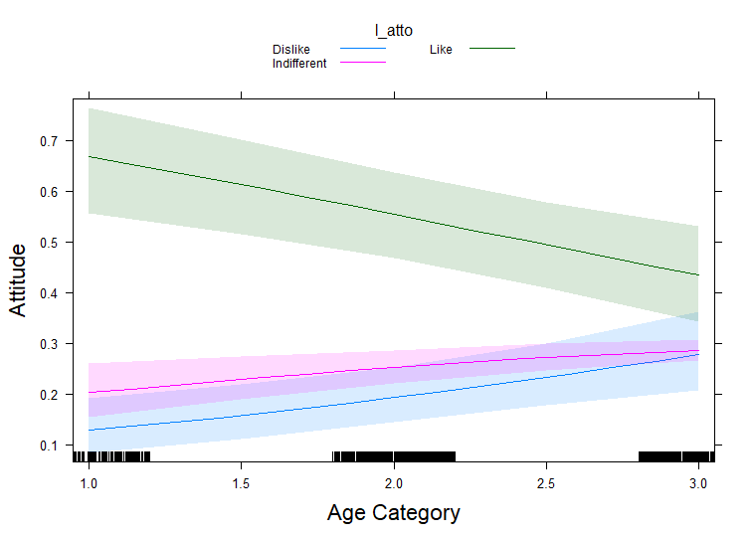

- Livestock size effect (demography model)

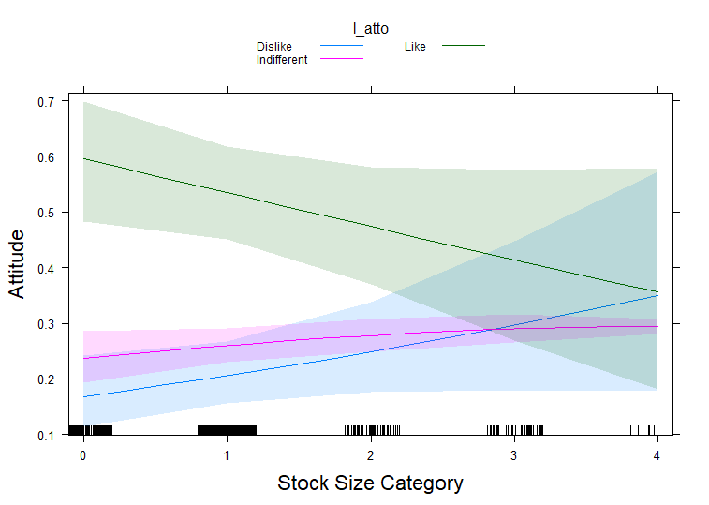

- Livestock lost to lions? (0 = N, 1= Y, all effects model)
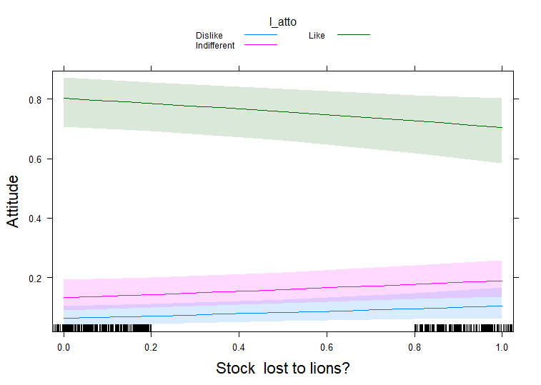
- Community/caste (demography model). Codes for x axis as in SI1.
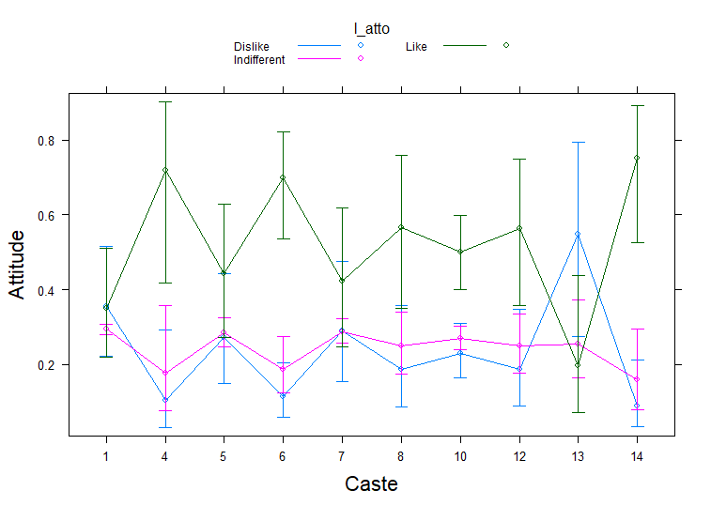

- Reported perception that conflict has increased in last ten years (all effects model, Likert scale predictor from Strongly Agree = 1 to Strongly Disagree = 5 on x axis)
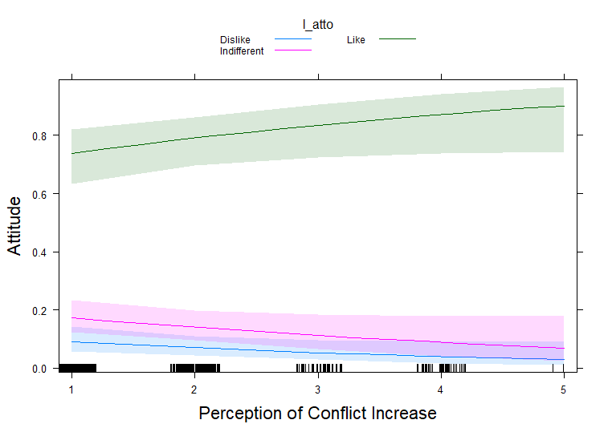
- Interaction between age category and reported knowledge of lion census estimate (0 = no knowledge, 1 = aware)
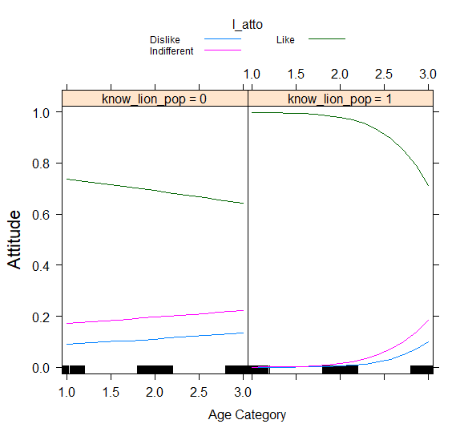

- Opinion on cooperation between people and forest department (all effects model, Likert scale predictor from Strongly Agree = 1 to Strongly Disagree = 5 on x axis)

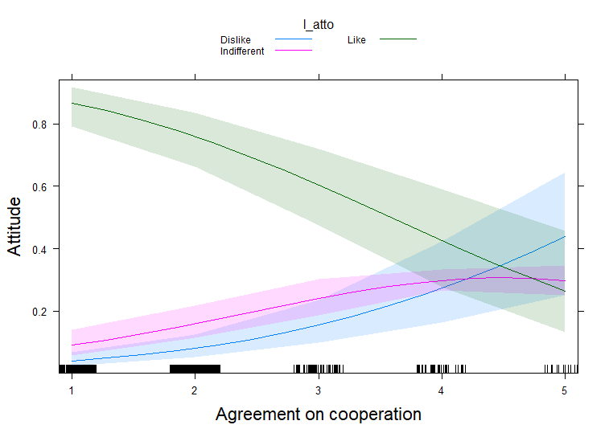
- Reported respondent awareness of discussion about lions and other forest related topics (x axis 0=never, 1= rarely, 2= sometimes, 3= often)
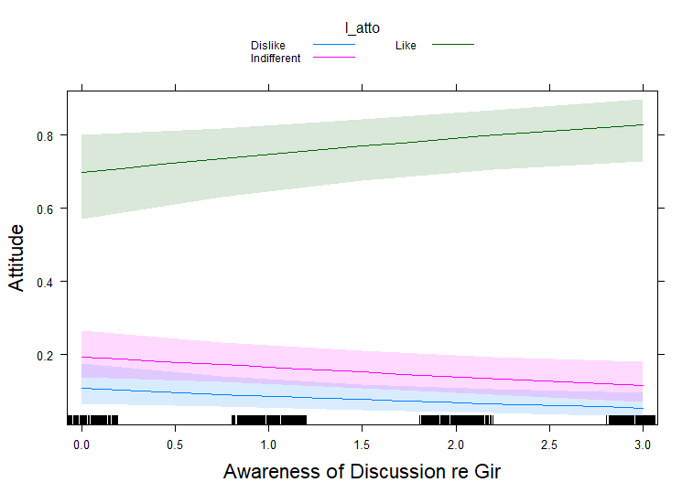

Table SI3
Output of mixed ordinal models predicting respondent attitude to leopards (1=’dislike’, 2=’indifferent, 3 = ‘like’, hence positive Parameter Estimates (PE) indicate more positive attitude). Variables included socio-demographic factors, conflict experience, GFD management, social awareness, knowledge with self-reported attitude towards leopards based on questionnaire survey of 990 people in Dhari Taluka, India between July 2016 and January 2017.
Coefficients:

Variables | Estimate | Std. Error | z value | Pr(>|z|)
Gender Male | 0.51575 | 0.55298 | 0.933 | 0.35098
Age (years) | -0.34545 | 0.12146 | -2.844 | 0.00445 **
Land-holding (bigha) | 0.15405 | 0.10605 | 1.453 | 0.14634
Livestock holding (numbers) | -0.33939 | 0.15431 | -2.199 | 0.02785 *
Livestock depredation | 0.20483 | 0.31713 | 0.646 | 0.51835
Direct human-leopard encounter | -0.09993 | 0.24706 | -0.404 | 0.68588
Heard about carnivore rescue and relocation by GFD | -0.08903 | 0.28642 | -0.311 | 0.75592
Not aware of carnivore rescue and relocation by GFD | -0.39802 | 0.51266 | -0.776 | 0.43753
Agreement on human-carnivore conflict has increased in last 10 years | 0.01688 | 0.09541 | 0.177 | 0.85956

Figure SI 4. Effect sizes in models predicting attitudes to leopards.
- Community/caste effect (demography model)
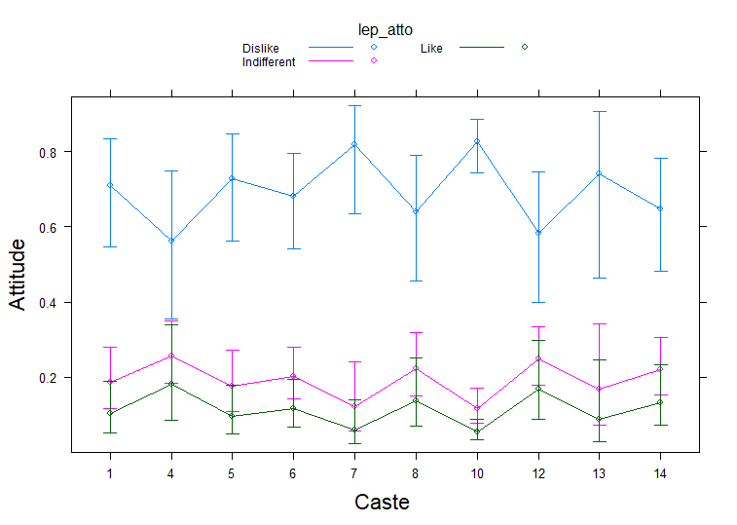
- Livestock size category (demography model)

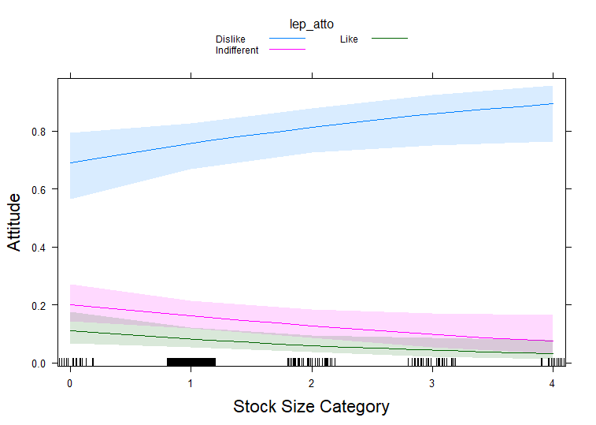
- Age category (demography model)

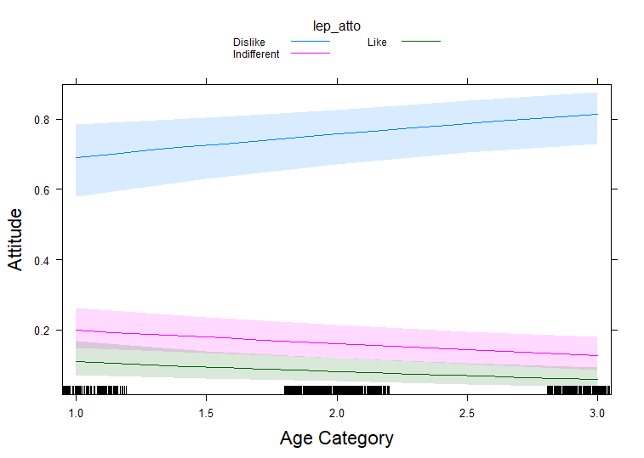

Figure SI5. Logistic model predicting probability of a respondent opting for the ‘allow to move unrestrained’ in response to the question about desired management of lions (a) and leopards (b) outside protected areas and near human habitation.

a)
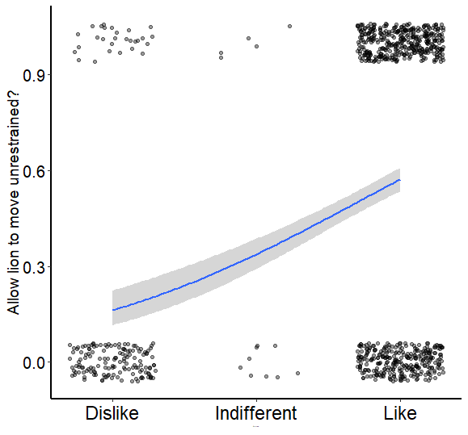
b)
