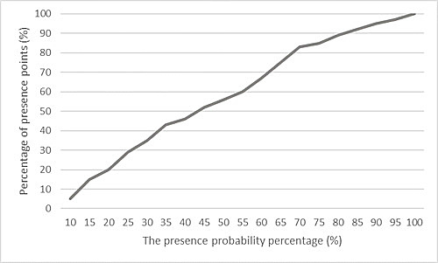
Fig. S1 Relationship between percentage of presence points and the presence probability percentage to define the suitability threshold.

