Supplementary Material

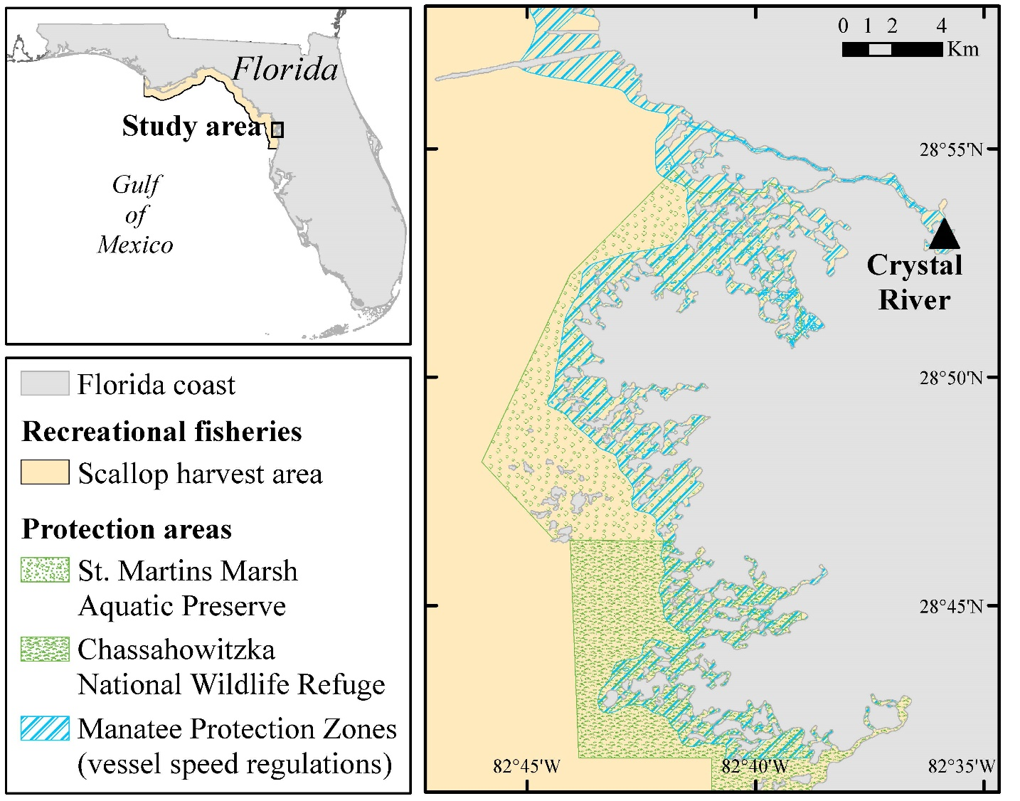

Supplementary Figure S1. Scallop harvest area and protection areas within the study region.

Supplementary Table S1. Details on sighting transects. One continuous transect was performed each day, with parallel sighting of vessels and turtles.

Date | Number of  vessels sighted | Number of  turtles sighted
Before Scallop Season
22-May-2016 | 106 | 4
30-May-2016 | 50 | 11
31-May-2016 | 8 | 18
8-Jun-2016 | 21 | 25
9-Jun-2016 | 21 | 36
15-Jun-2016 | 14 | 1
24-Jun-2016 | 34 | 9
Mean (SD) | 36.3 (33.7) | 14.0 (12.4)
During Scallop Season
25-Jun-2016 | 454 | 4
26-Jun-2016 | 489 | 1
27-Jul-2016 | 183 | 13
28-Jul-2016 | 78 | 4
2-Aug-2016 | 189 | 3
18-Aug-2016 | 141 | 24
26-Aug-2016 | 137 | 22
27-Aug-2016 | 463 | 19
11-Sep-2016 | 209 | 32
24-Sep-2016 | 258 | 5
Mean (SD) | 260.1 (151.8) | 12.7 (10.9)

Supplementary Table S2. Summary of tag deployment and performance.
Turtle ID |  |  |  | Flipper tag |  |  |  | Standard  SCL  (cm) |  |  |  |  |  | Satellite tracking
 |  |  |  |  |  |  |  |  |  | Releasing  site |  | Argos  ID | First uplink |  | Last uplink |  | Total  tracking days  (filtered) |  |  |  | Number of fixes (unfiltered) |  |  |  | Number of fixes  (filtered)
 |  |  |  |  |  |  |  |  |  |  |  |  |  |  |  |  | bef | dur |  |  | bef | dur |  |  | bef | dur
Green turtles
 | Cm_1 |  |  | NNQ848 |  |  |  | 60.2 |  | CNWR |  | 142708 | 01-Jun-2016 |  | 02-Aug-2016 |  | 62 |  |  |  | 1153 |  |  |  | 84
 |  |  |  |  |  |  |  |  |  |  |  |  |  |  |  |  | 24 | 38 |  |  | 511 | 642 |  |  | 41 | 43
 | Cm_2 |  |  | LLP018 |  |  |  | 33.4 |  | SMMAP |  | 159776 | 02-Jun-2016 |  | 03-Aug-2016 |  | 62 |  |  |  | 600 |  |  |  | 79
 |  |  |  |  |  |  |  |  |  |  |  |  |  |  |  |  | 23 | 39 |  |  | 247 | 353 |  |  | 33 | 46
Kemp’s ridley turtles
 | Lk_1 |  |  |  | LLP117 |  |  |  | 31.8 | SMMAP |  | 159779 | 01-Jun-2016 |  | 12-Jul-2016 |  | 41 |  |  |  | 859 |  |  |  | 217
 |  |  |  |  |  |  |  |  |  |  |  |  |  |  |  |  | 24 | 17 |  |  | 515 | 344 |  |  | 158 | 59
Loggerhead turtles
 | Cc_1 |  |  |  | NNQ840 |  |  |  | 71.3 | CNWR |  | 128354 | 04-Jun-2016 |  | 04-Sep-2016 |  | 92 |  |  |  | 1990 |  |  |  | 108
 |  |  |  |  |  |  |  |  |  |  |  |  |  |  |  |  | 21 | 71 |  |  | 314 | 1465 |  |  | 26 | 77
 | SMMAP = St. Martins Marsh Aquatic Preserve
 | CNWR = Chassahowitzka National Wildlife Refuge

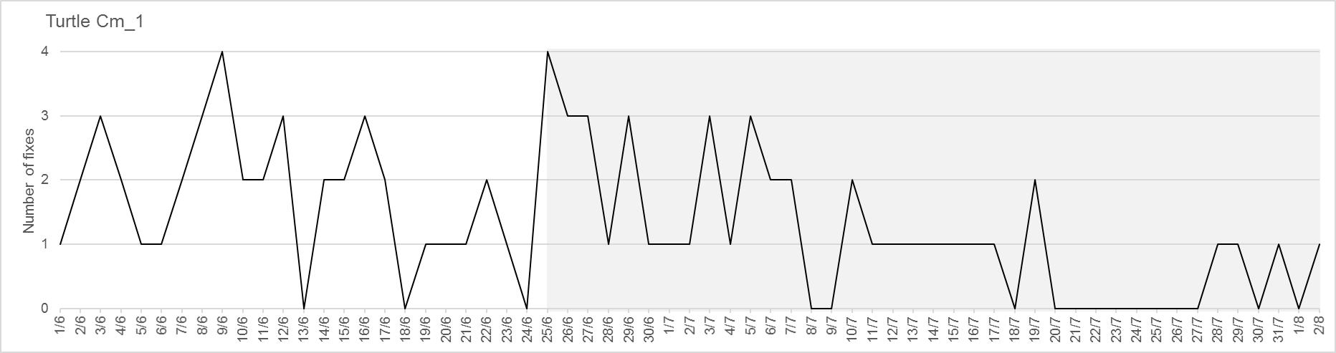
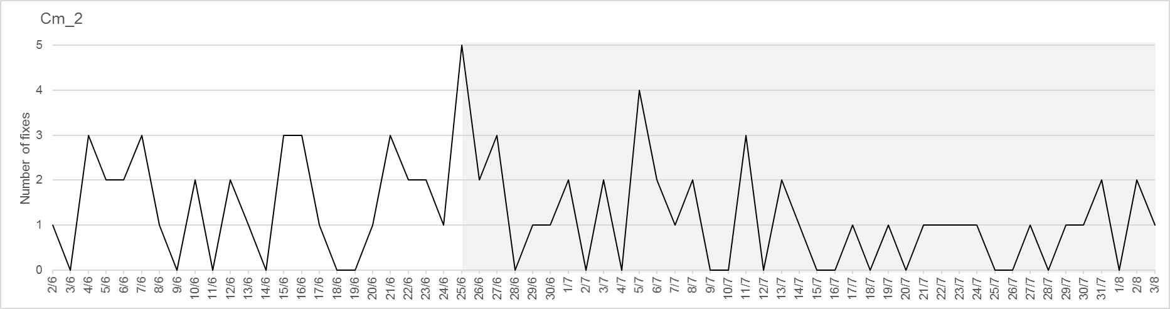
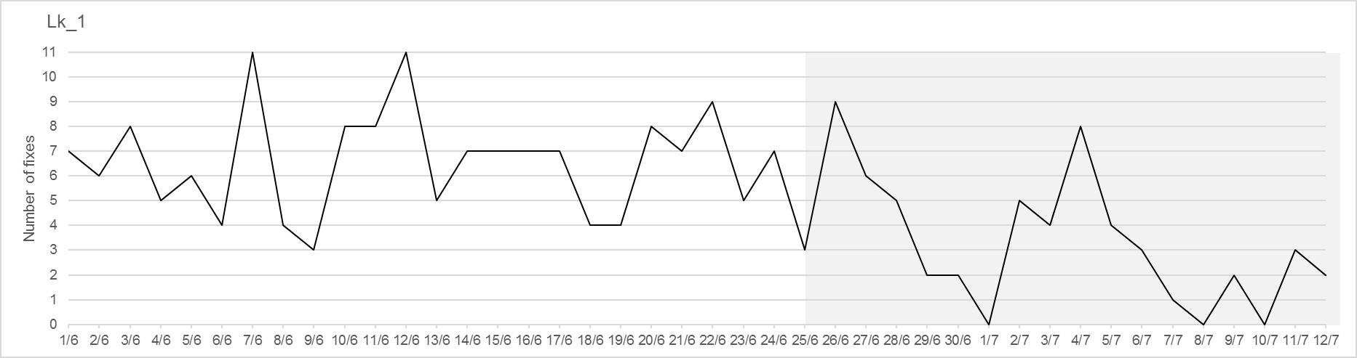
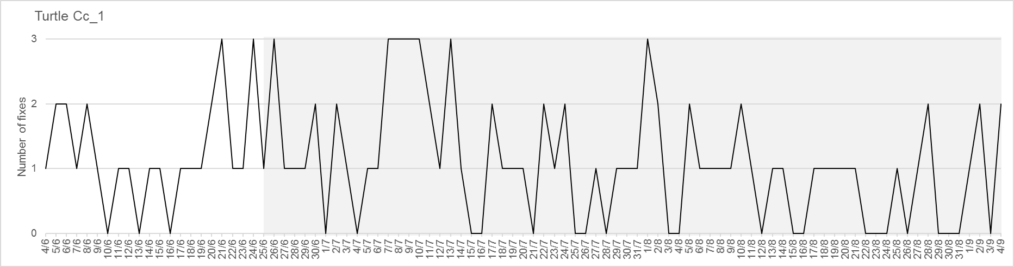
Supplementary Figure S2. Temporal distribution of filtered satellite-derived fixes for each tracked turtle.

