Seed dispersal syndromes in the Madagascan flora: the unusual importance of primates
Aurélie Albert-Daviaud, Sarah Perillo and Wolfgang Stuppy

Fig. S1 Plots showing the convergence of the multivariate imputations by chained equations algorithm for each variable, for the Madagascan endemic flora.

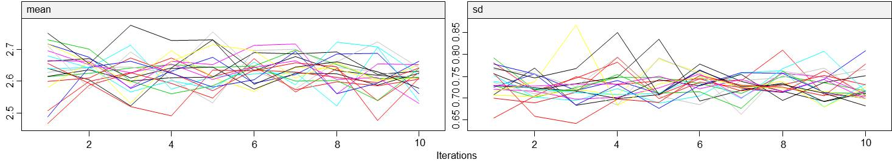
Convergence of the multivariate imputations by chained equations algorithm for ‘Pulp type’.

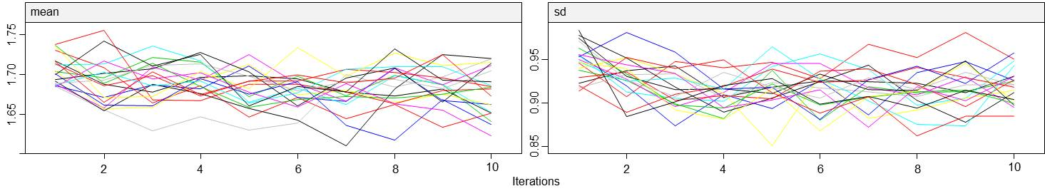
Convergence of the multivariate imputations by chained equations algorithm for ‘Fruit width’.

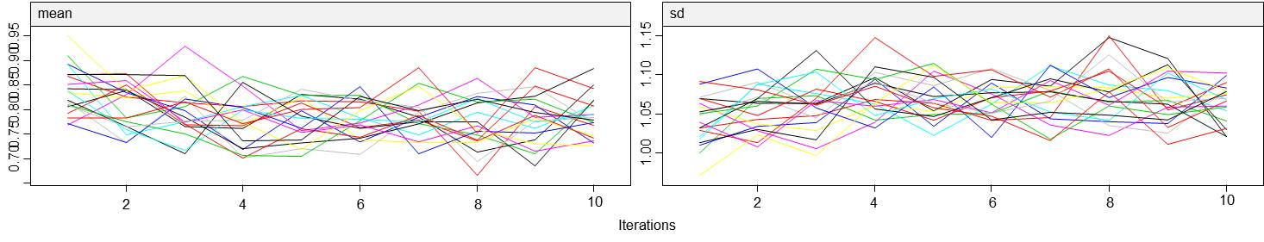
Convergence of the multivariate imputations by chained equations algorithm for ‘Seed width’.

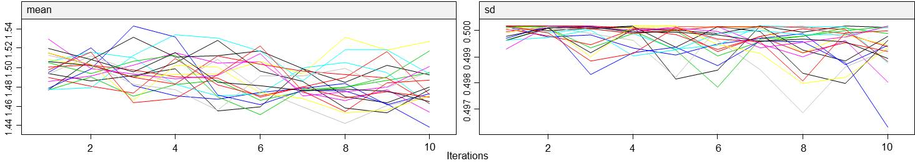
Convergence of the multivariate imputations by chained equations algorithm for ‘Bioclimate_Humid’
.

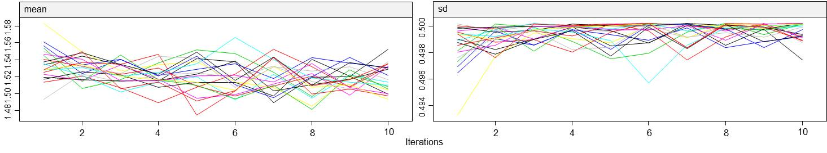
Convergence of the multivariate imputations by chained equations algorithm for ‘Bioclimate_Subhumid’

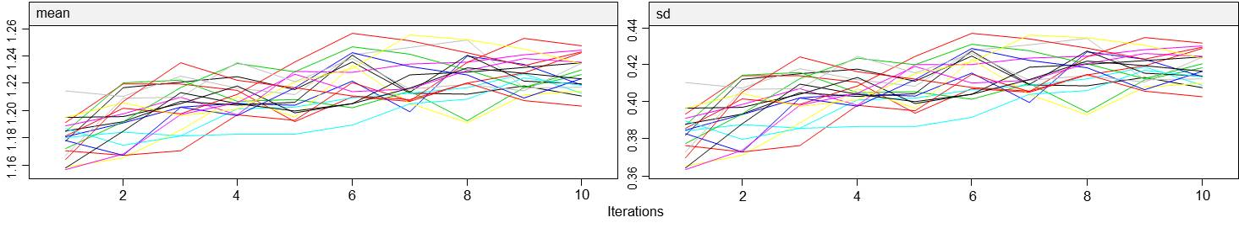
Convergence of the multivariate imputations by chained equations algorithm for ‘Bioclimate_Subarid’

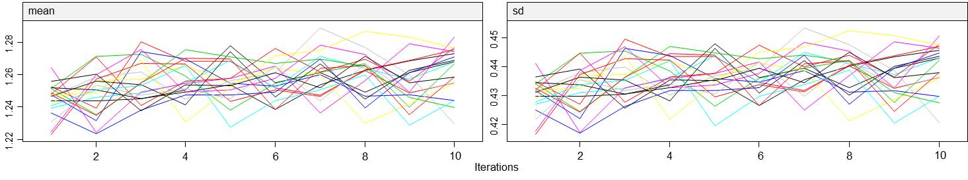
Convergence of the multivariate imputations by chained equations algorithm for ‘Bioclimate_Dry’

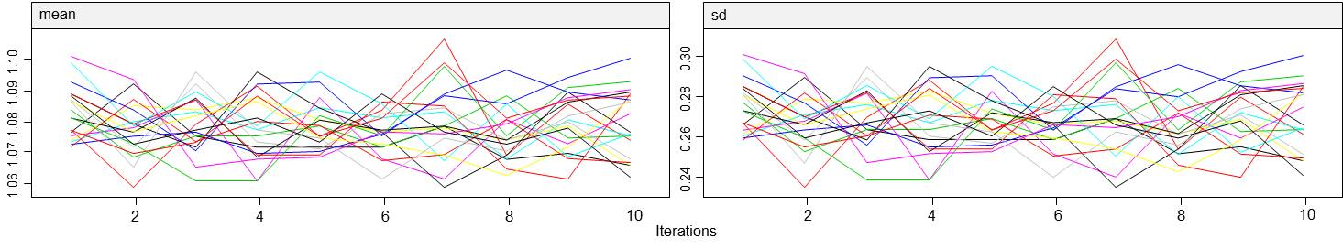
Convergence of the multivariate imputations by chained equations algorithm for ‘Bioclimate_Montane’

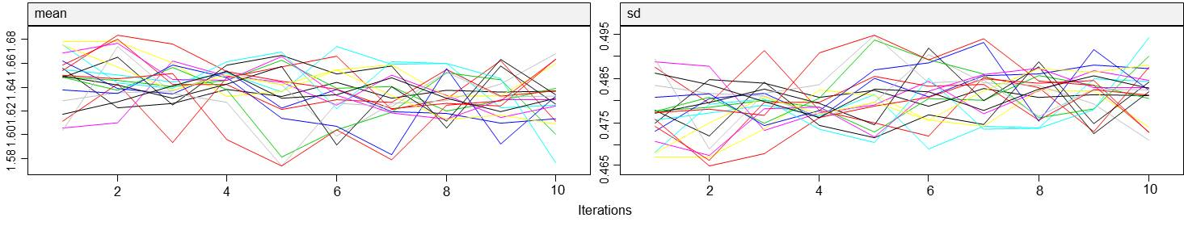
Convergence of the multivariate imputations by chained equations algorithm for ‘Vegetation_Forest’

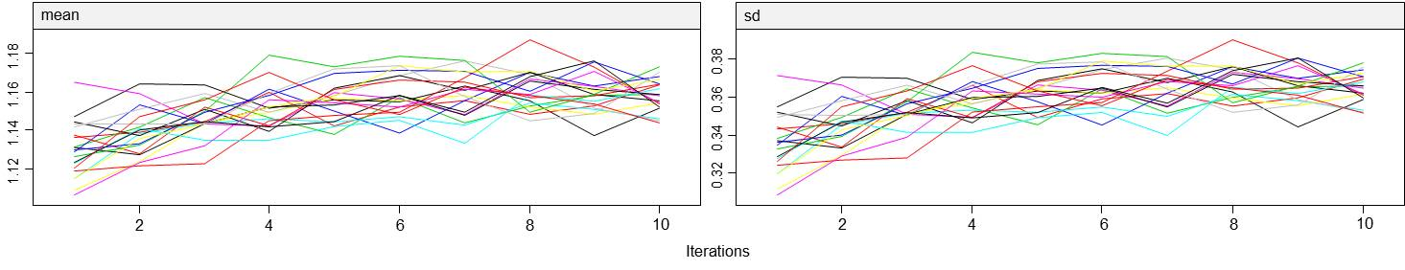
Convergence of the multivariate imputations by chained equations algorithm for ‘Vegetation_Bushland’

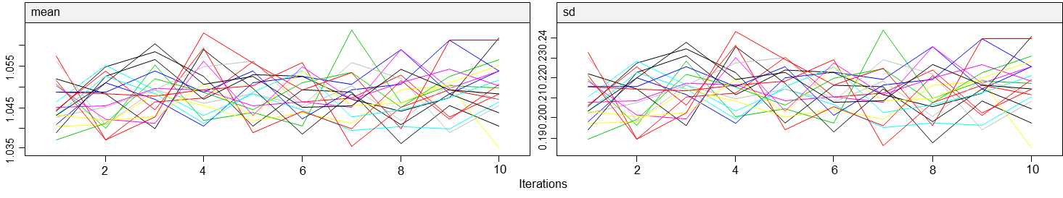
Convergence of the multivariate imputations by chained equations algorithm for ‘Vegetation_Shrubland’

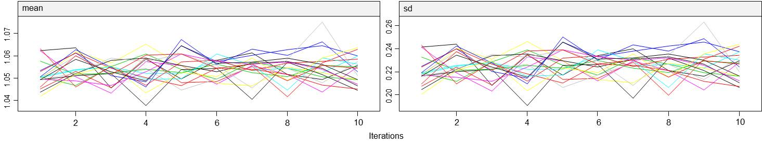
Convergence of the multivariate imputations by chained equations algorithm for ‘Vegetation_Grassland’

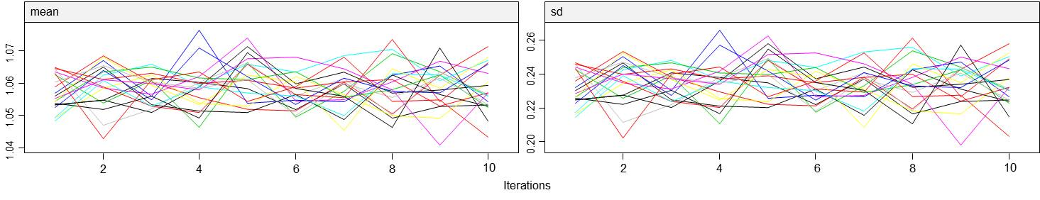
Convergence of the multivariate imputations by chained equations algorithm for ‘Vegetation_Anthropic’

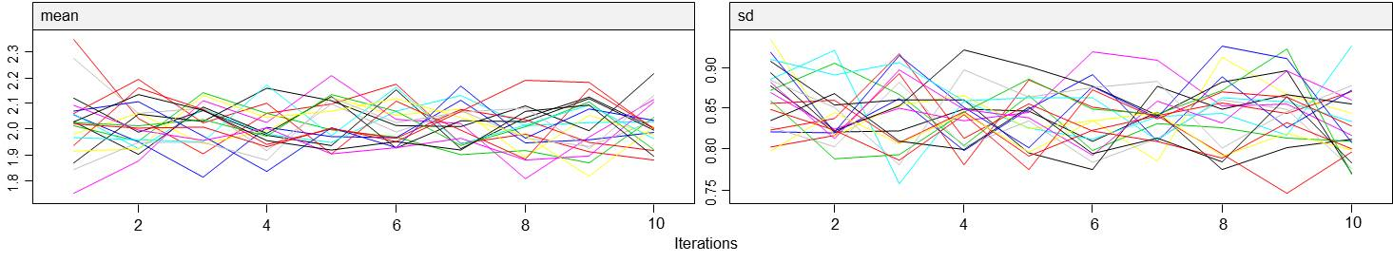
Convergence of the multivariate imputations by chained equations algorithm for ‘Fruit husk’

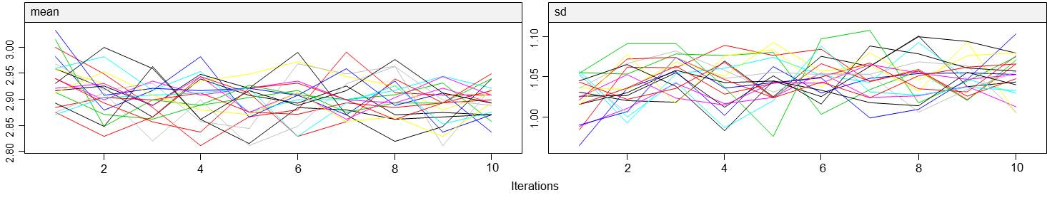
Convergence of the multivariate imputations by chained equations algorithm for ‘Life form’

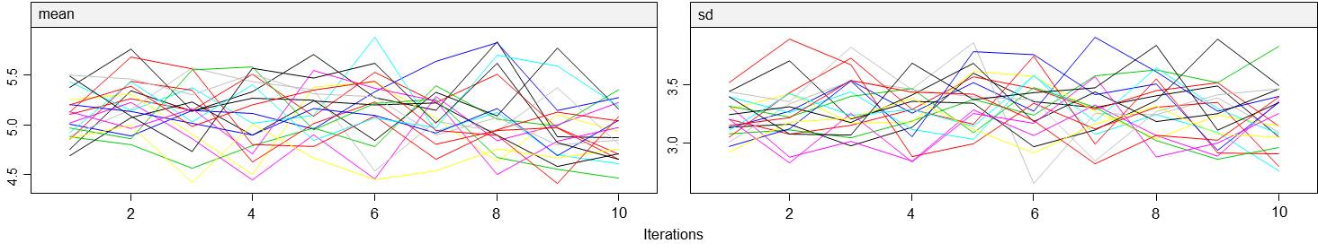
Convergence of the multivariate imputations by chained equations algorithm for ‘Fruit type’

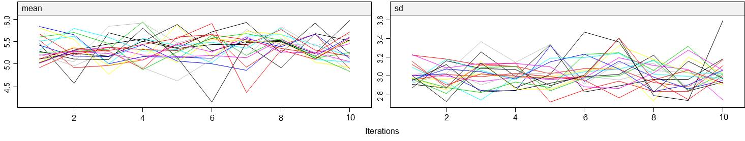
Convergence of the multivariate imputations by chained equations algorithm for ‘Diaspore colour’

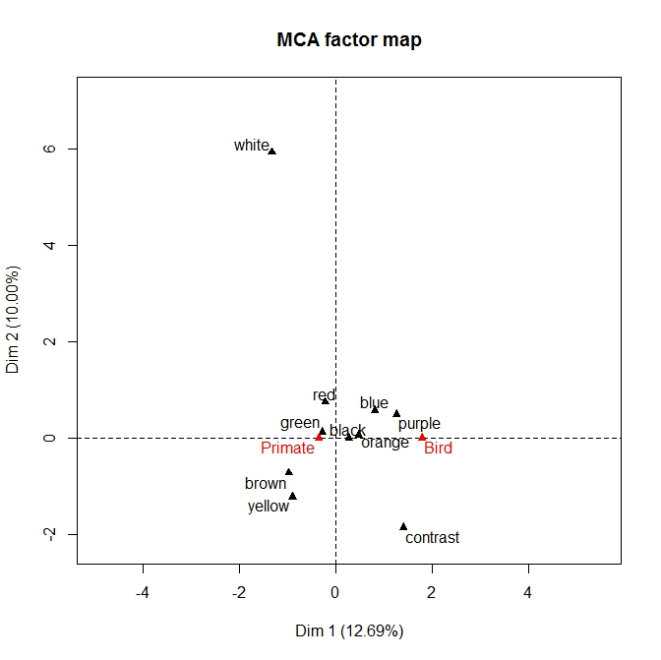
Fig. S2 Multiple correspondence analysis plot, highlighting the association between dispersers (red triangles) and diaspore colours (black triangles) for the endemic Madagascan flora.

