Ferric iron in chrome-bearing spinels:
implications for microprobe correction procedures

Hugh Rollinson and Jacob Adetunji

School of Built and Natural Environment, University of Derby,

Kedleston Road, Derby, DE22 1GB, UK

h.rollinson@derby.ac.uk

Supplementary Material. Details of the data sources and methodological approaches which lie behind this study - Mössbauer analysis, EPMA, site occupancies and the cation calculation scheme are given in the Supplementary Material. Data sources are given in Supplementary Table S1 and chemical data are given in Supplementary Tables S2 to S4.

Supplementary Material

Methodology
This study is based upon a core data set of samples analysed in our laboratory, augmented by an extended dataset of previously published data (Figure S1). All data have been processed in an identical manner using EPMA data and Fe²⁺/Fe³⁺ ratios determined by Mössbauer spectroscopy; these are used to calculate the cation values presented here. Details of the samples used and the mineral-chemical data are given in Supplementary Tables S1-S4.
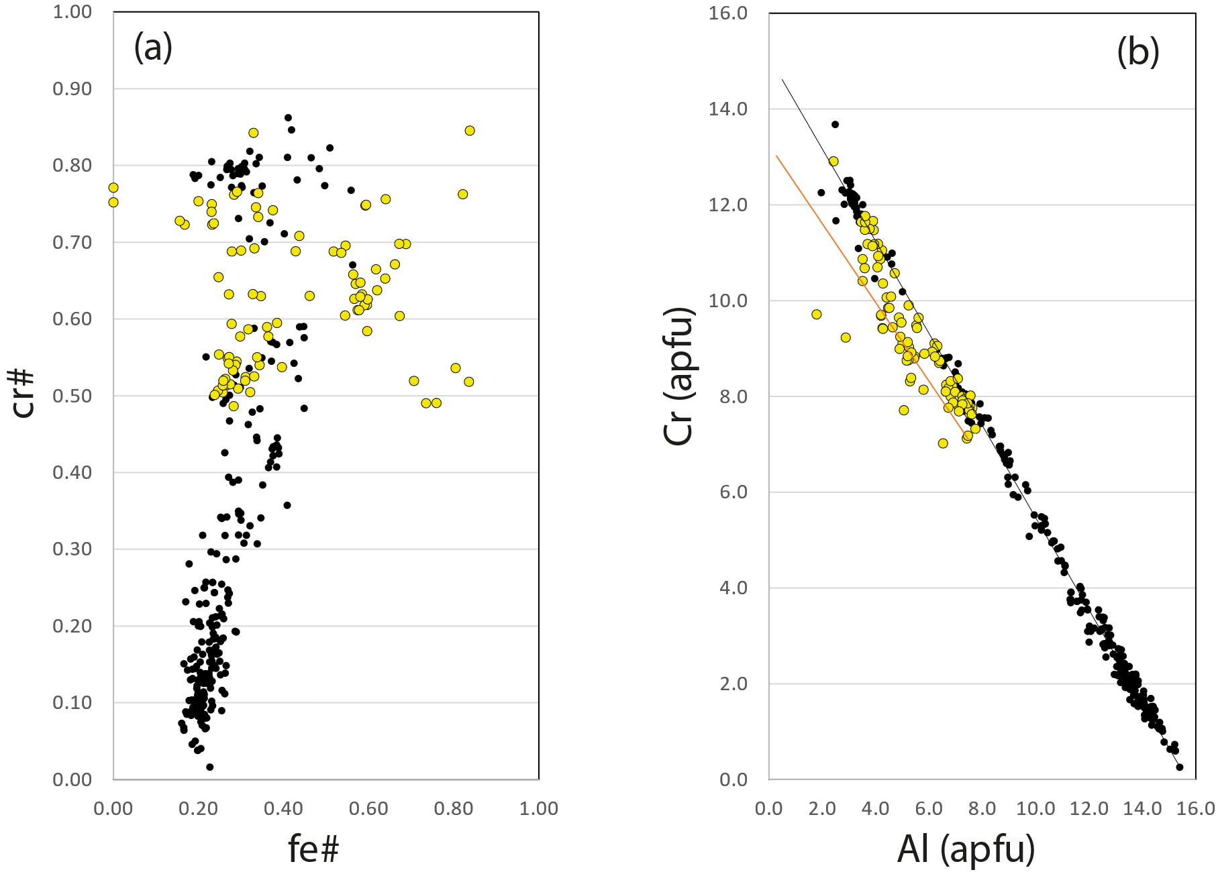

Figure S1. (a) and (b) Samples from the core data set (yellow symbols) relative to the whole data set (black symbols are the extended data set), showing that the samples from the core data set are representative of all high-Cr, high-Fe samples.

In the discussion below we focus on the methodological approaches that we have taken in our laboratory and the systematic errors associated with these methods. Because our dataset (the core dataset) is representative of the high-Cr, high-Fe compositions in the whole dataset we argue that this validates the approaches taken in other studies on Cr-spinels of similar composition. The systematic errors associated with the more aluminous samples from spinel peridotite xenoliths (cr# < 0.5, Al >~ 7.0 apfu) are discussed separately below.

Mössbauer spectroscopy
Mineral separates for Mössbauer spectroscopic analysis were prepared by first crushing each sample into progressively smaller fragments. Chromite separates were obtained from chromitite samples using a Franz magnetic separator. The rock grains were then split by nylon mesh sieves to <500μm and 500-700μm size fractions, and hand-picked for clean mineral separates to better than 99% purity. The purity was confirmed by the absence of additional peaks on the Mössbauer spectra.

⁵⁷Fe Mössbauer spectroscopic measurements at room temperature were made on the samples (absorbers), each prepared from ~60 mg of the sample, mixed with boron nitride as a binder. The mixture was spread uniformly over an area of ~1.8 cm² and pressed into a pellet. The spectrometer uses a 25mCi ⁵⁷Co in Rhodium matrix source mounted on a constant-acceleration transducer operated in a triangular mode in a velocity range, ±6mm/s. The Doppler energies from the 14.4keV γ-rays were detected with a YAlO₃:Ce scintillation counter. All spectra were acquired over 1024 channels in the velocity range -6 to +6 mm/s and calibrated against an α-Fe foil before folding. The least-squares fitting software MossA 1.01a (Prescher et al. 2012) was used to analyse the obtained spectra using different fitting models. The uncertainties were calculated using the covariance matrix. The best fits to the data were obtained by reduced χ² criteria (±0.126). The oxidation states of Fe-ions were then characterized by the centroid shift (δ) and the site occupancy determined by the quadrupole splitting (Δ_{EQ}). The uncertainties for δ, Δ_{EQ} and Full Width at Half Maximum (FWHM) are ±0.020, ±0.030 and ±0.025 mm/s, respectively, and less than ±2% absolute for absorption areas, hence uncertainties in the Fe³⁺/ΣFe ratio are less than ±2% absolute.

Two groups of Cr-spinels were encountered in this study. The first are mixed Mg-Al, Mg-Cr spinels with a low-Fe³⁺ content and structurally they are normal spinels. The second group are Cr-spinel samples with high-Fe³⁺ contents. As noted in the main text, cations of the A atom group are located in tetrahedrally coordinated sites, designated T sites, and cations of the B atom group are located in octahedrally coordinated, designated M sites (Bosi et al., 2019). Here we use a slightly looser definition and following Mössbauer convention refer to ‘A’ and ‘B’ sites. We used two different fitting models for the two groups, (1) and (2) respectively, and selected the best fit on the basis of the χ2 (±0.126) value closest to unity. Model (1) used a three-doublet fit (A1 A2 B) in which the Fe²⁺ occupies two non-equivalent tetrahedrally coordinated A1 and A2 sites and Fe³⁺ occupies the octahedrally coordinated B site. The splitting of the tetrahedrally coordinated site into A1 and A2 is attributed to either strain produced by the presence of next-nearest-neighbour cations, or the substitution of ions of different ionic radii such as Cr³⁺ or Al³⁺ at the octahedrally coordinated site, causing comparable strain or distortion of the tetrahedrally coordinated site. This model has been applied to the majority of the samples examined in this study. Model (2) used a three-doublet fit (A A B) in which all the Fe²⁺ is allocated to the tetrahedrally coordinated A site and Fe³⁺ occupies both tetrahedrally coordinated A and octahedrally coordinated B sites. The two tetrahedrally coordinated sites are located in non-equivalent next-nearest-neighbour configurations. Schmidbauer (1987) showed that for this group, during magmatic crystallization, progressive oxidation arising from electron diffusion could lead to the conversion of the Fe²⁺ occupying tetrahedrally coordinated sites to Fe³⁺. Electrons released are then localized in the octahedrally coordinated B sites, reducing Fe³⁺ to Fe²⁺. Mitra et al. (1991) fit spectra of Cr-spinel samples with similar high-Fe³⁺ compositions to those reported in many samples analysed. The (A1 A2 B) model is widely used and works well for spectra collected at both room temperature and at low temperatures. It was favoured by Rais et al. (2003) in their study of Oman. In both fitting models, (1) and (2), we selected the best fit on the basis of the χ2 (±0.126) value closest to unity. The criteria for the allocation of Fe-cation sites were based on the relative centroid shift and quadrupole splitting of doublets, with values [δFe³⁺] < [δFe²⁺] and [Δ_{EQ}Fe³⁺] < [Δ_{EQ} Fe²⁺], respectively (Pal et al., 1994; Rais et al., 2003; Rollinson et al., 2012).

The site occupancy was determined from the area ratio of the doublets. A correction for the difference between the recoil-free fractions at room-temperature was applied to the Cr-spinel doublets for Fe²⁺ and Fe³⁺ in the tetrahedrally and octahedrally coordinated sites, respectively, at room temperature, as discussed by De Grave and Van Alboom (1991), Eeckhout and DeGrave (2003) and Quintiliani (2005). Therefore, for accurate quantification of (Fe³⁺/ΣFe) for the ‘clean’ Cr-spinel spectra, we took into account in our calculation, the recoil free fractions, 0.687 and 0.887, for the observed Fe²⁺ and Fe³⁺ ions, respectively, for the room-temperature measurements. An example each of the fitted spectra obtained for the low-Fe²⁺ and high-Fe³⁺ are shown in the Figure S2.
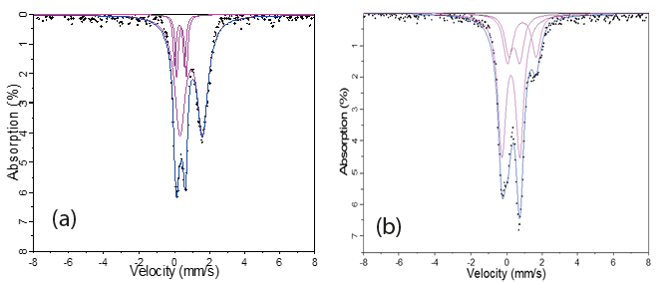
Figure S2. Mössbauer spectra of Cr-spinel samples from the Bushveld intrusion for (a) a low-Fe²⁺ sample fitted as three-doublet (A A B) (Fe³⁺/ΣFe=0.172, sample C1), and (b) a high-Fe³⁺ sample fitted as (A1 A2 B) (Fe³⁺/ΣFe=0.766, sample C5), based on fitting models1 and 2 respectively. Data from Adetunji et al., (2013).
In previously reported Mössbauer studies (e.g., Li et al., 2002; Quintiliani et al., 2006 and references therein), Cr-spinels were fitted with a large number of fitting models with up to seven absorption doublets, as well as applying quadrupole-splitting distributions to account for the typically broad absorption envelope of this type of spinel. The choice of fitting model reported by Lenaz, et al. (2013), showed that the number of Fe²⁺ and Fe³⁺ doublets did not
cause significant effects on the derivative of Fe³⁺/ΣFe ratios. This is also not expected, as the Fe³⁺ absorption is well-constrained by the asymmetry of two prominent high- and low-velocity components in the measured spectra, where the Fe³⁺ contribution occurs entirely within the low-velocity component. The spectra in the present study were fitted with one doublet assigned to Fe³⁺ and two doublets assigned to Fe²⁺ to account for the broad Fe²⁺ envelope. Only a small number of our Cr-spinel samples were fitted with four doublets, to ensure a good fit with χ² (±0.126) close to unity.

The more aluminous spinels found in spinel peridotites from our extended data set have low FeO_{tot} (< 20 wt %) and a maximum of 1.0 apfu Fe³⁺. Because spinel makes up only a small fraction of the rock, mineral separation normally requires a hydrofluoric acid dissolution stage to obtain a high purity separate. Wood and Virgo (1989) Woodland et al (2006) use similar fitting procedures to those described above and cite uncertainties in measured Fe³⁺/ΣFe ratios as +/- 0.01-0.02 absolute.

Electron probe micro-analysis (EPMA)

In our papers, mineral analyses were made on a Cameca SX100 electron probe microanalyser at the Department of Earth Sciences, University of Bristol, using wavelength dispersive detectors and the ZAF data reduction procedure. Operating conditions were 20kV accelerating voltage, 20nA beam current; the beam diameter was ca 1μm. The standards used were olivine (Mg, Si), albite (Al), wollastonite (Ca), ilmenite (Fe, Ti), chromite (Cr), and V, Mn, Ni and Zn metal. Detection limits in chromites were 0.01 wt % oxide Ca; 0.02 wt % oxide Ti; 0.03 wt % oxide Ni; 0.04 wt % oxide Mn, Zn; 0.05 wt % oxide, Mg, Al, Si; 0.07 wt % oxide, Fe; 0.09 wt % oxide Cr; 0.1 wt % oxide V. Two standard deviation relative errors on individual chromite point analyses are 1.4 % MgO, 1.6% Al₂O₃, 7.6 % TiO₂, 2.0% Cr₂O₃, 6.5 % FeO, 18.4 % MnO, 20% NiO, 39% V₂O₃, 62% ZnO. Multiple EPMA were made on individual grains, usually as cross grain traverses. It is assumed that these average data are representative of the average Fe²⁺/ΣFe data obtained from the Mössbauer measurements.

In the other studies quoted here a range of instruments were used. Bosi et al. (2004) and Lenaz et al. (2014) used a Cameca-Camebax electron microprobe and the raw data were reduced by PAP-type correction software (Pouchou and Pichoir 1986). Szilas et al, (2018) and He et al., (2021) used a JEOL JXA-8230 at Stanford University and the Institute of Mineral Resources, Chinese Academy of Geological Sciences respectively and Ruskov et al. (2010) a JEOL Superprobe 733 at the Geological Institute of the Bulgarian Academy of Sciences.

Wood and Virgo (1989) and more recently Davis et al. (2017) investigated the systematic errors introduced by the different data reduction procedures on the accuracy of spinel analyses made by EPMA. Davis et al. (2017) in a study of aluminous spinels (cr# = 0.07-0.43) concluded that compared to the ZAF correction, the PAP correction results in systematically lower Al₂O₃ (1.4 relative %), FeO (0.4%), and MgO (0.6%) and systematically higher Cr₂O₃ (0.7%) and that Fe³⁺/ΣFe ratios determined using the PAP procedure are 0.001 to 0.015 lower than those ratios determined using the ZAF procedure. On these grounds we treat our data as one homogeneous dataset.

Method of cation calculation
We have not assumed that our spinels are stoichiometric. For this reason, our cation calculations are based upon 32 oxygens (the number of oxygen ions in the unit cell) to give an expected composition [A²⁺]₈[B³⁺]₁₆O₃₂.

Most microprobe analyses include the minor elements NiO, ZnO and V₂O₃. Values for SiO₂ and CaO were retained in the calculation although concentrations are very low.
- The microprobe analysis with all iron as FeO was recalculated as cations to 32 oxygens. These data are referred to in the text as the ‘raw’ microprobe data.
- First, Fe³⁺ was calculated using the charge balance criteria of Droop (1987) and the resulting analysis recalculated to 32 oxygens. As expected cation totals are very close to 24.000.
- Second, Fe in the original cation calculation is allocated to Fe²⁺ and Fe³⁺ according to the Mössbauer Fe³⁺/ΣFe ratio (Fe³⁺/(Fe²⁺ + Fe³⁺). The oxygen values were then renormalised to 32, that is the cation values were multiplied by the number of oxygens atoms per molecule and then renormalised to 32, to account for the addition of Fe₂O₃. These oxygen values were then divided by the number of oxygen atoms per molecule to obtain the cation values. These are the cation values used in plots in Figures 1-4.
- Cation totals are not equal to 24.000. This is deliberate inasmuch as mineral stoichiometry cannot be assumed.

Site occupancy calculations
Site occupancy calculations are based upon single crystal X-ray diffraction studies and are based upon previously published work representing some of the samples reported here (Lenaz et al, 2014; Rollinson et al, 2017) and samples analogous to those utilised in this study (Lenaz et al., 2007). The distribution of cations between the T and M sites shown in Figure 5 was obtained using the method of Carbonin et al. (1996) and Lavina et al. (2002), in which crystal chemical parameters are calculated as a function of the atomic fractions at the two sites and fitted to the observed values obtained during the single-crystal X-ray measurements. Site atomic fractions were calculated by minimizing a function F(x), which takes into account the mean of the square differences between calculated and observed parameters from X-ray measurements divided by their squared standard deviations.

Additional Supplementary Figures

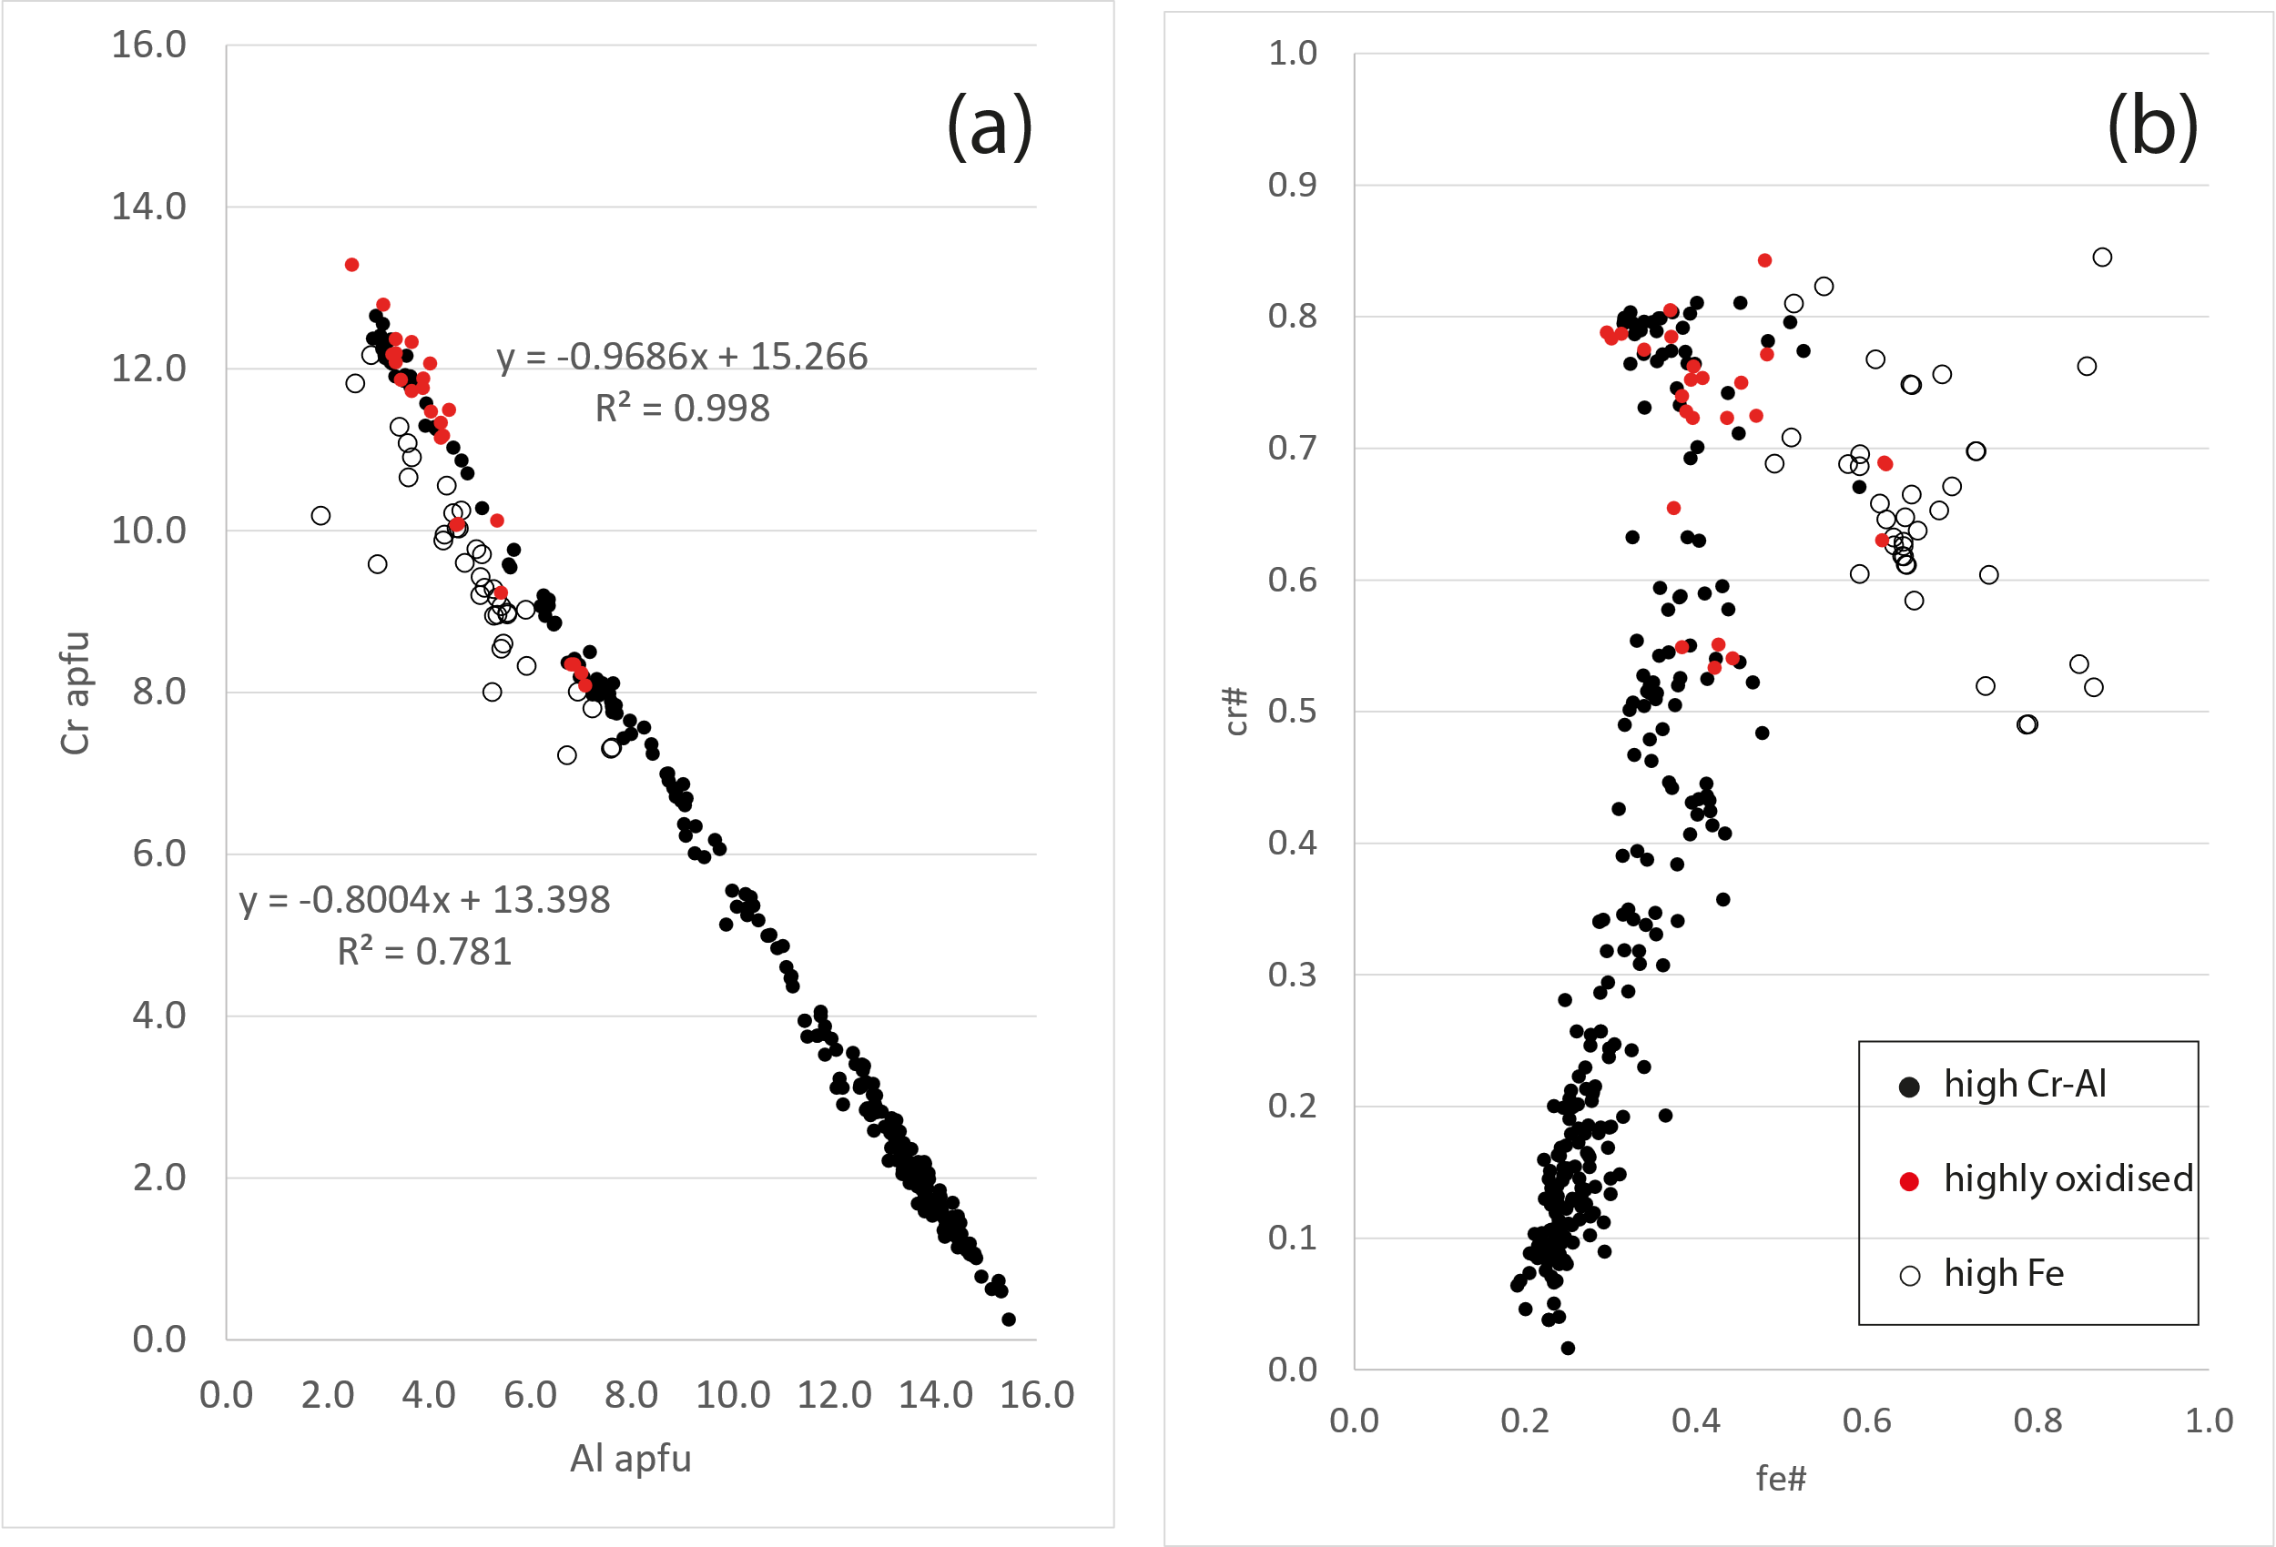
Fig. S3. (a) Cr-Al (apfu) cation plot for the uncorrected data in this study. (b) cr#-fe# ratio plot for the uncorrected data in this study. Symbols as in (b). These diagrams can be used to make a preliminary screening of spinel data with respect to their Fe³⁺ content.
Additional References for Methodology and Data Sources (Supplementary Table 1)
Bonadiman, C., Brombin, V., Andreozzi, G.B., Benna, P., Coltorti, M., Curetti, N., Faccini, B., Merli, M., Pelorosso, B., Stagno, V., Tesauro, M. and Pavese, A., (2021). Phlogopite‑pargasite coexistence in an oxygen reduced spinel‑peridotite ambient. Nature Scientific Reports 11, 11829.
Bryndizia, L.T., Wood, B.J. (1990) Oxygen thermobarometry of abyssal spinel peridotites: the redox state and C-O-H volatile composition of the Earth’s sub-oceanic upper mantle. American Journal of Science, 290, 1093-1116.
Carbonin S, Russo U, Della Giusta A. (1996) Cation distribution in some natural spinels from X-ray diffraction and Mössbauer spectroscopy. Mineral Mag 60, 355–368

De Grave, E. and Van Alboom, A. (1991), Evaluation of ferrous and ferric Mössbauer fractions. Phys. Chem. Minerals 18, 337-342.

Eeckhout, S.G. and DeGrave, D. (2003) Evaluation of ferrous and ferric Mössbauer fractions. Part II. Phys. Chem. Minerals 30, 142-146.
Eslami A., Grieco, G., Bussolesi, M., Ichiyama, Y., Lenaz, D., Skogby, H., Kutyrev, A.V., Cavallo, A., Khedr, M.Z., (2023). Co-occurrence of compositionally variable chromitites in the Sabzevar ophiolite, NE Iran. Lithos, 446-447, 107133
Goncharov, A.G. and Ionov, D.A., (2012) Redox state of deep off-craton lithospheric mantle: new data from garnet and spinel peridotites from Vitim, southern Siberia. Contrib Mineral Petrol DOI 10.1007/s00410-012-0767-z
Goncharov, A.G., Ionov, D.A. Doucet, L.S., Pokhilenko, L.N., (2012) Thermal state, oxygen fugacity and C–O–H fluid speciation in cratonic lithospheric mantle: New data on peridotite xenoliths from the Udachnaya kimberlite, Siberia. Earth Planet. Sci. Lett., 357-358, 99-110.
He, Y, Zhu, X., She, Y., Ma, J., Sun, J., Gao, Z., Wan, H. and Chen, Y. (2021) Mechanism of formation of podiform chromitite: Insights from the oxidation states of podiform chromitites and host peridotites from the Luobusa ophiolite, southern Tibet. Ore Geology Reviews 139, 104483
Ionov, D.A. and Wood, B.J. (1992) The oxidation state of subcontinental mantle: oxygen thermobarometry of mantle xenoliths from central Asia. Contrib. Mineral. Petrol., 111, 179-193.
Kuno, A., Santos, R.A., Matsuo, M. and Takano, B. (2000) Characterization of natural chromite samples from ophiolite complexes in the Philippines by ⁵⁷Fe Mössbauer spectroscopy. J. Radioanalytical Nuclear Chem 246, 79-83
Lavina B, Salviulo G, Della Giusta A (2002) Cation distribution and structure modeling of spinel solid solutions. Phys Chem Minerals 29, 10–18
Lenaz D, Skogby H, Logvinova AM, Sobolev NV, Princivalle F (2013) A micro-Mössbauer study of chromites included in diamond and other mantle-related rocks. Phys Chem Minerals 40, 671-679

Li, Z, Ping, J.Y., Jin, M.Z., Liu, M.L., 2002. Distribution of Fe²⁺ and Fe³⁺ and next-nearest neighbour effects in natural chromites: comparison between results of QSD and Lorentzian doublet analysis. Phys. Chem. Minerals 29, 485-494.
Mitra, S., Pal, T. and Pal, T. (1991) Petrogenetic implication of Mössbauer hyperfine parameters of Fe³⁺-chromites from Sukinda (India) ultramafites. Mineralogical Magazine, 55, 535-542.
Nasir, S., Abu-Alijarayesh, I., Mahmood, S. and Lehlooh, A., F. (1992) Oxidation state of the upper mantle beneath the northwestern part of the Arabian lithosphere. Tectonophysics, 213, 359-366.
Pal, T., Moon, H. and Mitra, S. (1994) Distribution of Iron Cations in Natural Chromites at different stages of Oxidation – A ⁵⁷Fe Mössbauer Investigation. J Geol Soc India 44, 53-64
Pouchou, J.L. and Pichoir, F. (1986) Les elements tres legers en microanalyse; possibilies des modeles recents de quantification. J. Microscopie Spectroscopie Electroniques 11, 229-250.
Prescher, C., McCammon, C., and Dubrovinsky, L., 2012. MossA: a program for analyzing energy-domain Mossbauer ¨ spectra from conventional and synchrotron sources. J. Appl. Cryst. 45, 329–331
Quintiliani, M., 2005. ⁵⁷Fe Mössbauer spectroscopy analysis of spinels: Fe³⁺/Fe_{tot} quantification accuracy and consequences on fo₂ estimate. Per. Mineral 74, 139-146.
Quintiliani, M., Andreozzi, G. B. and Graziani, G. (2006) Fe²⁺ and Fe³⁺ quantification of different approaches and fO₂ estimation for Albanian Cr-spinels. Am Mineral 91, 907–916
Rais, A,, Yousif, A.A., Al-Shishi, M.H., Al-Rawas, A.D,, Gismelseed, A.M. and El-Zain, M.E. (2003) Cation distribution and magnetic properties of natural chromites. Phys Stat Sol 739, 439-446
Rollinson, H. and Adetunji, J. (2015) The geochemistry and oxidation state of podiform chromitites from the mantle section of the Oman ophiolite: A review. Gondwana Research., 27, 543-554.
Ruskov, T., Spirov, I., Georgieva, M., Yamamoto, S., Green, H.W., McCammon, C.A. and Dobrzhinetskaya, L.F. (2010) Mössbauer spectroscopy studies of the valence state of iron in chromite from the Luobusa massif of Tibet: implications for a highly reduced deep mantle. J. Metamorph. Geol. 28, 551–560
Szilas, K., van Hinsberg, V., McDonald, I., Næraa, T., Rollinson, H., Adetunji, J. and Bird, D. (2018) Highly refractory Archaean peridotite cumulates: Petrology and geochemistry of the Seqi Ultramafic Complex, SW Greenland. Geoscience Frontiers 9, 689-714.
Woodland, A.B. and Kock, M. (2003) Variation in oxygen fugacity with depth in the upper mantle beneath the Kaapvaal craton, Southern Africa. Earth and Planetary Science Letters 214, 295-310
Woodland, A.B., Gräf, C., Sandner, T., Höfer, H.E., Seitz, H-M, Pearson, D.G., and Kjarsgaard, B.A., (2021) Oxidation state and metasomatism of the lithospheric mantle beneath the Rae Craton, Canada: strong gradients reflect craton formation and evolution. Nature Scientific Reports, 11, 3684.
Woodland, A.B., Kornprobst, J. and Wood, B.J. (1992) Oxygen thermobarometry of orogenic lherzolite massifs. Journal of Petrology, 33, 203-230.

