Ermakovite (NH₄)(As₂O₃)₂Br, a new exhalative arsenite bromide mineral from the Fan-Yagnob coal deposit, Tajikistan
Supplementary information
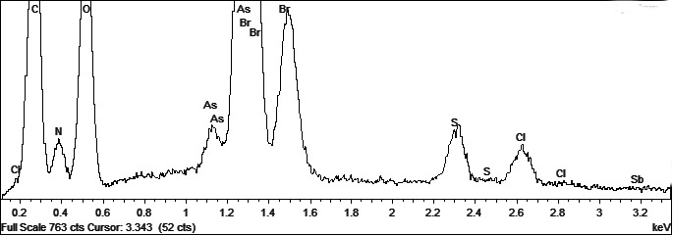
Figure S1. Fragment of the ED-spectra of ermakovite, obtained at 10 kV, 1 nA, ATW2 ultrathin window.
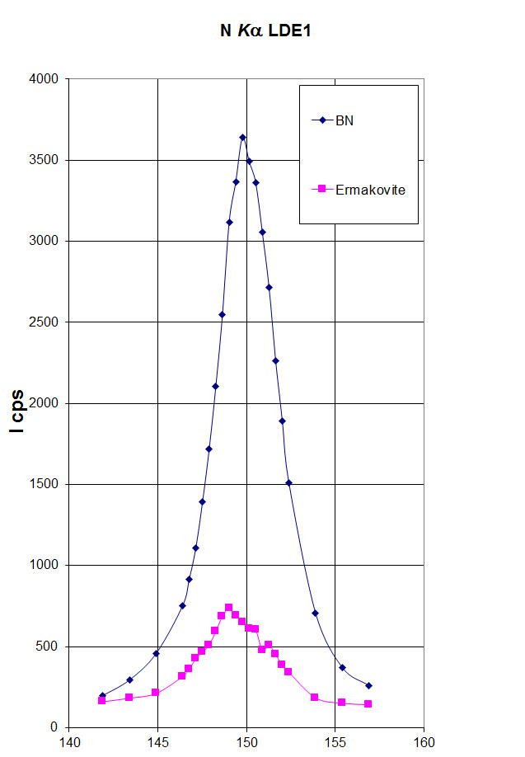
Figure S2. Fragment of the WD-spectra of ermakovite compared to that of boron nitride.

