Sapozhnikovite, Na₈(Al₆Si₆O₂₄)(HS)₂, a new sodalite-group mineral from the Lovozero alkaline massif, Kola Peninsula

Nikita V. Chukanov^{1,2}*, Natalia V. Zubkova², Igor V. Pekov^{2,3}, Roman Yu. Shendrik⁴, Dmitry A. Varlamov⁵, Marina F. Vigasina², Dmitry I. Belakovskiy⁶, Sergey N. Britvin⁷, Vasiliy O. Yapaskurt² and Dmitry Yu. Pushcharovsky²

Supplementary material
Mineralogical Magazine
https://doi.org/10.1180/mgm.2021.94

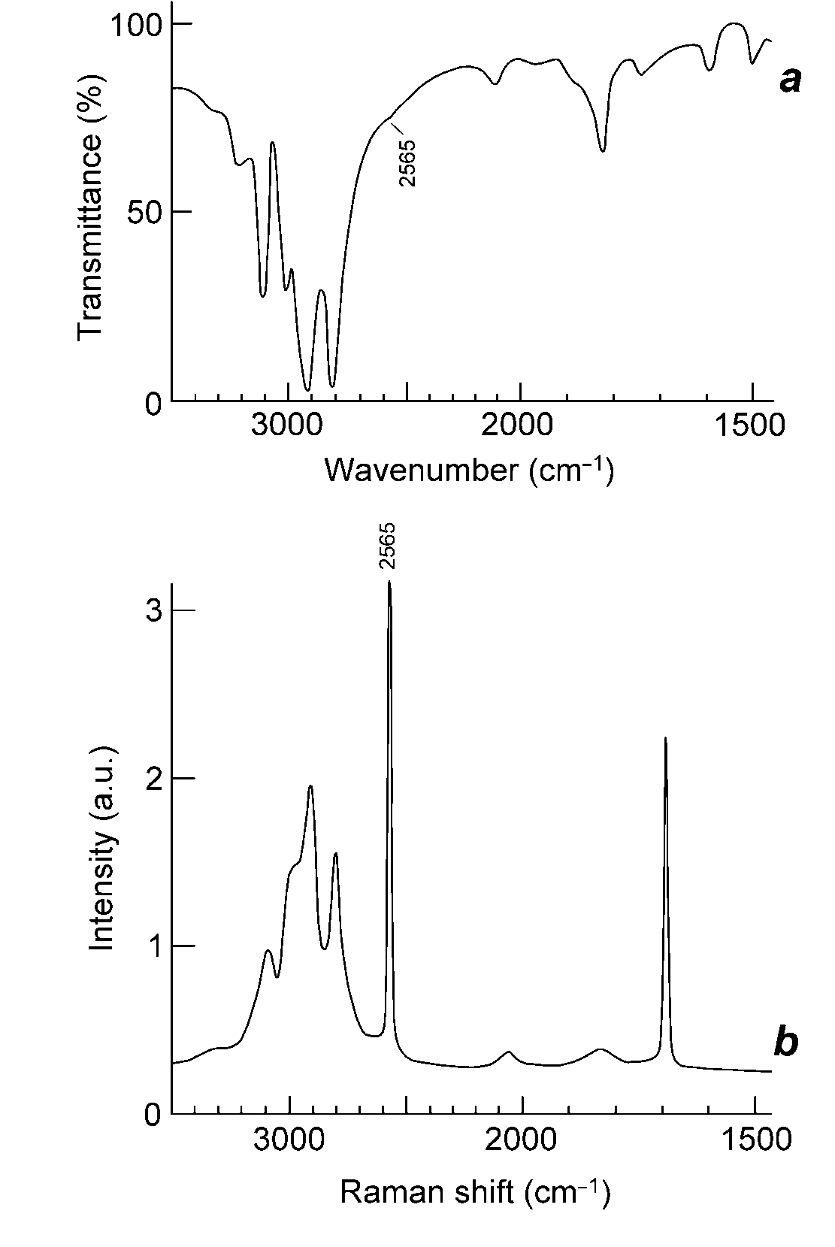
Fig. 1S. Infrared (a) and Raman (b) spectra of polycrystalline ammonium hydrosulfide (NH₄)(HS) drawn using data from Bragin et al. (1977). The band at 2565 cm^{–1} corresponds to stretching vibrations of the HS– anion.

Bragin J., Diem M., Guthals D., Chang S. (1977) The vibrational spectrum and lattice dynamics of polycrystalline ammonium hydrosulfide. Journal of Chemical Physics, 67, 1247–1256. https://doi.org/10.1063/1.434936
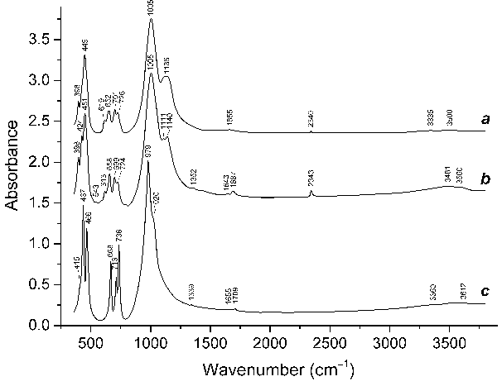
Fig. 2S. Powder infrared absorption spectra of (a) haüyne (Na_{5.52}K_{0.35}Ca_{1.99})(Si_{6.10}Al_{5.81}Fe³⁺_{0.09}O₂₄)(SO₄)_{1.97}Cl_{0.11}·nH₂O (Chukanov et al., 2020b), (b) nosean (Na_{5.72}K_{0.64}Ca_{0.33})(Si_{6.43}Al_{5.51}Fe³⁺_{0.06}O₂₄)(SO₄)_{1.21}Cl_{0.11}F_{0.09}·nH₂O (Chukanov et al., 2020a), both from the Laach Lake volcano, Eifel paleovolcanic region, Germany, and (c) S-free sodalite Na_{7.98}(Si_{5.80}Al_{6.20}O₂₄)Cl_{2.22} from the Vishnevogorskiy syenite-miaskite complex, South Urals, Russia (Nishanbaev et al., 2016). The spectra are offset for comparison.

Chukanov N.V., Vigasina M.F., Zubkova N.V., Pekov I.V., Schäfer C., Kasatkin A.V., Yapaskurt V.O., Pushcharovsky D.Yu. (2020a) Extra-framework content in sodalite-group minerals: Complexity and new aspects of its study using infrared and Raman spectroscopy. Minerals, 10, 363. https://doi.org/10.3390/min10040363
Nishanbaev T.P., Rassomahin M.A., Blinov I.A., Popova V.I. (2016) Minerals of sodalite-cancrinite pegmatites from the Vishnevogorsk miaskite massif, South Urals. Mineralogy, 3, 40–52 (in Russian).

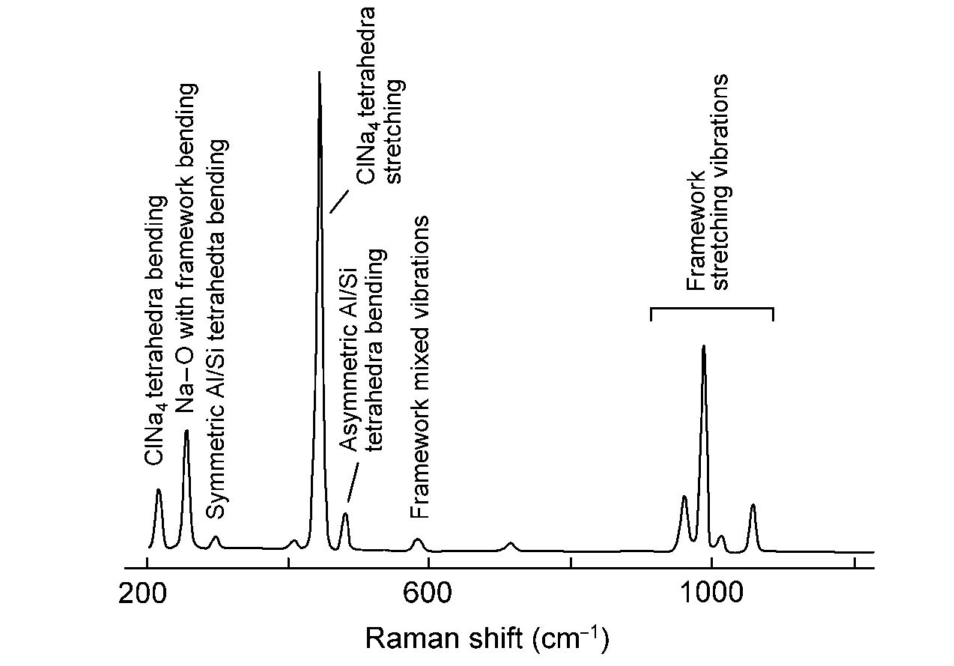
Fig. 3S. Calculated Raman spectrum of sodalite with the assignment of the bands, drawn using data from Hettmann et al. (2012).

Hettmann K., Wenzel T., Marks M., Markl G. (2012) The sulfur speciation in S-bearing minerals: New constraints by a combination of electron microprobe analysis and DFT calculations with special reference to sodalite-group minerals. American Mineralogist, 97, 1653–1661.

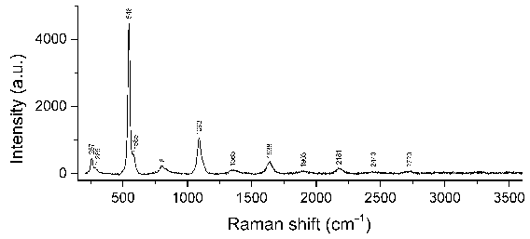
Fig. 4S. Raman spectrum of lazurite from the Malobystrinskoe gem lazurite deposit, Baikal Lake area, Russia drawn using data from Chukanov et al. (2020b).

Chukanov N.V., Sapozhnikov A.N., Shendrik R.Yu., Vigasina M.F., Steudel R. (2020b) Spectroscopic and crystal-chemical features of sodalite-group minerals from gem lazurite deposits. Minerals, 10, 1042. https://doi.org/10.3390/min10111042

