Mineralogical Magazine
Supplementary material.

Oberwolfachite, SrFe³⁺₃(AsO₄)(SO₄)(OH)₆, a new alunite-supergroup mineral from the Clara mine, Schwarzwald, Germany, and Monterniers mine, Rhône, France
Nikita V. Chukanov^{1,2*}, Gerhard Möhn³, Fabrice Dal Bo⁴, Natalia V. Zubkova², Dmitry A. Varlamov⁵, Igor V. Pekov², Laurent Jouffret⁶, Jean-Marc Henot⁷, Pascal Chollet⁸, Yannick Vessely⁹, Henrik Friis⁴, Dmitry A. Ksenofontov², Atali A. Agakhanov¹⁰, Sergey N. Britvin¹¹, Joy Desor¹², Natalia N. Koshlyakova² and Dmitry Yu. Pushcharovsky²

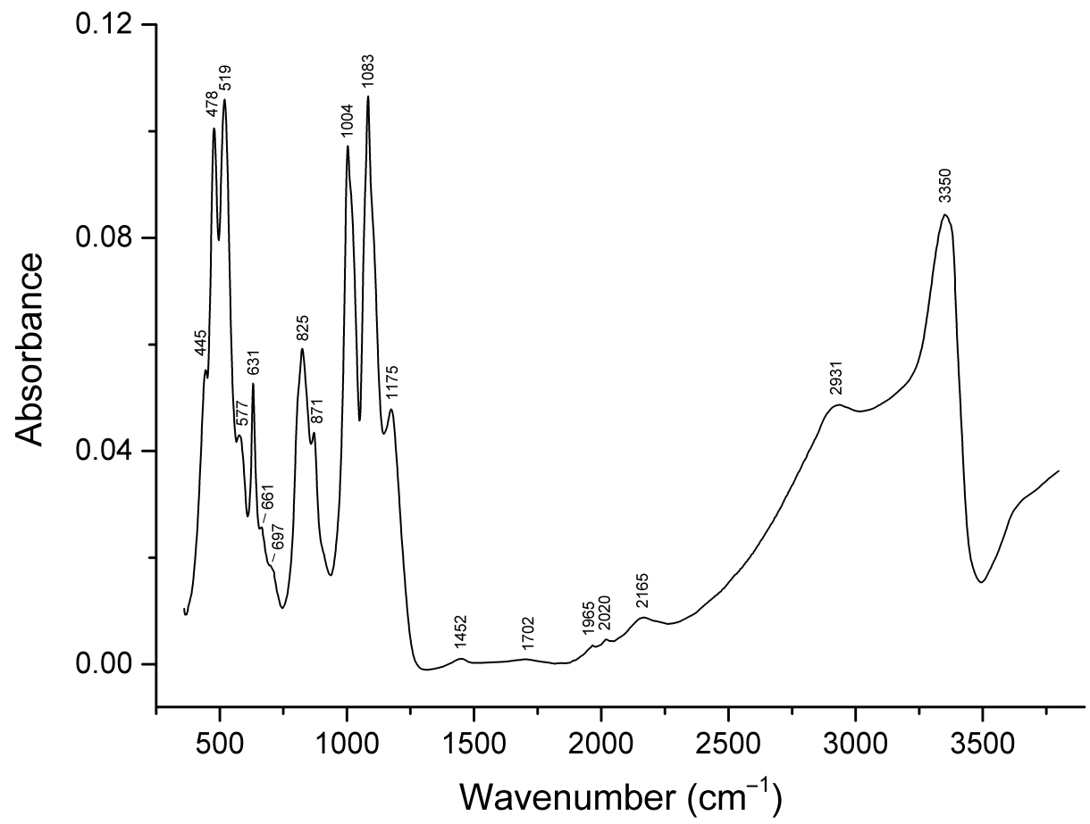
Figure 4S. Powder infrared absorption spectrum of oberwolfachite from the Monterniers mine.

