**Mineralogical classification and crystal water characterization of beryl from the W–Sn–Be occurrence of Xuebaoding, Sichuan province, western China**

**Ping Wang1,§, Thomas P. Gray2, Zhe Li3, Evan J. D. Anderson2, Julien Allaz4, Joseph R. Smyth5, Alan E. Koenig6,†, Lijian Qi7, Yan Zhou7, and Markus B. Raschke2,\***

*1 College of Physics, Sichuan University, Chengdu, Sichuan, 610064, China*

*2 Department of Physics, Department of Chemistry, and JILA, University of Colorado, Boulder, CO 80303, USA*

*3 Institute of Fundamental and Frontier Sciences, University of Electronic Science and Technology of China, Chengdu, Sichuan, 610054, China*

*4 ETH Zürich, Department of Earth Sciences, Institute of Geochemistry and Petrology, Clausiusstrasse 25, 8092 Zurich, Switzerland*

*5 Department of Geological Sciences, University of Colorado, Boulder, CO 80303, USA*

*6 United States Geological Survey, Geology, Geophysics, and Geochemistry Science Center, Lakewood, Colorado, USA*

*7 Laboratory of Gem and Technological Materials, Tongji University, Shanghai 200070, China*

[*\*markus.raschke@colorado.edu*](mailto:*markus.raschke@colorado.edu)

*§present address: Institute of Regulatory Science for Medical Devices, Sichuan University, Chengdu, Sichuan, 610064, China*

† *present address: Applied Spectra, Inc., West Sacramento, CA 95605, USA*

The supplement provides additional information and data to the main text of the paper.

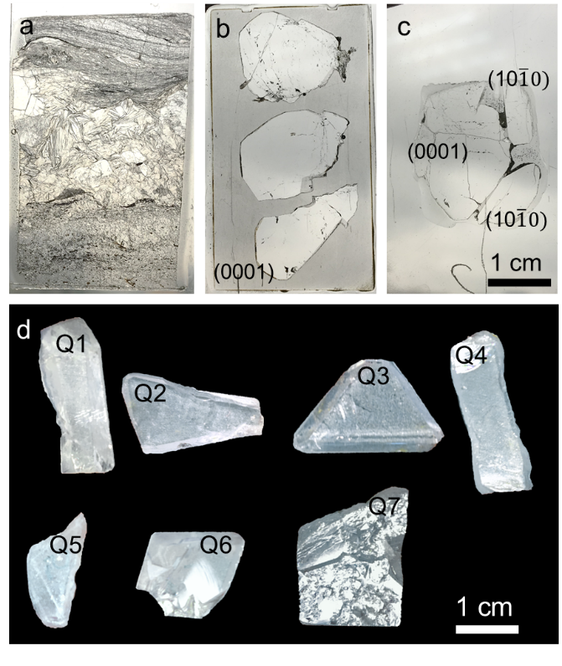

Figure S1. (a) Thin section sample 1702B2 with beryl from a small vein. (b) thin section 1901B1 with 3 single crystals in (0001) orientation. (c) thin section 1901B2 with 3 single crystals, one in (0001) and two under (10 $\overline{1}$ 0) orientation. (d) the different single crystal samples Q1–Q7 before cut and polish, with Q1–4 showing the (10 $\overline{1}$ 0) faces, Q4–5 the (11 $\overline{2}$ 1) faces, and Q7 the (0001) face. For details of the measurement on Q3, Q6 and Q7 see Fig. 3 in main text.

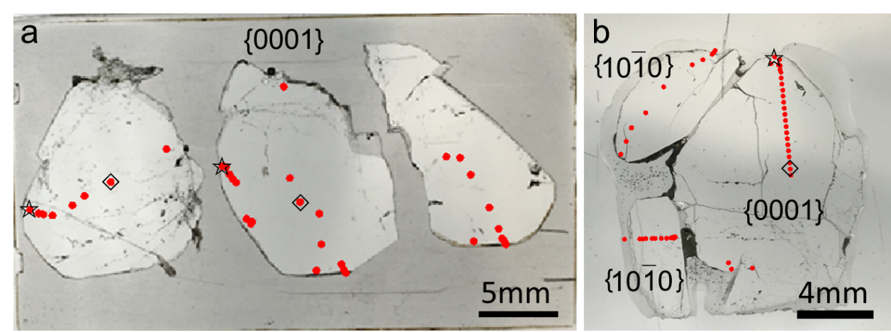

Figure S2. Beryl samples 1901B1 (a) and 1901B2 (b) with EMP measurement locations in red. ☆ and ◇ indicates the selected Na–rich and Na–poor measurement points, respectively, listed in Table 1.

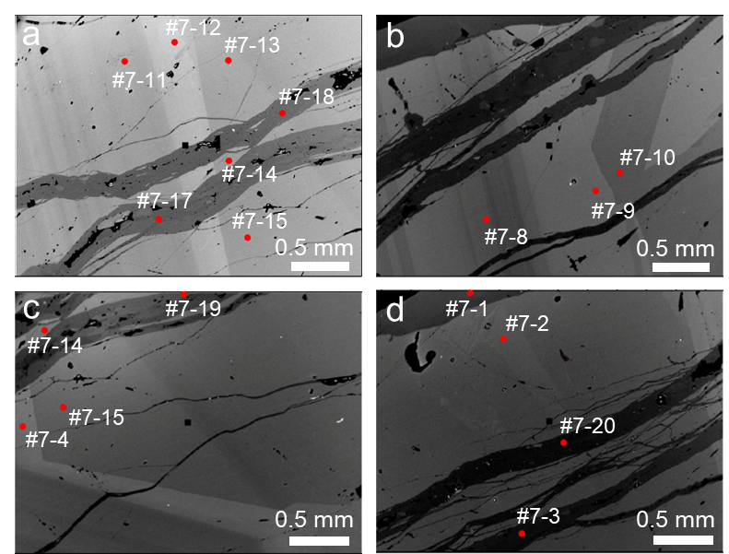

Figure S3. Locations of EMPA measurements on BSE images of single crystal beryl sample #Q7. #Q7–11~#Q7–13 are averaged to present low Na (primary) areas and #Q7–17~#Q7–19 averaged to present low Na (secondary) areas as listed in Table 1 in main text.

C:\Users\Zhe Li\Desktop\Fig7.tif

Figure S4. Representative Raman spectra with (*a*) Si–O, Al–O, and Be–O phonon modes below 1400 cm–1, and (*b*) the characteristic type II and type I water stretch modes at 3593 and 3604 cm–1, respectively.



Figure S5. Selected spectra in the secondary phase of transect #Q3–7 (red) with corresponding fit (green) to determine the strength of ${\text{ν}}_{\text{3}}^{\text{I}}$ and ${\text{ν}}_{\text{1}}^{\text{II}\text{s}}$. To improve the fit accuracy, the broad background centered at 3727 cm–1, and weak peaks at 3515, 3605 and 3651 cm–1 were also fit. Also shown is each fitted Lorentzian individually (black).

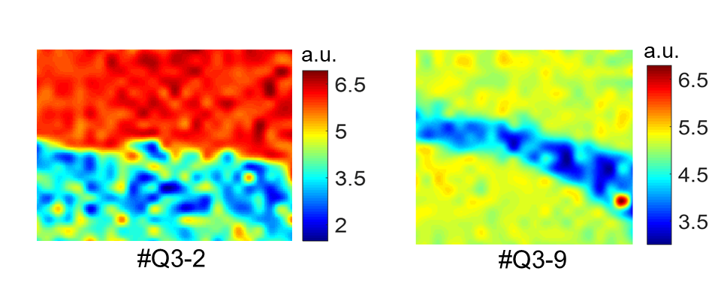

b

a

Figure S6. IR band centered at 3605 cm–1 mapping. (a) area #Q3–2, (b) area #Q3–9.

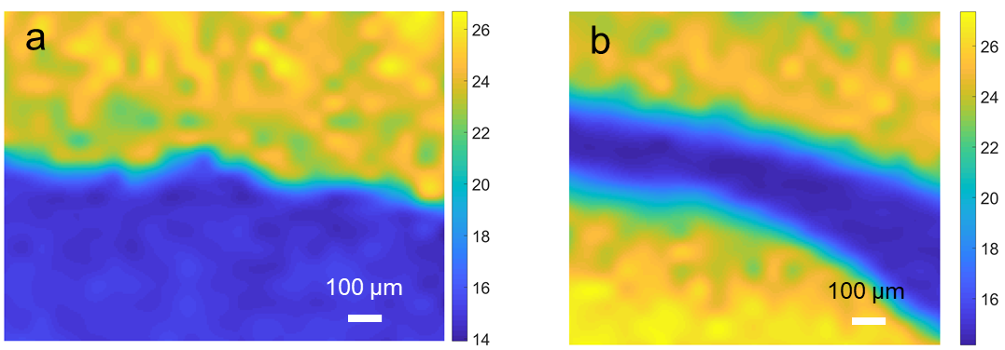

Figure S7. Fitted band at 3696 cm–1 (type I water) width imaging of beryl sample area #Q3–2 (a) and #Q3–9 (b), with primary (yellow/green) and secondary (blue) areas.



Figure S8. Combined A and T2 substitution expressed as R+ vs. Li+ + X2+ + Fe, assuming Fe is 2+. The deviation from the linear correlation suggests Fe is present as Fe3+.

Table S1 Summary of EMPA based composition analyses of Xuebaoding beryl from literature.

|  |  |  |  |  |  |  |  |  |  |  |  |  |  |  |  |  |
| --- | --- | --- | --- | --- | --- | --- | --- | --- | --- | --- | --- | --- | --- | --- | --- | --- |
|  |  | SiO2 | Al2O3 | Na2O | FeOt | MgO | K2O | MnO | TiO2 | CaO | Cr2O3 | CoO | NiO | BeO | P2O5 | Total |
| (Qi *et al.*, 2001a) | 1# | 63.78 | 18.7 | 1.62 | 0.19 | 0.08 | 0.05 | 0.02 | 0.01 | 0.01 | 0.01 | 0.01 | 0 |  |  | 84.48 |
| 2# | 63.97 | 19.1 | 1.41 | 0.09 | 0.04 | 0.04 | 0.01 | 0 | 0.02 | 0.01 | 0.02 | 0.01 |  |  | 84.72 |
| 3# | 64.99 | 18.92 | 1.56 | 0.08 | 0.04 | 0.05 | 0.01 | 0 | 0.02 | 0.01 | 0.01 | 0 |  |  | 85.69 |
| 4# | 64.63 | 19.09 | 1.49 | 0.2 | 0.11 | 0.04 | 0.01 | 0.01 | 0.02 | 0.01 | 0.02 | 0 |  |  | 85.63 |
| 5# | 63.7 | 18.87 | 1.43 | 0.17 | 0.03 | 0.05 | 0.02 | 0 | 0.01 | 0 | 0.02 | 0 |  |  | 84.3 |
| 6# | 64.89 | 18.86 | 1.45 | 0.22 | 0.05 | 0.03 | 0.02 | 0.01 | 0.01 | 0.02 | 0.02 | 0 |  |  | 85.58 |
| 7# | 64.8 | 18.84 | 1.48 | 0.15 | 0.07 | 0.03 | 0.01 | 0 | 0.01 | 0 | 0.02 | 0.02 |  |  | 85.43 |
| 8# | 64.15 | 18.78 | 1.35 | 0.16 | 0.07 | 0.04 | 0.01 | 0 | 0.01 | 0 | 0 | 0 |  |  | 84.57 |
| (Zhou *et al.*, 2002) | avg of 8 data | 64.36 | 18.89 | 0.035 | 0.16 | 0.06 | 1.13 | 0.014 | 0.003 | 0.37 | 0.01 | 0.015 | 0.003 |  |  | 85.05 |
| (Liu *et al.*, 2005) | 1# point | 66.77 | 17.95 | 0.42 | 0.21 | 0 | 0 |  | 0.05 | 0.02 | 0.05 | 0.02 |  | 14.23 | 0.33 | 100 |
| 2# point | 66.04 | 17.45 | 0.83 | 0.19 | 0 | 0.06 |  | 0 | 0 | 0 | 0 |  | 15.07 | 0.36 | 100 |
| 3# point | 67.25 | 18.45 | 0.65 | 0.18 | 0 | 0 |  | 0.02 | 0 | 0 | 0.05 |  | 13 | 0.4 | 100 |
| (Liu *et al.*, 2001b) | 1# | 66.77 | 17.95 | 0.42 | 0.21 | 0 | 0 |  | 0.05 | 0.02 | 0.05 | 0.02 |  | 14.23 | 0.33 | 100 |
| 2# | 66.04 | 17.45 | 0.83 | 0.19 | 0 | 0.06 |  | 0 | 0 | 0 | 0 |  | 15.07 | 0.36 | 100 |
| 3# | 67.25 | 18.45 | 0.65 | 0.18 | 0 | 0 |  | 0.02 | 0 | 0 | 0.05 |  | 13 | 0.4 | 100 |

Table S2 Infrared peak frequencies and mode assignment for beryl [after (Charoy *et al.*, 1996; Qi *et al.*, 2001b; Łodziński *et al.*, 2005; Adamo *et al.*, 2008; Della Ventura *et al.*, 2015; Mashkovtsev *et al.*, 2016)].

|  |  |  |
| --- | --- | --- |
| Group | Frequency/cm–1  Literature | Frequency/cm–1  Present Work |
| $${{\text{H}}_{2}\text{O} \text{ν}}_{\text{2}}^{\text{I}}$$ | 1598–1600 | 1600 |
| $${\text{H}}_{2}\text{O} {\text{ν}}_{\text{2}}^{\text{I}\text{Id}}$$ | 1620–1630 | – |
| $${{\text{H}}_{2}\text{O} \text{ν}}_{\text{2}}^{\text{I}\text{Is}}$$ | 1633 | 1637 |
| $${\text{CO}}_{2} {\text{ν}}_{2}$$ | 2358–2360 | 2358 |
| $${\text{H}}_{2}\text{O} {\text{2}\text{ν}}_{2}$$ | 3222–3240 | 3222–3240 |
| $${\text{H}}_{2}\text{O} {\text{ν}}_{\text{1}}^{\text{I}\text{Is}}$$ | 3584–3589 | 3588 |
| $${\text{H}}_{2}\text{O} {\text{ν}}_{\text{1}}^{\text{I}\text{Id}}$$ | 3590–3600 | 3602* |
| $${{\text{H}}_{2}\text{O} \text{ν}}_{\text{1}}^{\text{I}}$$ | 3602–3610 | 3602* |
| $${\text{H}}_{2}\text{O} {\text{ν}}_{\text{3}}^{\text{II}\text{s}}$$ | 3643 | 3651 |
| $${\text{H}}_{2}\text{O} {\text{ν}}_{\text{3}}^{\text{II}\text{d}}$$ | 3651–3671 | – |
| $${\text{H}}_{2}\text{O} {\text{ν}}_{\text{3}}^{\text{I}}$$ | 3690–3670 | 3696 |
| ${\text{H}}_{2}\text{O} {\text{ν}}^{\text{I}\text{I}}$*\*\** | 5275–5276 | – |

* This frequency is not differentiated between ${\text{H}}_{2}\text{O }{\text{ν}}_{\text{1}}^{\text{IId}}$ and ${{\text{H}}_{2}\text{O ν}}_{\text{1}}^{\text{I}}$

** Harmony frequency vibration

Table S3 Quantitative elements content obtained by EMPA for thin sections (TS) and single crystals (SC)

|  |  |  |  |  |  |  |  |  |
| --- | --- | --- | --- | --- | --- | --- | --- | --- |
| Sample number | | #1702B2 | #1702B2 | #1702B2 | #1901 | #1901 | #Q7 | #Q7 |
|  |  | TS | TS | TS | TS | TS | SC | SC |
| Wt % oxide | Ideal crystal | Low–Na **○** | High–Na **□** | Int.– Na △ | High–Na ☆ | Low–Na ◇ | Low–Na | High–Na |
| Na2O | – | 1.231 | 1.690 | 1.338 | 2.005 | 1.130 | 1.422 | 1.719 |
| MgO | – | 0.193 | 0.026 | 0.025 | 0.033 | 0.064 | 0.179 | 0.001 |
| K2O | – | 0.020 | 0.029 | 0.018 | 0.005 | 0.010 | 0.035 | 0.007 |
| Cs2O | – | 0.416 | 0.481 | 0.315 | 0.152 | 0.389 | 0.486 | 0.093 |
| CaO | – | 0.004 | 0.016 | 0.005 | – | 0.001 | – | – |
| TiO2 | – | 0.032 | – | 0.005 | – | 0.010 | – | 0.004 |
| FeO | – | 0.495 | 0.067 | 0.139 | 0.013 | 0.235 | 0.170 | – |
| MnO | – | 0.026 | – | 0.005 | 0.000 | 0.021 | – | – |
| SiO2 | 67.07 | 64.668 | 64.479 | 64.507 | 64.360 | 64.841 | 64.705 | 64.914 |
| Al2O3 | 18.97 | 17.810 | 18.307 | 18.210 | 18.481 | 18.366 | 18.079 | 18.516 |
| BeOcal | 13.96 | 13.574 | 13.588 | 13.553 | 13.607 | 13.632 | 13.598 | 13.676 |
| Total | 100.00 | 98.468 | 98.685 | 98.121 | 98.657 | 98.702 | 98.674 | 98.931 |
| apfu |  |  |  |  |  |  |  |  |
| Na | – | 0.220 | 0.301 | 0.239 | 0.357 | 0.201 | 0.253 | 0.304 |
| Mg | – | 0.027 | 0.004 | 0.003 | 0.005 | 0.009 | 0.025 | 0.000 |
| K | – | 0.002 | 0.003 | 0.002 | 0.001 | 0.001 | 0.004 | 0.001 |
| Cs | – | 0.016 | 0.019 | 0.012 | 0.006 | 0.015 | 0.019 | 0.004 |
| Ca | – | 0.000 | 0.002 | 0.001 | 0.000 | 0.000 | – | – |
| Ti | – | 0.002 | 0.000 | 0.000 | 0.000 | 0.001 | – | 0.000 |
| Fe | – | 0.034 | 0.005 | 0.010 | 0.001 | 0.016 | 0.012 | – |
| Mn | – | 0.002 | – | 0.000 | 0.000 | 0.002 | 0.000 | – |
| Si | 6 | 5.950 | 5.926 | 5.944 | 5.907 | 5.940 | 5.942 | 5.928 |
| Al | 2 | 1.931 | 1.983 | 1.977 | 1.999 | 1.983 | 1.957 | 1.993 |
| Becal | 3 | 3.000 | 3.000 | 3.000 | 3.000 | 3.000 | 3.000 | 3.000 |
| Lical |  | 0.000 | 0.000 | 0.000 | 0.000 | 0.000 | 0.000 | 0.000 |

Every value represents the average of three analysis. The measured points for ○ and □ are shown in Fig. 4f. The measured points for other symbols are shown in Figs S3–5.

–; close or below the detection limit.

# indicates the sample number.

Apfu calculation is based on 18 O and 3 Be.

Table S4 Quantitative elements content obtained by EMPA for thin sections (TS) and single crystals (SC)

|  |  |  |  |  |  |  |  |  |
| --- | --- | --- | --- | --- | --- | --- | --- | --- |
| Sample number | | #1702B2 | #1702B2 | #1702B2 | #1901 | #1901 | #Q7 | #Q7 |
|  |  | TS | TS | TS | TS | TS | SC | SC |
| Wt % oxide | Ideal crystal | Low–Na **○** | High–Na **□** | Int.– Na △ | High–Na ☆ | Low–Na ◇ | Low–Na | High–Na |
| Na2O | – | 1.231 | 1.690 | 1.338 | 2.005 | 1.130 | 1.422 | 1.719 |
| MgO | – | 0.193 | 0.026 | 0.025 | 0.033 | 0.064 | 0.179 | 0.001 |
| K2O | – | 0.020 | 0.029 | 0.018 | 0.005 | 0.010 | 0.035 | 0.007 |
| Cs2O | – | 0.416 | 0.481 | 0.315 | 0.152 | 0.389 | 0.486 | 0.093 |
| CaO | – | 0.004 | 0.016 | 0.005 | – | 0.001 | – | – |
| TiO2 | – | 0.032 | – | 0.005 | – | 0.010 | – | 0.004 |
| FeO | – | 0.495 | 0.067 | 0.139 | 0.013 | 0.235 | 0.170 | – |
| MnO | – | 0.026 | – | 0.001 | – | 0.021 | – | – |
| SiO2 | 67.07 | 64.668 | 64.479 | 64.507 | 64.360 | 64.841 | 64.705 | 64.914 |
| Al2O3 | 18.97 | 17.810 | 18.307 | 18.210 | 18.481 | 18.366 | 18.079 | 18.516 |
| BeOcal | 13.96 | 12.892 | 12.581 | 12.792 | 12.341 | 12.818 | 12.816 | 12.691 |
| Total | 100.00 | 97.787 | 97.678 | 97.359 | 97.391 | 97.888 | 97.892 | 97.946 |
| apfu |  |  |  |  |  |  |  |  |
| Na | – | 0.221 | 0.305 | 0.241 | 0.362 | 0.203 | 0.256 | 0.308 |
| Mg | – | 0.027 | 0.004 | 0.004 | 0.005 | 0.009 | 0.025 | 0.000 |
| K | – | 0.002 | 0.003 | 0.002 | 0.001 | 0.001 | 0.004 | 0.001 |
| Cs | – | 0.016 | 0.019 | 0.012 | 0.006 | 0.015 | 0.019 | 0.004 |
| Ca | – | 0.000 | 0.002 | 0.001 | – | 0.000 | – | – |
| Ti | – | 0.002 | – | 0.000 | – | 0.001 | – | 0.000 |
| Fe | – | 0.035 | 0.005 | 0.010 | 0.001 | 0.016 | 0.012 | – |
| Mn | – | 0.002 | – | 0.000 | – | 0.002 | – | – |
| Si | 6 | 6.000 | 6.000 | 6.000 | 6.000 | 6.000 | 6.000 | 6.000 |
| Al | 2 | 1.947 | 2.008 | 1.996 | 2.031 | 2.003 | 1.976 | 2.017 |
| Becal | 3 | 2.874 | 2.812 | 2.858 | 2.764 | 2.849 | 2.855 | 2.818 |
| Lical |  | 0.126 | 0.188 | 0.142 | 0.236 | 0.151 | 0.145 | 0.182 |

Every value represents the average of three analysis. The measured points for ○ and □ are shown in Fig. 4f. The measured points for other symbols are shown in Figs S3–5.

–; close or below the detection limit.

# indicates the sample number.

Apfu calculation is based on 6 Si.

Table S5 Atomic position coordinates and anisotropic displacement parameters

|  |  |  |  |  |  |  |  |  |  |  |  |
| --- | --- | --- | --- | --- | --- | --- | --- | --- | --- | --- | --- |
| # | Site | x/a | y/b | z/c | Occ | *U*11 | *U*22 | *U*33 | *U*23 | *U*13 | *U*12 |
| #Q7 | Be | 0.5 | 0 | 0.25 | 0.98(2) | 0.0086(7) | 0.0064(8) | 0.0076(8) | 0 | 0 | 0.0032(4) |
| Si | 0.38869(3) | 0.11788(3) | 0 | 0.993(4) | 0.00424(15) | 0.00404(15) | 0.00440(17) | 0 | 0 | 0.00228(10) |
| Al | 0.66667 | 0.33333 | 0.25 | 0.997(5) | 0.00451(10) | =*U*22 | 0.0044(2) | 0 | 0 | 0.00226(10) |
| Na | 0 | 0 | 0 | 0.309(9) | 0.0129(14) | =*U*22 | 0.028(3) | 0 | 0 | 0.0065(7) |
| O1 | 0.30598(12) | 0.23487(11) | 0 | 1 | 0.0116(4) | 0.0087(3) | 0.0174(4) | 0 | 0 | 0.0078(3) |
| O2 | 0.49800(7) | 0.14615(8) | 0.14510(7) | 1 | 0.0108(3) | 0.0105(2) | 0.0087(3) | –0.00292(17) | –0.00473(15) | 0.00637(17) |
| Ow | 0 | 0 | 0.25 | 0.914(18) | 0.051(2) | =*U*22 | 0.0285(19) | 0 | 0 | 0.0256(11) |
|  |  |  |  |  |  |  |  |  |  |  |  |
| #Q6 | Be | 0.5 | 0 | 0.25 | 0.97(2) | 0.0080(8) | 0.0056(9) | 0.0071(9) | 0 | 0 | 0.0028(4) |
| Si | 0.38872(4) | 0.11794(4) | 0 | 1.000(5) | 0.00424(17) | 0.00407(17) | 0.00437(18) | 0 | 0 | 0.00228(11) |
| Al | 0.66667 | 0.33333 | 0.25 | 0.993(6) | 0.0042(2) | =*U*22 | 0.0041(3) | 0 | 0 | 0.00211(11) |
| Na | 0 | 0 | 0 | 0.322(11) | 0.0139(17) | =*U*22 | 0.029(3) | 0 | 0 | 0.0070(8) |
| O1 | 0.30579(15) | 0.23478(13) | 0 | 1 | 0.0115(4) | 0.0086(4) | 0.0172(4) | 0 | 0 | 0.0079(3) |
| O2 | 0.49795(9) | 0.14614(10) | 0.14509(8) | 1 | 0.0108(3) | 0.0103(3) | 0.0083(3) | –0.0031(2) | –0.00480(19) | 0.0063(2) |
| Ow | 0 | 0 | 0.25 | 0.97(2) | 0.051(2) | =*U*22 | 0.029(2) | 0 | 0 | 0.0254(12) |
|  |  |  |  |  |  |  |  |  |  |  |  |
| #Q3 | Be | 0.5 | 0 | 0.25 | 0.97(2) | 0.0077(7) | 0.0057(9) | 0.0072(9) | 0 | 0 | 0.0029(4) |
| Si | 0.38866(4) | 0.11784(4) | 0 | 0.998(5) | 0.00407(16) | 0.00381(16) | 0.00411(17) | 0 | 0 | 0.00217(10) |
| Al | 0.66667 | 0.33333 | 0.25 | 0.995(6) | 0.0042(2) | =*U*22 | 0.0039(3) | 0 | 0 | 0.00207(10) |
| Na | 0 | 0 | 0 | 0.294(11) | 0.0129(17) | =*U*22 | 0.029(3) | 0 | 0 | 0.0064(8) |
| O1 | 0.30617(13) | 0.23492(12) | 0 | 1 | 0.0112(4) | 0.0081(3) | 0.0165(4) | 0 | 0 | 0.0076(3) |
| O2 | 0.49812(8) | 0.14613(9) | 0.14508(7) | 1 | 0.0103(3) | 0.0097(3) | 0.0079(3) | –0.00287(18) | –0.00458(16) | 0.00593(19) |
| Ow | 0 | 0 | 0.25 | 0.91(2) | 0.055(3) | =*U*22 | 0.030(2) | 0 | 0 | 0.0276(14) |

Table S6 Raman peak frequencies and mode assignment for beryl [after (Kim *et al.*, 1995; Qi *et al.*, 2001b)]

|  |  |  |  |  |
| --- | --- | --- | --- | --- |
| Symmetry | Present work | Reference | Calculated | Assignment |
| A1g | 322 | 323 | 286 | Al–O |
| 396 | 396 | 418 | Al–O |
| 617W | 625 | 580 |  |
| 685 | 685 | 665 | Si–O–Si |
| 1066 | 1070 | 1018 | Si–O |
| 1138 | 1139 |  |  |
| E1g | 137 | 144 | 152 | Ring rotation |
| 180 | 192 | 195 | Ring rotation |
| 245 | 255 | 227 |  |
| 442 | 450 | 407 | O–Be–O |
| 524 | 529 | 606 | O–Be–O |
| 684 | 683 |  | Leakage from A1g or E2g |
| 1009 |  |  | Be–O |
| E2g | 321 | 322 | 322 | Al–O |
| 398 | 398 | 392 | Al–O |
| 570 | 565 |  | O–Be–O |
| 684 | 685 | 706 | Si–O–Si |
| 998 | 1004 | 1000 | Be–O |
| 1067 | 1071 | 1086 | Si–O |
| Water | 3594 |  |  | Type II water stretch |
| 3604 |  |  | Type I water stretch |

Table S7 Chemical composition of Xuebaoding beryl by bulk chemical analysis from literature.

|  |  |  |  |  |  |  |  |  |  |  |  |  |  |  |  |  |  |  |  |  |  |
| --- | --- | --- | --- | --- | --- | --- | --- | --- | --- | --- | --- | --- | --- | --- | --- | --- | --- | --- | --- | --- | --- |
|  |  | SiO2 | BeO | Al2O3 | FeO | Fe2O3 | TiO2 | MnO | CaO | MgO | Na2O | K2O | Li2O | Rb2O | Cs2O | P2O5 | H2O+ | H2O– | TFe2O3 | LOI | Total |
| (Liu *et al.*, 2007) | 1# | 64.23 | 12.2 | 17.33 | 0.12 | 0.06 | 0 | 0.01 | 0.37 | 0.08 | 1.44 | 0.05 | 0.77 | 0.01 | 0.36 | 0 | 3.04 | 0.1 |  |  | 100.23 |
| 2# | 63.19 | 11.97 | 17.31 | 0.14 | 0.07 | 0.01 | 0 | 0.3 | 0.07 | 1.47 | 0.09 | 0.86 | 0.01 | 0.31 | 0.1 | 3.56 | 0.31 |  |  | 99.68 |
| 3# | 64.97 | 13.71 | 17.32 | **0.22** | **0.54_(!)** | 0 | 0.01 | 0.28 | 0.13 | **0.27_ (!)** | 0.03 | 0.3 | 0 | 0.11 | 0.1 | 1.97 | 0.08 | 3000 |  | 99.68 |
| (Liu *et al.*, 2012) | 1# | 63.47 | 11.41 | 17.66 |  |  | 0.01 | 0.01 | 0.04 | 0.1 | 1.58 | 0.08 | 2.62 |  | 0.82 | 0.01 |  |  | 1.26 | 2.36 | 101.41 |
| 2# | 63.23 | 11.75 | 17.75 |  |  | 0.01 | 0.01 | 0.04 | 0.12 | 1.41 | 0.08 | 2.6 |  | 0.87 | 0 |  |  | 1.26 | 2.32 | 101.45 |
| 3# | 63.03 | 12.52 | 17.56 |  |  | 0.01 | 0.01 | 0.04 | 0.11 | 1.45 | 0.06 | 2.89 |  | 0.89 | 0.01 |  |  | 1.29 | 2.34 | 102.21 |
| 4# | 62.79 | 12.23 | 17.46 |  |  | 0.01 | 0.01 | 0.04 | 0.1 | 1.66 | 0.06 | 3.1 |  | 0.79 | 0.01 |  |  | 1.08 | 2.46 | 101.8 |
| 5# | 62.85 | 12.31 | 17.51 |  |  | 0 | 0.01 | 0.04 | 0.09 | 1.63 | 0.08 | 3.01 |  | 0.91 | 0.01 |  |  | 1.2 | 2.42 | 102.07 |
| 6# | 63.34 | 12.56 | 17.71 |  |  | 0.01 | 0.01 | 0.03 | 0.12 | 1.29 | 0.07 | 2.82 |  | 0.7 | 0.01 |  |  | 1.03 | 2.28 | 101.98 |
| 7# | 63.24 | 12.03 | 17.56 |  |  | 0 | 0.01 | 0.03 | 0.11 | 1.59 | 0.08 | 3.04 |  | 0.92 | 0.01 |  |  | 1.08 | 2.28 | 101.98 |
| av. | 63.14 | 12.12 | 17.6 |  |  | 0.01 | 0.01 | 0.04 | 0.11 | 1.51 | 0.07 | 2.87 |  | 0.69 | 0.01 |  |  | 1.17 | 2.35 | 101.84 |
| (Guo *et al.*, 2000b) | 1# | 65.07 | 11.91 | 17.46 |  | 0.2 |  | 0.01 | 0.01 | 0.03 | 1.59 | 0.04 | 0.71 |  | 0.26 |  | 2.8 |  |  |  | 100.09 |
| 2# | 64.33 | 12.51 | 17.95 |  | 0.17 |  | 0.01 | 0.06 | 0.1 | 1.56 | 0.07 | 0.67 |  | 0.31 |  | 2.61 |  |  |  | 100.35 |
| (Lin *et al.*, 2000) | 1# | 63.84 | 13.28 | 17.27 | 0.11 | 0.56 | 0.15 | 0.01 | 0.88 | 0.03 | 1.53 | 0.05 | 0.63 | 0 | 0.33 |  | 2.16 |  |  |  | 100.83 |
| (Guo *et al.*, 2000a) | 1# | 65.07 | 11.91 | 17.46 |  | 0.2 |  | 0.01 | 0.01 | 0.03 | 1.59 | 0.04 | 0.71 |  | 0.26 |  | 2.8 |  |  |  | 100.09 |
| (Liu *et al.*, 2005) | 1# | 64.23 | 12.2 | 17.33 | 0.12 | 0.06 | 0 | 0.0047 | 0.37 | 0.078 | 1.44 | 0.054 | 0.77 | 0.0054 | 0.36 | 0 | 3.04 | 0.1 |  |  | 100.16 |
| 2# | 63.19 | 11.97 | 17.31 | 0.14 | 0.07 | 0.0062 | 0.004 | 0.3 | 0.073 | 1.47 | 0.091 | 0.86 | 0.0091 | 0.31 | 0.1 | 3.56 | 0.31 |  |  | 99.68 |
| 3# | 64.97 | 13.71 | 17.32 | 0.22 | 0.54 | 0 | 0.0047 | 0.28 | 0.13 | 0.27 | 0.027 | 0.032 | 0 | 0.11 | 0.0061 | 1.97 | 0.08 |  |  | 99.67 |
| (Liu *et al.*, 2001a) | 1# | 64.23 | 12.2 | 17.33 | 0.12 | 0.06 | 0 | 0.0047 | 0.37 | 0.078 | 1.44 | 0.054 | 0.77 | 0.0054 | 0.36 | 0 | 3.04 | 0.1 |  |  | 100.16 |
| 2# | 63.19 | 11.97 | 17.31 | 0.14 | 0.07 | 0.0062 | 0.004 | 0.3 | 0.073 | 1.47 | 0.091 | 0.86 | 0.0091 | 0.31 | 0.1 | 3.56 | 0.31 |  |  | 99.65 |
| 3# | 64.97 | 13.71 | 17.32 | 0.22 | 0.54 | 0 | 0.0047 | 0.28 | 0.13 | 0.27 | 0.027 | 0.032 | 0 | 0.11 | 0.0061 | 1.97 | 0.08 |  |  | 99.67 |

**References**

Adamo, I., Pavese, A., Prosperi, L., Diella, V., Ajò, D., Gatta, G.D. and Smith, C.P. (2008) Aquamarine, maxixe–type beryl, and hydrothermal synthetic blue beryl: Analysis and identification. *Gems & Gemology*, **44**, 214–226.

Charoy, B., De Donato, P., Barres, O. and Pinto–Coelho, C. (1996) Channel occupancy in an alkali–poor beryl from Serra Branca (Goias, Brazil): Spectroscopic characterization. *American Mineralogist*, **81**, 395–403.

Guo, Y., Wang, R., Xu, S., Fontan, F., Luo, Y. and Cao, Z. (2000a) A study of the structure of a rare tabular crystal of beryl. *Geological Review*, **46**, 312–317.

Guo, Y., Wang, R. and Xu, S. (2000b) Vibrational spectra of beryl from Xuebaoding, Pingwu County, Sichuan Province. *Geological Journal of China Universities*, **2**, 201–204.

Kim, C.C., Bell, M.I. and McKeown, D.A. (1995) Vibrational analysis of beryl (Be3Al2Si6O18) and its constituent ring (Si6O18). *Physica B: Physics of Condensed Matter*, **205**, 193–208.

Lin, J., Cao, Z., Liu, J., Li, Y., Zhang, Y. and Ying, S. (2000) Mineral spectroscopic studies of beryls from Xuebaoding, Sichuan. *Acta Petrrologica Et Mineralogica*, **19**, 369–375.

Liu, Y., He, M., Zhang, D., Yu, X. and Pan, Z. (2001a) Gemmology of beryl from Pingwu, Sichuan Province. *Journal of Gems & Gemmology*, **3**, 31–34.

Liu, Y., Zhang, B. and Yu, X. (2001b) The mineralogical characteristics and its application prospect of beryl in Pingwu, Sichuan. *Geology and Prospecting*, **37**, 55–57.

Liu, Y., Deng, J., Cai, K.Q., Zhou, Y., Wang, Q.F., Zhou, Y.H., Gao, B.F., De xiu, L.I., Fu yu, X.U. and Zhu, Y.R. (2005) Mineralogical characteristics of beryl in Pingwu County, Sichuan Province, south–west China. *Earth Science Frontiers*, **12**, 324–331.

Liu, Y., Deng, J., Li, G. and Shi, G. (2007) Structure refinement of Cs–rich Na–Li beryl and analysis of its typomorphic characteristics of configurations. *Acta geologica sinica*, **81**, 61–67.

Liu, Y., Deng, J., Shi, G. and Sun, D. (2012) Geochemical and morphological characteristics of coarse–grained tabular beryl from the Xuebaoding W–Sn–Be deposit, Sichuan Province, western China. *International Geology Review*, **54**, 1673–1684.

Łodziński, M., Sitarz, M., Stec, K., Kozanecki, M., Fojud, Z. and Jurga, S. (2005) ICP, IR, Raman, NMR investigations of beryls from pegmatites of the Sudety Mts. *Journal of Molecular Structure*, **744**–**747**, 1005–1015.

Mashkovtsev, R.I., Thomas, V.G., Fursenko, D.A., Zhukova, E.S., Uskov, V. V. and Gorshunov, B.P. (2016) FTIR spectroscopy of D2O and HDO molecules in the *c*–axis channels of synthetic beryl. *American Mineralogist*, **101**, 175–180.

Qi, L., Pei, J., Zhou, K., Shi, G. and Luo, Y. (2001a) Crystal defect and growth mechanism of alkali–rich beryl crystal from Pingwu, Sichuan, China. *Geological Science and Technology Information*, **20**, 64–70.

Qi, L., Ye, S., Xiang, C., Pei, J. and Shi, G. (2001b) Vibration spectrum and irradiation splitting of mixture in beryl channels. *Geological Science and Technology Information*, **20**, 59–64.

Della Ventura, G., Radica, F., Bellatreccia, F., Freda, C. and Cestelli Guidi, M. (2015) Speciation and diffusion profiles of H2O in water–poor beryl: comparison with cordierite. *Physics and Chemistry of Minerals*, **42**, 735–745.

Zhou, K., Qi, L., Xiang, C., Feng, Q., Wu, J. and Hao, Q. (2002) Geologic characteristic of forming beryl gem from Pingwu Sichuan. *Journal of Mineralogy and Petrology*, **22**, 1–7.