Supplementary Figure 1 - TEM-EDS spectra

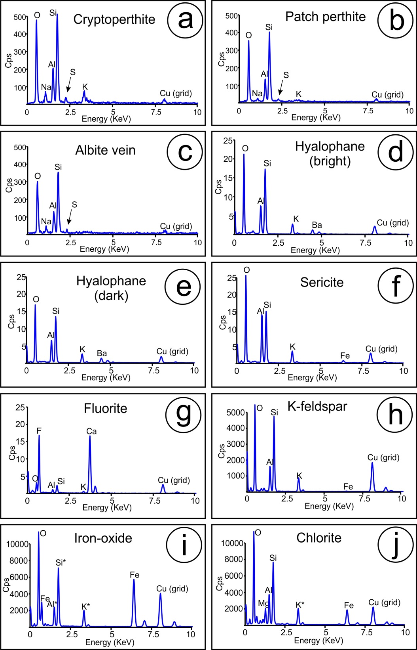

Fig 1 TEM-EDS spectra for various minerals identified. (a-c) Spectra corresponding to the perthite varieties for case study A shown in Fig. 4. (d-g) Spectra corresponding to various inclusions within the albite + sericite + hyalophane + fluorite assemblage for case study B shown in Fig. 8. Note: composition of hyalophane differs in association with brighter and darker zones visible on the HAADF-STEM images. (h-j) Spectra corresponding to K-feldspar, iron-oxide inclusions and chlorite found in case study C shown in Fig. 11. Note: for (i) element peaks marked as * represent interference with host K-feldspar due to small size of Fe-oxide inclusion. Beam size ~50 nm. Abbreviations: Cps - counts per second.

