Supporting Information

Flow field–flow fractionation (FlFFF) coupled to sensitive detection techniques: a way to get insight into the radionuclide interaction with colloidal systems
M. Bouby*, N. Finck, H. Geckeis

Karlsruher Institut für Technologie–Campus Nord (KIT–CN), Institut für Nukleare Entsorgung (INE), Postfach 3640, D–76021 Karlsruhe, Germany.
*E-mail: muriel.bouby@kit.edu

- Gorleben groundwaters characteristics
Table S1. Compositions of the groundwaters Gohy−532 and Gohy−2227 (Artinger et al., 1998; Geckeis et al., 2002).

 | Gohy–532 | Gohy–2227
Sampling depth (m) | 65−68 | 128−130
pH  redox potential (mV)  DOC (mg/L)  PEC (proton exchange capacity) | 8.9  -160  29.9  2.5 10⁻⁴ | 7.7  -123  81.9  6.7 10⁻⁴
HCO₃⁻ (mmol/L)  PO₄⁻ (mmol/L)  SO₄²⁻ (mmol/L)  Cl⁻ (mmol/L)  F⁻ (mmol/L) | 5.48  0.0253  0.005  3.71  0.0316 | 8.00  0.0358  0.282  33.67  0.2053
Si (mmol/L)  Na⁺ (mmol/L)  K⁺ (mmol/L)  Mg (mmol/L)  Ca²⁺ (mmol/L)  Sr²⁺ (mmol/L)  Al³⁺ (mmol/L)  Si (mmol/L)  Fe (mmol/L)  La (mmol/L)  Ce (mmol/L)  U (mmol/L)  Th (mmol/L) | 0.013  9.26  0.025  n.d.  0.047  0.0003  0.0007  0.0132  0.0052  1.1 10⁻⁵  2.4 10⁻⁵  1.5 10⁻⁶  4.3 10⁻⁶ | 0.0022  40.53  0.18  0.19  0.67  0.0024  0.0041  0.0221  0.0059  1.9 10⁻⁵  4.0 10⁻⁵  3.0 10⁻⁶  7.0 10⁻⁶
Ionic strength (mol/L) | 9.6 10⁻³ | 4.4 10⁻²

- Calibration of the AsFlFFF system

The Figure S1 and Table S2 give examples of results of the size fractionation of mixtures of polystyrene sulfonate salts with carboxylated particles. These results are obtained by using an ultra–filtration membrane with a pore size of 5 kDa. The elution flow conditions were changed compared to our previous work (Bouby et al., 2008) in order to improve the particles separation. They consist in an increase of the field flow (95 % of the inflow compared to 75 % previously) and a decrease in the elution flow rate (0.2 ml/min compared to 0.8 ml/min previously). These changes lead to a significant increase (i.e., multiplied by 1.5 ± 0.2) of the retention factor (k) for all the different standards used compared to previous work. In the mean time, as seen in Table S2, the separation factor (α) is favored in the smallest size range for an equivalent or slightly improved peak resolution (R_{s}). The retention factor is defined (Ettre, 1993) as k = (t_{R} - t₀) / t₀, where t_{R} is the retention time of the component and t₀ is the elution time for a non retained component (defined by the void peak position). The separation factor α and the peak resolution R_{s} are defined for two adjacent components 1 and 2 as α = k₂ / k₁ and R_{s}= 2 × (t_{R2} - t_{R1}) / (w_{b1} - w_{b2}), where w_{bi} is the average peak width at the base of the i^{th} component (w_{b} = 4σ for a Gaussian peak).
Figure S1. Results of the size calibration performed by injection of two mixtures of polystyrene sulfonate standard salts and carboxylated polystyrene particles (mean of three successive injections for each mixtures). Spectrophotometric UV detection at 225 nm. Membrane: regenerated cellulose, 5 kDa. The outflow rate is 0.2 mL/min and the cross flow decreases from 3.8 mL/min (i.e., 95 % of the total inflow) down to 0 mL/min after 38 min. Injection: 100 µL (see text and Table S2 for the mass concentration and reproducibility). Carrier: ultra–pure water and NaOH at pH 9.3.

Table S2. Mean values and standard deviations for the peak positions of the particles used for the size calibration after 6 successive injections.
Peak position / s
 | v_{p}^{b)} | PSS^{a)} / kDa |  |  |  |  | CP^{a)} / nm
 | v_{p}^{b)} | 1.29 | 4.4 | 15.2 | 29 | 81.8 | 24 | 105 | 207
Particle diameter [nm] ^{c)} |  | 1.8 | 3.2 | 5.7 | 7.7 | 12.5
Mass concentration [µg/L] |  | 100 | 100 | 100 | 100 | 100 | 2000 | 1000 | 1000
Mean value | 53.1  56.4 | 189.8  164 | 329.6  252 | 550.8  400 | 706.9  464 | 991.4  706 | 1183.6  862 | 1895.8  1569 | 2304.4  1834
Std. Dev. | 2.2  2.9 | 9.7  3.9 | 11.1  7.7 | 13.3  6.3 | 4.9  1.7 | 15.8  8.2 | 14.4  23.4 | 22.6  17.4 | 32.6  6.9
Rel. Std. Dev. (%) | 4.06  5.2 | 5.09  2.4 | 3.4  3.1 | 2.41  4.1 | 0.7  2.5 | 1.6  1.2 | 1.2  2.7 | 1.2  1.1 | 1.4  0.4
Retention factor (k)^{d)} |  | 2.6  1.9 | 5.2  3.5 | 9.4  6.1 | 12.3  7.2 | 17.7  11.5 | 21.3  14.3 | 34.7  26.8 | 42.4  31.5
Separation factor (α)^{d)} |  |  | 2.0  1.8 | 1.8  1.8 | 1.3  1.2 | 1.4  1.6 | 1.2  1.2 | 1.6  1.9 | 1.2  1.2
Peak resolution (R_{s})^{d)} |  |  | 0.7±0.1  0.6±0.1 | 0.9±0.2  1.0±0.2 | 0.5±0.2  0.3±0.1 | 0.7±0.2  1.4±0.4 | 0.5±0.1  0.5±0.1 | 1.7±0.2  1.6±0.1 | 0.7±0.1  0.7±0.1
a) PSS: polystyrene sulfonate standard salts; CP: carboxylated polystyrene particles
b) Void peak
c) Particle diameter of PSS colloids are determined according to (Millipore, 2000) and assuming a linear shape of the PSS under the given experimental conditions.
d) According to the definition by IUPAC (Ettre, 1993)
Data in grey are the results from fractionation with different elution flow conditions (Bouby et al., 2008).
- Closer look at the hectorite fractogram
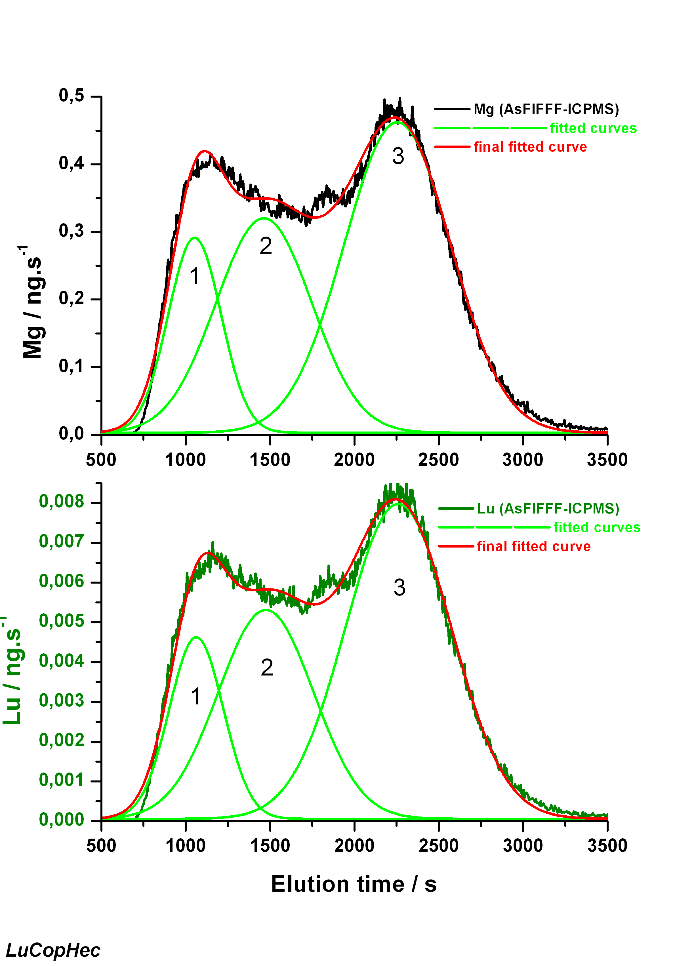
Figure S2. Mg− and Lu−fractograms modeling considering 3 Gaussian functions. The results are shown in the Table S3.

Table S3. Element mass and molar ratios determined by fitting the fractograms with Gaussian functions.

Mg (ng) | Lu (ng) | Mg:Lu (Molar ratio)
113.1 | 1.8 | 444.2
225.5 | 3.7 | 436.4
363.9 | 6.3 | 419.4

- Additional results for the Gorleben groundwater samples
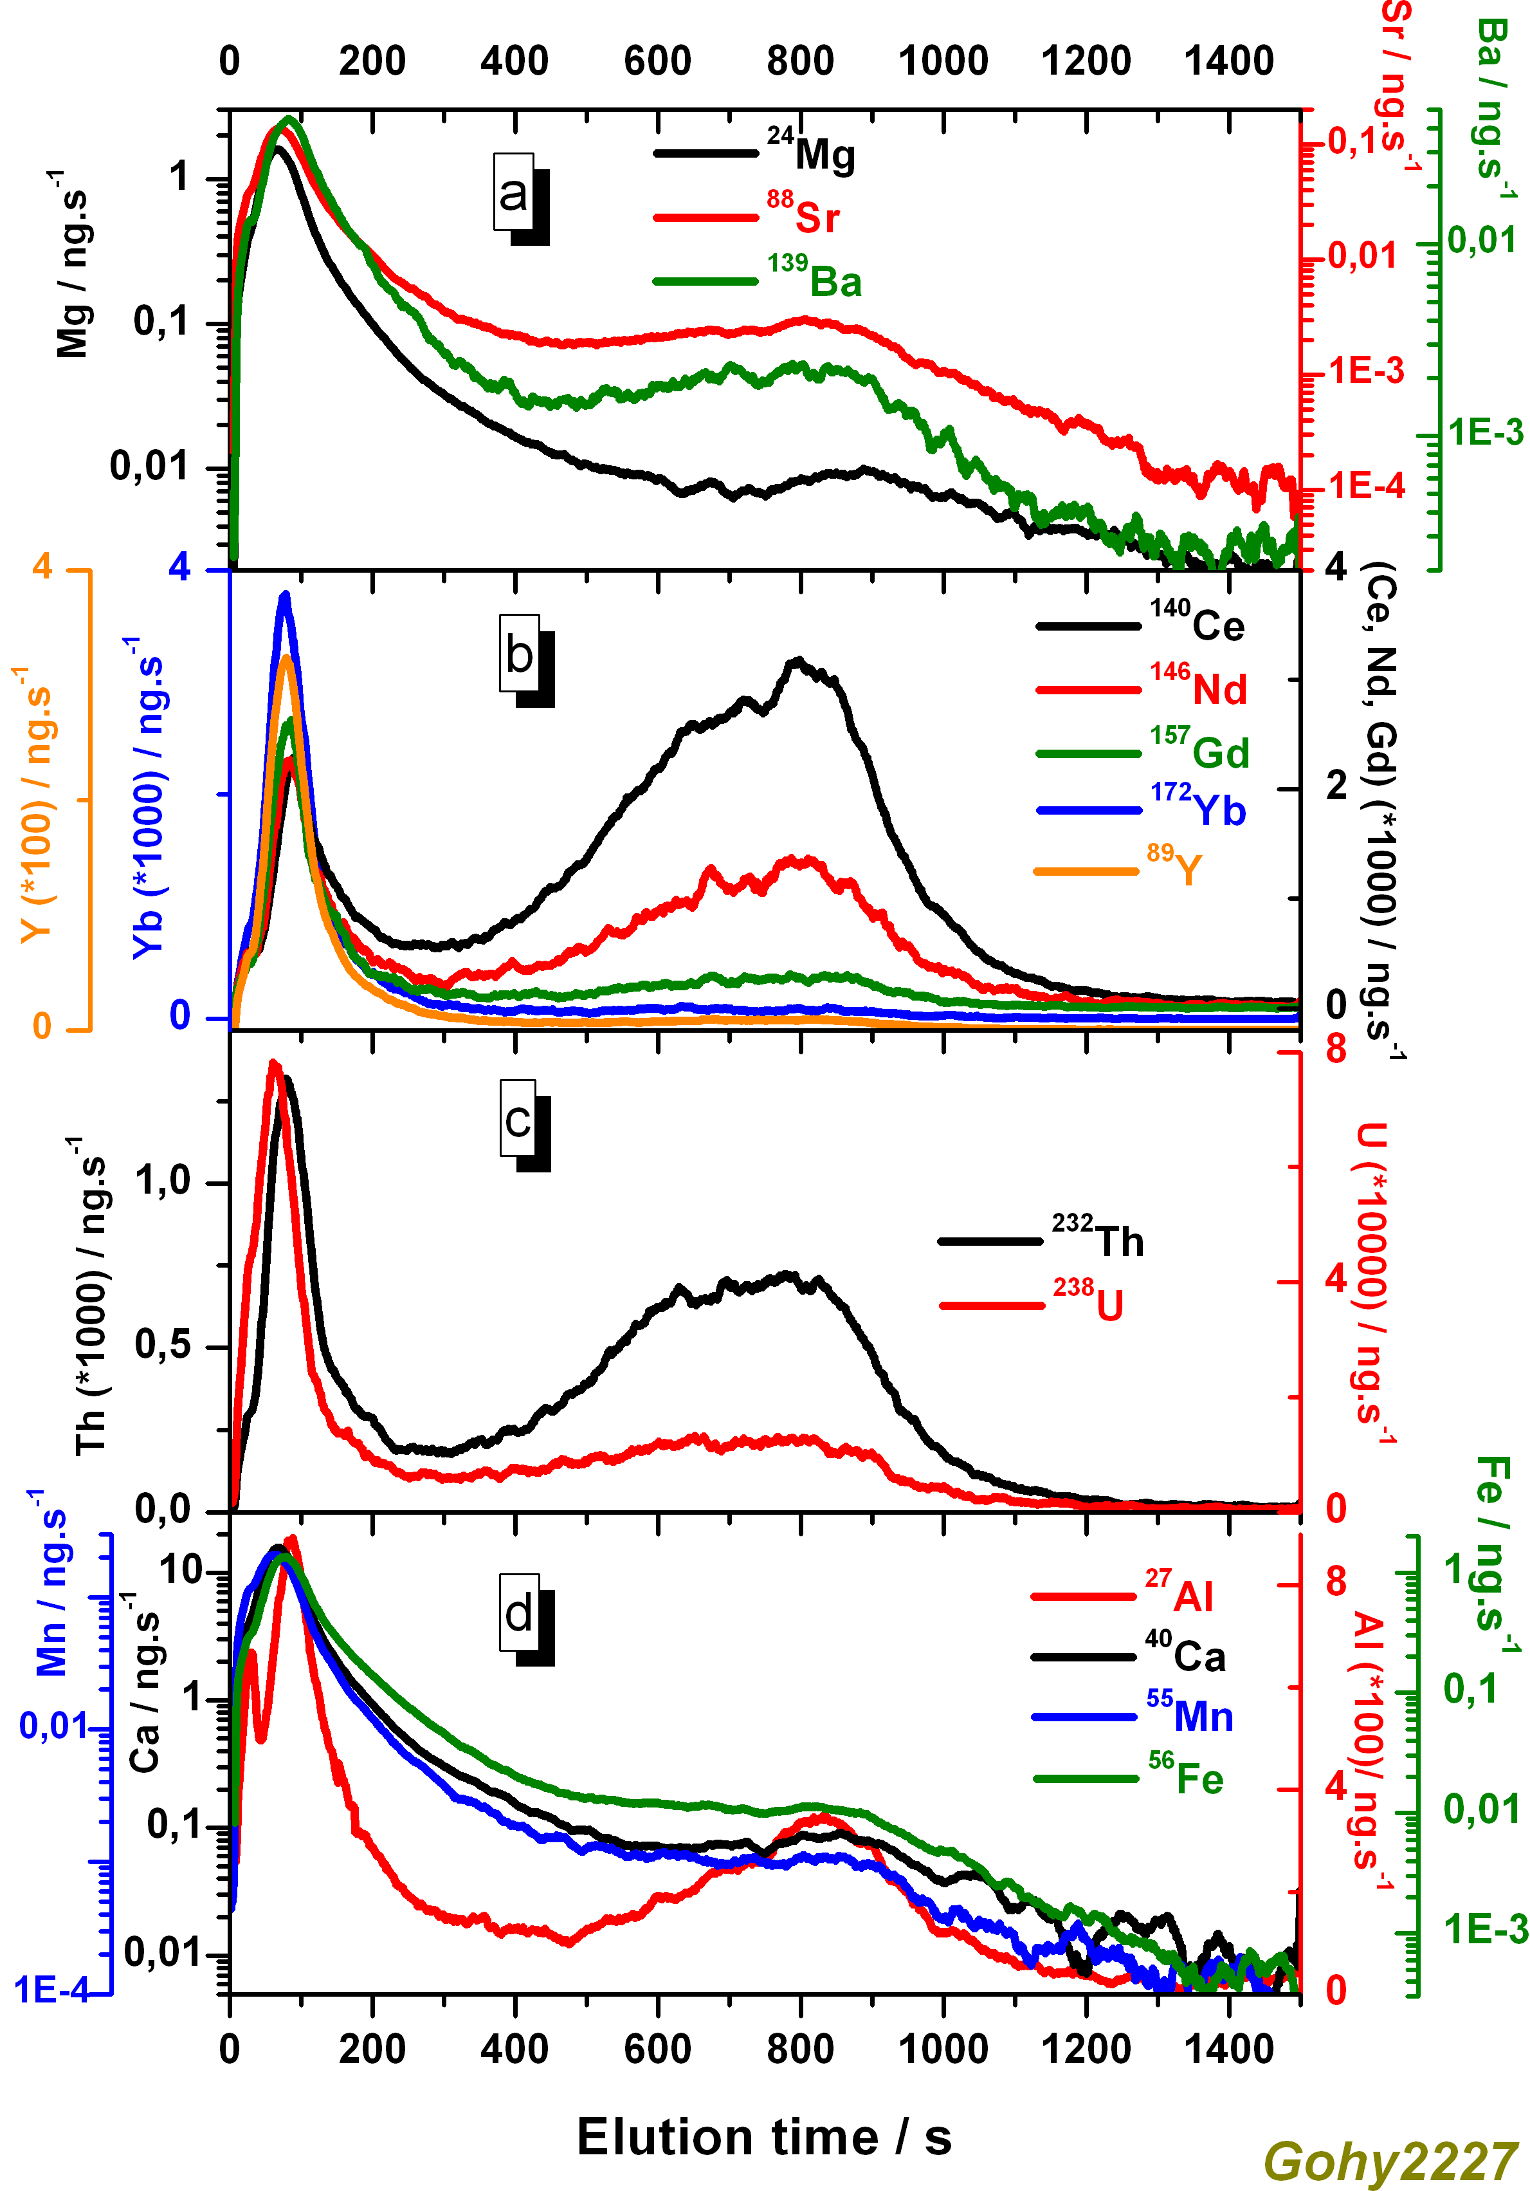
Figure S3. ICP–MS fractograms obtained by averaging two successive injections of 500 µL aliquots of Gohy–2227. Experimental conditions: regenerated cellulose membrane 1 kDa; spacer 500 µm; eluent: ultra–pure water with NaOH at pH 9.3; outflow rate 0.2 ml/min, programmed cross-flow: from 3.8 mL/min (i.e., 95 % of the total inflow rate) down to 0 mL/min in 38 min.
Figure S4. UV–fractograms obtained for two successive injections of 500 µL aliquots of Gohy–2227 (black) and Gohy–532 (red).

Table S4. Repartition and recovery of the elements constitutive of the colloidal fractions, and position of the first peak maxima of Gohy–2227.
Elements | Repartition (in % ± 5 %) |  | Recovery | Peak 1 maximum position
Elements | Peak 1  50 – 350 s  0.5 – 4 nm | Peak 2  350 – 1500 s  4 – 18 nm | (in % ± 5 %) | (in s ± 2 s)
²⁴Mg | 93 | 7 | 6 | 67
⁸⁸Sr | 86 | 14 | 11 | 69
¹³⁷Ba | 76 | 24 | 4 | 83
¹³⁹La | 27 | 73 | 61 | 87
¹⁴⁰Ce | 18 | 82 | 61 | 89
¹⁴¹Pr | 25 | 75 | 60 | 83
¹⁴⁶Nd | 29 | 71 | 63 | 85
¹⁴⁷Sm | 44 | 56 | 74 | 87
¹⁵³Eu | 78 | 22 | 91 | 78
¹⁵⁷Gd | 62 | 38 | 66 | 83
¹⁵⁹Tb | 72 | 28 | 68 | 85
¹⁶³Dy | 78 | 22 | 69 | 83
¹⁶⁵Ho | 82 | 18 | 65 | 83
¹⁶⁶Er | 84 | 16 | 73 | 76
¹⁶⁹Tm | 84 | 16 | 73 | 78
¹⁷²Yb | 85 | 15 | 72 | 78
¹⁷⁵Lu | 88 | 12 | 56 | 71
⁸⁹Y | 83 | 17 | 67 | 78
²³²Th | 29 | 71 | 66 | 80
²³⁸U | 47 | 53 | 41 | 62
²⁷Al | 42 | 58 | 27 | 84
⁴⁰Ca | 94 | 6 | 12 | 67
⁵⁵Mn | 94 | 6 | 38 | 64
⁵⁶Fe | 92 | 8 | 62 | 76
UV signal | 82 | 18 | n.d.* | ~ 60 – 70 s
*n.d.: not determined.

References
Artinger, R.; Kienzler, B.; Schüssler, W.; Kim, J.I. (1998) In: G. Buckau (Ed.). Effects of Humic Substances on the Migration of Radionuclides: Complexation and Transport of Actinides. First Technical Progress Report, Forschungszentrum Karlsruhe, Wissenschaftliche Berichte, FZKA 6124, pp 23–43.
Bouby, M.; Geckeis, H.; Geyer, F.W. (2008). Application of asymmetric flow field–flow fractionation (AsFlFFF) coupled to inductively coupled plasma mass spectrometry (ICPMS) to the quantitative characterization of natural colloids and synthetic nanoparticles. Analytical and Bioanalytical Chemistry, 392, 1447–1457.
Ettre, L.S. (1993). IUPAC. Nomenclature for chromatography, Pure and Applied Chemistry, 65, 819–872.
Geckeis, H.; Rabung, T.; Ngo Manh, T.; Kim, J.I., Beck, H.P. (2002). Humic colloid–borne natural polyvalent metal ions: dissociation experiment. Environmental Science & Technology, 36, 2946–2952.
Millipore (2000). www.millipore.com/techpublications/tech1/pf1172en00

