Supplementary materials

Comparison of age readings
To detect the differences of the age readings between the different age readers, the following formulas were used:
Average percentage error (APE) (Beamish & Fournier, 1981)
APE = $\frac{100}{n}\sum_{i=1}^{n}{\left(\frac{1}{r} \sum_{j=1}^{r}{\frac{\left|x_{ij}-{\overline{x}}_{i}\right|}{x_{ⅈ}}}\right)}$
where, n = number of otoliths; r = number of readings for each otolith; $x_{ij}$ = j value of age estimation for the i otolith; ${\overline{x}}_{i}$ = average age calculated for the i otolith
Coefficient of Variation (CV) (Beamish & Fournier, 1981)
CV= $\frac{100}{n}\left[\sum_{i=1}^{n}{\left(\frac{sd}{{\overline{x}}_{i}} \right)}\right]$
where, n = number of otoliths; sd = standard deviation for the i otolith; ${\overline{x}}_{i}$ = average age calculated for the i otolith
Percentage of agreement (PA)
PA=100 x (number of readers agreeing with modal age/total number of readers)
References
Beamish, RJ and Fournier DA (1981) A method for comparing the precision of set of age determinations. Canadian Journal of Fisheries and Aquatic Sciences, 38, 982–983.

Table S1
Common within-group slope (b), based on the formula: Otolith variable= aTL^{b} (Elliot et al., 1995), used for the standardization of the otolith morphometric variables: RA (Radius, mm), OL (Otolith Length, mm), OW (Otolith Width, mm), OA (Otolith Area, mm²), PE (Perimeter, mm) and EL (Ellipticity) for the combined data of Serranus hepatus in both study areas.
Otolith variable | b
RA | 0.78
OL | 0.75
OW | 0.95
OA | 1.76
PE | 0.84
EL | -0.25

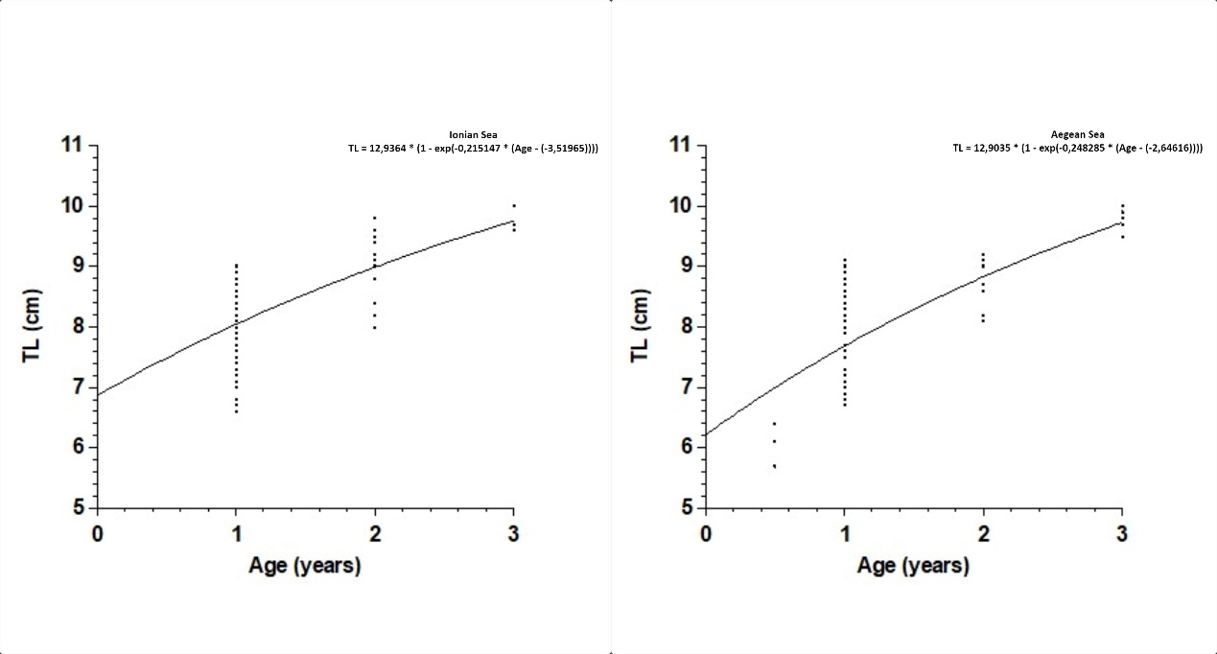
Figure S1. Age-length relationships for the E. Ionian and SW Aegean Seas (left and right respectively).

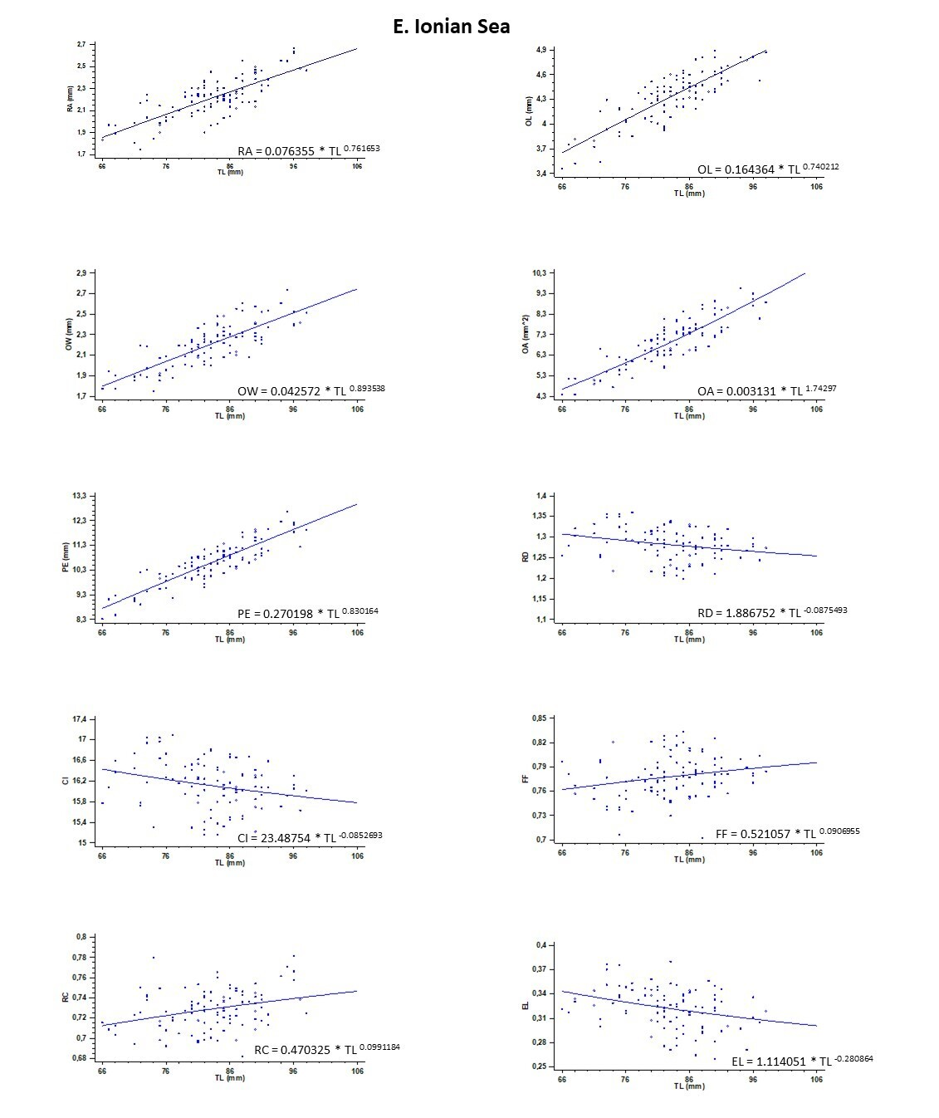
Figure S2. Exponential relationships of total length (mm) and otolith morphometric variables for the E. Ionian Sea. RA (Radius, mm), OL (Otolith Length, mm), OW (Otolith Width, mm), OA (Otolith Area, mm²), PE (Perimeter, mm), RD (Roundness), CI (Circularity), FF (Form Factor), RC (Rectangularity) and EL (Ellipticity).

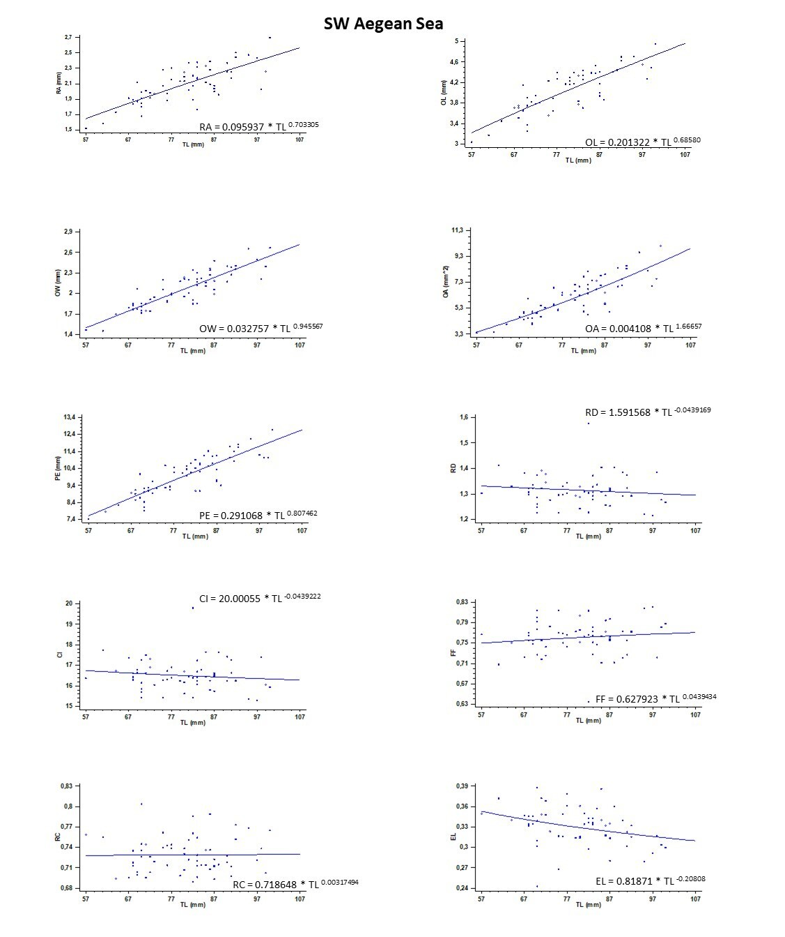
Figure S3. Exponential relationships of total length (mm) and otolith morphometric variables for the SW Aegean Sea. RA (Radius, mm), OL (Otolith Length, mm), OW (Otolith Width, mm), OA (Otolith Area, mm²), PE (Perimeter, mm), RD (Roundness), CI (Circularity), FF (Form Factor), RC (Rectangularity) and EL (Ellipticity).

Table S2
Results of Multivariate GLM (according to four different Tests) of the effect of study Area. df: degrees of freedom.
Multivariate Tests | Value | F | df |  | p-value
Pillai’s Trace | 0.095 | 3.030 |  | 5 | 0.012*
Wilks’ Lambda | 0.905 | 3.030 |  | 5 | 0.012*
Hotelling’s Trace | 0.105 | 3.030 |  | 5 | 0.012*
Roy’s Largest Root | 0.105 | 3.030 |  | 5 | 0.012*
* : significance level a = 0.05

