Supplementary tables and figures:
Table S1. All cetacean encounters made during visual surveys during the survey from Cape Town to Vema Seamount and back, with a daily encounter code (EncDaily). Species are MN (humpback whale), BP (fin whale), Bbor (sei whale), UBW (Unidentified Baleen Whale), UBAL (Unidentified Balaenopterid Whale, UO (Unidentified Odontocete) and UD (Unidentified Dolphin). Group size estimates provided as minimum/best estimate/maximum.
Date | Time | EncDaily | Species | Latitude | Longitude | Group Size
2019-10-24 | 09:24 | 20191024_01 | MN | -32.6123 | 12.83332 | 1/1/1
2019-10-25 | 06:59 | 20191025_01 | MN | -31.687 | 9.708992 | 1/1/1
2019-10-25 | 07:39 | 20191025_02 | UBAL | -31.6863 | 9.598545 | 1/1/2
2019-10-25 | 08:23 | 20191025_03 | UBAL | -31.6869 | 9.479283 | 1/1/1
2019-10-26 | 07:34 | 20191026_02 | MN | -31.5629 | 8.341433 | 1/1/2
2019-10-26 | 07:48 | 20191026_03 | UBW | -31.593 | 8.327997 | 1/1/1
2019-10-26 | 08:11 | 20191026_04 | MN | -31.6297 | 8.314275 | 2/2/3
2019-10-28 | 17:41 | 20191028_01 | BP | -31.8958 | 13.29866 | 1/1/1
2019-10-28 | 18:20 | 20191028_02 | BP | -31.9635 | 13.32667 | 1/1/2
2019-10-28 | 18:41 | 20191028_03 | UBAL | -31.9802 | 13.32991 | 3/3/4
2019-10-29 | 07:06 | 20191029_01 | UBAL | -31.7905 | 15.31281 | 1/1/1
2019-10-29 | 07:52 | 20191029_02 | BP | -31.8203 | 15.35247 | 1/1/2
2019-10-29 | 08:03 | 20191029_03 | UBAL | -31.8667 | 15.41376 | 1/1/2
2019-10-29 | 08:18 | 20191029_04 | UBAL | -31.8808 | 15.43165 | 2/2/3
2019-10-29 | 08:32 | 20191029_05 | UBAL | -31.9263 | 15.48208 | 1/1/1
2019-10-29 | 08:33 | 20191029_06 | UBAL | -31.9326 | 15.48877 | 1/1/2
2019-10-29 | 08:44 | 20191029_07 | UBAL | -31.9423 | 15.49898 | 1/1/2
2019-10-29 | 08:46 | 20191029_08 | UBAL | -31.946 | 15.50285 | 1/1/1
2019-10-29 | 09:23 | 20191029_09 | UBAL | -31.9917 | 15.54482 | 1/1/2
2019-10-29 | 09:25 | 20191029_10 | BP | -32.0005 | 15.55209 | 1/1/2
2019-10-29 | 11:49 | 20191029_11 | UBAL | -32.2082 | 15.78959 | 1/1/2
2019-10-29 | 15:23 | 20191029_12 | Bbor | -32.2475 | 15.64354 | 1/1/2
2019-10-29 | 15:27 | 20191029_13 | BP | -32.2554 | 15.62396 | 1/1/2
2019-10-29 | 15:43 | 20191029_14 | UBAL | -32.2721 | 15.58269 | 1/1/2
2019-10-29 | 17:14 | 20191029_15 | UBAL | -32.3622 | 15.41405 | 1/1/1
2019-10-29 | 17:26 | 20191029_16 | UBAL | -32.3767 | 15.39085 | 1/1/1
2019-10-29 | 17:38 | 20191029_17 | BP | -32.3952 | 15.34294 | 3/3/4
2019-10-29 | 17:55 | 20191029_18 | UBAL | -32.3946 | 15.32049 | 1/1/2
2019-10-29 | 17:57 | 20191029_19 | UBAL | -32.3944 | 15.31327 | 1/1/2
2019-10-30 | 07:08 | 20191030_01 | UO | -32.2382 | 13.02741 | 1/1/2
2019-10-30 | 08:16 | 20191030_02 | MN | -32.1986 | 12.82881 | 1/1/2
2019-10-30 | 08:32 | 20191030_03 | UO | -32.1954 | 12.76939 | 1/2/2
2019-10-30 | 10:52 | 20191030_04 | UBW | -32.1519 | 12.41344 | 1/1/2
2019-10-30 | 11:18 | 20191030_05 | UO | -32.1355 | 12.25933 | 1/1/2
2019-10-30 | 11:39 | 20191030_06 | UO | -32.136 | 12.21335 | 1/1/2
2019-11-04 | 08:52 | 20191104_01 | MN | -31.6511 | 8.348142 | 2/2/2
2019-11-04 | 16:19 | 20191104_02 | UBW | -31.6292 | 8.315558 | 1/1/1
2019-11-06 | 07:24 | 20191106_01 | MN | -32.7322 | 14.57392 | 1/1/2
2019-11-06 | 16:01 | 20191106_02 | UBAL | -33.2495 | 15.93817 | 1/1/2

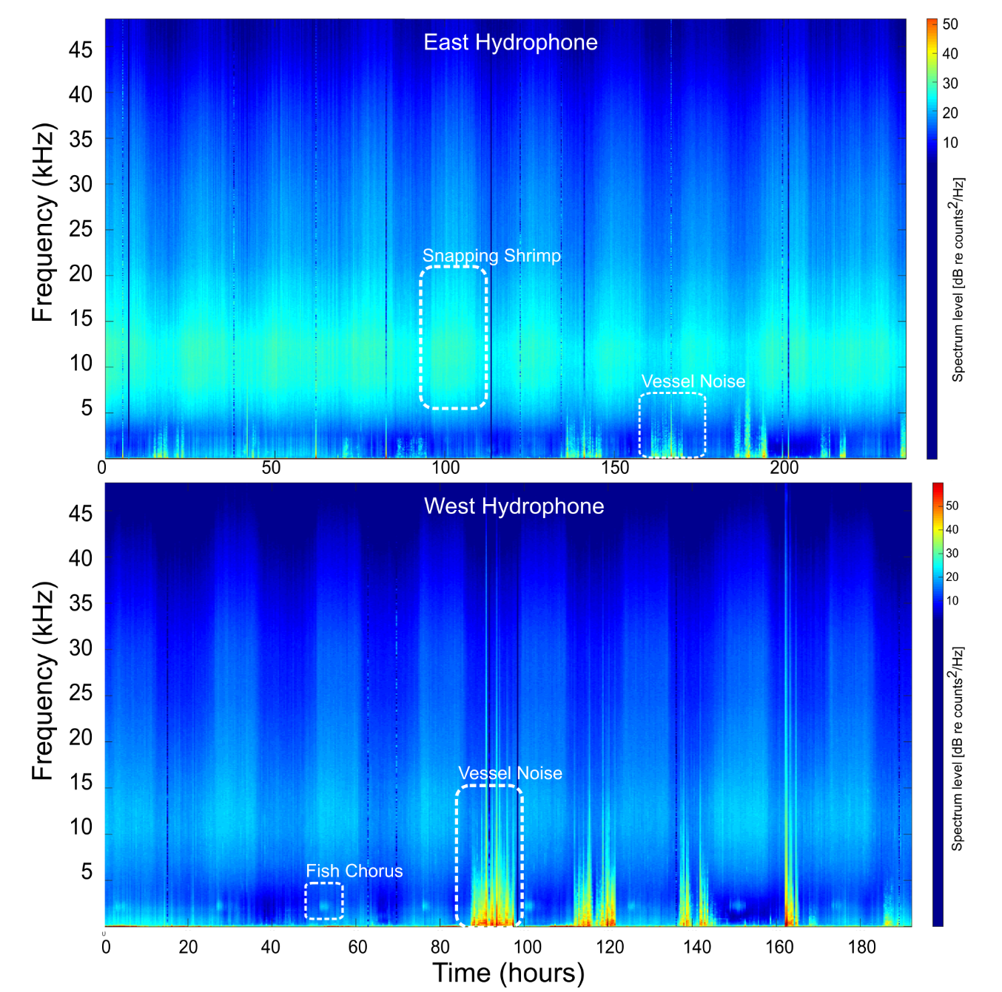
Figure S1. Long-Term Spectral Average (LTSA) showing the complete set of sounds recorded by the east and west moorings at Vema Seamount during October and Novermber 2019. Daily cycles in reef noise are clearly obvious as well as periods of high amplitude ship noise.

Figure S2. Diel patterns of occurrence of dominant whale calls detected and close boat noise over the duration of the deployment of two SoundTrap hydrophones on the western (left panels) and eastern (right panels) sides of Vema Seamount during October and November 2019. Data calculated as a proportion of detection positive minutes over a day (subsampled at 1 minute every 5) and plotted as a loess smoothed curve.

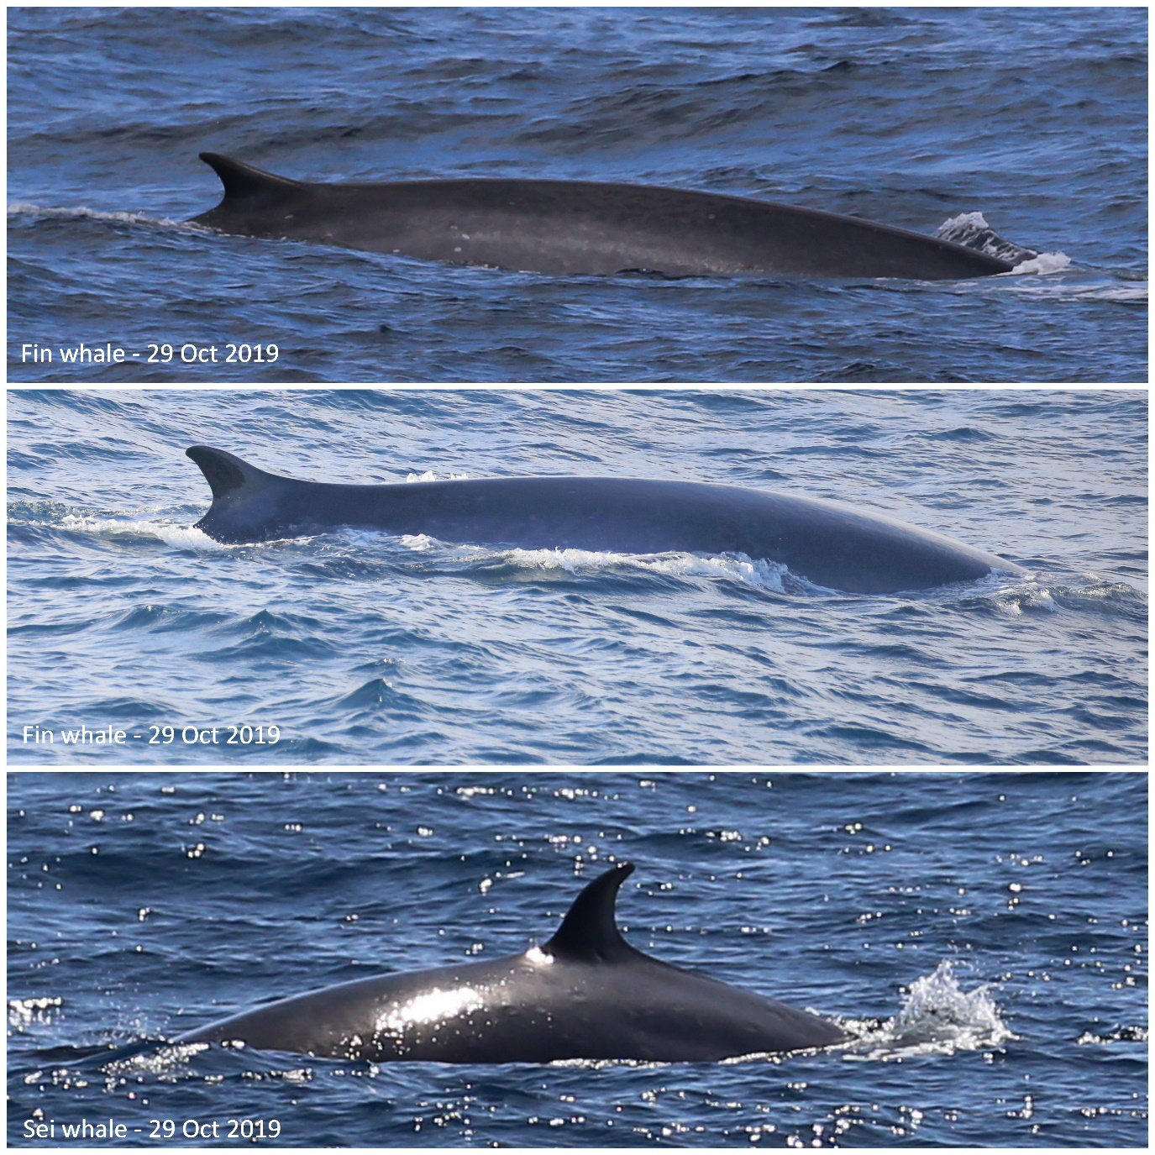

Figure S3. Photographs of whales identified off the western shelf of South Africa during a cruise to Vema Seamount during Oct-Nov 2019.

