APPENDIX/ Supplementary material
DNA barcoding reveals deep divergent molecular units in Pomatomus saltatrix (Perciformes; Pomatomidae): implications for management and global conservation
Maria Clara G. de Queiroz-Brito^{1,2*}, Carolina B. Machado³, Danielle de Jesus Gama Maia⁴, Uedson Pereira Jacobina⁵, Mauro Nirchio^{6,7}, Matheus M. Rotundo⁸, Rafael A. Tubino⁹, Pedro J. Iriarte^{10,11}, Manuel Haimovici¹², Rodrigo A. Torres²
¹Programa de Pós-graduação em Biologia Animal. Departamento de Zoologia. Universidade Federal de Pernambuco, Recife, Pernambuco, Brazil. (claraqueirozbrito@gmail.com; ORCID: 0000-0003-4441-518X)
²Laboratório de Genômica Evolutiva e Ambiental. Departamento de Zoologia. Universidade Federal de Pernambuco, Recife, Pernambuco, Brazil. (rodrigo.atorres@ufpe.br; ORCID: 0000-0002-1158-9899)
³Laboratório de Biodiversidade Molecular e Conservação. Departamento de Genética e Evolução. Universidade Federal de São Carlos, São Carlos, São Paulo, Brazil. (carolbioms@gmail.com; ORCID: 0000-0001-5195-5577)
⁴Programa de Pós-graduação em Ecologia, Universidade Federal do Rio de Janeiro, Rio de Janeiro, Brazil. (danielle.gamaia@gmail.com; ORCID: 0000-0001-7071-8083)
⁵Laboratório de Ictiologia e Conservação, Universidade Federal de Alagoas, Campus Penedo, Penedo, Alagoas, Brazil. (uedsonbio@gmail.com; ORCID: 0000-0002-5595-9812)
⁶Universidad de Oriente, Porlamar, Venezuela. (mauro.nirchio@gmail.com; ORCID: 0000-0001-7171-2433)
⁷Universidad Técnica de Machala, Machala, Ecuador.
⁸Acervo Zoológico da Universidade Santa Cecília, Santos, São Paulo, Brazil. (mmrotundo@hotmail.com; ORCID: 0000-0003-1886-5320)
⁹Universidade Federal Rural do Rio de Janeiro, Campus Seropédica, Seropedica, Rio de Janeiro, Brazil. (rattubino@gmail.com; 0000-0002-3175-4724)
¹⁰Universidade Nacional de Mar del Plata, Mar del Plata, Buenos Aires, Argentina. (firiarte@mdp.edu.ar; ORCID: 0000-0003-0353-8554)
¹¹Consejo Nacional de Investigaciones Científicas e Técnicas, CONICET, Argentina.
¹²Fundação Universidade Federal do Rio Grande, Rio Grande, Rio Grande do Sul, Brazil. (manuelhaimovici@gmail.com; ORCID: 0000-0003-1741-8182)
¹³Universidade Tecnológica Federal do Paraná, Campus Londrina, Paraná, Brazil.
*Corresponding author: claraqueirozbrito@gmail.com
Table S1. Details of Pomatomus saltatrix sequences used on this present work and information about vouchers, haplotypes, geographical coordinates and sample sizes.
Sampling site/Ocean or Basin | Geographical coordinates  Latitude/Longitude |  |  | Code** | Voucher |  | Hap | N
South Africa- Kwazulu Natal  (Indian Ocean) |  | -29.945.000/  31.000.000 | JF494266-JF494269; DQ885040 |  | South Africa Institute of Aquatic Biodiversity (Grahamstown, South Africa) |  | Hap1-Hap3 | 6
South Africa- Kwazulu Natal (Indian Ocean) |  | -30.333.000/ 30.750.000 | DSLAG1131-11; DSLAG1143-11; DSLAR018-08- DSLAR020-08; TZSAL562-13 |  |  |  | Hap1; Hap4-Hap6 | 6
South Africa- Kwazulu Natal (Indian Ocean) |  | -28.403.000/ 32.203.000 | HVDBM880-12; HVDBM881-12 |  | University of Johannesburg, Department of Zoology |  | Hap1 | 2
Madagascar (Indian Ocean) |  | -25.027.500/ 46.995.600 | SAIAD257-11 |  | South African Institute for Aquatic Biodiversity |  | Hap1 | 1
Namibia (Eastern South Atlantic) |  | -22.900.000/  14.533.306 | HVDB086-09; HVDBF240-11; HVDBF241-11; HVDBF486-12 |  | University of Johannesburg, Department of Zoology |  | Hap1 | 4
Cadiz, Barcelona, Istanbul and Canakkale (Mediterranean Sea)* |  | 35.004.702/  19.147.115 | JQ039400-JQ03406; JQ039425-JQ039429 |  |  |  | Hap1; Hap7-Hap17 | 12
Israel (Mediterranean Sea) |  | 31.795.000/ 34.619.000 | BIM139-13 |  | Tel Aviv University |  | Hap1 | 1
Israel (Mediterranean Sea) |  | 31.874.000/ 34.580.000 | BIM899-21 |  | Tel Aviv University, Steinhardt Museum of Natural History |  | Hap1 | 1
Turkey (Sea of Marmara) |  | 40.736.667/  28.237.500 | KC501113-KC501132; KY176580; JQ623971 |  | Biotechnology Institute of Ankara  University |  | Hap1; Hap18- Hap22 | 22
Turkey (Black Sea) |  |  | GBMNB10932-20 |  |  |  | Hap1 | 1
Australia- Queensland (South Pacific) |  | -20.650.758/  149.793.896 | DQ885110-DQ885114 |  | Australian National Fish Collection |  | Hap24; Hap25 | 5
Australia- New South Wales (South Pacific) |  | -34.050.000/ 151.083.000 | AMS933-08 |  | Australian Museum, Sydney |  | Hap24 | 1
Australia- New South Wales (South Pacific) |  | -33.473.300/ 151.447.000 | FOAK605-10; FOAK623-10; FOAK634-10; FOAK636-10 |  | Biodiversity Institute of Ontario |  | Hao24; Hap26; Hap27 | 4
Canada (Western North Atlantic) |  | 45.130.000/  -67.067.000 | KC015826; KC015828 |  | Dalhousie University |  | Hap28; Hap29 | 2
Tunisia (Mediterranean Sea) |  | 36.924.742/  10.465.154 | KY500055-KY500065 |  | National Museum of Natural History, Paris (MNHN HEL596) |  | Hap1; Hap12; Hap13; Hap16; Hap23 | 11
USA |  |  | ANGBF39604-19- ANGBF39606 |  |  |  | Hap33; Hap42; Hap43 | 3
USA- Maine |  | 43.886.367/  -68.653.508 | KC015828 |  | Dalhousie University |  | Hap30 | 1
USA (New Jersey, Florida, North Carolina and Maryland) (Western North Atlantic)* |  | 34.556.793/  -76.301.682 | JQ039407-JQ039424; JQ039430-JQ039435 |  |  |  | Hap29-Hap52 | 24
USA- Washington DC (Western North Atlantic) |  | 38.695.913/  -76.380.415 | HQ024997-HQ025000 |  | Smithsonian Institution, National Museum of Natural History |  | Hap34 | 4
USA- North Carolina (Western North Atlantic) |  | 35.517.000/  -75.367.000 | KP111079; KP111428 |  | NOAA, Northeast Fisheries Science Center |  | Hap30; Hap47 | 2
USA- Virginia (Western North Atlantic) (Environmental Sample) |  | 37.300.000/  -75.067.000 | KP111507 |  | NOAA, Northeast Fisheries Science Center |  | Hap51 | 1
USA- Virginia (Western North Atlantic) |  | 37.316.700; -75.483.3000 | KF930302 |  | Kansas University, Biodiversity Research Center |  | Hap54 | 1
USA- Alabama (Gulf of Mexico) |  | 30.155.978/  -87.929.962 | KF461220-KF461221 |  | Smithsonian Institution, National Museum of Natural History |  | Hap29; Hap55 | 2
USA- Florida (Western North Atlantic) |  | 27.321.300/  -80.228.000 | JQ842657 |  | Smithsonian Institution, National Museum of Natural History |  | Hap54 | 1
Mexico- Quintana Roo (Gulf of Mexico) |  | 21.426.000/ -87.342.000 | MXV296-11; MXV343-11 |  | El Colegio de la Frontera Sur, Unidad Chetumal |  | Hap30; Hap48 | 2
Venezuela- Islas Margaritas (Caribean Sea) |  | 11.079.358/  -64.077.210 | MN199456-MN199461 |  |  |  | Hap56- Hap58 | 6
BR- Rio de Janeiro  (Western South Atlantic) |  | -21.891.000/  -40.709.000 | JX124867-JX124869 |  | Paulista State University, Laboratory of Biology and Fish Genetics |  | Hap56 | 3
BR- São Paulo  (Western South Atlantic) |  | -23.506.000/  -45.034.000 | GU702357; GU702359-GU702362;  JQ365505-JQ365519 |  | Paulista State University, Laboratory of Biology and Fish Genetics |  | Hap56; Hap59- Hap65 | 20
Argentina- Buenos Aires  (Western South Atlantic) |  | -37.320.000/  -57.190.000 | EU074551-EU074555 |  | National University of Mar de Plata |  | Hap62; Hap66- Hap68 | 5
Argentina- Buenos Aires (Western South Atlantic) |  | -38.786.100/ -59.528.800 | EPQ030-19 |  | Museo Argentino de Ciencias Naturales, Bernardino Rivadavia |  | Hap59 | 1
Hap, Haplotype; N, Sample size
*These geographic locations were obtained directly with the authors of the reference paper (Miralles et al., 2014b)
**GenBank or BOLD code.
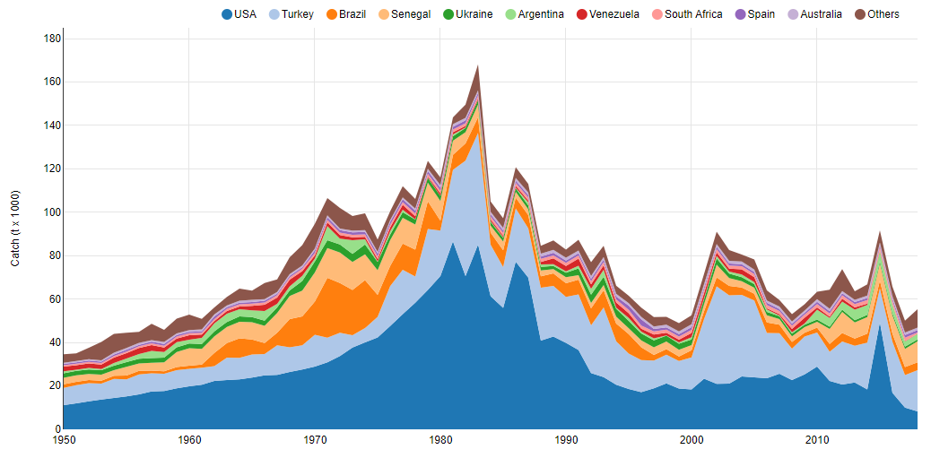
Fig. S1. Catch fisheries graphic of P. saltatrix around the world between 1950-2018. (Online resource available at Sea Around Us seaaroundus.org; ©The University of British Columbia and The University of Western Australia).
Fig. S2. Rarefaction curve of haplotype richness for each MOTU of Pomatomus saltatrix COI gene. Color dashed lines indicate the standard error, and the vertical black dashed line indicates the lowest number of sequences sampled for our database (N=12).
Fig. S3. Haplotype network based on TCS method generated on PopART of Pomatomus saltatrix. The pie charts represent the haplotypes, and different colors represents the different sample sites, showing the identified MOTUs. Lines between the haplotypes represent to base pair mutation and black circles are missing or unidentified haplotypes. [CAN: Canada; USA: United States (New Jersey, Florida, North Carolina and Maryland); USA-ME: United States, Maine; USA-WD: United States, Washington DC; USA-VA: United States, Virginia; USA-NC: United States, North Carolina; USA-FL: United States, Florida; USA-AL: United States, Alabama; MEDT: Mediterranean Sea (Cadiz, Barcelona, Istanbul and Canakkale); TUN: Tunisia; TUR: Turquia; NAM: Namibia; SA: South Africa; MAD: Madagascar; AUS: Australia; VEN: Venezuela; BR-RJ: Brazil, Rio de Janeiro; BR-SP: Brazil, São Paulo; ARG: Argentina; NI: Not informed].
Fig. S3. Demographic analysis of Mismatch Distribution for each MOTU of Pomatomus saltatrix. The blue line represents the values observed in present data; the red line represents the expected frequencies under the constant population size model; and the yellow line represents the expected frequencies under the demographic growth decline model. (a) MOTU I, (b) MOTU II, (c) MOTU III, (d) MOTU IV, (e) MOTU V.

