Supplementary Material

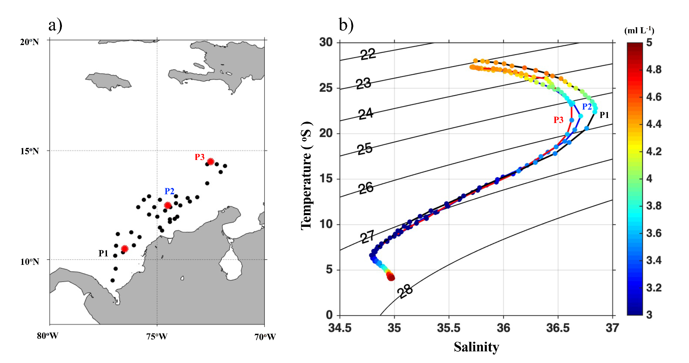

Figure S1. T-S-O2 diagram calculated for the study area (a) with World Ocean Atlas (2018) climatology (b). Red dots: P1, P2 and P3 are mean profiles for each sector. Black dot: sampling stations.

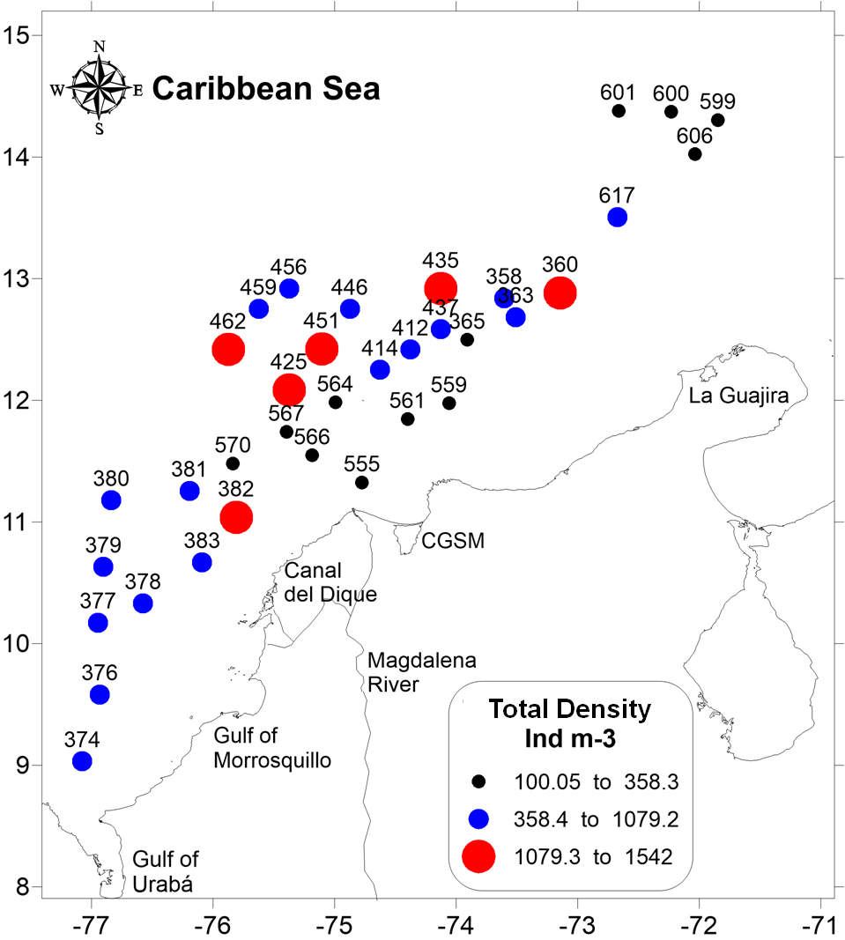
Figure S2. General density population distribution of copepods in the CAO ecoregion.

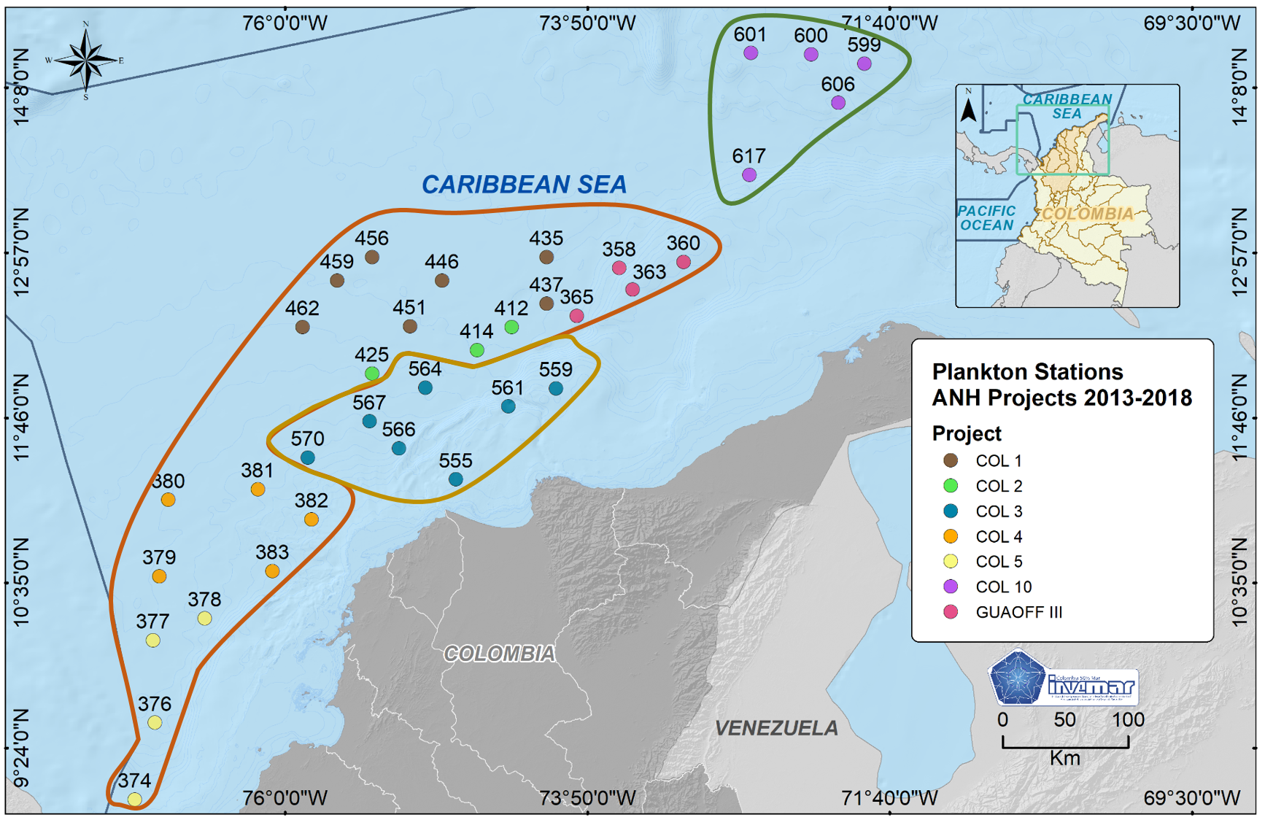Figure S3. Horizontal distribution of the copepod assemblage based on the associations obtained from the nMDS analysis. The offshore northeast zone (green = association 2), the influence of the Magdalena River zone (brown = association 1), the oceanic Colombian zone (orange=association 3).

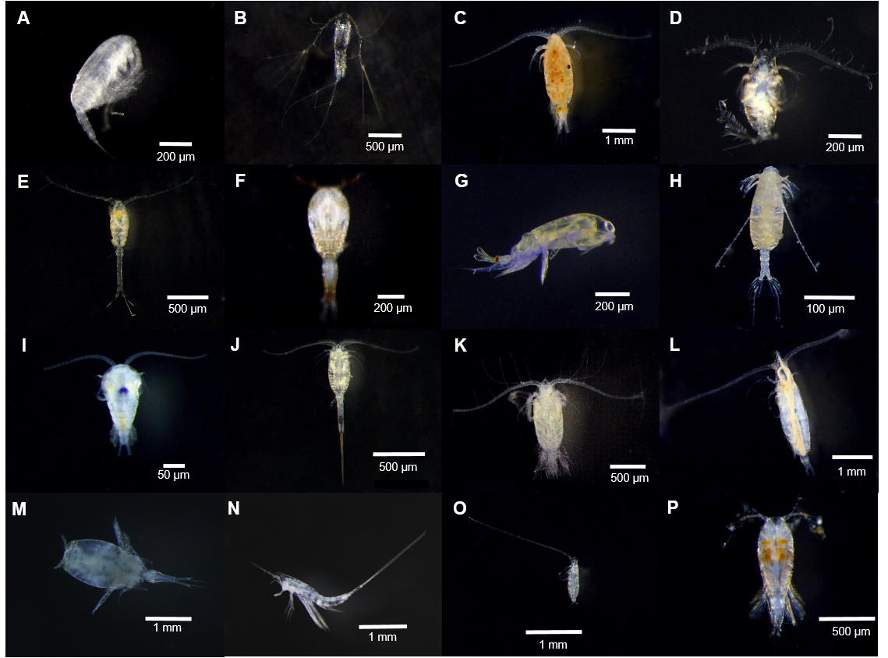
Figure S4. Sixteen species contributed more than 70% of accumulated density in each of the depth ranges. A. Clausocalanus furcatus, B. Mormonilla phasma. C. Pleuromamma abdominalis, D. Calocalanus pavo, E. Oithona setigera, F. Oncaea venusta, G. Farranula gracilis, H. Undinula vulgaris, I. Temora turbinata, J. Lucicutia flavicornis, K. Euchaeta marina, L. Rhincalanus cornutus, M. Agetus flaccus, N. Macrosetella gracilis, O. Mecynocera clausi, P. Conaea rapax.

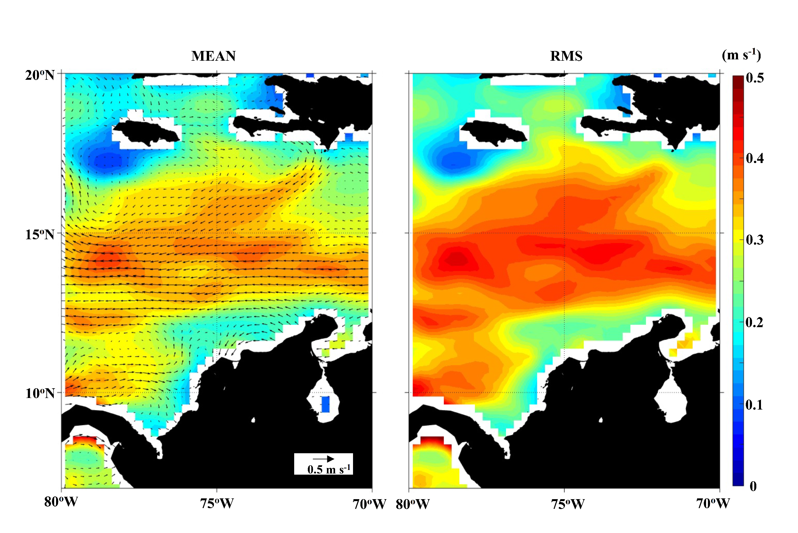
Figure S5. Climatology (1993-2019) of the geostrophic velocities for the Caribbean Sea (a); Background color (in m s-1) and arrows show the magnitude and direction of the surface currents, respectively. The root mean square (RMS) of the magnitude (b) of currents represented the amplitude of the interannual variability.

Table S1. Copepod’s assemblage variance explained by the environmental variables in the CAO ecoregion for all water columns and for a 0-200 m range of depth using a Distance-Based Linear model (DistLM). Marginal tests show the relative contribution of each variable tested individually, SS (Sum of squares), Pseudo-F (multivariate analogue of Fisher’s F ratio used in traditional regression), P (p-value), % Explicate (Describes the rise in the proportion of explained variation for each variable). Conditional tests show best results for each number of variables fit into the model based on AICc, R2 (the amount of explained variation), RSS (SS residual), No. Vars (Selected variables, refers to the order variables are listed in the marginal tests. Temp = Temperature, Sal = Salinity, Oxy= Dissolved oxygen, Sigma = Density, BVF= Brunt Vaisala Frecuency, MLD= Mixed Layer Depth.

All water column (0 – 1000 m) | Marginal test
 | Variable | SS (trace) | Pseudo-F | p-value | %explained
 | Temp | 32628 | 24.724 | 0.001 | 15
 | Sal | 21866 | 15.645 | 0.001 | 10
 | Oxy | 26858 | 19.727 | 0.001 | 13
 | BVF | 17745 | 12.431 | 0.001 | 8
 | Sigma | 31057 | 23.333 | 0.001 | 14
 | Conditional test (Best solution)
 | AICc | R2 | RSS | No. Var. | Predictors
 | 991,37 | 0.29 | 1.5215E+05 | 5 | All variables
0-200 m | Marginal test
 | Variable | SS (trace) | Pseudo-F | p-value | %explained
 | Temp | 2700.1 | 2.3411 | 0.012 | 7
 | Sal | 2073.7 | 1.7689 | 0.06 | 5
 | Oxy | 4677.9 | 4.2781 | 0.001 | 11
 | Sigma | 3465.8 | 3.0666 | 0.002 | 9
 | BVF | 7011.8 | 6.856 | 0.001 | 17
 | MLD | 3855 | 3.447 | 0.002 | 9
 | Conditional test (Best solution)
 | AICc | R2 | RSS | No. Var. | Predictors
 | 241.13 | 0.354 | 26322 | 3 | BVF, Oxy, MLD

