SUPPLEMENTARY MATERIAL

Factors affecting the seasonal variability of planktonic shrimps (Dendrobranchiata) along an estuary-ocean gradient on the Amazon Continental shelf
Leiliane Souza da Silva¹, Danielle Viveiros Cavalcante-Braga¹, Caio Brito Lourenço², Ralf Schwamborn³ and Jussara Moretto Martinelli-Lemos*¹
¹Aquatic Ecology and Amazon Fisheries Nucleus, Federal University of Pará, Brazil
²Agrarian Sciences Department, Federal Institute of Education, Science and Technology of Maranhão, Brazil
³Oceanography Department, Federal University of Pernambuco, Brazil
*Corresponding author: jussara@ufpa.br

Table S1. Specimens of the shrimp assemblage collected on the Amazon Continental Shelf. Development stages collected - MI: mysis I, MII: mysis II, MIII: mysis III, PL: post-larvae, JV: juveniles, and AD: adults. Sites where individuals were found on the shelf - 1: distance of 23 km, 2: 53 km, 3: 83 km, 4: 158 km, 5: 198 km, and 6: 233 km.
Taxa |  | Development  stages | ACS sites | Images
Luciferidae | Belzebub faxoni | MI-III, PL | All | 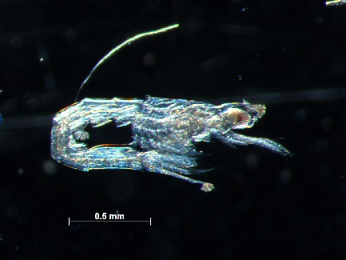 | 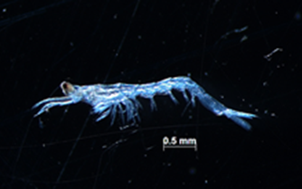
 | Belzebub faxoni | JV, AD |  | 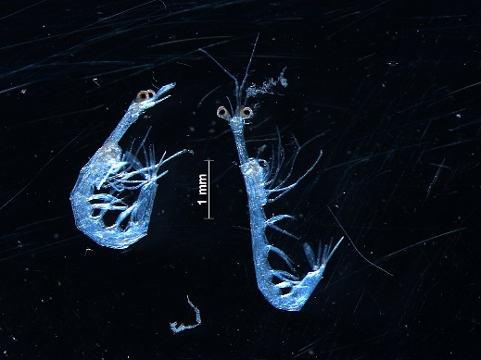

Table S1. Continued. Specimens of the shrimp assemblage collected on the Amazon Continental Shelf. Development stages collected - MI: mysis I, MII: mysis II, MIII: mysis III, PL: post-larvae, JV: juveniles, and AD: adults. Sites where individuals were found on the shelf - 1: distance of 23 km, 2: 53 km, 3: 83 km, 4: 158 km, 5: 198 km, and 6: 233 km.
Luciferidae | Lucifer typus | AD | 5 and 6 | 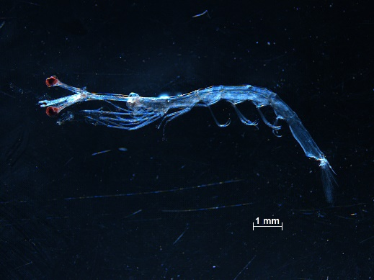
Sergestidae | Acetes spp. | MI-II, PL, JV, AD | 1, 2, 3, and 4 | 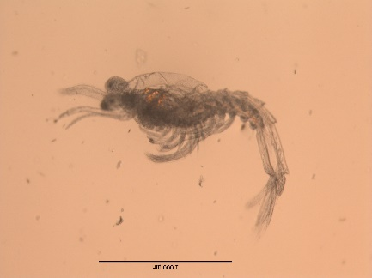 | 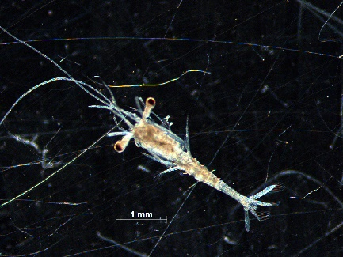
 |  |  |  | 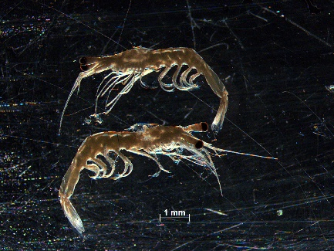
Table S1. Continued. Specimens of the shrimp assemblage collected on the Amazon Continental Shelf. Development stages collected - MI: mysis I, MII: mysis II, MIII: mysis III, PL: post-larvae, JV: juveniles, and AD: adults. Sites where individuals were found on the shelf - 1: distance of 23 km, 2: 53 km, 3: 83 km, 4: 158 km, 5: 198 km, and 6: 233 km.
Sergestidae | Sergestes sp. | MIII, PL | 6 | 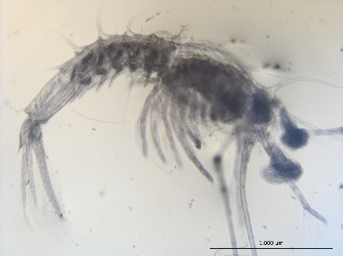 | 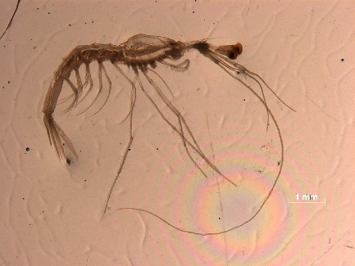
Sicyoniidae | Sicyonia spp. | MI-III, PL | 2, 3.4, 5, and 6 | 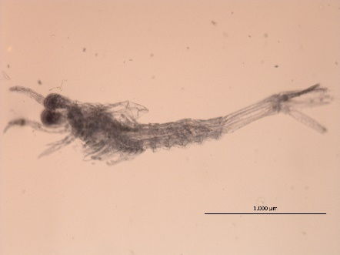 | 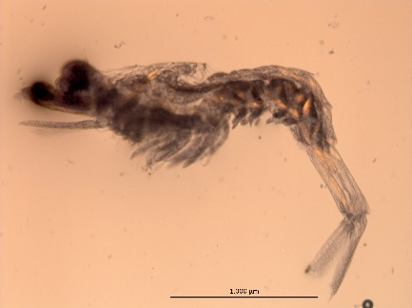
 |  |  |  | 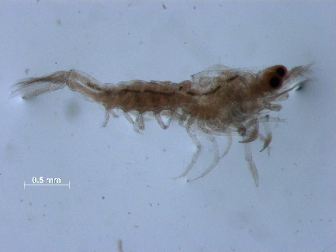

Table S1. Continued. Specimens of the shrimp assemblage collected on the Amazon Continental Shelf. Development stages collected - MI: mysis I, MII: mysis II, MIII: mysis III, PL: post-larvae, JV: juveniles, and AD: adults. Sites where individuals were found on the shelf - 1: distance of 23 km, 2: 53 km, 3: 83 km, 4: 158 km, 5: 198 km, and 6: 233 km.
Solenoceridae | Solenocera spp. | MI-III, PL | 3,4,5, and 6 | 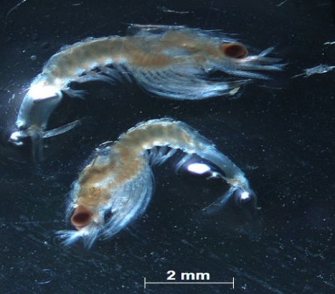 | 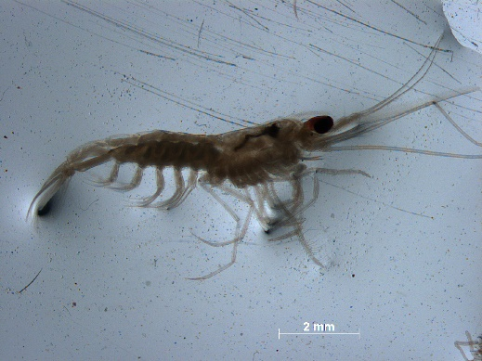
Penaeidae | Penaeus spp. | PL | 1, 3, 5, and 6 | 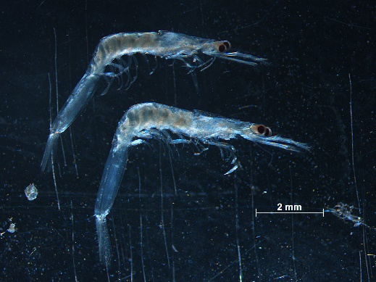

Table S1. Continued. Specimens of the shrimp assemblage collected on the Amazon Continental Shelf. Development stages collected - MI: mysis I, MII: mysis II, MIII: mysis III, PL: post-larvae, JV: juveniles, and AD: adults. Sites where individuals were found on the shelf - 1: distance of 23 km, 2: 53 km, 3: 83 km, 4: 158 km, 5: 198 km, and 6: 233 km.
Penaeidae | Xiphopenaeus sp. | MI-III | 1, 2, 3, 5, and 6 | 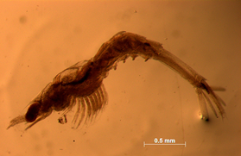
 | Penaeidae spp. | MI-III | 2, 3.4, 5, and 6 | 