Interannual variability and decadal stability of benthic organisms on an Indonesian coral reef
Alberto Rovellini, Matthew R. Dunn, Elizabeth A. Fulton, Lisa Woods, Jamaluddin Jompa, Abdul Haris, James J. Bell
Supplementary Online Information

Selection of number of CPCe points
Trials were carried out to determine the minimum number of points per picture that were necessary to accurately measure the percentage cover of the five live benthic categories and free space. Three randomly selected 25 cm x 25 cm images were analysed with 20, 40, 60, 80, 100, and 120 randomly assigned points per image. Each image was analysed 8 times for every number of points, with the points being re-randomised at every re-analysis. Mean and SD percentage cover of the benthic groups were calculated over the 8 values of cover per number of points, and the coefficient of variation (SD / mean) was calculated as a measure of the precision of the number of points in consistently quantifying the benthic groups. Low numbers of points corresponded to a high coefficient of variation, and the method gained precision with an increasing number of points. It was determined that for more than 80 points per 25 cm x 25 cm there was no clear improvement in the coefficient of variation for most benthic groups (Fig. S1).
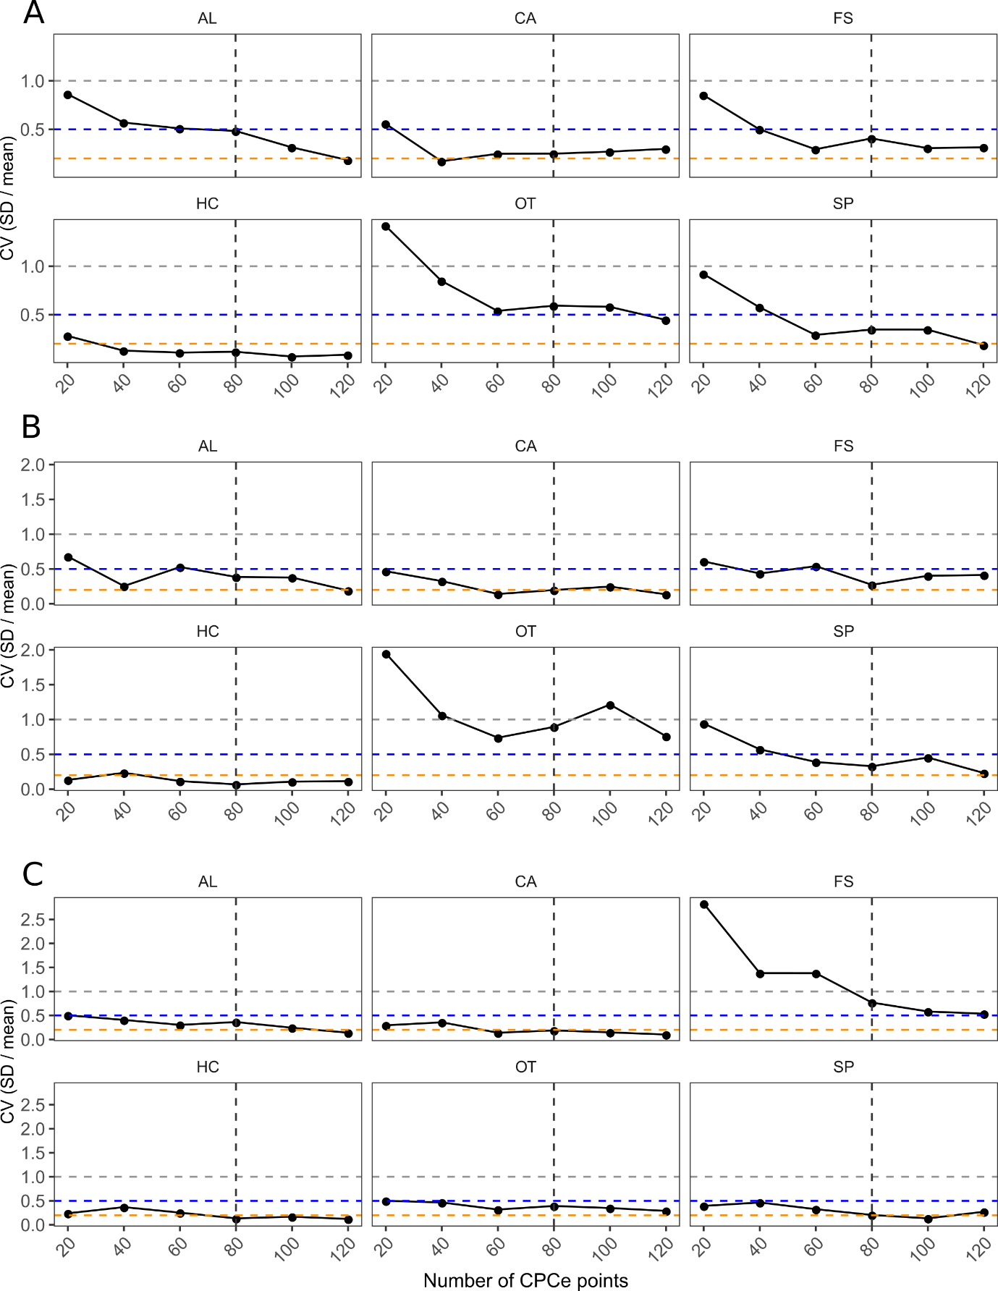
Figure S1. Coefficient of variation (SD / mean) obtained by averaging over values of percentage cover that had been calculated for each benthic group in 8 iterations for each amount of CPCe points (20, 40, 60, 80, 100, 120 random points per 25x25 cm image). In each panel, horizontal lines indicate CV = 1, 0.5, and 0.2 (grey, blue, and orange respectively); vertical dashed line indicates 80 CPCe points / image (the chosen amount). The evaluation of CV per number of points was carried out for 3 different, randomly selected 25x25 images, indicated by letters A, B, and C. AL: algae; CA: CCA; FS: free space; HC: hard corals; OT: other invertebrates; SP: sponges.
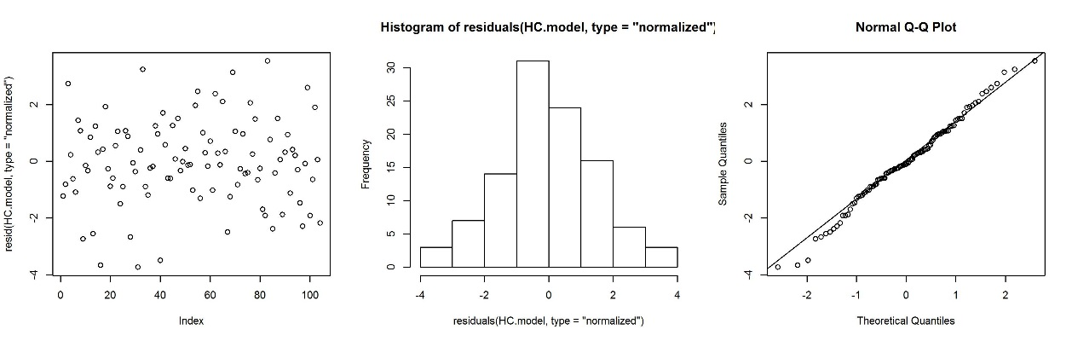
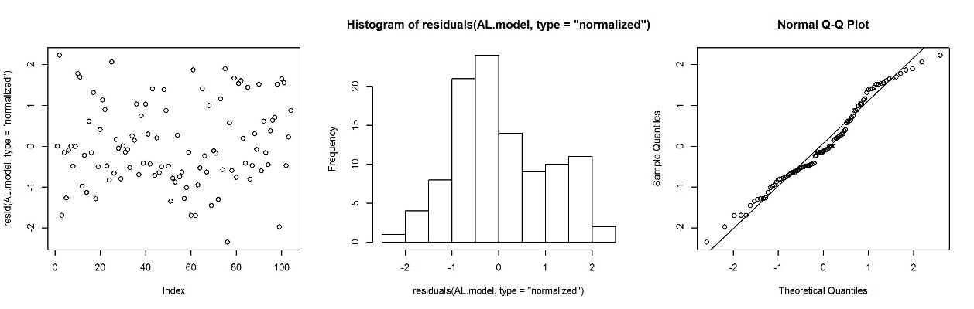
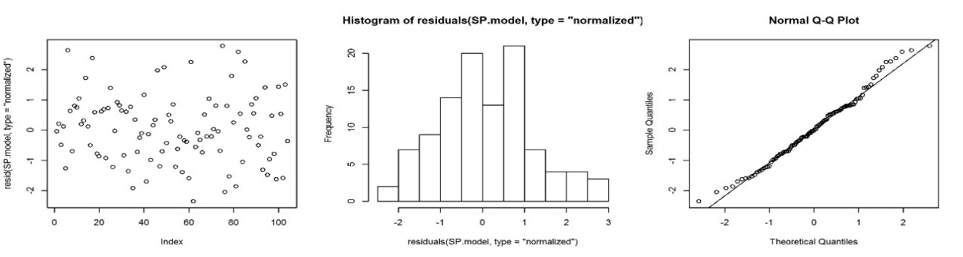
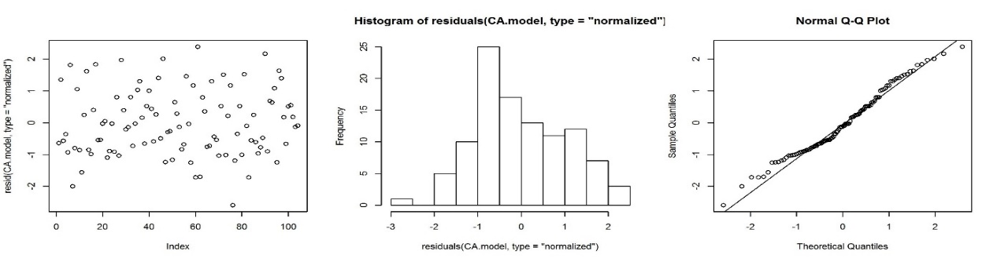
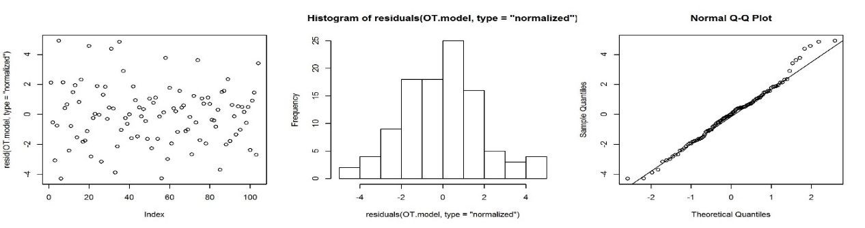
A
B
C
D
E
Figure S2. Scatterplot of the normalised residuals (left), histogram of the normalised residuals (middle), and quantile-quantile plots (right) of the Linear Mixed effects Models (LMMs) that showed significant fixed effects. A: coral % cover as function of site; B: sponge % cover as function of site; C: algae % cover as function of site; D: crustose coralline algae (CCA) % cover as function of site, year, and combination of the two; E: other invertebrates % cover as function of site, year, and combination of the two.
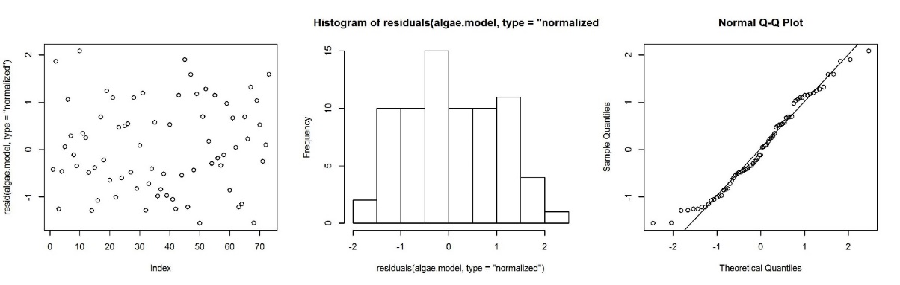
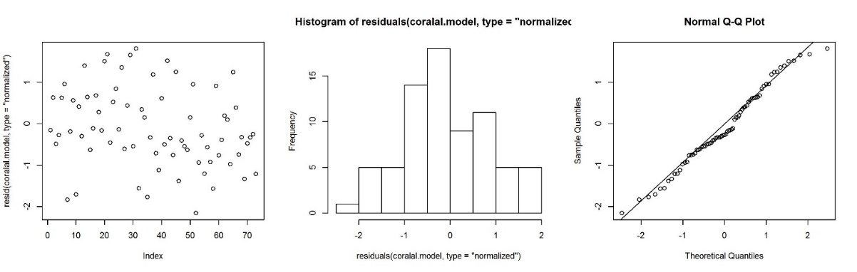
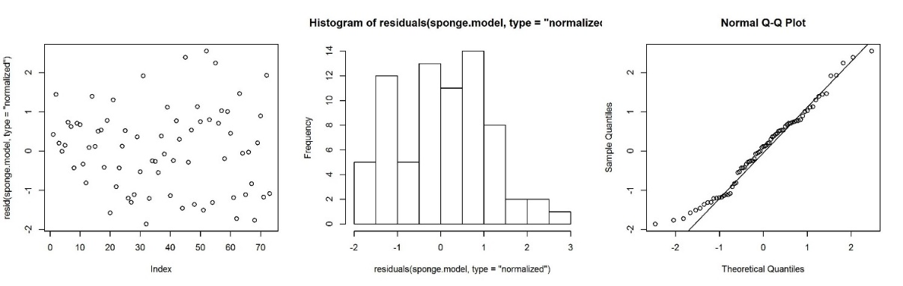
F
G
H
Figure S2 Continued. F: algae % cover (in year y) as function of free substrate % cover (in year y-1) and site; G: CCA % cover (in year y) as function of free substrate and turf % cover (in year y-1); H: sponge % cover (in year y) as function of free substrate and turf % cover (in year y-1).

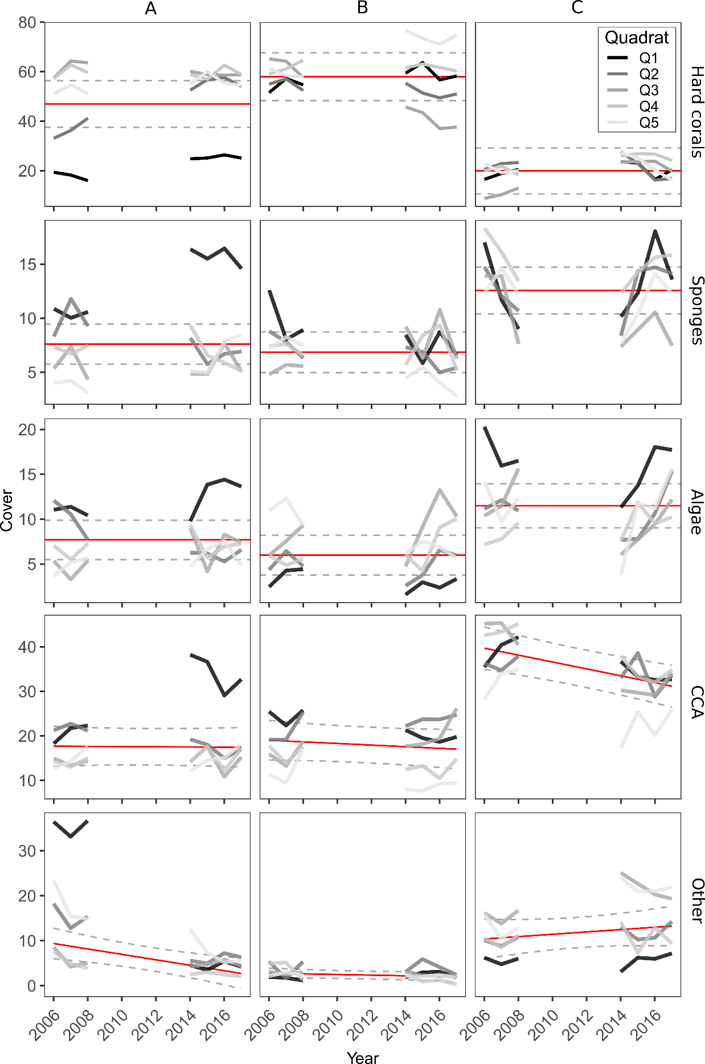
Figure S3. Temporal dynamics of the benthic groups at the three Sites on the Buoy 3 reef. Lines in different colours represent the raw data from different quadrats. Red lines represent the mean effects estimated by the linear mixed -effects models (LMMs), dashed lines represent 95% confidence intervals of model estimates.
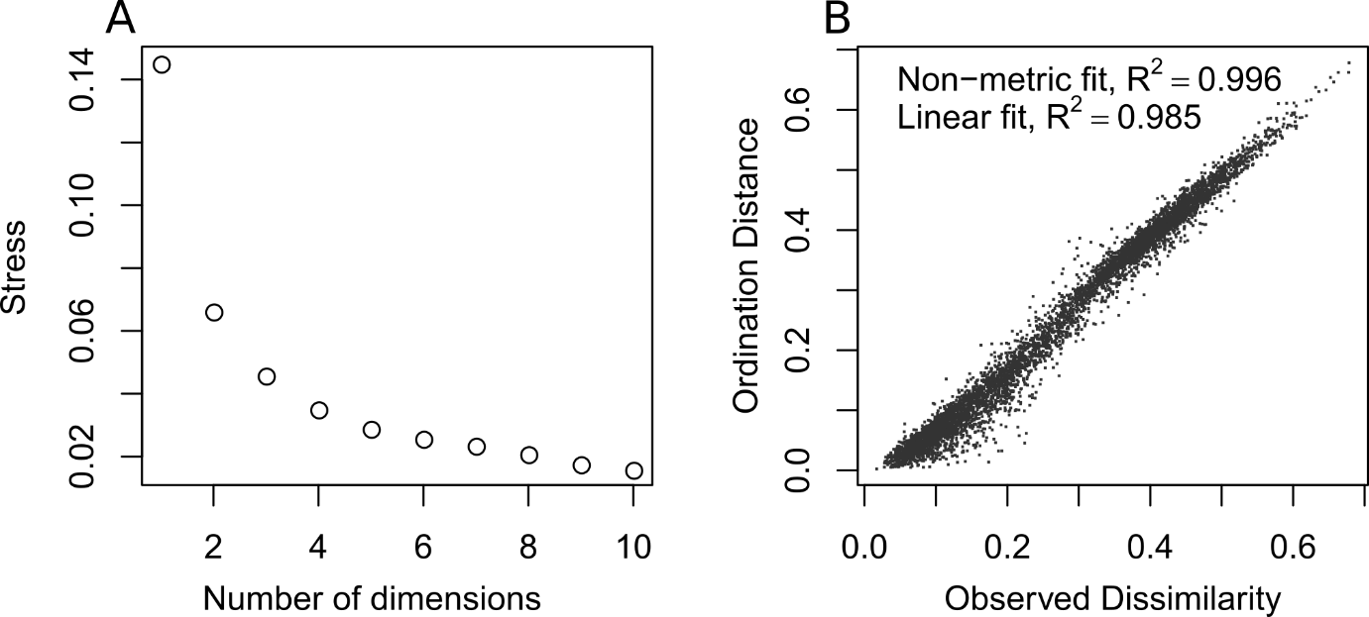
Figure S4. Diagnostics for the nonmetric Multidimensional Scaling (nMDS) plot executed on community data at Buoy 3 (Fig. 4 in main text). A: scree plot showing the stress function for increasing number of dimensions. The chosen value of two dimensions for the nMDS corresponded to a stress value close to 0.07. B: Shepard plot showing the relationship between the observed Bray-Curtis dissimilarities between quadrats at Buoy 3 (x-axis) and the ordination distance in two nMDS dimensions (y-axis). Of the measures of goodness of fit reported in the plot, the nonmetric fit is based on stress S, and it is defined as R² = 1-S*S, whereas the “linear fit” is the squared correlation between fitted values and ordination distances (see Oksanen et al. 2019).

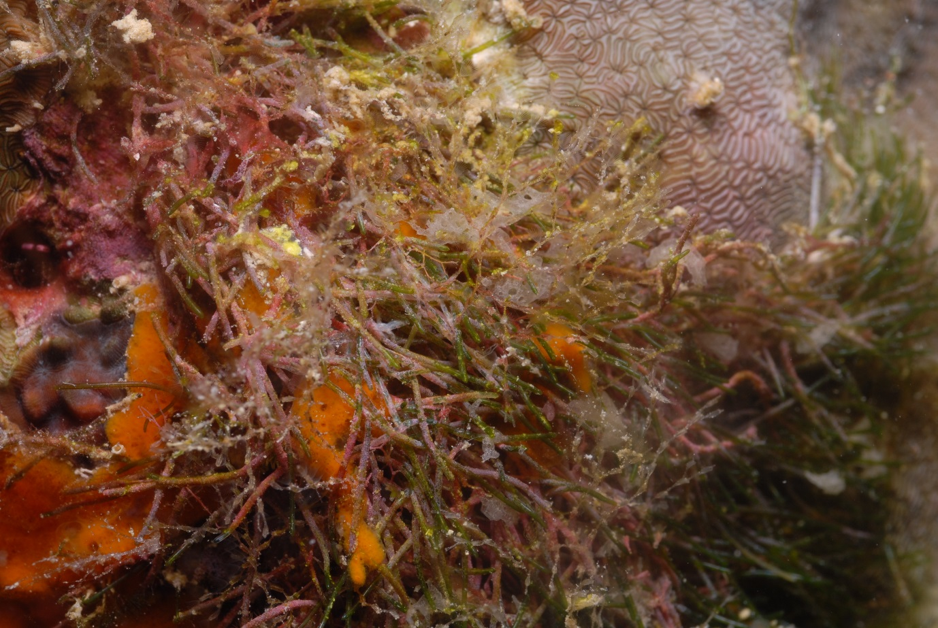
Figure S5. Example of association between filamentous turfing algae and a calcareous sponge (Clathrina sp., white in between algal filaments) in one of the quadrats.
References
Oksanen J, Blanchet FG, Friendly M, Kindt R, Legendre P, McGlinn D, Minchin PR, O’Hara RB, Simpson GL, Solymos P, Stevens MHH, Szoecs E and Wagner H (2019) vegan: Community Ecology Package. Available at: https://cran.r-project.org/package=vegan
Rovellini A, Dunn MR, Fulton EA, Webster NS, Smith DJ, Jompa J, Haris A, Berman J, Bell JJ (2019) Decadal variability in sponge abundance and biodiversity on an Indo-Pacific coral reef. Marine Ecology Progress Series 620: 63–76.

