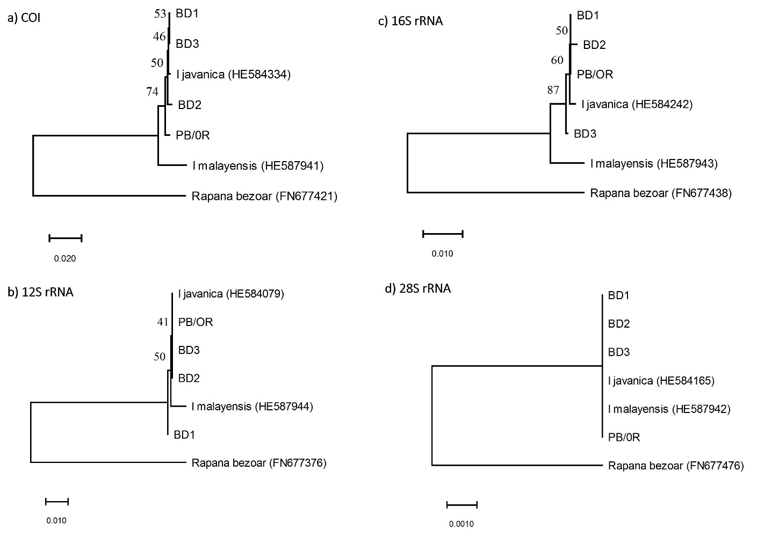

Supplementary Figure S1. Four Indothais specimens (BD1, BD2, BD3 and PB/OR), which were morphologically identified as I. malayensis, were used. Sequences of I. javanica and I. malayensis reported in a previous study (Claremont et al., 2012) were obtained from GenBank database. Similarly, sequences of Rapana bezoar from another study (Barco et al., 2010) was used as outgroups. All sequences were aligned using ClustalW via MEGA X (Kumar et al., 2018). Columns with gaps or missing data were excluded from the analysis. Thus, a total of 658, 548, 666 and 1422 bp of COI, 12S rRNA, 16S rRNA and 28S rRNA sequences were analysed, respectively. MEGA X was used to construct trees using Neighbor Joining algorithm with the evolutionary distances calculated using Kimura 2-parameter method. Bootstrap test was also conducted with 1000 replicates, and the bootstrap percentage values are shown at the tree nodes.

